Appointment of Head of Junior School

Information for candidates

Contents:

- St Edmund’s School

- Background

- The Junior School

- The Role

- Skills and Qualities

- Conditions of Service

- How to Apply

- THE SCHOOL

St Edmund's School is a co-educational day and boarding school with c. 600 pupils from the ages of 3 to 18. The school is officially designated by the DfE as “a school of religious character”. The Choristers of Canterbury Cathedral, who are full members of the Junior School, were incorporated into St Edmund's in 1972. The Head is a member of the Headmasters' and Headmistresses’ Conference (HMC) and the Head of the Junior School is a member of the Incorporated Association of Preparatory Schools (IAPS) and of the Choir Schools' Association (CSA).

Until August 1996, the school was owned and governed by the Clergy Orphan Corporation and was originally founded to educate the sons of deceased clergymen of the Church of England and the Church in Wales. The school still maintains this role to a small extent. Furthermore, the Archbishop of Canterbury is Patron of the school. From September 1996, the school has been completely independent. Its assets, including its properties and trust funds, are owned by an independent charitable company, limited by guarantee. The trustees are the school Governors.

The Pre-Prep, Junior, and Senior Schools are on the same site and are closely integrated, using the same Chapel, music and art facilities, dining hall, science laboratories and sports hall. The school prides itself on its friendly, family environment where every pupil is known and valued.

Although the majority of children are day pupils, one quarter of the school’s pupils are boarders, from a wide range of backgrounds. The school operates a five-day teaching week, but also runs a Saturday morning activities programme which is optional for Senior School day pupils. All boarders participate in both Saturday and Sunday activities programmes.

The school adjoins the University of Kent and is able to make use of many of the university's facilities: the Templeman Library, the Gulbenkian theatre and the public lectures amongst others. London’s West End is within easy reach. Further information about St Edmund’s may be found on the school’s website: www.stedmunds.org.uk.

- BACKGROUND

This post arises from the promotion of the current post-holder to the Headship of St Edmund’s School (3-18).

- THE JUNIOR SCHOOL

The Junior School has a very strong family ethos and we work hard to help and encourage our pupils in a caring, positive learning environment. Our nurturing approach is underpinned by dedicated and committed teaching, small class sizes, close links with our parent community and a clear focus on first rate pastoral care. To this end, we seek to understand our pupils as individuals and support them closely throughout their learning journey.

Outside of the classroom, pupils benefit from a rich and varied extra-curricular programme. Our school offers outstanding opportunities to participate and excel in sport, music, drama and the creative arts.
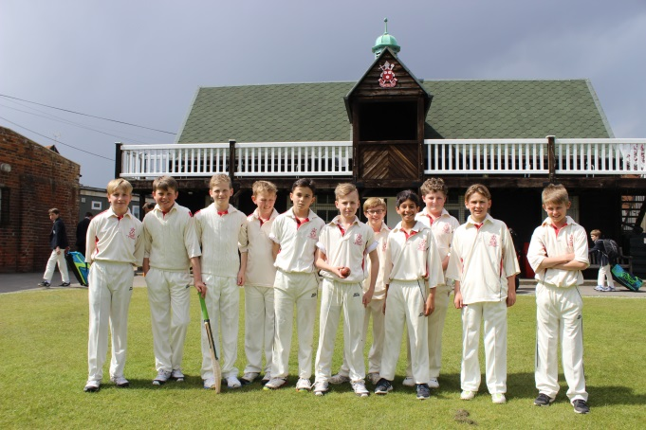

The Junior School has its own unique character but it also benefits enormously from being part of the wider St Edmund’s family based upon a common set of educational values. We also share the wonderful facilities of our St Edmund’s site and work closely with our colleagues in Pre-Prep and the Senior School to ensure a smooth transition through each stage of your child’s learning journey.
We currently have approximately 180 boys and girls aged 7–13. The school welcomes a broad range of academic ability amongst its pupils, but is selective. Most Junior School pupils are day pupils, though there are 45 boarders living in two boarding houses. School House in the main school building accommodates 20 boys and girls, and Choir House is home to the 25 choristers of Canterbury Cathedral in the Cathedral Precincts a mile away.

The Junior School is organised into two main sections: the Lower School (Years 3 to 5) and Upper School (Years 6 to 8). Currently, there is one form in Year 3, two forms per year group in Years 4 to 6 and three forms per year group in Years 7 and 8. Class sizes vary but in Upper School there are usually 15-16 pupils in a class.

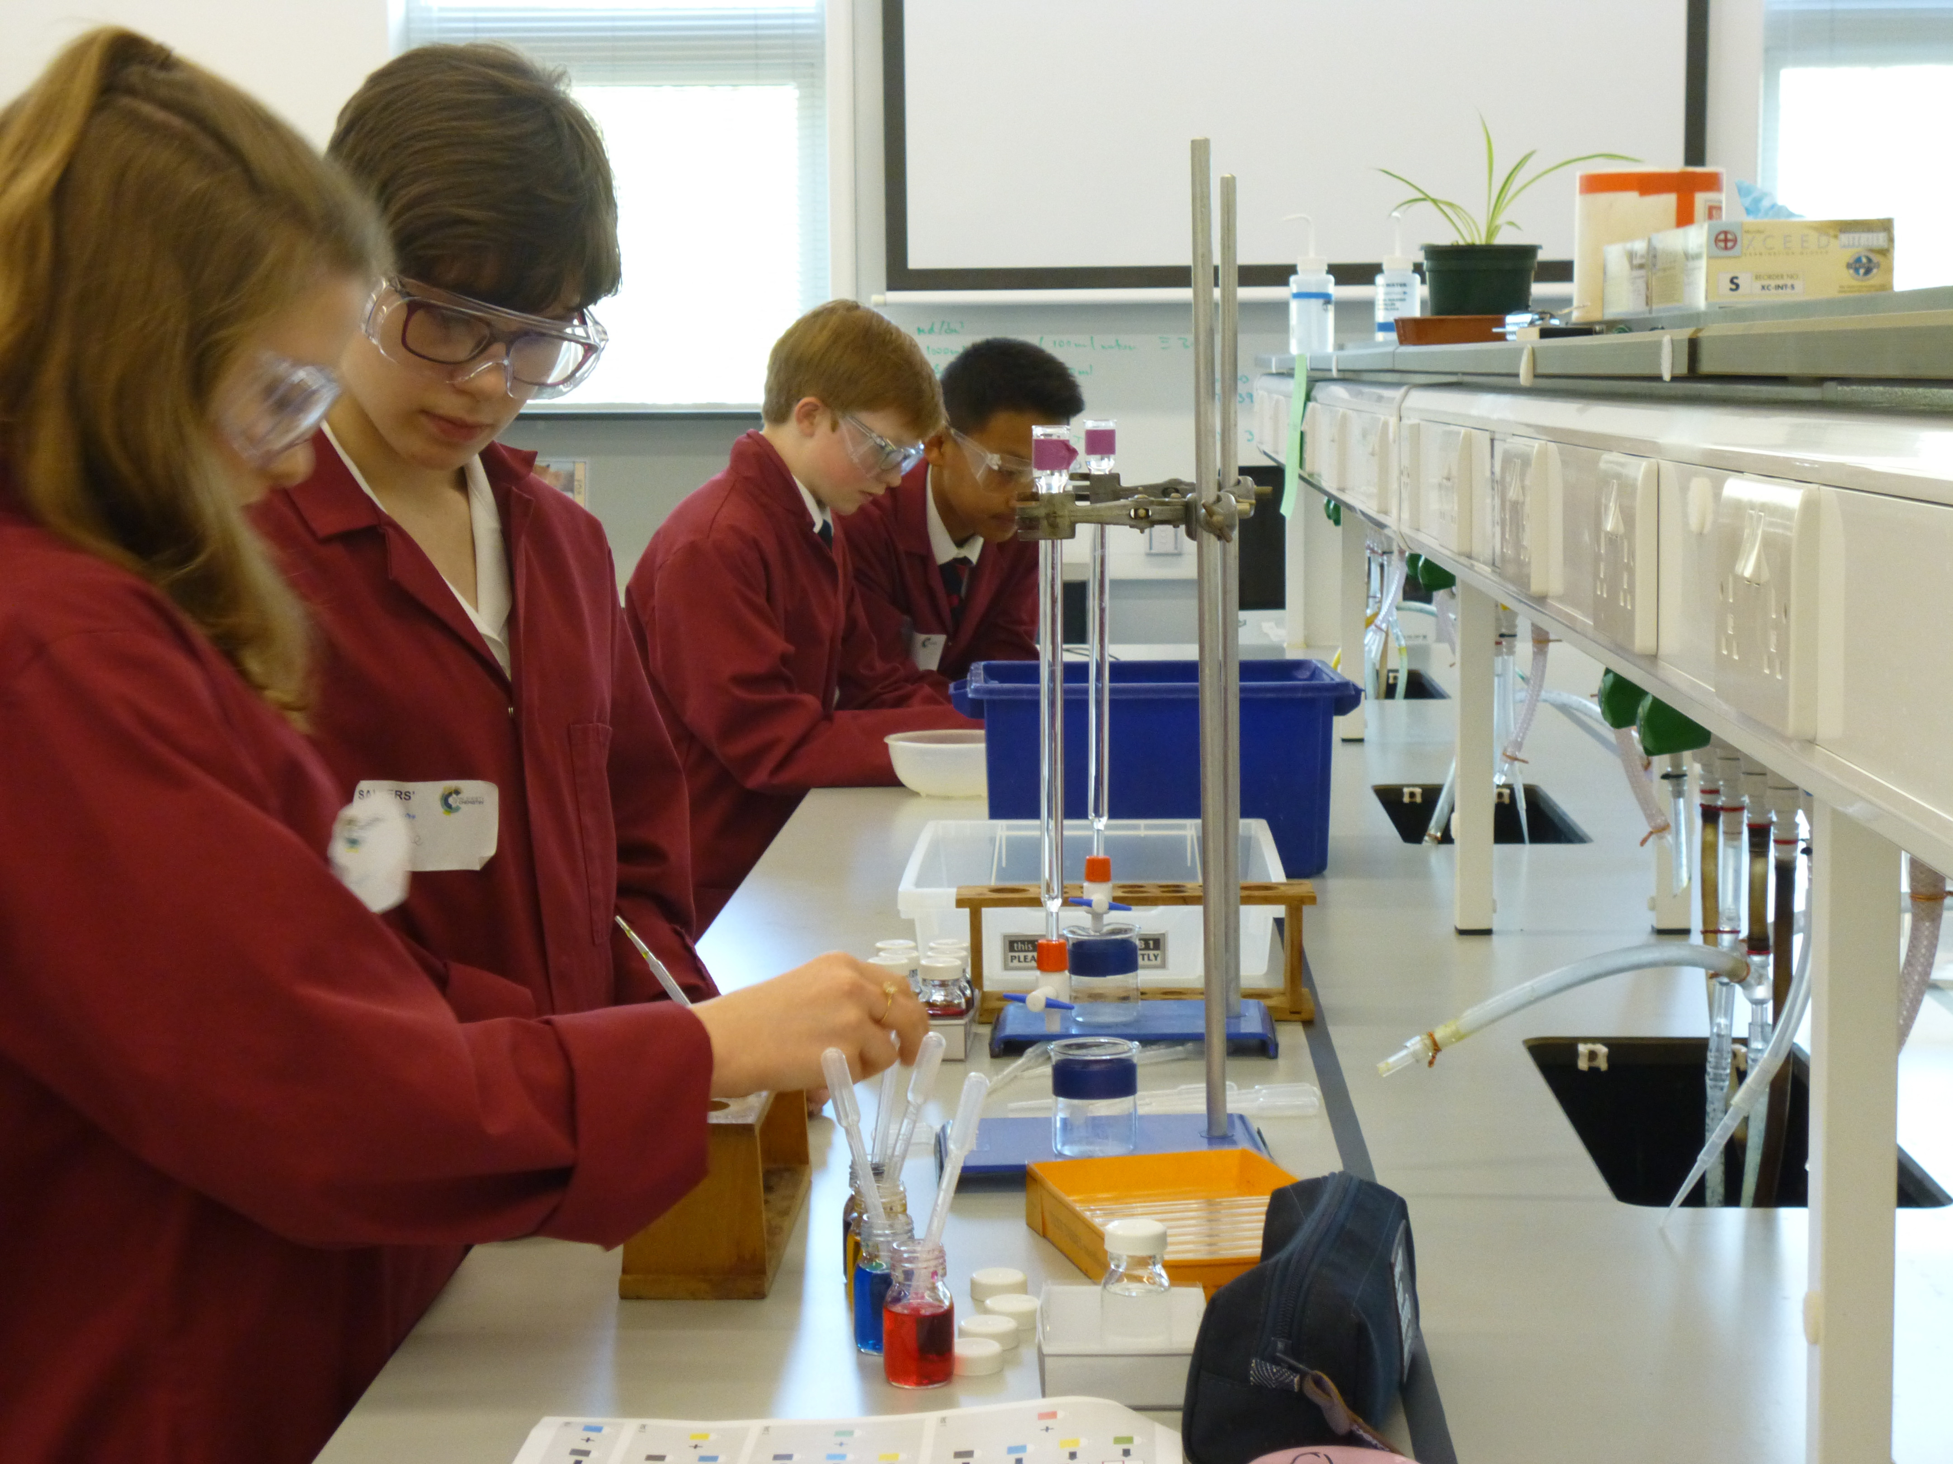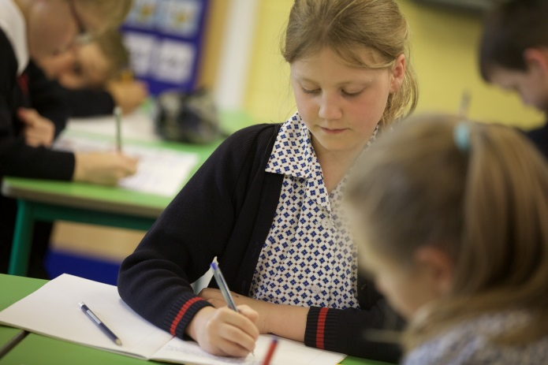

The Pre-Prep, Junior and Senior Schools at St Edmund’s share a single campus and work in close co-operation. The Head of St Edmund’s, currently Louise Moelwyn-Hughes (to be succeeded by Mr Edward O’Connor in September 2018), has overall responsibility for the running of the 3-18 school, but in all practical respects the Head of the Junior School manages daily matters in respect of the Junior School. The relationship between Pre-Prep, Junior and Senior Schools is a happy one and St Edmund's derives much of its strength and its capacity to work efficiently from its close-knit structure.

- THE ROLE

The Head of the Junior School has overall responsibility for the day-to-day running of the Junior School, and the safeguarding and educational development of Junior School pupils. The main responsibilities of the Head are:

Leadership

- To embody and actively promote the 3-18 ethos of St Edmund’s School

- To provide effective, caring and energetic leadership

- To be a member of the Whole School Executive Group

- Contribute to the 3-18 School Strategic Plan

- The production (and implementation) of the Junior School Development Plan which outlines the school’s aims, and its short, medium and long term objectives. The Junior School Development Plan dovetails with those of the Pre-Prep and Senior Schools in achieving the overall St Edmund’s School strategy

- Produce regular reports for Governors and represent the Junior School in Governors’ Meetings

- Communicate clearly, promptly and effectively with parents, professional bodies and other relevant groups

Pupils
- To ensure a safe and happy learning environment for all pupils

- Deliver a rich, balanced curriculum which meets the needs of Junior School children

- Monitor the quality of teaching and learning across Junior School, to ensure consistently high standards
- Ensure the provision of outstanding pastoral care for all pupils
- Monitor pupils’ personal and academic progress and ensure appropriate support is provided when necessary

- Ensure that pupils with Additional Educational Needs are appropriately supported at all times

- Advise Junior School parents and the 3-18 Head of St Edmund’s School on Junior to Senior School 13+ transfer issues

Staff

- Inspire and motivate staff to perform at the highest possible level

- Be responsible for the selection, appointment, guidance and performance management of Junior School staff

- Oversee and develop the Junior School Staff Appraisal and Continuing Professional Development process

Marketing & Recruitment

- Recruitment of pupils, ensuring that the Junior School roll is full

- Working with the Marketing and Communications department to promote the Junior School via its website, prospectus, annual review, local media and other means

- To be a figurehead of the Junior School, engaging with the local community and with other schools

- Work with the Junior School Parents’ Association to organise social events/raise funds for the benefit of the Junior School community

Policies & Compliance

- Ensure the Junior School is compliant with all statutory and regulatory requirements

- Oversee and update Junior School policies

- Lead preparations for ISI inspections in the Junior School

- SKILLS AND QUALITIES

The successful applicant is likely to have a record of proven success in primary or preparatory schools together with some, or all, of the following attributes:
- Educated to degree level, and holding Qualified Teacher Status, with a strong track record in teaching
- Excellent leadership and interpersonal skills
- A thorough knowledge and understanding of ISI regulations and compliance
- A capacity for hard work and a determination not to settle for second best
- Well-developed written and oral communication skills
- Experience of successful leadership and management at a middle or senior level
- A commitment to getting the best outcome for each and every pupil
- Effective team working skills and a ‘can do’ attitude
- Experience of managing organisational change
- A deep understanding of the national policy context for education
- A proven commitment to the continuing professional development of staff
- A kind, approachable manner and the willingness to be accessible to all members of the school community

- CONDITIONS OF SERVICE

St Edmund’s School Canterbury is committed to safeguarding and promoting the welfare of children, and applicants must be willing to undergo safeguarding screening appropriate to the post, including checks with past employers and the Disclosure and Barring Service.

Personal information provided by candidates will be kept on a secure file in the school and will not be released to third parties outside the school without the permission of the person concerned, except where there is a legal requirement so to do.

An attractive salary will be paid dependant on skills and experience and a four bedroom family house next to the school site is also provided to the Head of Junior School (and his/her family). The school is a member of the Teachers’ Pension Scheme. Fee remission for school staff is also available. Lunch is offered free of charge for all staff whose working hours encompass the time of school lunch and who accept the necessary supervisory role of staff and pupils during this period.

- HOW TO APPLY

Applications must take the form of a completed Teaching Staff Application for Employment Form, a full curriculum vitae, and a concise covering letter (addressed to the Head of St Edmund’s School, Mrs Louise Moelwyn-Hughes) outlining the candidate’s suitability for the post. The names and contact details (including emails) of three referees are required.

Online application forms are available through TES or on request from the Bursar’s Secretary – eb@stedmunds.org.uk.

Applicants should fill in the form including as much detail as possible and enclose a covering letter.

Applications should be posted or emailed to:

Mrs Elaine Bishop, Bursar’s Secretary
St Edmund’s School Canterbury
St Thomas Hill
Canterbury
CT2 8HU

Fax: 01227 471083
Email: EB@stedmunds.org.uk

The deadline for the receipt of applications is 5pm on Friday 2nd March. Long List interviews will take place on Thursday 8th March. Short List interviews will take place on Wednesday 14th March.

Personal information provided by the candidates will be kept securely by the School and will not be released to third parties outside of the School without the permission of the person concerned, except where there is a legal requirement to do so.

