We are looking for an outstanding teaching practitioner to lead our high performing and successful Mathematics Department.

Our aim is clear - we want our all our students to succeed and achieve in mathematics; whether this is offering our low ability students Functional Skills Qualifications or our high ability students individualised STEP tuition to ensure they have the opportunity to study at the best possible institutions in the country.
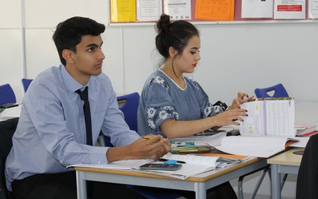
Our results are outstanding, reflecting the genuine dedication that every teacher has to ensuring progress for every student. In 2016-2017, we had a Progress 8 score of 0.65 and Level 4-9 of 89% at GCSE. Our A level results are similarly impressive with 72% of students achieving A*-B grade and 100% of Further Mathematicians achieving A*-B grade.

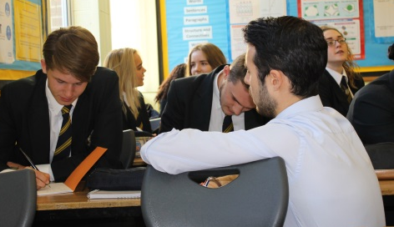
Although we teach in sets, extension, challenge and differentiation are important aspects of planning and delivery. We want every student to access the Mathematics curriculum but also to extend all students regardless of their ability. We pride ourselves at being up to date with current Mathematical teaching techniques and pedagogy to enable our students to succeed.

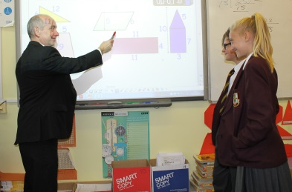
The Mathematics Department is based in a wing of the school, comprising eight dedicated Mathematics rooms and a further four dedicated ICT rooms. In addition, we have a room dedicated to teaching low ability small groups, equipped with kinesthetic resources and a specialist numeracy coordinator. The department is fully staffed with fully qualified mathematics teachers and we also activity recruit graduates to strengthen our team.

