CHADWELL HEATH ACADEMY

APPOINTMENT OF HEAD OF
MUSIC

DETAILS FOR APPLICANTS

Chadwell Heath Academy a company limited by guarantee, registered in England with number 7346826
Chadwell Heath Academy
Christie Gardens, Chadwell Heath, Romford, Essex RM6 4RS
Tel: (020) 8252 5151 Fax: (020) 8252 5152
Email: office@chadwellacademy.org.uk

Headteacher: Mr. S. N. Bull

Dear Colleague,

We are pleased to receive your enquiry about the post of Teacher in the Music Department.

The following pages give more details about our school and the type of person we are seeking for this post. It is difficult to judge what information to give to help people decide whether they wish to submit a formal application. If you would like further information please telephone the School. Further information about the school is also available on our website: www.chadwellacademy.org.uk

The closing date for applications is as advertised. Shortlisting will take place shortly thereafter and interviews will be held during the following week.

If you would like your application acknowledged, please enclose a stamped addressed envelope.

Thank you for your interest in the post.

Yours sincerely

S. N. Bull
Headteacher

THE POST

The post requires someone with ambition, enthusiasm and energy to continue the development of Music both within the curriculum and as part of wider school life.

As Head of Department you will be responsible for:

- progress and attainment in Music at all Key Stages, including the performance of pupils in examination at GCSE and A-Level

- leading curriculum planning, its resourcing and development at all Key Stages

- monitoring and developing the quality of Music teaching through regular and effective performance management

- running the peripatetic programme and co-ordinating extra-curricular activities in Music

- organising and leading a range of musical events during the School year

- all aspects of department management, including the effective use of the Music Budget

- the Health and Safety at Work Act, as it applies to the Music Department

THE DEPARTMENT

The Department has its own suite of rooms consisting of two classrooms, practice rooms, a recording studio and a computer room. All classrooms are connected to the internet and are fitted with projectors and whiteboards.

The Department is well-equipped with a wide range of teaching materials which include: a range of percussion instruments and strings, drum-kits, keyboards, pianos, Apple I-Mac workstations running Logic Audio, a 16-channel mixer, two AD converters, an Apple Mac Quad Xeon, Focusrite Voicemaster Pro and Genelec 8030 near field monitors.

The Department is provided with both technical and administrative support. There are also three peripatetic teachers who work on a one-to-one basis with examination candidates and pupils interested in developing their musicianship.

At Key Stage 3 Music is taught to mixed-ability groups in one, weekly, 1 hour 10 minute lesson. Year 7 groups consist of 30 pupils. In Years 8 and 9 the number of pupils taught in each class reduces to 23.

At Key Stages 4 and 5, group size is dependent on recruitment. Pupils opting to study Music at GCSE are taught the OCR syllabus. At A-Level students follow the EDEXCEL syllabus for Music Technology.

There are a range of extra-curricular opportunities for pupils interested in Music, including choir, orchestra and pop-group rehearsals. Concerts provide pupils with an opportunity to perform in front of an audience and are performed in the school hall.
THE SCHOOL

We are an 11-18 all ability, mixed comprehensive with a roll of over 1250 pupils. In 2010 we became one of the first Ofsted outstanding schools to convert to Academy status.

Our aim is to provide, within a framework of good discipline and encouragement, the opportunities for all our pupils to achieve their very best. Our examination results place us amongst the top comprehensive schools in the Borough and our intention is to ensure that we remain so.

The School has undergone extensive refurbishment and we are well equipped with general teaching rooms, subject specialist areas, a Sports complex of Sports Hall, Dance Studio, Fitness Room and Gymnasium, hard play areas and a sports field.

Session Times are: 8.45 a.m. - 1.10 p.m. and 1.55 p.m. - 3.20 p.m.

On joining the School, pupils are placed in forms, which are arranged to contain an even spread of abilities. These social groupings remain together until the end of Year 11. Extra teaching groups are formed in a number of subjects to bring class sizes down to the low 20’s. There is progressive setting in Mathematics and Science in order that teaching may be carried out at levels most suited to the pupils’ developing needs. Pupils with learning difficulties receive help from a support teacher/assistant working alongside the class teacher during lessons.

Years 7-9: All pupils follow a common core of subjects which include all the National Curriculum subjects to Key Stage 3: Art, Design and Technology, Drama, English, French, German, Geography, History, Mathematics, Music, Physical Education, Religious Studies, Science and Citizenship / Personal, Social and Economic Education. From Year 8, all pupils follow an Information and Communication Technology course. All courses in the Lower School are arranged in 8 week modules which end with an assessment.

Years 10-11: All pupils study English, English Literature, Mathematics, Science and ICT. They also follow a programme of Citizenship / Personal, Social and Economic Education, and Physical Education. Pupils then have a choice of a range of subjects to complete their timetable. These additional subjects are selected after consultation between pupils, parents and teachers. Most pupils are expected to gain 8 or 9 high grades at GCSE.

The range of option subjects available for Years 10 and 11 include: Art and Design, Business Studies, Dance, Drama, Food Preparation and Nutrition, French, Geography, German, History, Media Studies, Music, Physical Education, Product Design and Religious Studies.

Sixth Form: We have a large and flourishing Sixth Form of around 320 students and offer a range of qualifications at both A-Level and BTEC / CTEC. All students who have not achieved a Grade 4 in English or Mathematics follow a re-sit course in those subjects.

Courses currently available in the Sixth Form at A-Level are: Art, Craft and Design, Biology, Business Studies, Chemistry, Dance, Drama and Theatre Studies, Economics, English Literature, Film Studies, French, Further Mathematics, Geography, German, History, Law, Mathematics, Music Technology, Physical Education, Physics, Product Design, Psychology and Religious Studies. At BTEC we offer Sports and at CTEC we offer: Business Studies, Digital Media, Information Technology and Laboratory Skills. A Certificate or Diploma is also available in Financial Studies.

Homework

Homework is set regularly via Show My Homework and parents are asked to assist the School in ensuring that sufficient time is spent on it. A Pupil Planner, in which homework is also recorded, is used as a regular means of communication between school and home.

Pastoral Care

There is a happy atmosphere in the School, and this is due to the success of our pastoral teams. Each pupil has a Form Tutor, who takes a close interest in the development of the pupils in their Form Group. Each Year Group has a dedicated Head of Year who leads the pastoral team with the support of a Deputy Headteacher. Information about progress is regularly available through Effort and Attainment Grade reports. There is also an end-of-year report for each pupil and a formal parents’ evening for each Year Group. In addition, parents are welcome to see staff by appointment.

Careers guidance is available at all stages of a pupil's schooling, but concentrated advice is given from Year 9 onwards. All Year 10 pupils have two weeks of Work Experience in the Summer Term.

Parents

The full support of parents is required in matters such as the wearing of School Uniform, the spending of adequate time on homework and the enforcement of the Home School Agreement, a copy of which is supplied to parents of all pupils who enter the School.

Discipline

We strive to encourage the development of self-discipline. Good behaviour is expected both inside and outside school. Should a pupil's behaviour cause the School concern, parents are kept fully informed. There are clear rules, and those who transgress are punished.

Uniform

A smart uniform imparts a sense of belonging and helps to maintain the high tone of the School. For these reasons a full school uniform is worn by all pupils below the Sixth Form. Pupils who arrive improperly dressed are liable to be sent home.

Extra-Curricular Activities

These are encouraged and available to all members of the School. The Physical Education Department offers a wide range of sporting activities. There is also Orchestra, Choir and instrumental groups, Science Club, Computer Club, Drama Club and many more. There are several drama and musical presentations throughout the year. Pupils undertake fieldwork in Geography and Science, while trips to France, Germany and Spain serve to improve their awareness of life in other countries, enhance their understanding of foreign languages, or simply give them an opportunity to ski.
HOW TO APPLY

Please complete all sections of the Application Form. If you wish to write your letter on separate sheets of paper, please do so. The Letter of Application should make clear your views on teaching the subject and outline your reasons for making the application.

Applications should be addressed to the Headteacher and arrive no later than as advertised.

DIRECTIONS TO THE ACADEMY
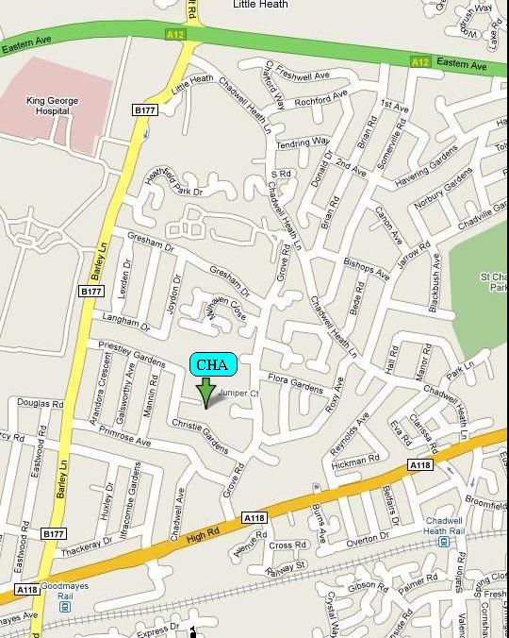

By Car
- From the M25 exit at Junction 28 – signposted A12 Romford
- Follow the A12 - signposted London
- Turn Left off the A12 – signposted Chadwell Heath/King George Hospital
- The 4th turning on the left is Priestley Gardens. The School is at the end of the road.
By Train
- From Liverpool Street Station to Goodmayes Station via the National Rail – Great Eastern Line
- Turn right out of the station
- Proceed across the traffic lights along Barley Lane
- The 4th turning on the right is Priestley Gardens. The School is at the end of the road.

