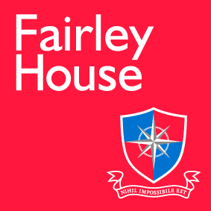

January 2017

Dear Candidate

Thank you for your interest in this role at Fairley House.

Fairley House is an outstanding specialist Independent School meeting the needs of pupils aged 5-14 with dyslexia, dyspraxia and dyscalculia. We are based in central London with one school in SW1 and one in SE1 – approx. fifteen minutes’ walk between the two. We currently have 190 children on roll and have recently expanded into KS4.

We are looking for an experienced examinations officer.

This can be a standalone administration role or as part of a teaching contract, if you are a teacher please contact us for a teachers application form and the job description for a teacher.

If you are a teacher you must possess a recognised teaching qualification and have or be willing to undertake our Fairley House Certificate or if you want further CPD an OCR level five qualification in teaching dyslexia, (we have our own OCR teaching centre).

Fairley House operates its own competitive pay scale, and salaries are enhanced to reflect our status as a leading Central London SEN Independent School. We offer benefits such as free school lunch during term time, cycle to work scheme, childcare vouchers and the Perk box discount package.

We are keen to attract a diverse range of teachers and if you have any queries as to whether or not this role may be right for you then please do feel free to contact me me HR Manager hr@fairleyhouse.org.uk

Applications need to be with us by 10th May 2017, shortlisting will take place the following week and interviews are expected to take place before half term.

Fairley House is committed to the safeguarding and welfare of child and successful applicants must be willing to undergo an enhanced DBS check, personal and professional reference check and a medical.

I look forward to receiving your application.

Yours sincerely
Michael Taylor
Headmaster

