Dear Candidate,

Thank you for your interest in working at Thetford Grammar School, I would like to give you some insight into who we are and why this is such an exciting time to join our school.

I am very proud to have been selected by the Governors and Directors to lead TGS; having taken up my post in August of this year, I am looking to appoint a sole Deputy Head who is ready to get fully involved in all aspects of this exceptional 3-18 school as we welcome our first international pupils and begin an ambitious programme of growth and development.

Thetford Grammar School has a long and distinguished history as a seat of learning dating back over 1400 years. In modern times, we have a strong reputation for academic excellence, with pupils at all stages of the school achieving the highest levels of success in a wide range of disciplines. Our GCSE and A level results are significantly above local and national averages and we successfully prepare students for entry to top universities including Oxford and Cambridge each year.

As an all-through school, the pupil journey from 3 to 18 is central to our planning. Our aim is to provide the most comprehensive programme of academic and personal development possible. An approach to teaching and learning, and to the monitoring of teaching and learning, that supports creativity, risk-taking and critical engagement with pedagogy is essential to achieving this. Our next Deputy Head will enjoy working closely with teachers to enable reflective, evidence-based classroom practice.

Likewise, our next Deputy Head will appreciate that we are a school where relationships between pupils and staff, and between staff and parents, reflect the highly personalised level of care and attention that TGS specialises in.

Looking ahead, Thetford Grammar School plans to grow in number and reach, both locally and further afield. TGS is an integral part of Thetford’s rich and distinguished history, and we are determined to be of continued benefit to our town and community. Opportunities for creative partnerships with other local institutions and outreach projects are an important part of the school’s outlook. At the same time, we will be establishing an international perspective and presence, as well as raising our national profile as one of the country’s leading independent schools.

For the right person, this is an opportunity to help shape the future of Thetford Grammar School. Candidates excited by such a prospect are invited to contact the school to arrange an informal discussion and possible visit ahead of application.

Yours faithfully,

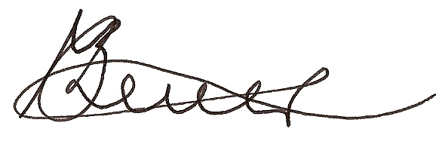

Michael Brewer

