Applicant Information Pack
Teaching Assistant (Term time only, pro-rata)

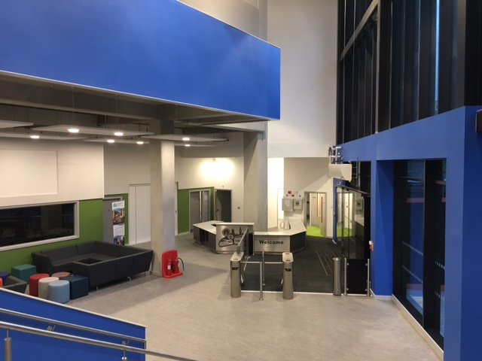

Sir Simon Milton Westminster UTC is committed to safeguarding and promoting the welfare of children and young people and expects all staff and volunteers to share this commitment. Appointed staff will be subject to Disclosure and Barring Service (DBS) checks. The UTC is committed to equal opportunities.

Letter from the Joint Headteachers

Thank you for your interest in working for Sir Simon Milton Westminster University Technical College.

We are a new University Technical College that educates the young women and men that will become the next generation of professional engineers, technicians and innovators.
Sir Simon Milton Westminster University Technical College delivers academic excellence, alongside problem solving and valuable technical skills, for London’s 14 to 19 year olds.
Our students are inspired by solving real life community and industry problems, working alongside professionals from our sponsors in the transport engineering and construction industries. These industries are rapidly transforming London and there is an enormous need for the ambitious, high achieving, young women and men that will come through our UTC with their innovative thinking, team working and project management skills, all standing on a bedrock of excellent academic qualifications.

Students work on the employers’ business challenge projects, benefitting from University of Westminster student mentors, and learning how to apply their English, Computer Science, Science and Engineering to London’s real-life industry projects.

The flagship UTC building is a short walk from the transport hub of London Victoria railway station. This location enables unparalleled access to our high profile industry partners: Network Rail, Landsec, Sir Robert McAlpine, Alstom, BT Fleet, Colas Rail and Transport for London.
We have a strong, passionate and committed senior leadership team, and with the support of outstanding staff across all areas, we look forward to the continued evolution of the UTC. We are looking for an engaging and passionate Computer Science teacher to join us in facilitating continued and ever more success.

Sir Simon Milton Westminster UTC’s staff are team players, prepared to do the extra things that really make a difference for students and colleagues and are excited about learning and student success. This is an exciting opportunity. As a new UTC, our staff will have the ability to influence and shape their area of work.

We do hope that you will apply for a position with us. You are very welcome to book an appointment to visit us; our staff and students will make you feel very welcome.

Mike Finn & Antonia Evans

Joint Headteachers

Benefits of Working at the UTC

Letter from the Joint Headteachers

- Generous leave and holiday entitlement
- Conveniently situated within walking distance of London Victoria, Pimlico and Sloane Square stations.
- Exciting and innovative educational institution, allowing you to influence and shape your area of work
- Work alongside top employers
- Unrivalled opportunities for career development
- Work within a brand new building designed for modern technical education
- Outstanding resources to support learning, including an exceptionally high IT/ student ratio and industry standard specialist equipment
- Outstanding internal and external professional development opportunities to help you excel in your role and shape your skills and future potential.
- Opportunities to gain funding for additional leadership qualifications, such as the NPQML/ SL/H.
For Teachers:
- Class sizes and student numbers that will allow you to personalise your approach to the students
- Benefits are aligned with the Teachers’ main scale pay and conditions, including a generous inner London allowance
- An additional UTC allowance of £2000 per annum on top of pay scale

Job Description and Person Specification:
Teaching Assistant

Role: Teaching Assistant

Responsible to: Assistant Principal

Job Purpose
To work as a Teaching Assistant supporting in lessons and working with the teaching staff across all disciplines to ensure the exceptional progress of our learners. Teaching assistants may also support students by supervising independent study periods, as well as working with students one- to- one or in small groups.

The College is committed to safeguarding and promoting the welfare of children and young people and expects all staff and volunteers to share this commitment. Appointed staff will be subject to Disclosure and Barring Service (DBS) checks

A Teaching Assistant is required to help shape an all new, highly advanced university technical college for 14-19 year olds.

RESPONSIBLE TO: Assistant Principal

To work as a Teaching Assistant supporting UTC’s lessons and working with the teaching staff in all disciplines to ensure the exceptional. Progress of our learners. Teaching Assistants may also support students by supervising independent study periods, as well as working with students one- to- one or in small groups.

DUTIES AND RESPONSIBILITIES

- Assist in the educational and social development of pupils under the direction and guidance of the, SENDCO and class teachers and senior leadership team.

- Provide support for individual and groups of children inside and outside the classroom.

- Assist in the implementation of Individual Education Healthcare Programmes (EHCPs) for students and help monitor their progress.

- To work with the teachers to develop lessons, work plans and resources.

- To support student achievement by providing constructive feedback to students on their work measured against the learning outcomes.

- To be proactive in managing behaviour, promoting self-control, independence and integration of the students.

- To assist with the ordering & storage of equipment, stock and stationery.

- General clerical duties concerned with keeping textbooks and coursework (as required) in good condition.

- To support teachers, where possible, on educational trips & visits & help cover personal preparation and marking time/ independent learning periods.

- To undertake all duties and responsibilities in accordance with College policies, including Equal Opportunities; Data Protection; Health & Safety; Child Protection/ safeguarding and Quality and Financial regulations. To report any concerns to the appropriate person.

- To take full responsibility for personal professional development and training.

Person Specification: Teaching Assistant (TA)

The College is committed to safeguarding and promoting the welfare of children and young people and expects all staff and volunteers to share this commitment. Appointed staff will be subject to Disclosure and Barring Service (DBS) checks

The appointed person will be expected to possess:

- good all round level of education to include Maths and English to GCSE (Grade A – C or 4 +) or equivalent level (level 2);

- qualifications at Level 3 (A Level or BTEC) or above;

- competent ability as a Microsoft Office user;

- a good knowledge of relevant Health and Safety requirements;

- a demonstrable knowledge of Equality and Diversity issues;

- previous experience working in an educational environment or with young people (desirable);

- organisational skills with excellent attention to detail;

- good interpersonal, time management and organisation skills;

- the ability to work using own initiative;

- the ability to work positively with young people, understanding their needs, worries or concerns;

- a First Aid Certificate or willingness to achieve one within a specified time period;

- an understanding of Child protection (Safeguarding) and the willingness to increase knowledge;

- previous TA experience (desirable);

- a TA qualification (desirable).

Salary: £17,000 to £20,000 pro rata per annum, negotiable depending on experience

Hours: 37.5 hours per week, 40 weeks a year (term time +2 weeks)

