Lark Hill Road
Preston
Lancashire
PR1 4HD

Tel: 01772 460181
Fax: 01772 204671
Email: hr@cardinalnewman.ac.uk
Web: www.cardinalnewman.ac.uk
Dear Applicant

We are delighted that you are considering applying for the post of Temporary Part Time Teacher of Foundation Learning (up to a maximum of 0.6fte) to take up post the end of August 2018 initially until 31st August 2019.

Cardinal Newman is a wonderful place to work and we welcome applications from those who are keen to gain a broad experience of working in an outstanding institution. We are a happy and thriving Catholic Sixth Form College and welcome colleagues and students into our community regardless of their religion or belief, ethnicity, gender, disability, sexual orientation, marital or pregnancy status.

At Cardinal Newman, we are committed to the development of the whole person and we value each student as an individual, with a unique mix of skills and talents. Our students achieve outstanding results, which consistently place Cardinal Newman amongst the top four Colleges nationally for Value Added. We were awarded Beacon Status in 2010 and the College was awarded an ‘outstanding’ Inspection in May 2009. However, we are as proud of our students’ social, cultural and spiritual achievements as we are of their outstanding exam results. We have a fabulous team of colleagues who give up an extraordinary amount of time to support their students and their fellow members of staff. The dedication and attention to quality they exhibit is what makes our College so successful.

If you meet the criteria of the post advertised and feel that you would enjoy working here, we hope you will make an application to join us. We welcome applications from suitably experienced and newly qualified teachers for appointment to this teaching post.

Completed application forms should be returned to the Human Resources Department (via email or post) by 9:00am on Wednesday 23rd May 2018. We do ask that you accept, in the interests of economy, that if you have not heard from us by the end of May you have not been selected for interview on this occasion. We will confirm receipt of all applications by email within one working day of receipt. Please call the HR team if you have not received a confirmation email by the closing date.

Should you have any questions, which are not covered in the enclosed information, please do not hesitate to contact the Human Resources Department.

Yours faithfully
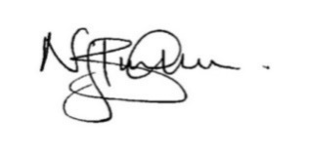
Nick Burnham
Principal

Mission Statement

As a Catholic Sixth Form College we strive to be a centre of educational excellence for the community built on faith, respect and trust. We celebrate diversity amongst all out students and staff and seek to nurture the gifts of each individual through high quality teaching and learning and dedicated pastoral care.

Values Statement

Cardinal Newman College is a community which aims to live out the gospel values of service and love. This means that:

- The individual student is central to all our endeavours
- The College values each individual as a unique person irrespective of gender, race, belief or ability and regards each person, made in the image and likeness of God, as worthy of the utmost respect
- The College strives to develop each person intellectually, socially and spiritually through an inclusive programme of study and enrichment
- The College values the spiritual journey of each individual and will offer opportunities for each to engage appropriately in their spiritual search
- The College is committed to creating a culture that is open and welcoming, free from fear and from violence of any kind, in which all individuals feel safe, happy and secure
- The College provides learning environments that are stimulating, enjoyable and challenging to students, fostering their creativity, imagination and search for truth
- The College encourages individuals to contribute positively to the world in which they live, to challenge injustice and to seek out more co-operative, just and peaceful forms of human existence.

Foundation Learning Department - Background Information

The Foundation Learning Department currently offers the following courses:

- Functional Skills (Numeracy)
- Functional Skills (Literacy EL3,EL2,EL1,L1)
- ASDAN Short Course in Citizenship L1
- Edexcel Certificate / Diploma Personal Progress Entry Level 1
- Edexcel Certificate in Skills for Independence and Work Entry Level 2
- IT Skills
- Silver Duke of Edinburgh Award

Course profiles and results:

The department’s students are drawn from a wide catchment area including Preston itself as well as surrounding areas such as Leyland, Chorley and Lytham St Anne’s. All classes contain a mix of abilities, and require teaching accordingly. They are usually composed of around 10 students.

About the Department:

There are currently 5 members of teaching staff (including this vacant post) and 6 support tutors in the Foundation Learning department. The members of the department are experienced staff who have very high expectations of themselves and their teaching and pastoral support for students. The staff in Foundation Learning work very much as a team and share an office. There is a dedicated suite of Foundation Learning classrooms in the St Augustine’s building all with electronic whiteboards, a kitchen and one IT Suite. The Foundation Learning department provides specialist educational provision for students with MLD and SLD and disabilities aiming to improve the skills and competencies needed in adult life. The course is taught in small groups and tailored to meet the learners’ individual needs and requirements, working towards either supported living or employment. Approximately 40 learners enrolled on the courses in September 2018 and enrolment is currently taking place for 2018/2019 entry. The broad range of courses provide an opportunity for learners to have their achievements recognised and assist learners with personal and work related skills; develop personal and inter-personal skills to enable the learner to enhance their quality of life and behaviour within accepted norms and to develop independent living; develop skills to work safely in particular environments; provide opportunities for experiential learning and aids learners to develop mental and physical co-ordination, dexterity, mobility and confidence.

Job Description and Person Specification

JOB DESCRIPTION
TEACHER

Responsible to: Head of Department

Main Duties and
Responsibilities:

- To contribute fully to the mission and values statement of the College ensuring its effective implementation in all aspects of College life.
- To plan, prepare and deliver high quality lessons in order to achieve excellent student outcomes.
- To set and mark work in accordance with College and department Assessment policy, to record work carried out and assessment of same.
- To develop rapport with individuals and whole groups in order to facilitate the learning process.
- To liaise with the Head of Department in contributing to the administration, necessary to support the teaching and learning within the subject area.
- To attend and contribute to team, full staff and other relevant meetings.
- To communicate and consult with parents, carers, students as appropriate, including attendance at Consultation and Open Evenings.

PERSON SPECIFICATION
TEACHER

Qualifications / Attainments:

The successful candidate should have:

- An appropriate degree
- A teaching qualification (e.g. PGCE, DTLLS or equivalent)

Experience / Knowledge:

The successful candidate should be:

- Able to demonstrate a proven track record of successful student outcomes within 14-19 age range.
- An excellent classroom teacher
- Able to plan and manage effective lessons
- Able to evidence high levels of student satisfaction as appropriate
- Able to demonstrate experience of setting and achieving high standards in respect of student retention and achievement
- Able to demonstrate leadership and motivational skills
- Able to demonstrate a creative and innovative approach to the development of teaching and learning
- Able to display a high level of skills in teaching, learning and assessment
- Competent in IT skills
- Able to meet deadlines
- Able to respond flexibly to new challenge and opportunities
- Able to work with other staff as a team

Personal / Skills / Attitudes:

The successful candidate should:
- Display the values, attitudes and behaviour consistent with the Catholic Ethos of the College
- Have a commitment to Equality/Diversity and Safeguarding of young people and vulnerable adults
- Have eligibility to work in the UK
- Have Disclosure and Barring Service clearance (following appointment)
- Have an ability to create high quality materials to use within the department and to use departmental resources and materials effectively
- Have a high level of communication and interpersonal skills
- Have an ability to enthuse and innovate
- Have a passion for the subject area
- Have an ability to set and achieve high standards for themselves, colleagues and students
- Have a high level of organisational and administrative skills
- Have a commitment to a student-centred approach to the learning process
- Have the ability to work effectively in a number of different teams
- Have an awareness and understanding of current developments in subject areas
- Have the ability to manage student progress and achievement and complete all relevant documentation

About Cardinal Newman College
Based in the heart of Preston city centre, Cardinal Newman College is a Catholic Sixth Form College. Our core activity is to provide education for students aged 16-18, offering a range of A Level and BTEC courses, at both level 2 and 3. The College also offers a Foundation Learning course for young people with specific learning needs. In addition to the 16-18 provision, Cardinal Newman also offers a range of University courses, including Foundation Degrees in Teaching and Learning Support and Early Years, as well as the School Direct Programme, offering Initial Teacher Training for graduates looking to get into teaching.

Cardinal Newman College is the post-16 provider for the Newman Partnership, a working group consisting of the College and ten Catholic Partner High Schools. The location of these schools demonstrates the wide area from which the College draws a significant proportion of its full time 16–18 learners. Because of its distinctive ethos, its reputation, the levels of achievement, the support the College offers students and its provision of high quality courses, Cardinal Newman College is an attractive option for learners who attend other high schools in Preston and the surrounding area as well. Year-on-year applications from these schools have increased significantly.

An Outstanding College

Cardinal Newman is one of the highest performing sixth form colleges nationally for Value Added. The latest Ofsted Inspection in the summer of 2009 graded all areas of the College as ‘outstanding’. It confirmed that there is a culture of high expectations and rigorous quality improvement in all areas. Standards, expectations and processes have continued to improve since then. Students achieve well above their (high) target grades and make a positive contribution to the College and its wider community. Student attendance and behaviour are exemplary, illustrating that the Catholic mission and ethos of the College is lived out at all levels.

Every year, the vast majority of the College’s students, progress to Higher Education with almost 40% of those taking up places at Russell Group Universities.

Our Community

Links with the local and Catholic partner high schools are very strong. The Principal meets regularly with Head Teachers and the Newman Partnership Head Teachers meet to discuss and share a wide range of curriculum, pastoral and strategic issues. Relationships with College trustees, and with the Diocese of Lancaster are maintained through the foundation governors.

The College has outstanding links with both the local and wider community. Learners and staff fully contribute to this for example students at the College are continually seeking to engage in volunteer work within the community. Voluntary work is carried out in the local community by the CAFOD Group; Foundation Learning students; Health and Social Care students; the Medical Society and Chaplaincy. The curriculum departments also contribute widely to the links with local community groups, charities and local primary schools.

As a Catholic Sixth Form College we strive to be a centre of educational excellence for the community built on faith, respect and trust. We celebrate diversity amongst all our students and staff and seek to nurture the gifts of each individual through high quality teaching and learning and dedicated pastoral care.

Students study in a purposeful and diverse environment with a strong focus on respect in which every learner genuinely does matter. The team of specialist RE teachers live out the college’s commitment to ‘valuing the spiritual journey of each individual and offering opportunities for each to engage appropriately in their spiritual search’.

College Facilities

At Cardinal Newman College, we are blessed with wonderful surroundings for our students to work, learn and relax in. The College contains Lark Hill House, which was built in 1797 as a private house for Samuel Horrocks, a cotton manufacturer and later Mayor and Member of Parliament for Preston. In 1919 it became Lark Hill Convent Grammar school, which began taking sixth form students in 1967 from other local Catholic Secondary Schools. It finally became Cardinal Newman College in 1978, when it merged with Winckley Square Convent School and Preston Catholic College, taking its name from Cardinal John Henry Newman.

Over the past few years the College has embarked on an extensive redevelopment programme with approximately £16 million worth of investment in state-of-the-art facilities, which perfectly combine the old with the new.

In 2009 we saw the addition of the St Cecilia Building and the St Augustine’s Building in 2010, which was renovated and refurbished to house classrooms, drama/dance studios, as well as the original sports facilities. 2015 saw the addition of yet another new building in the form of St Francis, which is home to new classrooms for Sociology and Maths, as well as Open Learning Centres, Seminar rooms and a Mango Bean Coffee shop.

A further addition to the College’s already outstanding facilities, in the form of a brand new state-of-the-art gym in the St Augustine building, opened in October 2016. This was accompanied by a complete refurbishment of the social space and café area of the St Augustine’s is building. This site also added a new modular building within its grounds, where RE lessons are now delivered from the eight classrooms it has provided.

Staff at Cardinal Newman College

Cardinal Newman College has achieved all of its success through the hard work, skills and commitment of its 280 plus staff. We seek to work with an inclusive and transparent style of management, which is open, consultative and encourages all staff to participate in the leadership and management of the College. The development of staff skills is a priority for the College and teams are encouraged to innovate and continuously improve Cardinal Newman’s curricular and pastoral offer to its students.

What our staff say about working at Cardinal Newman College

Over the last five years staff have been asked to take part in an annual staff survey. The college’s score, as determined by staff, has improved year on year and we are pleased that the scores for all areas (culture, demands, control, relationships, change, role, support, personal wellbeing and work-life balance) places the college at or above the top 10% of employers who take part in the same survey.

What our students say about Cardinal Newman College

Name: David Corr
Previous School: Astley Park
Programme of Study: Foundation Learning
“I wanted to come to Newman because my brother came here and I had heard good things about the course from people I know who were already studying it. I like meeting old friends and making new ones as well as being challenged by my work. I have lots of fun making clubs at lunchtime so that me and my friends can do things that we enjoy like dancing!”

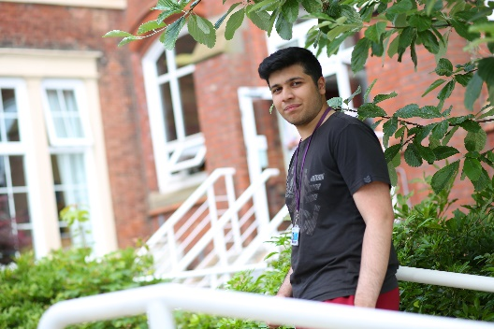
Name: Adil Lakha
Previous School: Archbishop Temple
Programme of Study: A Levels in Biology, Chemistry, Maths and Physics
“There are plenty of excellent enrichment opportunities available at Newman where you can stretch yourself beyond the standard course syllabus. All of my teachers have been enthusiastic and engaging and they are always willing to give me extra help outside of my lessons. I have really enjoyed my subjects and I have met some great friends here at Newman.”

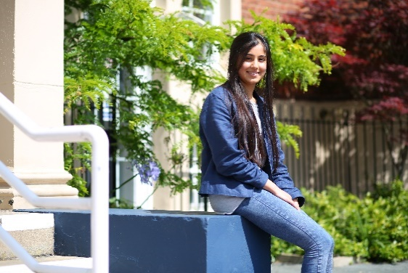
Name: Henna Reddy
Previous School: Westholme
Programme of Study: A Levels in Biology, Chemistry and Maths
“Newman has opened my eyes to lots of opportunities and has allowed me to grow so much as a person, both academically and socially. I’ve had the chance to meet so many different people and the teaching here is excellent.”

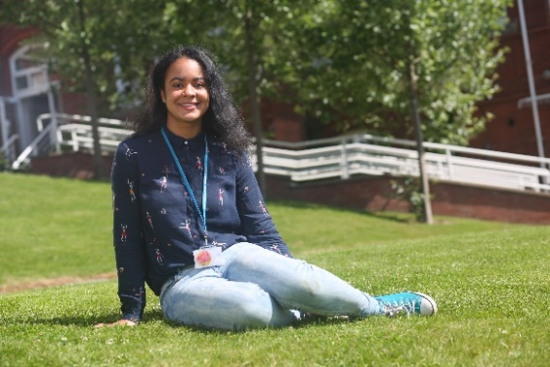

Name: Ella Shaw
Previous School: Leyland St Mary’s
Programme of Study: A Levels in French, Spanish, English Literature
“I have been able to develop my own interests and I have loved the independence that college has given me. Newman is definitely an amazing College and you feel part of something when you’re here. There hasn’t been a day where I have regretted coming to Newman, it’s everything I hoped College would be.”

Name: Abbie Lund
Previous School: Clitheroe Royal Grammar School
Programme of Study: A Levels in Maths, Physics and Further Maths
“I decided to come to Newman because I wanted a change of scene and the chance to meet new people. Throughout my two years here I have always been encouraged to excel. When choosing which college to attend, make sure to go somewhere you feel comfortable and choose subjects you enjoy, success comes a lot more easily when you’re happy!”

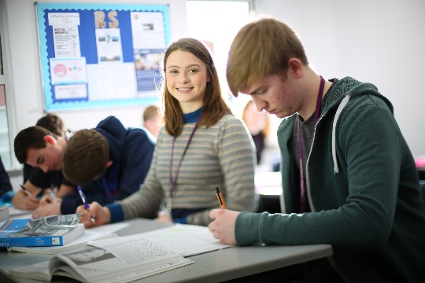
Isabella Raven
Previous School: Broughton
Programme of Study: Religious Studies, Philosophy, English Literature and EPQ
“I felt that coming to Newman would be a big step up from high school but Newman has made the transition much easier. You have a lot more independence when you come to College but the teachers are really supportive and welcoming. They will help you whenever you need it, but also push you to achieve your best. Newman has changed my life!”

Temiloluwa Onilogbo
Previous School: Lancaster Royal Grammar
Programme of Study: A Levels in Maths, Chemistry, Physics and French
“The most important thing is picking courses that interest you and if a College you like has these subjects; go for it! For me, Newman has been a great step up from High School. You can meet people from all over Lancashire, who are actually interested in the subjects that they take, creating a welcoming learning environment.”

Matthew Holden
Previous School: Holy Cross
Programme of Study: A Levels in Economics, Modern World History, English Literature & Business Studies
“After researching local colleges and attending several open days, I was impressed by Newman’s facilities and friendly atmosphere. Their reputation as a brilliant college and their position in Sixth Form College League Tables also helped me decide that Newman was the right college for me.”

