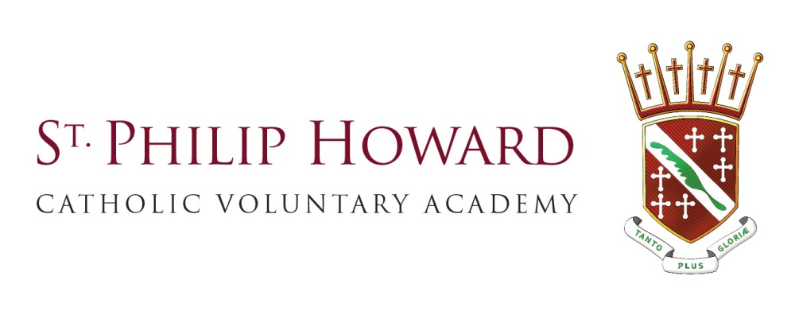

Science Technician
Dates: March 2018
Location: Glossop, High Peak, Derbyshire
Contract type: Full Time
Contract term: Permanent

Salary: Scale point 11-13 £16163-£16,579 pro-rata per annum
Term time only

An exciting opportunity has become available for a Science Technician at Philip Howard Catholic Voluntary Academy.

St Philip Howard Catholic Voluntary Academy is an 11-16 secondary school located in the heart of the local community of Glossop in the High Peak Borough of Derbyshire. With 441 students currently on roll, it opened on 1 September 2015 and is under the dynamic sponsorship of the Nottingham Roman Catholic Diocese Education Service where it continues to build on the strong spiritual and moral framework that has helped make the school so very popular over the years.

St Philip Howard Catholic Voluntary Academy is an exciting place to be. We are on a journey of improvement and moving forward at a fast pace.

We are seeking a consistently good science technician who is well motivated and has the ability to work with minimum supervision and willingness to undertake personal development and training to update knowledge and skills. This post is ideally suited for someone who is able to communicate with and maintain positive relationships with students, parents, staff and suppliers. . It offers an excellent opportunity for someone who is keen to gain experience within a highly ambitious and hardworking organisation that both encourages and challenges everyone.

You will have:
- Qualified in High GCSE (or equivalent) Chemistry.
- Experience of working within a laboratory environment
- Good organizational skills, ability to work with interruptions, multi task and reprioritize to meet deadlines.
- Ability to work effectively as a member of a team
- Good clear communication skills, oral and written.
- Excellent interpersonal skills
- An excellent telephone and personal manner
- Ability to stay calm under pressure
- Eye for detail and committed to accuracy
- Able to coach, inspire and enthuse students and colleagues effectively
- Ability to handle sensitive and confidential issues
- Ability to keep to procedures
- Knowledge of Health and safety and safe working practices

You can expect:
- Outstanding professional support to ‘raise the bar’
- Opportunities for significant career development
- A vibrant and dynamic student body which deserves the very best in teaching and support

Should an outstanding candidate apply for the position, we would be willing to explore enhanced career development opportunities within St Philip Howard Catholic Voluntary Academy which would attract an additional pay award. St Philip Howard Catholic Voluntary Academy looks forward to an exciting and optimistic future.

Visits to the Academy are strongly encouraged. For an application pack or to arrange a visit please contact Kimberley Ward at St Philip Howard Catholic Voluntary Academy on 01457 853611 or via email: info@sph.academy.

An enhanced DBS disclosure will be required for this position. A conviction may not exclude candidates from appointment but will be considered as part of the recruitment process.

The Academy is committed to safeguarding and promoting the welfare of children and young people and expects all employees and volunteers to share this commitment.

Our school/academy will become part of the St Ralph Sherwin Catholic Multi Academy Trust on 1st September 2018, a family of 25 academies within the Catholic Diocese of Nottingham. The new arrangement is part of the Diocesan Plan for Catholic Schools the primary aim of which is to protect and secure high quality Catholic education in the Diocese of Nottingham for the long-term. Full details of the plan and the staffing structures can be found at http://dioceseofnottingham.uk/education. Your post will transfer to the new employer on 1st September 2018 under the Transfer of Undertakings Protection of Employment (TUPE) regulations with continuity of service preserved. Should you have any questions about the transfer to the St Ralph Sherwin Catholic Academy Trust then please address these to the Headteacher of the school/academy to which you are applying initially.

Closing Date: 10.00am Wednesday 21st February 2018

Interviews: Week Commencing Monday 26th February 2018

