****Manshead**

CE Academy

**Teacher of Mathematics**

**Recruitment Information Pack**



Bond

Manshead CE Academy

Dunstable Road

Caddington

Bedfordshire

LU1 4BB

***‘I will lift my eyes to the hills’***

****Manshead**

CE Academy

**TEACHER OF mathematics**

**recruitment information pack**

**Contents**

Letter from the Headteacher 3

Academy Introduction 4

Academy’s Vision and Values 5

The Diocese of St Alban’s Multi-Academy Trust 6

Application Process 7

Vacancy Advert 8

Job Description 10   
  
  
Person Specification 14

Academy Statistics 15

****Manshead**

CE Academy

March 2018

Dear Colleague

Thank you for your interest in the position of **Teacher of Mathematics** at Manshead CE Academy. I hope you find the information to be both interesting and useful.

Manshead CE Academy is a rapidly improving academy with a distinct Christian ethos, providing high quality education for 1100 children from age 11 to 18. The academy has moved forward greatly since it converted to become a sponsored academy in May 2017. The staff, students, parents and local community are all very keen to move the academy forward to be the place of choice and to ensure outstanding outcomes for all groups of learners.

We are an active member of the Diocese of St Alban’s Multi-Academy Trust and work closely with local primary schools to develop and share best practice.

This position requires an outstanding individual with the drive, ambition and commitment to raise both the progress and attainment of our students. We are looking for a candidate who is an outstanding practitioner; who has drive and ambition, and who is willing to go the extra mile for the learners within the academy. **We are willing to negotiate the starting salary and a substantial retention and recruitment allowance is available for the right candidate.** There is also the possibility of a TLR payment for a specific role within the mathematics team.

As we are unable to write to all unsuccessful applicants, if you do not hear from me again, may I thank you again for your interest and wish you every success with any other applications you may make. Due to time constraints, we are only able to provide feedback to applicants who reach the interview stage.

The academy is committed to safeguarding and promoting the welfare of children and young people and expects all staff and volunteers to share this commitment.

I look forward to receiving your application.

Yours sincerely



Mike Smith

**Headteacher**

**Manshead**

CE Academy

### INTRODUCTION

At Manshead CE Academy, we have a strong, caring, Christian ethos and aim to provide learners with a high quality, broad and balanced curriculum; we place great emphasis on striving for personal success whatever the starting point for the individual. We are confident that whatever the abilities, talents and needs of the child, we will be able to support, encourage and challenge them to reach their potential.

**Why choose Manshead CE Academy?**

1. Our vision: ***“I will lift my eyes to the hills” (Psalm 121)*** seeks to raise the aspirations of all; ensure that all set the highest ambitions for themselves and pursue excellence in all aspects of life.
2. Our core purpose: ***learners first***in everything that we do
3. We are very proud of the ***broad and balanced curriculum*** we offer at Manshead CE Academy.  We aim to ensure that each learner enjoys their time with us and that they each achieve success in every course they study from Year 7 to Year 13.
4. ***Personal Development Education*** (PDE) at Manshead CE Academy ensures that learners acquire the knowledge, understanding and skills they need to manage their lives now and in the future. As part of a whole-academy approach, PDE develops the qualities and attributes learners need to thrive as individuals, family members and members of society.
5. ***Outcomes for learners*** at Manshead CE Academy continue to improve year on year. The 2017 GCSE Progress 8 score is the best score of all secondary schools in Dunstable and the A level results are in the top 10% nationally (ALPS2).

We are proud that our Academy is sponsored by the Diocese of St Albans Multi-Academy Trust. Following the principles used to establish Church of England schools in the 1800s, the Diocese of St Albans Multi-Academy Trust remains committed to providing a locally based high-quality education to meet the needs of their local community, whilst benefiting from a regional network of support.

**********Manshead**

CE Academy

### ACADEMY’S VISION AND VALUES

**Our core vision:**

***“I will lift my eyes to the hills” (Psalm 121)***

* To raise the aspirations of all within the wider academy community
* To seek guidance and support when times are challenging
* To inspire all to achieve the highest ambitions and goals
* To attain excellence in all aspects of life

**Our core mission:**

The mission of Manshead Church of England Academy is to create an atmosphere of Christian values, attitudes, practice and knowledge such that all learners will have the opportunity to nurture their faith. All learners will be able to widen and deepen themselves through inspirational learning opportunities, achieving outstanding outcomes and prepare fully for life within the wider world community.

**Our core ethos and values:**

Manshead Church of England Academy is a community inspired by **CHRIST** to serve others.

​

**Common Good**

To promote a spirit of hospitality, grace, charity, social justice, global stewardship and concern for others leading to a contribution to the common good.

**Hope**

To be an educational community built on foundations of faith, hope and love, which reflects Christ’s message of compassion, peace, trust and forgiveness.

**Respect**

To build a community of mutual respect and dignity working towards a common understanding of high standards of behaviour, good manners and individual accountability, as well as encouraging learners to make responsible and positive choices.

**Inspiration**

To be a caring, supportive and inclusive community inspired by Christ, recognised by our love of God and of our neighbour whilst nurturing qualities of endurance, wisdom, ambition, courage and commitment, in order to live fulfilling and purposeful lives.

**Service**

To follow Christ's example of serving others, in a climate of reverence, humility, friendship, thankfulness and cooperation.

**Talents**

To encourage all members of the wider academy community to foster a love of life-long learning so that they can use their talents to the full, pursuing excellence in all things and in doing so, bring Christ to each other



THE SPONSOR

**The Diocese of St Alban’s Multi-Academy Trust**

**History**

The Diocese of St Albans Multi-Academy Trust is a Church of England Trust established in September 2016 primarily for Church of England schools in the Diocese of St Albans, which consists of the Local Authority areas of Hertfordshire, Bedford Borough, Central Bedfordshire, Luton, parts of the London Borough of Barnet and two parishes in Buckinghamshire. It is passionate about creating and maintaining Church of England Academies that serve their local communities through the provision of a rich and diverse curriculum underpinned by Christian Values.

**The Trust today**

The Trust admitted its first Academies, Churchfield CE Academy, Thomas Whitehead CE Academy and Manshead CE Academy, between 1st March and 1st May 2017. Caldecotte CE Academy, Kensworth CE Academy and Totternhoe CE Academy are all now part of the Trust.

As a Church of England Multi-Academy Trust our commitment to a locally based education is delivered through an approach consistent with the faith and practice of the Church of England. The Trust is committed to providing a locally based high quality education that enables schools to meet the needs of their local community, whilst benefitting from a regional network of support. Academies that are part of the Trust retain their name, school uniform, local customs and through the Academy Council will promote local engagement in school life.

As part of the Diocese of St Albans educational provision academies within DSAMAT are called to live God’s love by being distinctively Christian, community focussed and by serving the common good. All academies in the Trust seek to deliver the curriculum within a programme of Christian values and virtues in an overarching ethos that sees each individual child as being of worth and having the capacity to grow into a fully rounded person.

**Future Development**

The Diocese of St Albans Multi-Academy Trust has a vision to grow steadily over the next 10 years until it is working with up to 40 Church of England academies. These will be located in two regional hubs (Bedfordshire and Hertfordshire) of approximately 20 schools each. As the Trust grows and develops regional hub boards will assume responsibility for the day to day running of academies leaving the Trust Board to focus on the strategic growth of the Trust.

****Manshead**

CE Academy

### The APPLICATION Process

Further details about the work of the Diocese of St Alban’s Multi-academy Trust, including academies it currently sponsors, can be found at <http://stalbansdmat.co.uk/>

Completed applications should be returned to [hillmanb@mansheadschool.co.uk](mailto:hillmanb@mansheadschool.co.uk)or by post to Mrs B Hillman, Manshead CE Academy, Dunstable Road, Caddington, Beds LU1 4BB.

An email will be sent to shortlisted candidates with details of the interview process. If you have not heard from us within 2 weeks of the closing date please assume your application has been unsuccessful.

**Queries**

If you have any queries on any aspect of the application process or need additional information please contact Mrs B Hillman on 01582 679400.

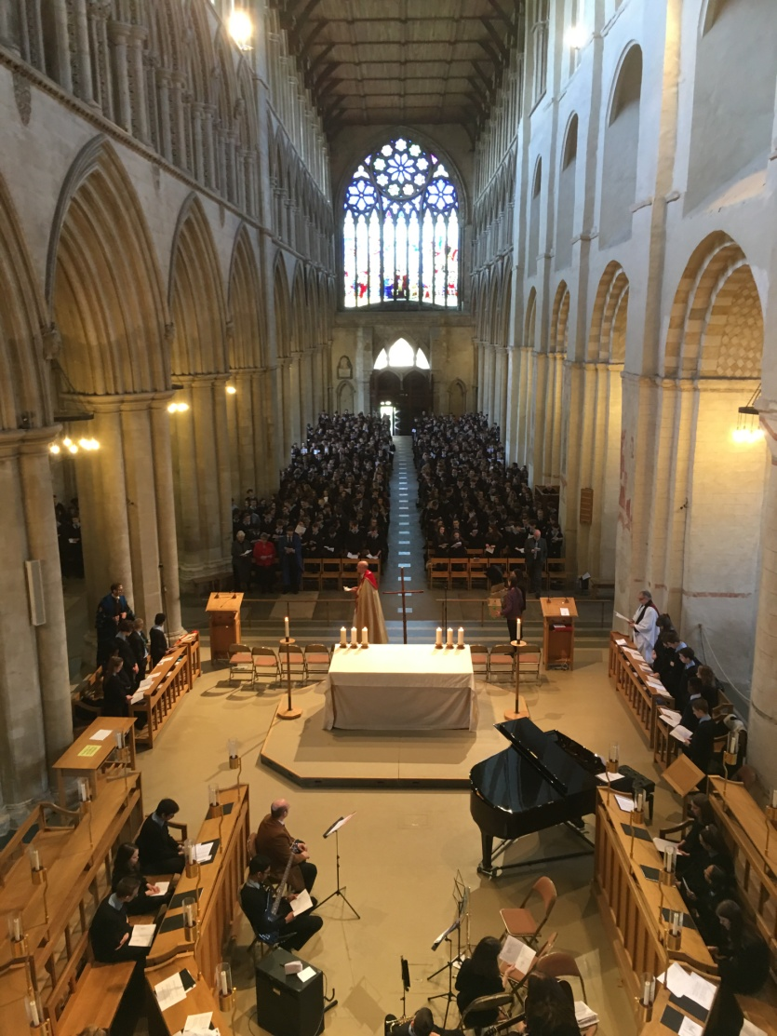

**********Manshead**

CE Academy

**Teacher of Mathematics**

**Salary Range: MPS/UPS**

***Starting salary negotiable with a substantial retention and recruitment allowance available for the right candidate. TLR also available for specific responsibilities within the mathematics team***

**Required: September 2018 or sooner if possible**

Manshead CE Academy is a new and expanding academy in Dunstable, determined to become one of the best schools in the region. There is a currently a focus on developing facilities across the academy and a major refurbishment plan is being actioned.

We are seeking to appoint an inspirational Teacher of Mathematics to deliver high quality lessons to students across years 7 to 11. There will be the opportunity to deliver the subject up to A-level within our growing Sixth Form provision. Applications are welcome from both NQTs (July start possible) and experienced teachers.

**We can offer you:**

* A great career opportunity to develop professionally in an expanding academy
* An opportunity to work across a growing MAT to widen and broaden your experience
* A fantastic working environment with the most up to date technology

**We would like to hear from you if you**:

* Are determined to make a difference
* Have the highest expectations for all young people
* Are passionate about learning and creativity
* Are enthusiastic, self-motivated and keen to progress

For more information on this role, and to apply, visit our website: <https://mansheadschool.co.uk/vacancies/>

**To find out more about Manshead CE Academy, visits are positively encouraged in order meet our students, staff and the Headteacher. For further information or to arrange a visit, please contact Bernie Hillman, HR Manager, on 01582 679400 or email** [hillmanb@mansheadschool.co.uk](mailto:hillmanb@mansheadschool.co.uk)

**Closing date: Monday 23rd April 2018 – 12 noon**

**An application pack can be downloaded from**

[www.mansheadschool.co.uk](http://www.mansheadschool.co.uk)

***‘I will lift my eyes to the hills’***

****Manshead**

CE Academy

**JOB DESCRIPTION – TEACHER OF MATHEMATICS**

|  |  |
| --- | --- |
| **Post Title:** | Teacher |
|  |  |
| **Salary:** | MPS/UPS |
|  |
| **Core Purpose:** | 1. *To support the work of the curriculum leadership team to implement and deliver an appropriately broad, balanced, relevant and differentiated curriculum for students, supporting the curriculum area, in accordance with the aims and objectives of the academy.* 2. *To contribute to raising standards of attainment and achievement by monitoring and supporting student progress, and developing students as a teacher and tutor.* 3. *To facilitate and encourage a learning experience which provides opportunities for students to achieve their potential.* 4. *To share and support the academy’s responsibility to provide and monitor opportunities for personal and academic growth and success.* |
| **Reporting to** | Curriculum Leader – Mathematics |
| **Liaising with** | Senior Leaders (SLT), Curriculum Leader (CL), teaching and non-teaching colleagues, Phase Leaders, support staff and other relevant staff with cross-academy responsibilities, partner schools, other academy partners and parents. |
| **Learning and Teaching** | * To assist in the development of appropriate specifications, resources, schemes of learning, marking policies and teaching strategies in the Curriculum Area (CA) * To contribute to the CA’s improvement plan and its implementation * To undertake a designated programme of teaching and to plan and prepare courses and lessons * To contribute to the whole academy’s planning activities * To participate in ‘learning walks’ and other learning evaluation strategies in accordance with academy policy * Implementing academy policies relevant to teaching and learning, including behaviour, homework and assessment. |
| **Teaching** | * To teach students according to their educational needs, including the setting and marking of work to be carried out by the students in the academy and elsewhere * To assess, record and report on the attendance, progress, development and attainment of students and to keep such records as are required * To provide, or contribute to, oral and written assessments, reports and references relating to individual students and groups of students * To ensure that ICT, Literacy, Numeracy and cross-curricular themes are reflected in the teaching/learning experience of students * To ensure a high quality learning experience for students which meets internal and external quality standards * To prepare and update subject materials * To use a variety of delivery methods which will stimulate learning appropriate to student needs and demands of the specification. * To maintain discipline in accordance with the academy’s procedures, and to encourage good practice with regard to punctuality, behaviour, standards of work and homework. |
| **Curriculum** | * To assist in the process of curriculum development and improvement planning * To support, change and develop the curriculum to ensure the continued relevance to the needs of students, examining and awarding bodies and the academy’s aims and objectives * To assist the CL to ensure that the curriculum area provides a range of teaching that complements the academy’s strategic objectives * To support the academy’s extra-curricular offer. |
| **Quality Assurance** | * To help to implement academy quality assurance procedures and to adhere to those * To contribute to the process of monitoring and evaluation of the curriculum area, in line with agreed academy procedures, including evaluation against quality standards and performance criteria. To seek/implement modification and improvement where required * To review from time to time methods of teaching and programmes of work * To take part, as may be required, in the review, development and management of activities relating to the curriculum, organisation and pastoral functions of the academy. |
| **Assessment** | * To maintain appropriate records and to provide relevant accurate and up-to-date information for the academy’s MIS * To complete the relevant documentation to assist in the tracking of students * To track student progress and use information to inform learning and teaching * To mark, grade and give written/verbal and diagnostic feedback as required * To undertake assessment of students as requested by external examination bodies, departmental and academy procedures * To support the establishment of a robust target-setting process within the curriculum area * Where appropriate, provide all relevant bodies with robust information relating to student performance and assessment. |
| **Personal Development** | * To engage actively in performance management review(s) * To participate in the academy’s ITT programme where appropriate * To take part in the academy’s staff development programme by participating in arrangements for further training and professional development * To continue personal development in the relevant areas including subject knowledge and teaching methods * To work as a member of the curriculum team and contribute positively to effective working relations within the academy * To participate in the interview process for teaching posts when required and to support the induction processes for new staff within the team. |
| **Communication** | * To communicate effectively with the parents of students, as appropriate * Where appropriate, to communicate, and represent the views, of the academy, in a professional manner * To follow agreed policies for communications in the academy * To take part in marketing and liaison activities such as Open Evenings, Parents’ Evenings and liaison events with partner institutions * To contribute to the development of effective subject links with external agencies. |
| **Management of Resources** | * To assist the curriculum leaders to identify resource needs and to contribute to the efficient/effective use of physical resources * To co-operate with other staff to ensure a sharing and effective usage of resources to the benefit of the academy, curriculum area and the students * To look after academy equipment and resources allocated to the teacher and the teacher’s teaching area (classroom/workshop/lab etc.). |
| **Pastoral System and Safeguarding** | * To evaluate and monitor the progress of students and keep up-to-date student records as may be required * To contribute to the preparation of education plans, progress files and other reports * To alert the appropriate staff to problems experienced by students and to make recommendations as to how these may be resolved * To communicate as appropriate, with the parents of students and with persons or bodies outside the school concerned with the welfare of individual students, after consultation with the appropriate staff * To contribute to PDE and CEIAG activities according to academy policy * To be a Form Tutor to an assigned group of students * To promote the general progress and well-being of individual students and of the Form Tutor group as a whole * To liaise with Year Managers and Curriculum Leaders to ensure the implementation of the academy’s Pastoral System * To register students accurately, accompany them to assemblies and supervise them in assembly, encourage their full attendance at all lessons and their participation in other aspects of academy life. |
| **Operational** | * To promote teamwork and to motivate staff to ensure effective working relations. |
| |  | | --- | | **Other Specific Duties**  All teachers are expected to meet the Teachers Standards, and demonstrate consistently high standards of personal and professional conduct, uphold public trust in the profession and maintain high standards of ethics and behaviour, within and outside the academy. | | Whilst every effort has been made to explain the main duties and responsibilities of the post, each individual task may not be identified. Employees will be expected to comply with any reasonable request from the principal to undertake work of a similar level that is not specified in this job description.  This job description is current at the date shown. In consultation with you, it may be changed by the Headteacher to reflect or anticipate changes in the job commensurate with the grade and job title. | | |

*With the exception of the Redundancy Payments Modification Order which applies, for the purposes of occupational entitlements, for example to sick pay or maternity pay, the Trust does not recognise continuous or aggregated service with other academy trusts or with local authorities.*

*The Academy is committed to safeguarding and promoting the welfare of children and expects all staff to share this commitment. Applicants must be willing to under child protection screening appropriate to the post, including checks*

****Manshead**

CE Academy

**PERSON SPECIFICATION – TEACHER OF MATHEMATICS**

|  |  |  |
| --- | --- | --- |
| **Job Title: Teacher** | | |
| **KEY CRITERIA** | **ESSENTIAL** | **DESIRABLE** |
| **Qualifications & Experience** | * education to degree level or equivalent * QTS/QTLS (or willing to train with immediate effect) * an excellent track record of recent, relevant professional development * accountability for the performance of a cohort of young people * experience of effective teaching and performance within the curriculum area. | * innovative use of resources * working with young people and inner city communities * leadership of a community project or an area of academy development * taking accountability for the success of an initiative |
| **Knowledge & Understanding** | * the principles behind quality teaching and learning their potential for raising standards * the principles and characteristics of effective academies * the principles and practices of planning and delivery * effective review and evaluation procedures * the application of ICT, Literacy and Numeracy to effective teaching | * community/voluntary/parent/partner agency links * strategies for ensuring equal opportunities for staff, students and other stakeholders * innovative approaches to working with students, parents, staff and the local community |
| **Personal Qualities** | * a commitment to the Christian distinctiveness of the academy * a commitment to inclusive education * evident enjoyment in working with young people and their families * empathy in relation to the needs of the academy and the local community * ability to inspire confidence in staff, students and parents * set high standards and provide a role model for students and staff * adaptability to changing circumstances/new ideas | * personal ambition and potential for further promotion * intellectual ability and curiosity * determination to succeed and the highest possible expectations of self and others * vision, imagination and creativity * personal impact and presence * an excellent record of attendance and punctuality |
| **Communication Skills** | * communicate the vision of the academy in relation improvement plans * communicate effectively orally and in writing to a range of audiences | * develop, maintain and use an effective network of contacts |
| **Decision Making Skills** | * make decisions based on analysis, interpretation and understanding of relevant data and information * demonstrate good judgement | * think creatively and imaginatively to anticipate, identify and solve problems |
| **Self Management Skills** | * prioritise and manage own time effectively * work under pressure and to deadlines * reliability, integrity and stamina * resilience and perspective | * achieve challenging professional goals * take responsibility for own professional development |
| **Team Working skills** | * work effectively as a member of a team * deal sensitively with people and resolve conflicts * seek advice and support when necessary | * motivate all those involved in the delivery team * liaise effectively with other organisations and agencies |

****Manshead**

CE Academy

|  |  |  |
| --- | --- | --- |
| **Manshead CE Academy Facts and Statistics** | | |
| **Type of School** | Sponsored Academy | |
| **Age Range** | 11-18 | |
| **Location** | Dunstable Road, Caddington, Beds LU1 4BB | |
| **Denomination** | Church of England | |
| **Co-educational or single sex** | Co-Educational | |
| **Number of students on roll** | 1104 | |
| **Attendance** | 2016-17: 93.86%; 2017-18 YTD: 94.4% | |
| **Date school established** | May 2017 | |
| **Number of teaching staff** | 69FTE | |
| **Number of associate staff** | 100FTE | |
| **% of students on free school meals** | 19%(2017 ) | |
| **% of students with SEN** | 14% (2017) | |
| **% of students with EAL** | 6% (2017) | |
| **GCSE results - Progress 8** | 2016 | -0.09 |
| 2017 | 0.02 |
| **ALPS Score - Post 16**  *(1 = highest; 9 = lowest)* | 2016 | 3 |
| 2017 | 2 |
| **No of students in 6th Form** | 200 | |