THE GRANGE SCHOOL

Specialising in Business & Enterprise

CLEANING SUPERVISOR

THE GRANGE SCHOOL

The Grange School is a well-established, friendly school, specialising in Enterprise.
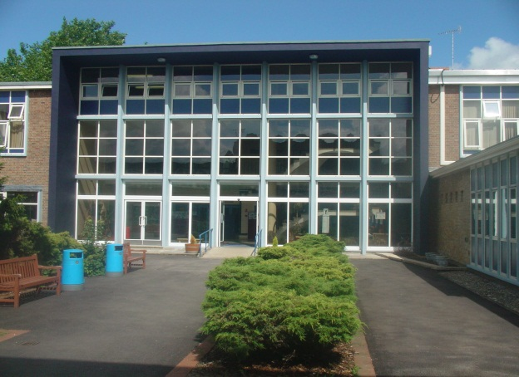
Enterprise is a driving factor throughout learning as evidenced by our Grange Enterprise and Learning Skills (GELS) which are embedded across the curriculum.

We aim to equip all students with the adaptability and flexibility to meet the demands of a rapidly changing world and to promote a sense of responsibility towards others, the school and the wider community. The support and guidance of students is based on a Year system and aims to develop co-operation, involvement and respect in all students.

A broad and balanced curriculum is provided for Years 7 to 9. In Years 10 and 11 all students will study English, Mathematics, Science, PE, RE, ICT/Computing and PSHCE (Personal, Social & Health and Citizenship Education). Students can then choose from a range of additional GCSE, BTEC and vocational courses. We offer a range of traditional and vocational courses at Key Stage 5. The curriculum in all Key Stages is further enhanced through wide ranging extracurricular experiences.

We aim to attract energetic and conscientious staff who have a commitment to the education of our students. The professional development of all staff is an important focus for the school. We strive to create a learning environment which serves the needs of all the members of our diverse and vibrant community.
THE GRANGE
SCHOOL CLEANING SUPERVISOR

The School Cleaning Supervisor will work closely with the site team and the cleaning team to ensure cleaning jobs are delivered to a high standard. As well as responsibility for cleaning their own specific areas, the Cleaning Supervisor will also be responsible for supervising a team of cleaning staff, undertaking daily inspections and ensuring staff are working productively and safely.

Main Responsibilities:

- Working closely with the Site Manager to ensure a successful cleaning team.
- Supervising a team of people, in conjunction with the site team, to ensure jobs are delivered to a high standard.
- Implement and develop quality control procedures to ensure high standards are maintained.
- Train and develop staff where necessary (e.g. COSH)
- Be responsible for ensuring the cleanliness and daily tasks of your designated area and for maintaining high and consistent standards.
- Take initiative to perform cleaning and tidying tasks that are not specifically contained within the rota but require attention as part of maintaining overall high standards.
- Liaise with the Site Manager, School Caretakers and other members of staff as required to ensure the cleaning rota operates smoothly around both school events and outside lets.
- Report cleaning supplies requirements and stock levels to the Site Manager.
- Ensure Health & Safety, quality and general procedure compliance.
- Keep accurate time-sheets for any hours worked over the core hours in this contract and ensure they are signed by the Site Manager.

Person Specification:

Knowledge:

- Some knowledge of Health & Safety Regulations as they relate to the operation of cleaning equipment and the dilution of cleaning materials.

Experience:

- Experience as a cleaning supervisor

Personal Attributes:

- Strong people skills – ability to motivate others
- Attention to detail and high standards of work
- Good relationship building skills with the ability to communicate at all levels
- A good understanding of Health and Safety regulations.
- Good written and spoken English
- Willingness to participate in further training and development opportunities offered by the school, to further knowledge.
- Willingness to maintain confidentiality on all school matters.
- Will need to be able to manage some heavy lifting.

Skills
- Ability to work effectively and supportively as a member of the school team.
- Ability to work in an organised and methodical manner.
- Ability to act on own initiative, dealing with any unexpected problems that arise.
- Ability to demonstrate commitment to Equal Opportunities.
Job Summary

- 22.5 hours per week for 39 weeks of the year, Monday to Friday term time only plus Inset days. Working hours to be 3:15 to 7:45 pm Monday to Friday.

- Contract type: Permanent, Part time.
- Probationary period: 12 months.
- Bucks Pay Range 2, Point 11 (c.£9,645) to Point 15 (£10,833) approximately.

