Teacher of English Job description
(Part time)

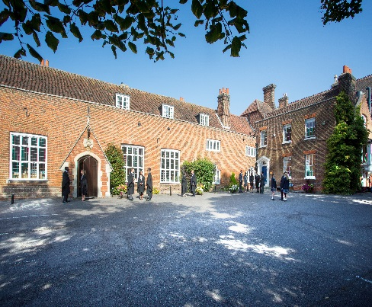

Introduction

Chigwell School is seeking a well-qualified, committed teacher to join our highly successful English department from September 2018. It is anticipated that the successful candidate will have had experience in another maintained or independent school. Chigwell School is not only highly successful academically but also excels in sport, music, art and drama. This post would be suitable for someone wishing to gain further experience or for an NQT. This is a permanent position, part time.

Background

Founded in 1629 by Samuel Harsnett, the son of a Colchester baker who went on to become Archbishop of York, Chigwell School stands on it original site with the original school building still in use. However, whilst Chigwell of today is conscious of its long-standing history, it is a forward-looking, ambitious, co-educational independent school of 930 pupils aged four to eighteen. It enjoys excellent facilities, a dedicated staff, bright and hardworking pupils, and a site of 100 acres.

Chigwell School is located in the picturesque village of Chigwell just over ten miles from central London and on the Central Line. The extensive, beautiful grounds are close to the edge of Epping Forest and it is rare for a school to have so much space and yet be so close to the centre of the Capital. Most pupils are day pupils but in the Sixth Form, there is a small community of international boarders, roughly thirty from sixteen countries, and these live in four small boarding houses.

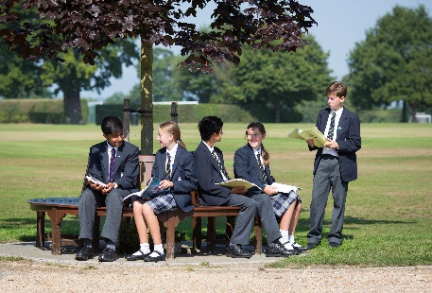

As well as being an academic school, Chigwell has the reputation for providing a rich and full education, with plenty of opportunities for all pupils who are enthusiastic, co-operative and able. Chigwell is a caring and friendly school, with a close sense of community, not least between colleagues. As the Good Schools Guide reports: Academically, pupils are put through their paces but it all seems to be done in such a civilised and pleasant manner that you are more likely to hear pupils talk about opportunities and prospects than pressure and stress. “Anyone who wants to do well here, will do well” said one student, and I can’t think of a nicer place to succeed.”

The School Development Programme

Over recent years, the School’s facilities have been extensively developed in order to enhance the educational experience that pupils receive. The development programme has included the following additions:
- 2008 Wilson Building teaching block
- 2008 Floodlit AstroTurf pitch
- 2009 Junior School library extension
- 2010 Complete redevelopment of catering facilities
- 2010 Sixth Form coffee shop
- 2010 Harsnett’s and Church House converted into boys’ boarding houses
- 2012 The Old Chigwellian Club and land was incorporated into the school estate
- 2013 Pre Prep School built and opened
- 2013 Two new science labs created
- 2014 Drama Centre balcony extended to provide additional music and drama rehearsal space
- 2016 The Risham Sarao Sixth Form Centre was completed
- 2017 Extension of the Dining Hall.

In the future we plan to:
- Renovate the Chapel
- Develop the Sports Centre
- Expand our music facilities
- Further expand our provision of bursaries

The School

Some pupils join in Reception and there are two classes in each of the three Pre Prep year groups. A small number of other children join the Junior School at 7+ (Year 3) and there are two or three classes in each of the KS2 year groups. At 11+ (Year 7), there is a further entry with four classes making up Years 7 to 11. Again, there is a small entry into the Sixth Form. Entry at each stage is selective and although there are three main sections to the School (Pre Prep, Junior School and Senior School) these sections work closely together and there is a common ethos running throughout.

There are over a hundred teachers and together with the support staff, there is a friendly, mutually-supportive atmosphere. All teaching staff contribute to the extra-curricular programme.

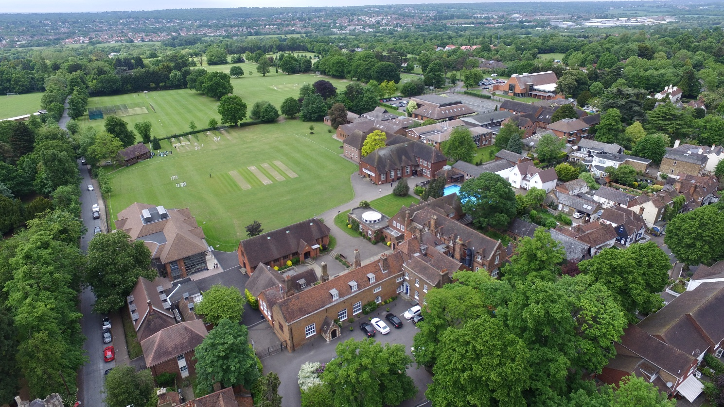

The Department

English at Chigwell is taught in a way that combines academic rigour with an enthusiastic and flexible approach. Four full time and two part time teachers, each different in style, are united in the aim of offering a lively experience of English for the students within the clear framework provided by the Scheme of Work. A good deal of emphasis is placed on literature throughout our teaching, as we believe that engagement with a wide variety of good writing is at the heart of developing both imagination and style. We also expect appropriate attention to be given to the full range of skills, both written and oral, that will equip our pupils to succeed in the world around them.

Each of the English classrooms is equipped with interactive whiteboards. The drama centre is used for single drama periods and is often booked for English classes.

The department’s public examination record throughout is good, although we are always looking to extend and enrich our most able students at GCSE and A Level. The OCR Literature Specification is offered at A Level and we expect a take up of between 25 and 35 students every year at AS; typically this means two or three sets of Literature. Results at AS and A2 are consistently excellent (82% A*-B). At GCSE all students take Edexcel English Language and Literature. 100% of students achieve a C grade or above and last year 78% achieved an A* or an A in Language with 83% being awarded an A* or an A in English literature.

It is felt vital, however, to promote enjoyment of the subject well beyond the syllabus and the department is always looking to strengthen and expand an already busy extra-curricular programme that ranges from the Junior Reading Award scheme to a flourishing senior English society. The English department is also responsible for the production of the school magazine and for all debating and public speaking. Drama is a considerable strength of the School, and while there is a separate Drama department there is inevitably an overlap with English, not least in organising visits to the theatre. In addition, the English department put on an annual production and in recent years this has ranged from Shakespeare and Webster to Friel and Stoppard. We also work closely with the librarians, with whom we share the promotion of reading throughout the School. This includes the organisation of visiting writers and storytellers such as Ben Haggarty, Jan Blake, Meg Rosoff and Patrick Ness and the organisation of the school’s own ‘Big Read’ project.

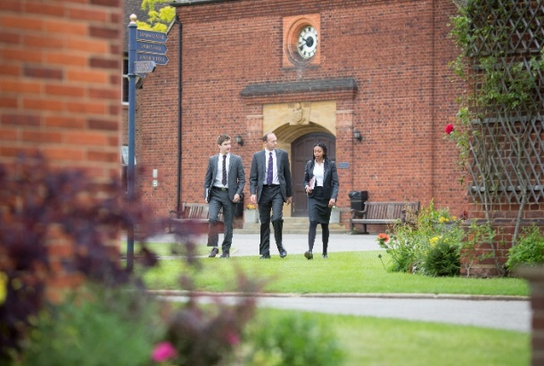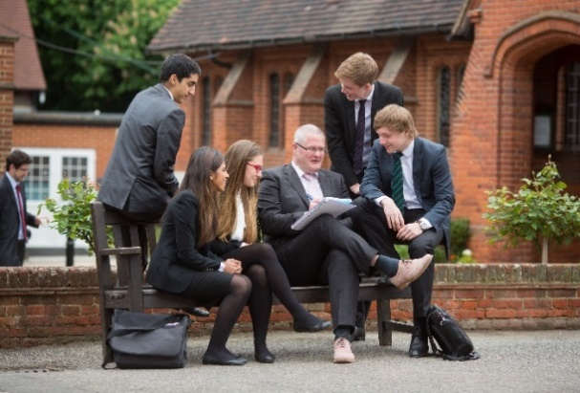

The Person

We are looking for an excellent practitioner who enjoys working with young people and has the capacity to inspire both pupils and colleagues. Enthusiasm and ability are as important as experience and this would be an ideal post for a teacher looking to broaden his / her own experience or for an energetic young teacher new to the profession. Applicants are expected to be IT literate and to demonstrate an interest in developing the use of ICT in the classroom. A commitment to engendering a love of reading and independent study skills is also essential, as too is a dedication to facilitating whole school literacy. He/she should be able to work well with colleagues and parents and be prepared to play a full part in the life of the School, being involved in extra-curricular activities and assisting in the pastoral care of pupils through the school’s tutorial system. Such involvement is at the heart of what Chigwell offers to its pupils.

Chigwell School is increasingly using ICT as a teaching, learning and administrative tool. All rooms are networked, they have integrated whiteboards and are fitted with projectors, and all teachers receive a laptop.

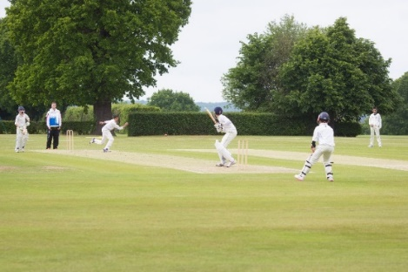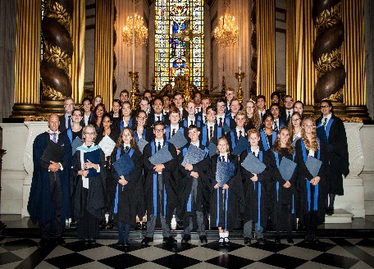

Remuneration

The salary is competitive based on National Pay Scales with a Chigwell enhancement. There is fee remission for the children of teaching staff, subject to the normal admission criteria. Lunch is provided free of charge for all staff whose working hours encompass school lunchtime.

Chigwell is a very happy place to work, the environment is pleasant and colleagues are supportive of each other. There are good relationships between teaching and support staff, staff and pupils, and between staff in different sections of the School. There is an induction programme and an annual appraisal system linked to INSET. The School is a strong supporter of Continuing Professional Development (CPD).

Other benefits of working at Chigwell School include:

- Commitment to professional development  - Access to the School Pension Scheme  - Free lunch and refreshments during term time  - Childcare Vouchers  - Personal Accident Cover  - Employee Assistance Support Programme  - On site free parking and cycle racks  - Use of School Library | - Medical Centre on site  - Free use of School’s sports facilities outside of the School day  - A supportive community of highly motivated students and staff  - A beautiful working environment- 100 acres site beautifully landscaped with a number of listed buildings
Applications

Applicants should complete the teaching staff application form which can be accessed directly from our website: www.chigwell-school.org (Vacancies) and sent to the HR department: hr@chigwell-school.org

The Head of English, Mrs Emma Rea, will be happy to answer any questions; she can be contacted at the School by telephone 020 8501 5700 or by e-mail to erea@chigwell-school.org

Applications will be considered immediately upon receipt and candidates will be contacted by telephone or email to attend an interview if required.

Chigwell is committed to safeguarding and promoting the welfare of children and young people and expects all staff and volunteers to share this commitment. Applicants must be willing to undergo child protection screening including checks with past employers, prohibition orders and enhanced DBS.

