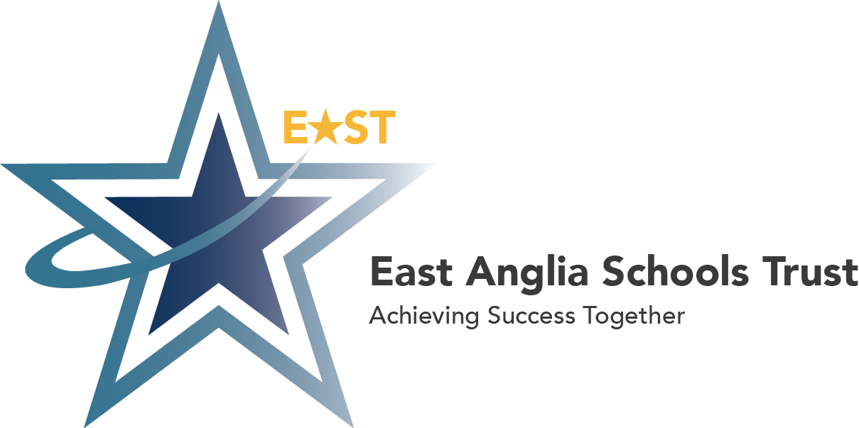
Orde Avenue
Gorleston-on-Sea
Great Yarmouth
NR31 6SZ

Phone • 01493 652111
Fax • 01493 440211

Email • admin@east.school
Website • www.east.school
East Anglia Schools Trust • A charitable company limited by guarantee and registered in England & Wales with company number 08432486 •
Registered Office: Orde Avenue, Gorleston, Great Yarmouth, Norfolk NR31 6SZ • Tel: 01493 652111 • email: admin@east.school

Job focus: Midday Supervisory Assistant
We are looking to appoint an enthusiastic and committed individual to join our valued lunch time team. This team is responsible for supervising the children during the lunch period at Cliff Park Junior School.

You will need to be calm, caring, patient and enjoy working with children. An essential aspect of your role will be to encourage and support positive eating habits, demonstrating a fair and consistent manner in line with our Behaviour Policy.

Key expectations of the role:
• Ensure the safety and wellbeing of the children.
• Supporting good behaviour expectations on the playground.
• Encourage good eating habits.
• Supervise and play with children on the playground.
• Offer a positive role model.
• Responsibility for clearing away lunch plates etc. supporting the kitchen staff in this role.
• Supporting kitchen staff through stacking chairs and cleaning down tables etc.
• Supervise during wet lunchtimes.
• Offer minor first aid when necessary.
• Work with others in the team.

In our school we are strongly committed to safeguarding our children. Successful candidates will be subject to Enhanced DBS checks and vetting procedures.

