St. Joseph’s Catholic High School
Business & Enterprise College
Living, Loving & Learning Through Christ

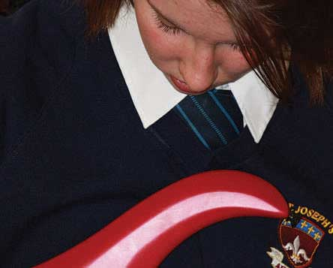
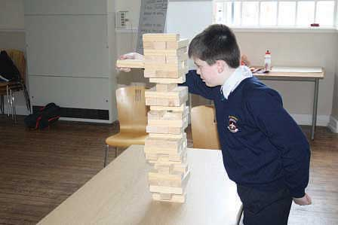
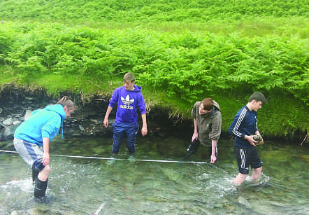
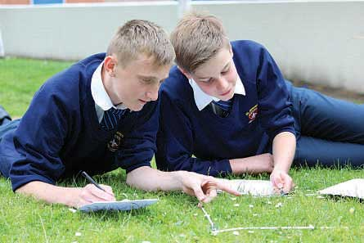

Temporary

Teacher of PE
to start September 2018

St Joseph’s Catholic High School - serving the community

• Judged ‘Good’ in their recent Ofsted
• Improved GCSE results
• Improved A* As
• Excellent Pastoral Care

Harrington Road, Workington CA14 3EE. 01900 873290
www.st-josephs.cumbria.sch.uk

St. Joseph's
Catholic High School

Dear Candidate, Business & Enterprise College

Thank you for taking an interest in our school.

Thank you for your interest in a post at St Joseph's. I hope you find all the available information useful when applying for this role. I thought it would be useful if I gave you a personal perspective of our school about what life is like at St Joseph's. Hopefully this will help you decide whether or not
our school is a place where you would be happy and flourish, and where you could do an
outstanding job for our children.

St Joseph's Catholic High School is part of the Catholic Diocese of Lancaster. We are a group of four secondary schools in Cumbria who work collaboratively for the benefit of all the children we serve.

St Joseph's is situated in Workington town centre. The original school, built in the 1920s (but don't worry, the first thing visitors comment on is how vibrant the learning environment is) has changed significantly in recent years as we expand and improve our facilities.

Our new Sports Hall & Fitness Suite is the newest addition. We are a growing school and are oversubscribed for September 18. Our P8 improved in 2017 and will improve further in 2018.

We are very fortunate to work with such a brilliant group of students. If you come to visit us, you will see that they are happy, hardworking and very positive about our school.

Achievement is at the forefront of everything we do at St Joseph's and it would be fair to say it is "cool" to achieve. Our staff are vibrant, enthusiastic and passionate about ensuring our students get the very best deal. Staff are very welcoming and most people feel part of the team from day one.

At our last OFSTED inspection (2016) we were judged to be Good. As you can imagine we are very proud of achieving this result but we know we can improve further. It is pleasing for students' and staff's hard work to be externally recognised in this way. Please do not think we know all the answers, we don't. Our Mission is to be excellent and to live love and learn through Christ. This starts by employing the very best teachers and we are hoping this is where you can help.

If you think that you have what it takes to join St Joseph's and play your part in improving the school further, please complete the application process.
Although we understand that it's not always possible for you to visit us in advance, if you are able to do so, you will find that a very warm welcome awaits and be able see first-hand what makes St Joseph's such a great place to work in.
I look forward to hearing from you. Yours faithfully,

Jacky Kennedy, Head teacher
L ·l·l·
0 _
t!.l.!,! .l,!'

J'.ETVVOf KOF 0,...."1l"
EXCE LL E NCE ;!r';'. ,
Headteacher: Miss J.A. Kennedy BA (Hons)

Harrington Road . Workington. Cumbria CA14 3EE Tel: (01900) 873290
EmaiI: office@st-josephs.cumbria.sch.uk www.st-josephs.cumbria.sch.uk

St Joseph’s Catholic High School
Business & Enterprise College
Harrington Road, Workington, Cumbria CA14 3EE
01900 873290
NOR 697 - 11-16
Head teacher Miss J Kennedy.
Temporary teacher of PE (preferably Female) to cover for a maternity leave.
September 2018 - March 2019
M1 to UPS3.

We have an exciting opportunity for an enthusiastic qualified teacher of PE to join our thriving PE department. The successful candidate must have a creative approach to teaching and should be able to motivate and engage students in Sport.
We require a teacher to cover for this maternity leave from September 1st 2018 until the end of the Spring term 2019 (although a successful applicant could start sooner if available). We are looking for a teacher who will be able to deliver routinely good lessons in all year groups.

St Joseph’s Catholic High School is a popular school. We are situated in an area of outstanding beauty on the fringes of the Western Lake District which provides a lovely place to live and work and unique extra–curricular opportunities for our students. We offer a very supportive staff community. We have dedicated CPD and or department time on a weekly basis. We ensure dedicated planning and preparation time by allocating more than the 10% normally afforded to staff. In return the person appointed will have:

If you would like more information on the job or a visit to the school, please telephone
We offer a very supportive staff community. We have dedicated CPD and or department time on a weekly basis. We ensure dedicated planning and preparation time by allocating more than the 10% normally afforded to staff.
In return the person appointed will have:

• A commitment to the Catholic ethos of the school
• High standards and expectations
• Highly developed inter personal skills
• A commitment to teamwork
• A positive outlook

St Joseph’s Catholic High School is a popular school. We are situated in an area of outstanding beauty on the fringes of the Western Lake District which provides a lovely place to live and work and unique extra–curricular opportunities for our students.

If you would like more information on the job or a visit to the school, please telephone Sybil Worsley, Business Manager on 01900 873290. Applications to be returned to Sybil Worsley at the school address.
Closing date: 23rd April 2018 Interviews on Monday 30th April 2018.

PE Department

The department is made up of a Head of Department, a male PE teacher and a part time Female PE teacher and a Sports Development Officer, PE is well regarded within the school for its success at GCSCE with the highest results in 2017. We offer a BTEC level 1/level2 First Award in sport over a three-year key stage 4. There are 3 lessons in Year 11 and 4 lessons per week in years 9 and 10.

FACILITIES
We have a new sports hall which opened in September 2017 consisting of a Sports Hall, Fitness Suite, Changing facilities, a large office and a classroom. We are able to play the following sports: Football, Rugby Union and League, Netball, Gymnastics, Hockey, Table Tennis, Badminton, Tennis, Volley Ball, Dance, Rounder’s, Soft Ball and of course we are on the edge of the Lake District National Park where there are lots of opportunities for different activities from walking, climbing to water sports.

Results:

 | 14/15 | 40% | n/a
GCSE PE A*-C | 40.9% | 66% | 60.6%
BTEC Sport L2 | n/a | n/a | 91.3%
Whole School Progress 8 | n/a | -0.51 | -0.25

Extra-Curricular

The department offer a number of extracurricular activities which vary throughout the year. We have the usual teams that take part in fixtures with other schools throughout the year.
The Sports Development Officer runs activities offered to all young people in every holiday which has an excellent take-up.

Person Specification for Teacher of PE and Dance
 | Essential | Desirable
Qualifications/ training/ competencies | Qualified teacher status | Evidence of participation in professional development or further study
 | Relevant qualification in subject area (degree) PE and preferably Dance | Practising Catholic
 | Teaching qualification (PGCE/Cert Ed)
Relevant experience | Outstanding teaching ability | Experience of dealing with a wide range of students and responding to their needs
 | Experience of effective team working and promoting effective relationships | Understanding and experience of exam board procedures and administration
 | Ability to use IT in teaching and administrative duties | Experience of teaching to A level
 | Ability to teach across the ability range in Key Stage 3 and 4
Knowledge | Knowledge and understanding of equality and diversity issues
 | Knowledge and understanding of different teaching strategies and ability to apply these appropriately
Skills | Excellent communication skills
 | Student focused
 | Flexible approach
 | Ability to manage time effectively and meet deadlines
 | Ability to demonstrate patience and understanding with learners
Personal Qualities | Commitment to actively supporting the school’s distinctive ethos
 | Commitment to develop Performing Arts both in the school and wider community
 | Ability to work as part of a team
 | Ambition and the capacity for hard work
 | Energy and imagination
 | A talent for motivating students across a range of abilities
 | Good organisational skills
 | Determination to achieve the very best result for every student

ST JOSEPH’S CATHOLIC HIGH SCHOOL BUSINESS AND ENTERPRISE COLLEGE
TEACHER JOB DESCRIPTION
Catholic Nature of the School;
There is an expectation that all staff up hold and support the Catholic nature of the school in all aspects of school life.
Curriculum development; The post of Performing Arts Teacher requires that this new area of the curriculum will be developed with the Faculty leader, not just for the curriculum but through extra -curricular activities. In addition to this you will be required to work with feeder Primary students developing the Arts.
You will coordinate all the peripatetic teaching and line manage the staff.
Specialism: St Joseph’s is a Business and Enterprise College and there is an expectation that all Teachers play a big role in embedding the specialism in to their subject area under the guidance of their head of Department.
Professional Attributes | Relationships with children and young people.

C1 | Have high expectations of children and young people including a commitment to ensuring that they can achieve their full educational potential and to establishing fair and respectful, trusting, supportive and constructive relationships with them
C2 | Hold positive values and attitudes and adopt high standards of behaviour in their professional role

Consistently and effectively plan lessons and sequences of lessons, to meet pupils’ individual learning needs.

2.1a | Derive your planning from the school’s agreed schemes of work or long term planning and the relevant aspects of the National Curriculum.
2.1b | Identify record and communicate learning objectives for lessons and sequences of lessons.
2.1c | Take account of the needs of individual pupils, groups or classes in your planning.
2.1d | Demonstrate progression in pupils’ acquisition of knowledge, skills and understanding in your planning of sequences of lessons.
2.1e | Make effective use of homework and other opportunities for learning outside of the classroom.

STANDARD 2.2 | Consistently and effectively use a range of appropriate strategies for teaching and classroom management.

2.2a | Understand and apply effective lesson structures, classroom organisation, teaching strategies and methods appropriate to motivate different pupils and groups of pupils.
2.2b | Use a range of strategies to ensure that there is appropriate pace and challenge in lessons for all pupils.
2.2c | Manage efficiently and creatively the full range of resources available, including adults other than teachers.
2.2d | Provide positive and targeted support for any pupils with particular learning needs.
2.2e | Set clear expectations for maintaining appropriate learning behaviour.
2.2f | Maintain high levels of behaviour and discipline, dealing promptly and effectively with misbehaviour and bullying.

STANDARD 2.3 | Consistently and effectively use information about prior attainment to set well-grounded expectations for pupils, and monitor progress to give clear and constructive feedback.

2.3a | Regularly evaluate the progress of pupils in relation to their prior attainment.
2.3b | Use analysis of data from internal school assessments and National Curriculum assessments to plan lessons and sequences of lessons.
2.3c | Use local and national comparative school data together with information about prior attainment to establish benchmarks and set targets for improvement.
2.3d | Report to colleagues on the progress of an individual, group or class, e.g. when changing classes.
2.3e | Monitor the progress of pupils through the continuous assessment of attainment against the learning outcomes set.
2.3f | Provide constructive, formative and summative feedback to pupils.
2.3g | Report to parents on the progress achieved by their child and the action required for further improvement.
2.3h | Liaise and work effectively with other professionals and agencies involved in the assessment and provision for pupils’ needs, e.g. educational psychologist and SENCO.

STANDARD 3 | As a result of your teaching, your pupils achieve well in relation to their prior attainment, making progress as good as or better than similar pupils nationally.

3a | Demonstrate that all pupils make appropriate and consistent progress against their prior attainment.
3b | Develop pupils’ literacy, numeracy and ICT skills though all subject teaching.
3c | Demonstrate that the level of pupils’ progress is as good as or better than local or national pupil performance in similar settings.
3d | Demonstrate that pupils of different background, behaviour and / or ability make appropriate progress.

STANDARD 4.1 | Take responsibility for your own professional development and use the outcomes to improve your teaching and pupils’ learning.

4.1a | Participate in and engage with school and/or external INSET and professional development activities.
4.1b | Demonstrate improvement in your teaching and pupils’ learning as a result of professional development.
4.1c | Share the outcomes of professional development with colleagues.
4.1d | Use the opportunity of changing duty, role or responsibility to develop further professional expertise.
4.1e | Take action as a result of feedback and identified development needs.

STANDARD 4.2 | Make an active contribution to the policies and aspirations of your school.

4.2a | Implement school policies and procedures consistently.
4.2b | Make an identifiable contribution to the development of school policy and practice.
4.2c | Ensure your work contributes to the school’s ability to meet its aims, vision and values.
4.2d | Contribute to team, departmental or school improvement planning.
4.2e | Demonstrate that your work contributes to the progress made by the school in achieving its priorities for development.

STANDARD 5 | Professional characteristics – how you are an effective professional who challenges and supports all pupils to do their best.

5a | Provide challenge and support to all pupils.
5b | Inspire trust and confidence in pupils.
5c | Build team commitment amongst pupils and with colleagues.
5d | Engage and motivate pupils to do their best.
5e | Demonstrate analytical thinking in your work.
5f | Demonstrate positive action to improve the quality of pupils’ learning.

Reviewed February 2018

Staff development/ Career development
We are part of the Western Lakes Teaching Schools Alliance and are continuing to build on the already strong links with other schools in the area. We have dedicated time after school on a Thursday for CPD/Department meetings. This time is used for whole school training, sharing best practice and work in departments.

The development of our staff is of the highest importance and it is a strong feature of our school and many staff have benefitted from internal promotions over the years. Career development is one of our school’s priorities in the school improvement plan 2017/2018 and we will be working with each member of staff to identify where they want to be in their stage of their careers and finding opportunities to gain experience receive mentoring and training to help the individual achieve their goals.

Business and Enterprise:
The school became a Business and Enterprise College in 2003 and we were re- designated as high performing as part of our Ofsted inspection in March 2009. We were awarded the ‘Centre for Excellence in Enterprise Education’ by the University of Warwick in May 2011. We were one of the first schools to receive this award in Cumbria.

Our Business and Enterprise is delivered through the curriculum where possible; as part of our Pupil Personal Development Days and as one-off Enterprise activity days. We celebrate National Enterprise week in November through form activities; Careers talks at breakfast and lunch time; extra-curricular events after school.

We have developed many partnerships with local business and commerce that help us out with events and in curriculum areas throughout the year. We hold a work ready day with mock interviews for Year 10 and year 11 students.

Students take part in a number of external competitions throughout the year.

Conditions of Service
The above responsibilities are subject to the general duties and responsibilities contained in the statement of Conditions of Employment.

These duties may be amended as necessary at the discretion of the Headteacher in light of the future development of the school.

The creation of a truly Christian environment in which the Gospel is lived and experienced by all members of its community, is the central aim of St Joseph’s. All applicants are expected to be supportive of this central aim.

Features of West Cumbria
The School is situated at the western fringe of the Lake District National Park.
Many staff choose to live locally and enjoy a rural lifestyle in towns such as Cockermouth, Keswick and the villages in West Cumbria.

Housing and rented accommodation are generally readily available at prices which are lower than urban and city locations.

The school exhibits all the advantages of a smaller comprehensive school. Children are known by name by all, standards of discipline and the quality of staff pupil relationships is excellent.

Closing date for applications 9th April interviews 18th April 2018.

Our School Mission Statement

AT ST. JOSEPH’S CATHOLIC HIGH SCHOOL
WE WILL CHALLENGE YOU TO AIM HIGH, WE EXPECT YOU TO SUCCEED

LIVING LOVING LEARNING

All members of the school community – pupils, staff, governors and parents – will be united in sharing a common purpose: to achieve their personal best, to pursue lifelong learning, to develop and model respect for themselves and others and lay a significant role in the life of the local community; and they will be able to articulate this common purpose and support each other to achieve these goals.

LIVING LOVING LEARNING

Our School will be characterised by positive, appropriate, productive and warm relationships all of which are at the heart of our faith. We will encourage all members of the community to reflect on and develop their relationships with each other to promote tolerance and understanding.

LIVING LOVING LEARNING

All members of the school community will strive to achieve excellence – their personal best in all areas of school life; academically, in extra-curricular activities and through their embodiment of positive attitudes and qualities.

Living, Loving and Learning through Christ

