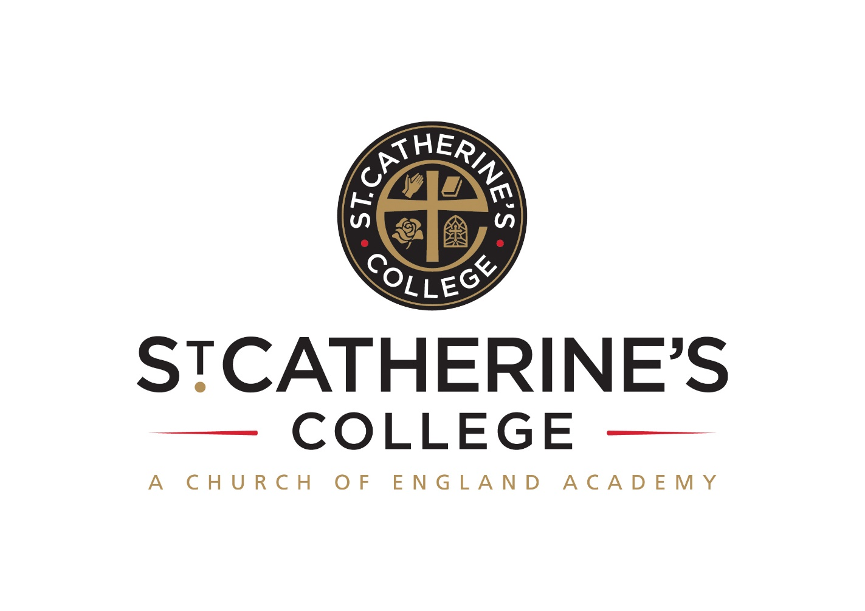 **TEACHER OF ENGLISH**

**Salary: TMS**

**Full or part time – permanent post**

Required Easter or September 2018

**INFORMATION FOR APPLICANTS**

**CONTENTS**

1. Letter from Principal 
2. Person Specification

January 2018

Dear Applicant

**Teacher of English**

Thank you for your interest in this post.

We are proud of our college, our talented and highly motivated staff and pupils. Our staff team work tirelessly to ensure that teaching is the best it can be and everyone has a role to play in this. We support each other and there is an open, friendly and collegiate atmosphere where new members of the team are welcomed and supported.

We are:

* An Investors in People Gold Award School, which means that we invest heavily and value the development of all our staff
* An inclusive Church of England School with the benefits of links with The Diocese of Chichester and the opportunity to promote strong lasting values based on the Christian faith
* Recognised by Ofsted as a strong ‘good’ and are working towards outstanding. We are also rated as ‘outstanding’ for leadership and our Christian distinctiveness as a Church School.

Understandably this letter and our website only gives a flavour of the college. We therefore encourage visits for prospective candidates to see our college in action. We do understand however that visits are not always possible or practical and you would not be at a disadvantage if you are unable to visit the college.

**The Post**

We are looking to recruit to our existing strong team a committed Teacher of English who is passionate about their subject area.

This post would particularly suit a NQT.

Additionally at St Catherine’s College we are part of a growing trust called DCAT (Diocese of Chichester Academy Trust) currently part of six academies.

In terms of English at St Catherine’s College, we follow a condensed two year Key Stage 3 and, therefore, a three year Key Stage 4. Pupils follow the WJEC (Eduqas) English Language and AQA English Literature GCSE examinations. OFSTED have recognised that ‘Higher proportions of students make expected progress in English than is the case nationally’.

**We offer you**

* **Excellent career development opportunities**

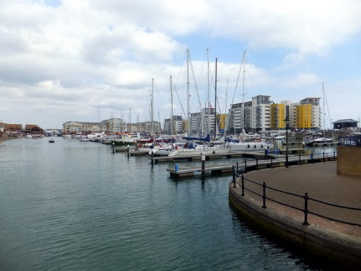

* **A geographical location**, being situated near Sovereign Harbour, Eastbourne’s award winning Marina. It is part of several miles of beautiful coastline, including the South Downs National Park, the white cliffs of Beachy Head and 1066 country
* **A friendly**, supportive and caring staff team
* **A fabulous staff room** with complimentary tea and coffee
* A café that serves at breakfast, break and lunch using freshly sourced ingredients
* **Plentiful staff car parking** in two on site car parks
* Did you know that buying a house in East Sussex can be cheaper than in many other counties in the UK. Average house prices are lower than the national average.

**Your Application**

Completed application forms and letters of application should be sent directly to the college addressed to Mrs S Windsor, Head of Personnel swindsor@stcatherines.college, and arrive by no later than **noon on Thursday 25 January 2018**.

Please use the standard application form, accompanied by a letter of application, which must be no more than two sides of A4. We are unable to consider CVs in place of application forms unless you are a person with a disability and a CV is the most convenient method of applying. In your letter of application you should clearly address the relevant sections of the Person Specification for this post and may find it helpful to use headings. We are committed to safeguarding and promoting the welfare of children and young people, successful applicants will need to undertake a DBS enhanced clearance.

I am conscious of the time and effort it takes to submit an application and am grateful for your interest. Shortlisted candidates should hear from us shortly after the closing date. St Catherine’s is a thriving college with a bright future and a vibrant and collegiate atmosphere within which to work. I am keen that we appoint quality candidates to join what is, I believe, one of the best staff teams. If I can be of any assistance or provide any further information, please do not hesitate to contact me.

Yours faithfully



Mark Talbot

Principal

**Meet the English Department:**

   

Fran Asta-Watts Harriet Clarke Amber Elliott Malika Hand

English Teacher of English KS4 Lead English Teacher of English

Intervention Lead

   

Richard Newham Sophie Thomas Katie Ward Sarah Williams

Teacher of English Deputy Vice Principal KS3 Lead English Acting Head of English

 

Susan Williams Debbie Mewett

Acting Director HLTA

**PERSON SPECIFICATION: TEACHER OF ENGLISH**

|  |  |  |  |
| --- | --- | --- | --- |
| **Attributes** | **Essential** | Desirable | |
| Qualifications and training | * Qualified teacher status recognised by the DfES * Graduate with a degree in English or a related subject |  | |
| Experience |  | 🖹A track record of outstanding practice as an English teacher | |
| Skills and Abilities | * Be a talented classroom practitioner, with potential to develop further * 🗣Able to teach English to GCSE * Enthuse pupils for English / Literacy * Ability to work in collaboration with other members of staff * 🗣Possess good ICT skills and be able to use them in their own teaching * 🗣 Able to communicate well, both in writing and orally * Able to manage time effectively and work to deadlines | 🖹The capacity to contribute to the wider extra-curricular offer for pupils | |
| Knowledge and Understanding | * 🗣Understanding of the principles, processes and strategies underpinning outstanding teaching and learning * 🗣 Outstanding knowledge of current educational developments/issues in English teaching |  | |
| Values | * 🗣 Be broadly in sympathy with the aims and ethos of the School * A commitment to comprehensive education, equal opportunities and inclusion * A passionate commitment to achieving the highest standards for all learners * A commitment to teaching approaches which make learning interesting, challenging, relevant and effective * An enthusiasm for running and involvement in, extra-curricular activities | * 🗣 A practising Christian |
| Personal Qualities | * Shows warmth, care and a sensitivity to the needs of others * Is self-motivated and hard working * Possesses a sense of humour and the humility to admit mistakes * Shows imagination, vision and proactivity * Possesses an infectious enthusiasm, stamina and considerable energy * Ability to work under pressure to achieve, to have high expectations, lead by example and meet deadlines | 🖹 Has a good health and attendance record |

**Criterion assessed by:** 🖹 = application form; ✍ = letter of application; 🗣 = interview

