Dear Colleague,

Thank you for taking the time to find out more about the role of Head of Drama at Haverstock School. We hope very much that you enjoy reading the information provided and that you decide to apply for this role.

I became Headteacher of Haverstock in September 2017 and have been working with my team of committed colleagues to improve the school from the ‘Requires Improvement’ Ofsted judgement in January last year. The school has a great deal of strengths and I hope that you are attracted to join a school which is on a journey of rapid improvement.

A key pillar of our journey has been a movement towards a ‘disruption free’ classrooms model. Teachers now have very high expectations of students and those who do not meet them are managed and supported centrally so that class teachers do not need to run detentions. This has led to much better relationships with students and has enabled colleagues to focus on teaching and learning.

The Drama Department at Haverstock has a proud history, first class resources and fantastic facilities, including two fully operational studios and a multi-purpose performance hall with first class sound and lighting equipment. Alongside the Head of Drama, there is one teacher of Drama within the department.

We have recently moved to studying BTEC Drama for our students who begin their Key Stage 4 courses at the start of Year 9. Students who choose Drama will have six hours per fortnight of curriculum time and the subject has a high uptake. Students study Drama for one hour per week at Key Stage 3. We do not currently offer any courses at Key Stage 5 but are keen to do so in the future. Realising this ambition will lead to an increased TLR for the post holder.

The department has a very strong link with the Roundhouse with projects for next year including a Film and Drama Project, a Spoken Word Project and a Street Circus project. Working with our newly appointed Head of Music, there will be opportunities to grow this link further to enhance the range of opportunities that are available for our students.

The department has a proud history of productions and works closely with the Music department to deliver these. There is a significant whole school funding to support with productions and we are very keen to continue the high standards that have been set in previous years.

The closing date for applications is Friday 20th April at noon and interviews will be held in the following week. We regret that we are only able to contact short-listed candidates but please do forewarn your referees of the possible request for a reference. Please note - references will be requested prior to interview unless indicated on application form not to do so.

Thank you, again, for requesting information about becoming Head of Drama at Haverstock School. If you would like to find out more in advance of applying, please don’t hesitate to contact jobs@haverstock.camden.sch.uk to arrange an informal discussion or visit to the school. We very much look forward to receiving your application.

Yours sincerely

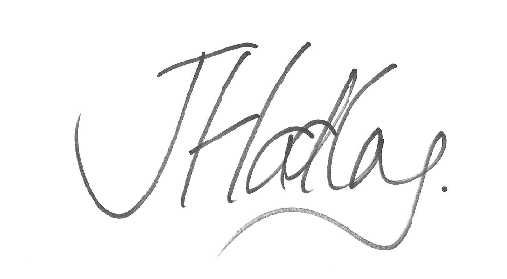

James Hadley
Headteacher

