Castle Donington College

Teacher of Maths
TMR/UPR
NQTs are welcome to apply
Start date: Autumn Term 2018

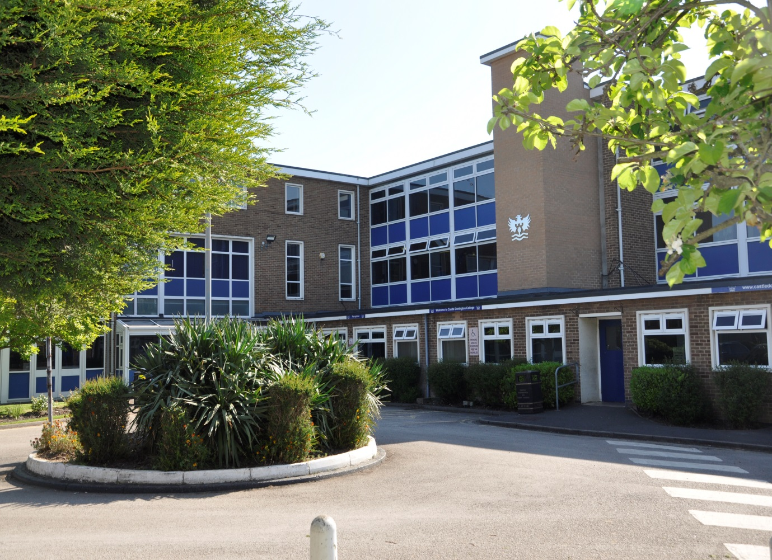

Applicants Information Pack

Teacher of Maths
Dear Applicant,

Thank you for your interest in the post of Teacher of Maths at Castle Donington College. I hope the enclosed pack will be of interest to you and I look forward to receiving your completed application. We welcome applications from experienced and newly qualified teachers.

Castle Donington College is in the process of extending its age range and began teaching KS4 courses from September 2017 for first examinations in 2019. We currently have 430 students on roll in Years 7 to 10. From September 2018 we will be an 11-16 school. The College is situated on the North West edge of Leicestershire on the Leicestershire, Derbyshire, and Nottinghamshire border. It has excellent links to these cities, being close to the M1 and A50.

We believe we have the makings of an outstanding school. In March 2015 we received an Ofsted rating of Good with Outstanding behaviour and safety. We are very proud of our community and the students we serve and so are seeking to appoint an inspirational teacher with the highest personal, academic and professional standards to join our growing Maths Department. This vacancy arises from our expansion and increasing admission numbers. The future is exciting and we are totally committed to ensuring our first KS4 results, in 2019, are excellent. You can be a part of our future.

Maths is a key subject within the Castle Donington Curriculum. The Maths Department is currently housed in 5 rooms, offering the successful candidate their own teaching room. Students study Maths for four lessons a week currently and experience a full extra-curricular programme of clubs and activities. Maths is a well-regarded department, delivering to students in KS3 and KS4 in ability groups.

- Head of Department – Stuart Saunders
- Teacher of Maths – David Anslow
- Teacher of Maths – Amy Beazley
- Teacher of Maths and Science – James Melvin
- Teacher of Maths and SENCO - Alison Dakin
- Teacher of Maths– Vacancy

The successful candidate would need to be able to operate within a close, dynamic and forward thinking team. The Maths department are committed to developing challenging, engaging and exciting learning experiences for our students. The department has a passion for Maths and the successful candidate must share this enthusiasm. You will demonstrate a clear understanding of GCSE courses, whilst contributing to maintaining and developing the existing KS3 curriculum. You will be able to demonstrate impact in achieving further increases in attainment and progress for all students. All teachers at Castle Donington College are also Tutors. The pastoral care and monitoring of progress of students is an essential part of the teacher’s role.

All our staff have the highest expectations of themselves and the students. They work closely to share best practice and drive school improvement. In a recent staff survey 100% of respondents said that Castle Donington College was a good place to work.

This opportunity comes at a critical time. We are well into our first year of delivering GCSE courses and a KS4 curriculum. The advertised post comes with challenges and will require personal drive and ambition. However, we believe candidates with passion for their subject and the ability to teach creative and innovative lessons will flourish and the rewards will be great.

We are committed to a happy, purposeful and secure environment that provides the opportunity for all to grow and develop. Our teachers are highly valued, well regarded and fully supported. We can offer a coherent programme of induction and we have a strong commitment to professional development through our Professional Learning Programme. Your development will be a key priority for us, regardless of your experience.

We welcome and encourage prospective candidates to come and visit, to meet our staff and students and to experience first- hand the ethos and values of the College.

Yours faithfully,

Julie Sheppard
Principal

Our Ethos and Values
At Castle Donington College, we are concerned, first and foremost with people. The staff and Governors are committed to delivering the best possible experience for all of our students. We care passionately about the quality of education we provide.
We consider traditional attitudes and values to be important and so aim to provide individual care and attention for each child and to create a stimulating environment so that effective teaching and learning can take place. Castle Donington College has the highest expectations of its students both academically and socially.
What students can expect from us:

- A challenging inclusive curriculum
- A wide range on curriculum activities
- Good and outstanding teaching everyday
- Targeted and timely support and intervention
- Outstanding pastoral care
- The highest expectations without exception
- Values rooted in respect, kindness, trust and support
- A safe learning environment free from disruption
- To be well prepared for next stage in education, training or employment and for adult life
- We know individual strengths and weaknesses of our students

What we expect from students:

- Excellent attitude to learning everyday
- A relentless desire to achieve in all areas
- Excellent attendance
- Impeccable conduct every day
- Curiosity and resilience
- To capitalise on advice and feedback in order to improve
- The highest aspirations for their futures

Person Specification- Teacher of Maths
 | Essential / desirable
Qualifications and Knowledge
Qualified to degree level and above | E
Qualified to teach in the UK | E
Right to work in the UK | E
Knowledge of KS3 and KS4 curriculum in Maths | E
Understanding of assessment and monitoring of Maths | E
Understanding of role regarding safeguarding and child protection | E
Experience
Recent teaching of Maths at KS3 and KS4 | E
Experience of teaching Maths at KS5 | D
Experience of teaching in more than one school | D
Proficient at using data to monitor , implement appropriate intervention and raise attainment and levels of progress | E
A proven track record of excellent outcomes for students | E
Teaching and Learning
Excellent classroom practitioner | E
Willingness to implement strategies to improve and sustain the highest quality teaching, learning and achievement | E
Strong communication, planning and organisational skills | E
Ability to apply highly effective behaviour for learning strategies | E
Ability to demand high standards, using flair and creativity to engage and enthuse students | E
Ability to challenge students of all abilities, needs and backgrounds. | E
Effective organisational skills including the ability to meet deadlines | E
High expectations for accountability and consistency | E
Ability to work independently and as part of a team | E
Commitment to take a lead in promoting innovations that raise students’ levels of attainment and progress | E
Skills and attributes
A positive outlook, well-motivated, enthusiastic and energetic | E
Commitment to own professional development | E
Professional appearance and manner | E
Work in ways that promote equal opportunities | E
Self-awareness, empathy, ability to manage feelings, motivation and social skills | E
The ability to influence and motivate others in a positive way | D
Commitment to supporting the full life of the school | D
Excellent health and attendance record | E
Able to demonstrate resilience, motivation and commitment to driving up standards | E

Castle Donington College
Job Description Teacher of Maths

Job Title: | Teacher of Maths | Reporting to: | Head of Department
Department: | Maths | Line Managing: | -
Working with: | The Leadership Team, Middle Leaders, relevant teaching staff, Tutor Team, support staff, parents | Salary | MPR / UPR
Post Type | Permanent / full time

Safer Recruitment Statement
Castle Donington College is committed to safeguarding and promoting the welfare of pupils and young people and expects all staff and volunteers to share this commitment.

Responsibilities of all teachers:
- To have an understanding of and always act within, the statutory frameworks which set out your professional duties and responsibilities.
- Treat all pupils with dignity, building relationships rooted in mutual respect and at all times observing proper boundaries as appropriate to their professional role within the College.
- Having a regard for the need to safeguard pupils’ well-being in accordance with statutory provisions. To ensure all pupils are safe at all times.
- Show a tolerance of and respect for the rights and beliefs of others.
- Not undermining fundamental British values, including democracy, the rule of law, individual liberty and mutual respect and tolerance of those with different faiths and beliefs.
- Ensuring that personal beliefs are not expressed in ways which exploit pupils’ vulnerability or might lead them to break the law.
- To have proper and professional regard for the ethos, policies and practices of the College and maintain high standards in your own attendance and punctuality.

Role of all teachers:
To make the education of pupils your first concern. To be accountable for achieving the highest possible standards in work and conduct. Teachers at the College act with honesty, integrity and work in the best interests of the pupils at all times.
All teachers will:
- Encourage good progress and outcomes
- Demonstrate good subject and curriculum knowledge
- Plan and teach well-structured lessons
- Adapt teaching to respond to the strengths and needs of all pupils
- Make accurate and effective use of assessment
- Manage behaviour effectively to ensure a safe and productive learning environment
- Fulfil wider professional responsibilities
- Keep themselves and others safe

Responsibilities of a Teachers at Castle Donington College Specific to the post
All teachers have a responsibility to inspire and engage pupils to demonstrate a passion for your subject, continuously improving classroom practice and achieving excellent outcomes for all pupils by:
- Ensuring teaching, behaviour and outcomes are good or better in your lessons
- Demonstrating excellent subject knowledge
- Adapting your teaching to respond to the strengths and needs of all pupils
- Participating fully in the College’s quality assurance programme in order to raise standards
- By sharing best practice internally and externally to ensure the quality of teaching is good or better
- Ensuring all pupils engage and make progress by making effective use of the available data to plan and deliver engaging lessons
- Making effective use of resources for learning and using the latest technologies for learning to ensure best pupil outcomes and experience
- Ensuring that all pupils in your lessons achieve at least expected levels of progress and a high proportion exceed them
- Identifying, tracking, analysing and responding to data in relation to reporting on outcomes, to ensure that the highest outcomes possible are achieved
- Contributing to the creation of schemes of work that challenge, stretch and fire the imaginations of our pupils
- Challenging pupils by ensuring behaviour strategies are followed consistently in line with College procedures
- Ensuring that incidents of poor pupil behaviour are successfully dealt with to minimise disruption to learning
- Carry out appropriate duties and participate in meetings as defined by the relevant rota and calendar
- Personally and collectively support pupils in becoming confident individuals, successful learners and responsible citizens
- Respond speedily to parental concerns
- Act as role models by demonstrating a professional level of dress, appearance and behaviour.
- Treat all colleagues with respect
- Engage actively in the Performance Management process
- Be expected to comply with any reasonable request from a manager to undertake work at a similar level that is not specified in this job description
- Be a form tutor

The responsibilities listed above are subject to the general duties and responsibilities contained in the statement of conditions of employment and National Teaching standards.
This job description is current at the date shown, but following consultation with you, may be changed by the Principal to reflect or anticipate changes in the job that are commensurate with the salary and job title.

Written May 2015
Reviewed December 2017

How to apply

Appointment of | Teacher of Maths
Salary | TMR/UPR
Start date | Autumn Term 2018
Closing date | Monday 5th February 2018 9.00am
Interview date | Week commencing 5th February 2018 TBC

To apply;
- Complete the application form and attach a letter of application, no more than two sides of A4, which sets out your experience to date and what you feel you can contribute to the post. Please ensure that your letter of application matches your philosophy, practice and experience to the items listed in the job and person specification.

- Email the application form and letter to: ldeley@castledonington.leics.sch.uk
Or
Post in an envelope clearly marked ‘Maths Vacancy’ to:
Lorraine Deley,
Principal’s PA
Castle Donington College
Mount Pleasant
Castle Donington
Derby
DE74 2LN

If you are shortlisted you will be contacted by email or letter with further details prior to interview.

Please be aware, as the applicant, you are responsible for ensuring your application reaches us before the deadline/closing date. Late applications will not be accepted.

