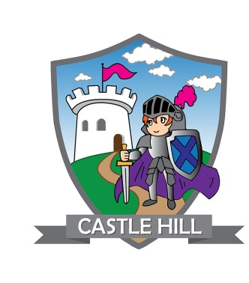

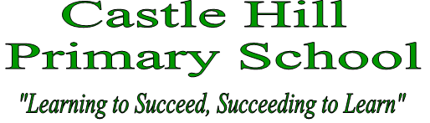
email admin@castlehill.rbksch.org
www.castlehill.kingston.sch.uk

OUTSTANDING KS1 TEACHER REQUIRED
Full time, enhanced academy pay scale
(Inner London Salary for Outer London location)

If you are an forward thinking , dynamic Teacher looking for a fantastic career opportunity, then we would like to hear from you. Castle Hill Academy is the lead school in our Multi Academy Trust and aims to provide outstanding opportunities for staff and pupils alike. We are currently growing our MAT and would love to hear from teachers who want to be part of this journey. Castle Hill is a popular two form entry primary school, situated in the Royal Borough of Kingston with excellent transport links.

If you are someone who;
- is committed, flexible and a good team player,
- is keen to develop your own expertise, grab opportunities, and share good practice with others,
- is creative, innovative and able to think outside of the box,
- is able to inspire, motivate and challenge others (colleagues and pupils),
- has strong subject knowledge in all curriculum areas,
- has high expectations of pupil achievement and does not set limits on learning,
- has a good sense of humour,
- is committed to making a positive contribution to the wider life and ethos of the school,
then we are the place you need to be. We can offer you;
- enthusiastic pupils who are eager to learn,
- excellent learning and professional development opportunities,
- a supportive, friendly and collaborative working environment,
- outstanding career progression opportunities,
- an enhanced salary package.
Visits to the school are warmly welcomed and encouraged, please telephone the school office to make an appointment. Information pack available on the school website, please click here and navigate to Vacancies on our About Us page.

Closing date Friday 18th May 2018 at noon interviews taking place week commencing 21st May 2018.

