Application for Teacher of German

Dear Applicant,

I would like to take this opportunity to offer you a warm welcome on behalf of Caister Academy and Creative Education Trust, to what I firmly believe is an exciting and amazing opportunity.

Caister Academy is a small 11-16 academy serving families in and around Great Yarmouth and Caister on Sea. We are proud to be part of the Creative Education family of academies. The Creative Education Trust is a charity and social enterprise set up in 2011 with support from leaders in the creative industries, innovation- based businesses and education. Their mission is to improve standards of education and skills for children and young people across the UK, equipping them to be successful adults in the competitive, globalised world of the future. Their ambition is to be among the very best providers of publicly-funded education in the country.

We are looking to appoint a teacher who shares our belief that all pupils have the right to succeed and have access to the very best education. The successful candidate will be required to work independently and collaboratively as part of the languages curriculum area. They will plan and deliver high quality lessons clearly focussed on learning and will monitor and support student progress, contributing to raising standards and student attainment. The ideal candidate will be able to inspire, engage, motivate and challenge pupils to raise achievement at all levels and enable all to be the best they can be.

We hope you are up for this incredible challenge and opportunity. If we are the right school for you, I sincerely hope that you make an application. Please feel free to contact us for a tour or informal discussion.

Yours sincerely
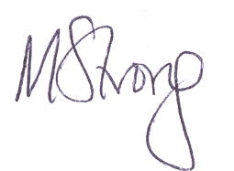
Mrs M Strong
Principal

