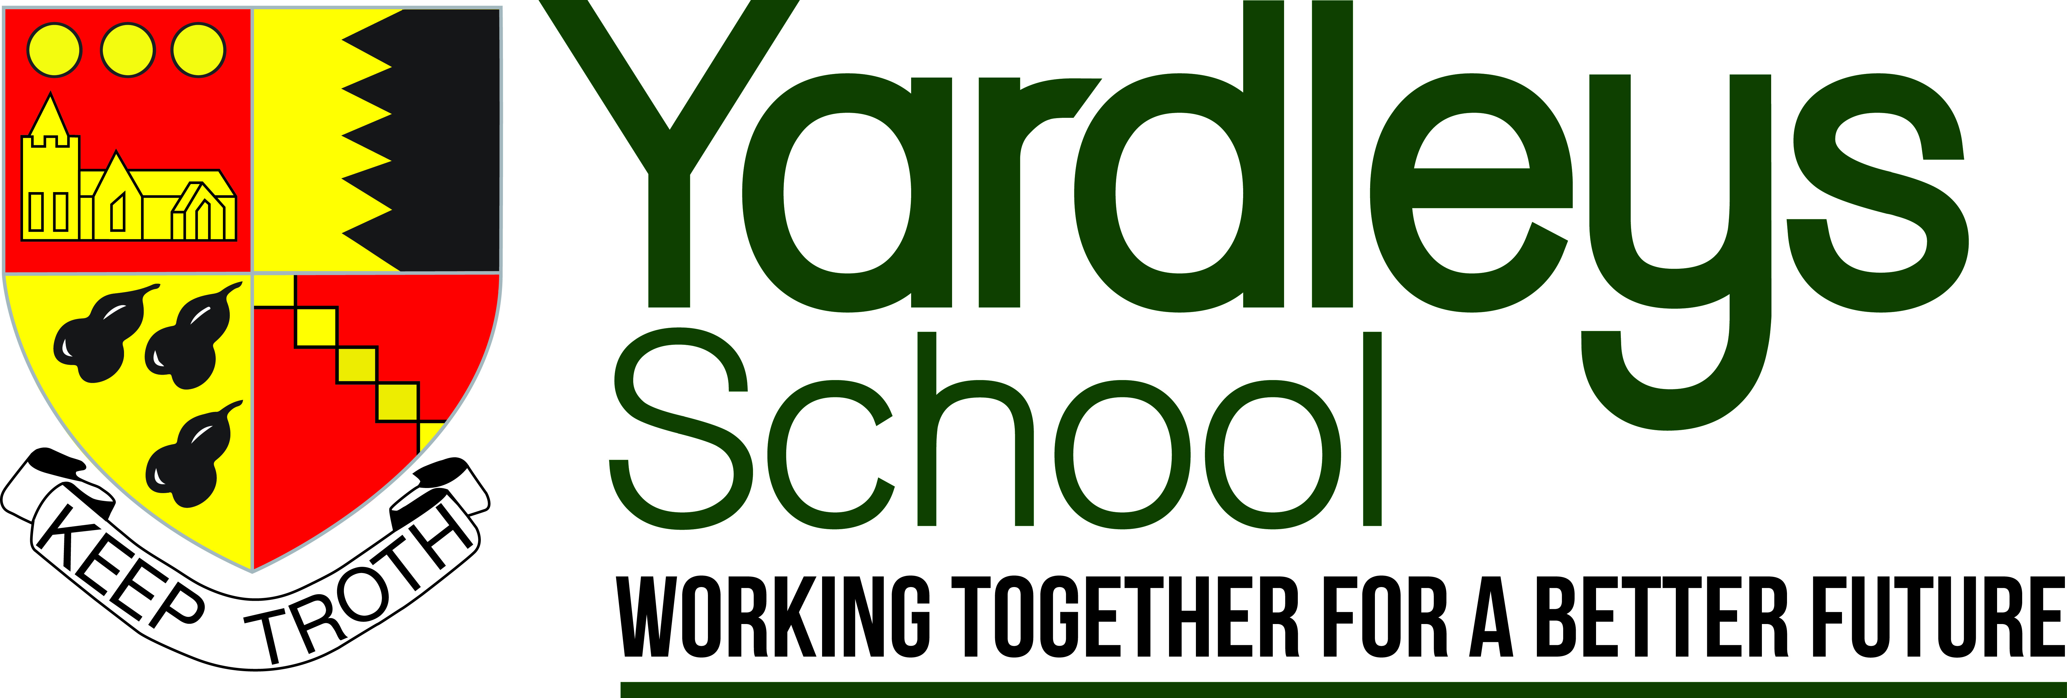

INFORMATION FOR PROSPECTIVE CANDIDATES

Headteacher: Mr B Evans B A (Hons.), NPQH
Reddings Lane, Tyseley, Birmingham, B11 3EY
Tel: 0121 464 6821
Fax: 0121 464 6824
www.yardleys.bham.sch.uk

Our aims

As a school we aim:

- to excite, inspire and challenge so pupils enjoy learning.
- to be a strong community that has a shared purpose, values and collaborative ethos.
- to strive for excellence and the highest standards from everyone.
- to educate the whole child so they are ready for life.
- to work in partnership with the wider community.

Our values

- Positivity - high expectations, challenge
- Curiosity - wondering why, how
- Empathy - understanding others
- Integrity - being true to yourself; self-respect
- Resilience - grit, determination
- Reflection - thinking about; learning from

Introduction to Yardleys School
“This outstanding school exemplifies the very best in educational provision, showing that young people can achieve exceptionally well, irrespective of circumstances that for many would put them at risk of failure” – Ofsted
The collaborative ethos which permeates all parts of the school is summed up by our motto “Working together for a better future”. This results in a highly supportive community, which allied with excellent student behaviour and a well organised school, allows teachers to focus on their teaching and improving their practice.
Judged ‘Outstanding’ by Ofsted in 2010, Yardleys is a thriving, heavily oversubscribed 11-16 multi-ethnic academy in Birmingham, with 913 students on roll.
Yardleys is a multi-cultural school which reflects the diversity of the local community, serving an area of high socio-economic deprivation. Almost all the students are from minority ethnic backgrounds. The percentage of pupils with English not as first language currently stands at 87%. The school also has more boys than girls (57% to 43%) on its roll. The school has a much higher than the national average number of students who are eligible for Pupil Premium (at 53%).
The school is highly focused on raising standards of pupil achievement and is successful at doing so. Yardleys School is in the top 100 most improved schools and consistently in the top 10% of schools nationally for value added. The average attainment of students arriving in Year 7 is well below the national average. Despite this, 51% of students gained A*-C grades in both English and Maths last year, and 99% of students achieved 5 or more passes at A*-G. Moreover, Ofsted remarked on the ‘exuberant learning environment’ at the school.
The school is proud of the many awards that we have managed to secure including Investors in People, Leading Edge Status, SSAT Outcome Award for exceptional student progress and Stonewall School Champion.
“The commitment which the school has made to improving pupil behaviour means that staff are now able to focus on teaching, and improving progress” *
Yardleys has outstanding pastoral care including safety, behaviour and personal development. The school operates a year group system with five Heads of Year. All teaching staff, as well as some support staff, can expect to be form tutors. Our House system runs alongside this and promotes a healthy competitive spirit. Students are very hard working and enjoy coming to the school (reflected in the school’s excellent attendance statistics). You will find them to be lively, friendly and enthusiastic. The many displays of students’ work reflect the vibrant and creative nature of the school. There is an emphasis on traditional values, high standards and expectations in all aspects of school life.
“Good-humoured, open and friendly dialogue between teachers and students reinforces a delightful working ethos in lessons.” – Ofsted
The school places great emphasis on development of the whole child and offers a range of enrichment activities including the Duke of Edinburgh award scheme, educational visits, extra-curricular and sporting opportunities. Students develop strong values of mutual respect and tolerance of those with different faiths, beliefs and characteristics.
The school is fortunate to enjoy excellent facilities on a modern, single site which was re-developed under a PFI arrangement. The building is organised into faculty areas with extensive modern facilities for, in particular, ICT, Science, Mathematics, Sports and Performing Arts. Other features include an interactive whiteboard in every room and a set of wireless laptops in each faculty. Alongside the new building the school has extensive playing fields and a roof garden.
“Staff are proud to work within Yardleys and are proud of its achievements”*
The sustained educational excellence at Yardleys has been down to the dedication, commitment and hard work of the staff and students in raising student achievement. The school has focused upon developing excellence within teaching and learning, introducing rigorous methods of tracking student progress and ensuring the highest standards of behaviour. A key strength is the teamwork and collaborative ethos amongst all staff, teaching and support.
The School places high importance on the training and professional development of all staff, particularly those new to the School. This includes mentoring, weekly training sessions and subject collaborative planning. Performance management is far more focused on improvements in teaching practice rather than just exam results. The School has consistently achieved IIP status.
The school is highly committed to supporting its staff and has adopted policies to ensure all teachers have adequate planning, preparation and assessment time. Where possible the school invests in extra teaching staff to provide smaller class sizes. In total the school employs around 50 support staff who work alongside the teaching staff to improve opportunities for all students. In addition to administrative, technical support and premises staff, the school has a strong team of Teaching Assistants, Cover Supervisors and a School Nurse.
“A strong leadership team provides visible and empathic support to all staff”*
The Senior Leadership Team (SLT) comprises eight members: Headteacher, three Deputy Headteachers, three Assistant Heads and an Academy Business & Support Manager. Whilst each member of the SLT has specific responsibilities, everyone contributes to discussions on all issues related to the organisation and development of the school.
A significant strength of the school in recent years has been its work to engage with a range of external partners locally, nationally and regionally. Yardleys School is part of a collegiate of local schools which offers a range of further support and opportunities for all staff. The school has a range of excellent partnerships, including strong working ties with the local schools, post-16 providers and the wider local community.
We offer a broad, rich and balanced curriculum. We have a two year Key Stage 3 and a three year Key Stage 4 with a free choice for pupils to select their options. Teaching and learning is at the heart of all we do, demonstrated not only in lessons but also though extra-curricular programme. We offer extra literacy lessons in Year 7 & 8 for pupils to improve their reading and writing, Further Maths for more able pupils and the three separate sciences are available to all students. We check progress through regular tests and internal exams and have a range of online resources to support students. Current priorities focus on the achievement in Maths and English, the achievement of higher ability students, closing the gap for Pupil Premium students and literacy.
The Governors are extremely supportive of the Headteacher and leadership team, believing that an excellent school is based on teamwork. The Governors recognise the important distinction between governance and management and work tirelessly to ensure the success of the school. Governors are forward thinking and retain a deep commitment to ensuring the school continues to serve its local community.
“There is a uniqueness about this school” *
Thank you for your interest in our school. We look forward very much to receiving your application.

*Investors in People report October 2015

