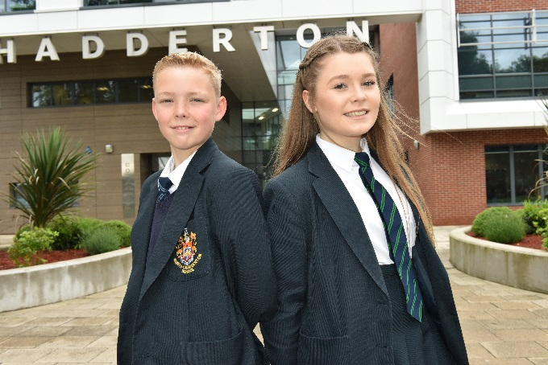
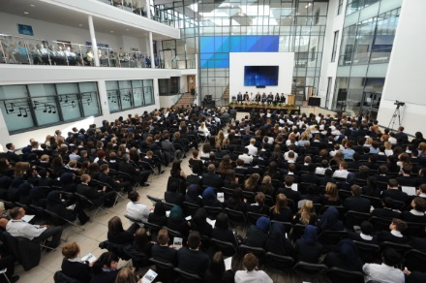
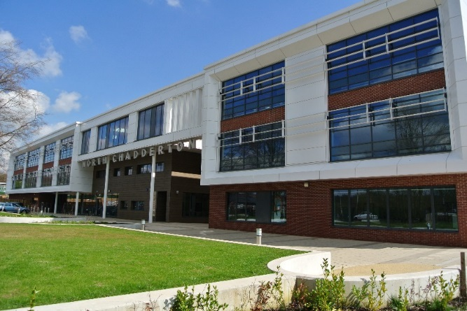
‘Driven To Be Outstanding
In All That We Do’
DO YOU WANT TO BE PART OF SOMETHING SPECIAL?

Dear Applicant,

Thank you for your interest in North Chadderton School.

North Chadderton School is a successful, progressive, vibrant 11-18 Academy. It is part of the Oak Trust for Inspirational learning and leadership (OTILL), a Multi Academy Trust (MAT) which opened in September 2017. The MAT will have a Secondary – Primary focus and serve the local community.

North Chadderton is consistently oversubscribed, attracting students from outside of our catchment area. Our main priority is the provision of the highest quality education for all our students and we are very proud of our excellent reputation in the community. The schools mission statement “Driven to be outstanding in all that we do” is central to all that the school focuses on.

It is our vocation and privilege to guide our students to become everything they are meant to be and more. We provide a stimulating and challenging environment where students are encouraged to work hard and achieve their full potential. To achieve this, our first priority is the recruitment, investment and professional development of the very best staff for our students. The successful applicant will receive induction, support from colleagues at all levels, and extensive opportunities for professional/personal development and training. This includes the opportunity to engage in internal and external training opportunities to build Leadership succession within the school.

We are looking for innovative, dynamic, motivated and qualified staff that see themselves as part of “one team” and who are determined to make North Chadderton an Outstanding school, following our Ofsted judgement in May 2017 which states the school “continues to be good”. Parental feedback stated “the school provides an excellent learning environment in which I feel children are developed not just academically but also that they are socially aware and able to contribute to the world outside of school”.

Our mission statement “Driven to be outstanding in all that we do” underpins everything we do. The very best staff for our school will be those people who have ambition for our students and who show imagination, creativity, dedication and resilience as we work together to build an exciting future for North Chadderton School.

North Chadderton is a highly successful school and if you are inspired by what you read and share our vision please visit our website for further information.

I welcome your application and I look forward to meeting you.

Joy Clark
Headteacher

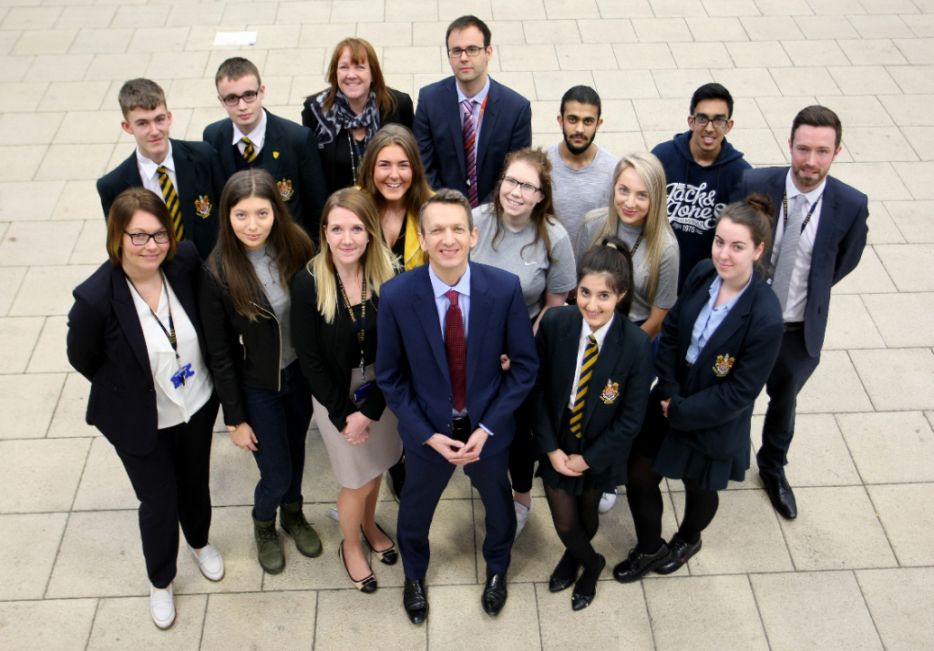
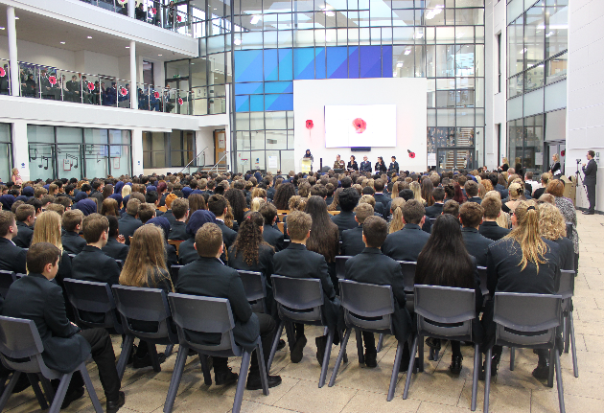
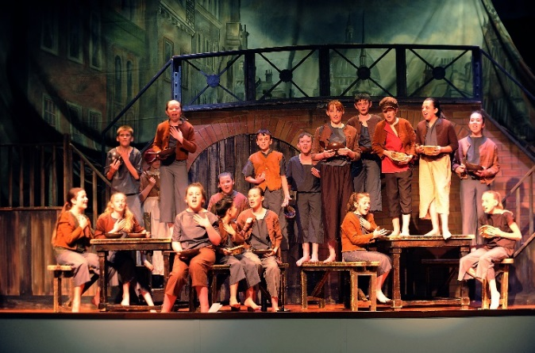
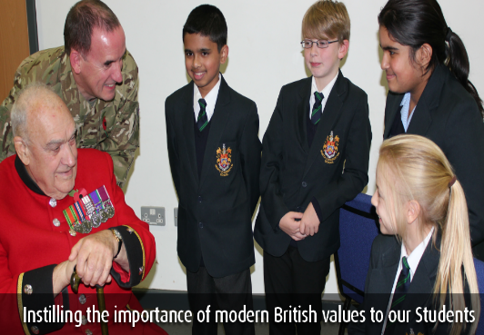
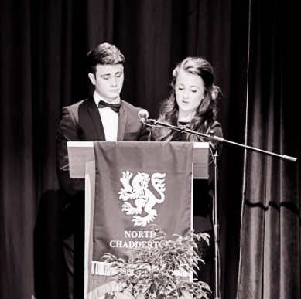
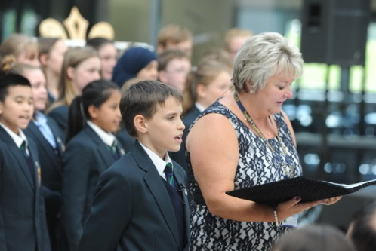
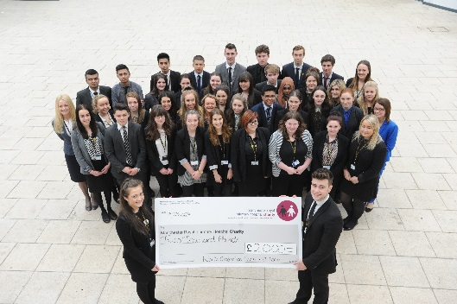
North Chadderton is a very special place with a proud record of success and a
very strong reputation within the community.

Our mission statement is to be “Driven to be outstanding in all that we do” and
this underpins everything that takes place at the school.

We have a total focus on the success and achievement of every single student
as well as their all-round development and preparation for future life.

Our philosophy focuses on strong traditional values and we have high expectation
and standards including behavior and respect throughout our entire community.

Our school’s success relies on a strong team ethic. All staff, teaching and support,
are seen as one team. They are trained accordingly and work together cohesively
to consistently drive up expectations and outcomes within the school.

We maintain excellent relationships with all our stakeholders.
OUR ETHOS AND VALUES
‘Driven to be outstanding in all that we do’

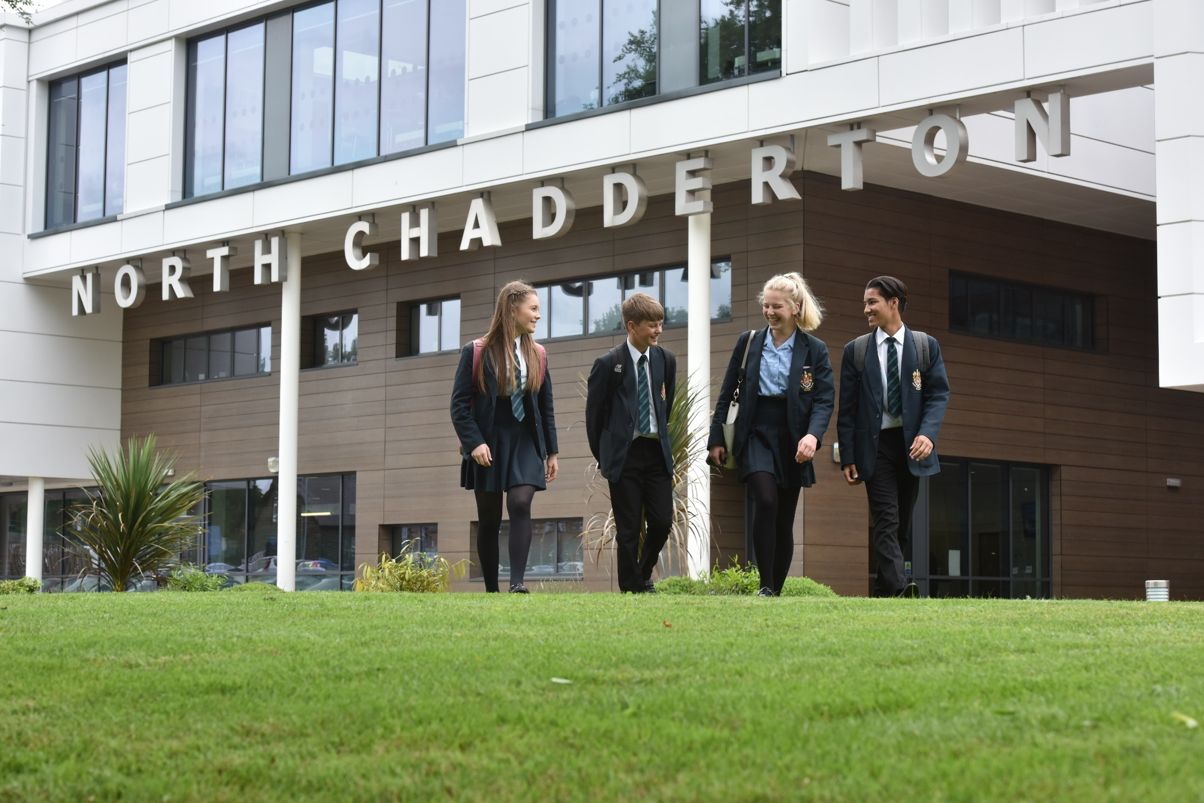
Type of School | Academy
Age Range | 11 - 18
Number of Students | 1418 pupils
Number of Teachers | 102
Number of Support Staff | 106
Average of Class Size | KS3 – 25 KS4 – 20 KS5 - 12
Proportion of students eligible for FSM | 9%
Proportion of students from Ethnic Minorities groups | 31%
2015 – 2016 overall attendance | 95.4%
Last Ofsted report | May 2017 ‘Good’
NORTH CHADDERTON
KEY FACTS

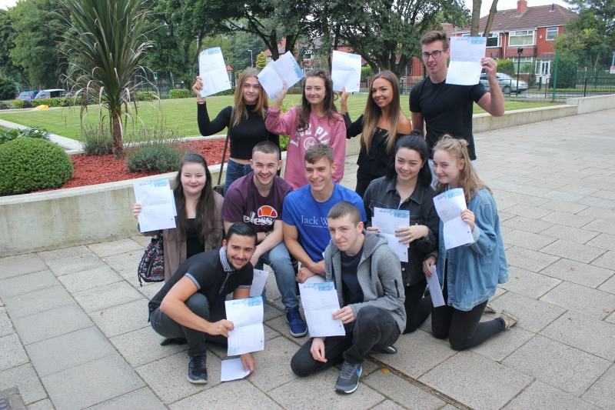
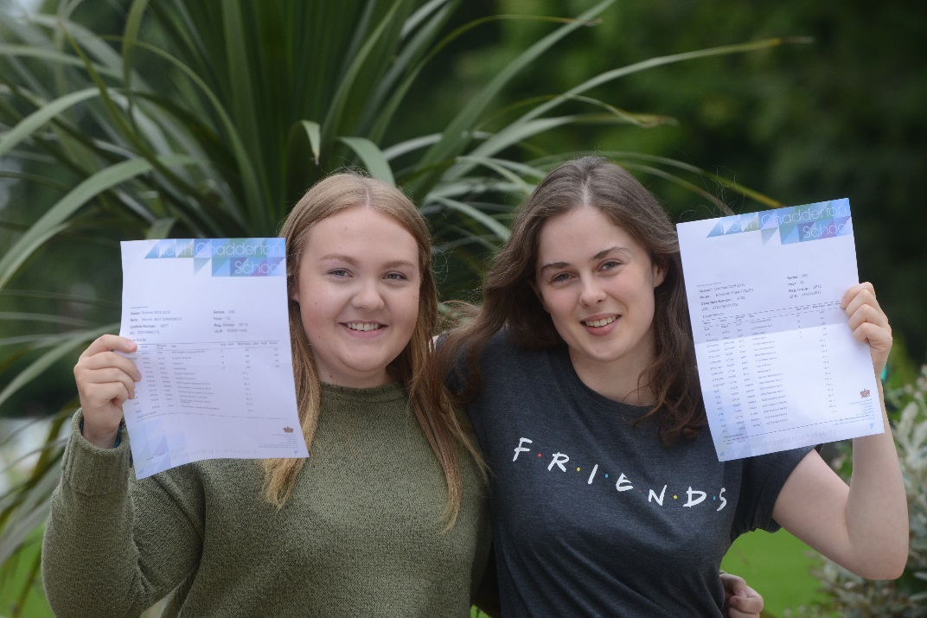

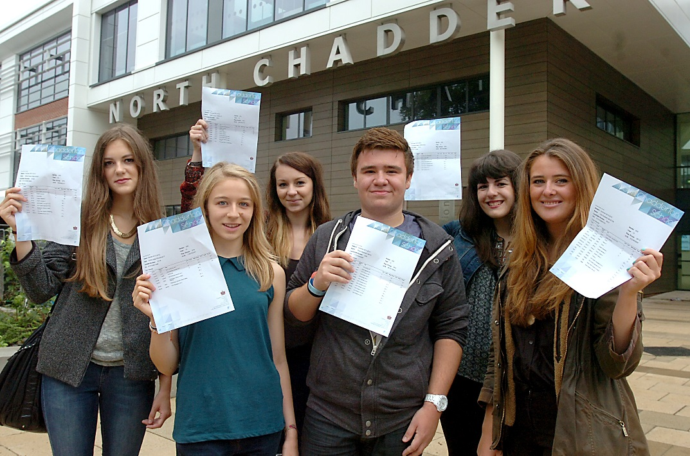

EXAMINATION RESULTS

GCSE | 2017
5+ standard passes including English and Mathematics | 63%
Progress 8 | -0.01
Total Attainment 8 | 45.03
Achieving English Baccalaureate (standard pass) | 2.1%
9 - 4 English | 81%
9 - 4 Mathematics | 70%

A Level | 2017*
Achieving 3 or more A* - E (or equivalent) | 97%
Achieving 2 or more A* - E (or equivalent) | 99%
Achieving 1 or more A* - E (or equivalent) | 100%

*Overall figures (A level, Academic and Applied General Qualifications)

WHAT WE WILL OFFER YOU
A Supportive Workplace | Wellbeing and ‘One’ Team
- A supportive working environment.  - An excellent NQT and RQT programme to ensure you receive the best support and encouragement to allow you to excel in your subject.  - Employee Assistance programme.  - On site 1:1 counselling service.  - Bespoke mentoring for all phases of your career. | - Whole Team Briefing and breakfast on a Friday morning.  - The opportunity for time off in lieu (TOIL)  - Childcare vouchers  - Cycle to work schemes  - Staff exercise classes and sport teams.  - A chance to take part in fundraising events such as our whole school sponsored walk, Christmas Markets and Red Nose Day concert.  - An opportunity to be a part of ‘one team’.  - The opportunity for you to ‘have your say’ and contribute to the success of North Chadderton. An employee voice is extremely important here.
Working Environment | Development Opportunities
- A new state of the art building.  - A great working environment.  - Access to new state of the art technology.  - Onsite secure car parking. | - Development and training opportunities: We will offer you an extensive weekly CPD programme bespoke and tailored to your individual professional development needs.  - The opportunity to be part of a co-coaching pair or triad with a focus on teaching and learning or developing your leadership skills.  - The opportunity for Aspiring Leaders to join our ‘Talent Programme’ and work with a coach from the Senior Leadership team  - The opportunity for Middle Leaders to take part in a leadership development programme

WHAT WE EXPECT FROM ALL MEMBERS OF OUR TEAM

- To become fully involved in our school community

- To communicate professionally at all times

- To act as role models for our students

- To get involved in enrichment activities

- To promote the schools ethos and values

- To promote and follow the schools policies, procedures and professional practice

- To promote team work and respect for others

- To have a passion for teaching and learning that motivates our students and encourages them to develop and succeed.

OUR TEAM

Here at North Chadderton School we are all ‘One Team’. We understand the importance of our staff and how every individual plays a crucial role in ensuring our students are provided with the best education and school life. We currently have 203 staff consisting of approximately 105 teachers and 98 support staff.

Each curriculum area has its own staff base which allows staff time to plan, prepare and assess within their own departmental areas as well as to share good practice.

As an organisation we ensure that all our staff are provided with a supportive environment and numerous development opportunities as investment and the professional development of the staff body is central to the ongoing success of the school.

All staff are engaged in weekly training and development to ensure that the highest possible standards of academic and personal achievement are met. This dedicated professional development time on Wednesday afternoon’s further builds on pedagogy and other key issues where we want staff to be confident team members. We also have an innovative in-house Talent programme that provides leadership opportunities for all staff, both teaching and support, and which helps the school plan for succession.

In addition to support and development opportunities we also have a huge focus on staff wellbeing and encourage our staff to get be involved in life at North Chadderton. In addition to the daily briefing, every Friday all staff meet for a ‘Team Briefing’ where colleagues have the opportunity to meet up over breakfast.

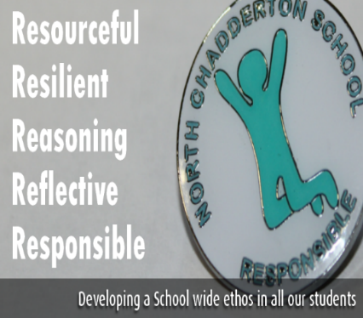
OUR STUDENTS
The Student Body

Each Year group admits 240 students which arrive annually from over 40 primary schools. The school is very substantially oversubscribed and the number of applications annually is considerably more than places available.
Our students come from a mix of social backgrounds. There are approximately 31% of ethnic minority children, mainly Bangladeshi and Pakistani in origin. Currently 9% of students qualify for free school meals.

The Curriculum

Students are taught a broad and balanced curriculum. In response to Progress 8, the school moved to a two year Key Stage 3 curriculum and a three year Key Stage 4 curriculum. The Key Stage 3 curriculum covers a strand core of English, Maths and Science complemented by Modern Languages, History, Geography, Religious Education, Technology, Dance, Music, Drama, Art, IT and Physical Education. As well as being taught core subjects in Key Stage 4, students have a wide range of Option choices available to them. These subjects include History, Geography, Computer Science, ICT, Business Studies, Music, Drama, Dance Psychology, Sociology, a selection of Technology subjects, Art, Modern Foreign Languages, PE, Creative Media, Early Years, Health and Social Care, RE and Film Studies. At Key Stage 5 the school provides a wide range of academic AS and ‘A’ Level courses, complemented by a small number of vocational courses. Careers information and guidance throughout the school are excellent. The School has achieved the ‘Inspirational Advice and Guidance’ Award and ensures that all students are directed to courses to suit their aptitude, ability and aspiration. Clear progression routes are outlined and explained.

Extra-Curricular opportunities and enrichment

The school’s aim is to develop students academically and socially. There is an extensive range of extra-curricular opportunities to enable young people to raise their aspirations, widen their horizons and build their self-confidence. All staff are encouraged to contribute to these opportunities. Music, Sport and Drama are only a few of the clubs in which students can become well rounded individuals with outside interests. The Duke of Edinburgh Award Scheme and many clubs linked to subjects across the curriculum flourish. The students also have a wide range of opportunities for educational visits and trips both within this country and abroad, which provide exciting opportunities and challenges.

Here at North Chadderton we have created excellent relationships with our local community and we work closely with local charities, parents, businesses and organisations. As a school we have organised a range of events that involve our community and partners, work closely with our neighbouring primary schools and provide letting opportunities for local sport groups.
Friends of North Chadderton
We have a Friends of North Chadderton group where parents, staff and members of the community organise fundraising events to benefits our students. The events that have been organised include the North Chadderton Christmas Market, Summer Festival, Year 7 Halloween party and Ladies Fashion events. These events have been hugely successful and have seen students and members of our community win an Xbox, PS4, Televsions and an Apple iWatch.
School Fundraising
We understand the importance of helping our local community and we are dedicated to fundraising for a different charity each year. We have raised over £20,000 for our local hospice Dr Kershaw’s and Cancer Research. Our students choose a new charity each year, this year our school charity is ‘I Love Manchester’. The funds we raise are generated from our whole school sponsored walk, Christmas markets organised by our Sixth Form students and a wide range of other fundraising events.
OUR COMMUNITY
Our Location

We are located in Chadderton, Greater Manchester in a sought after green belt area. Our school is a 5 minute drive to the M62 providing easy access to major cities such as Manchester, Leeds and Liverpool. We have 3 car parks on site available for all staff to use. If you prefer not to drive, there is a bus stop directly outside the school and we are less than a mile away from the nearest train station which can transport you to Manchester City Centre in under 10 minutes and provides a direct route to Leeds station. Our current staff use a variety of transport and live in and around Greater Manchester and Yorkshire.

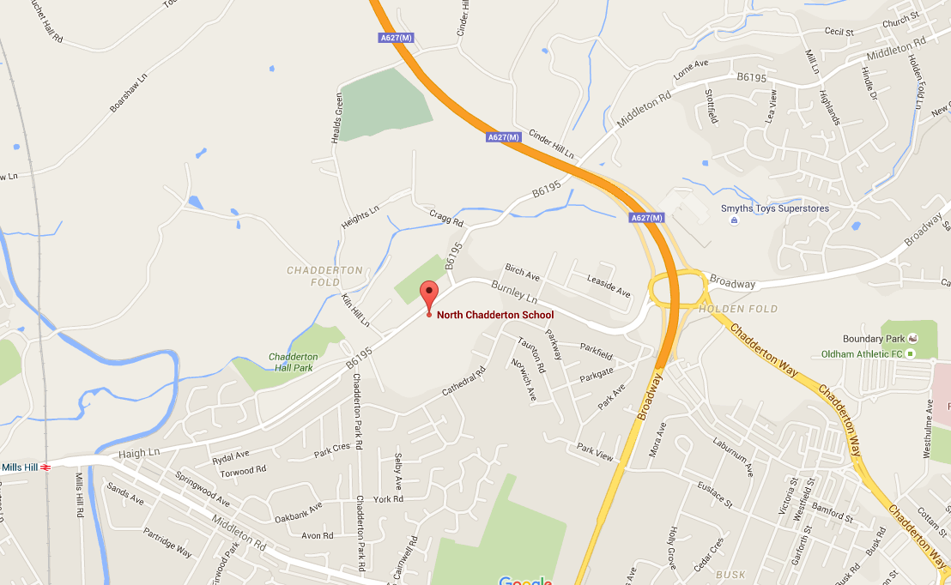
North Chadderton School
Chadderton Hall Road
Chadderton
OL9 0BN
01616249939
moffice@northchadderton.oldham.sch.uk

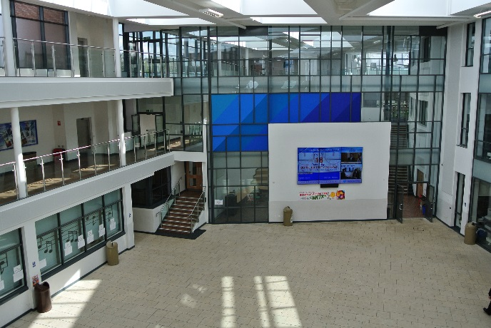
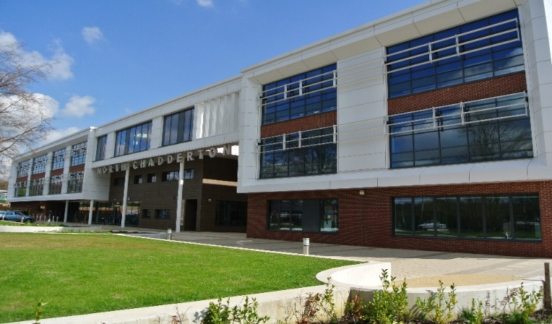
HOW TO APPLY

Please visit our school website www.northchaddertonschool.co.uk where you will find the job description, person specification and application form for this position.
A fully completed application form should be either emailed to recruitment@northchadderton.oldham.sch.uk or handed in at our main reception.

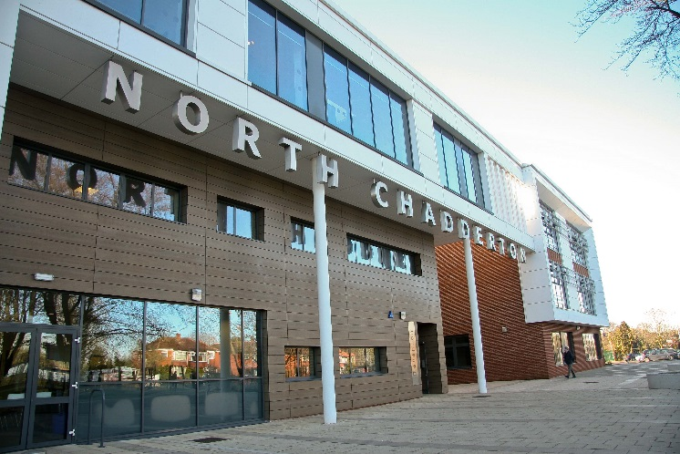
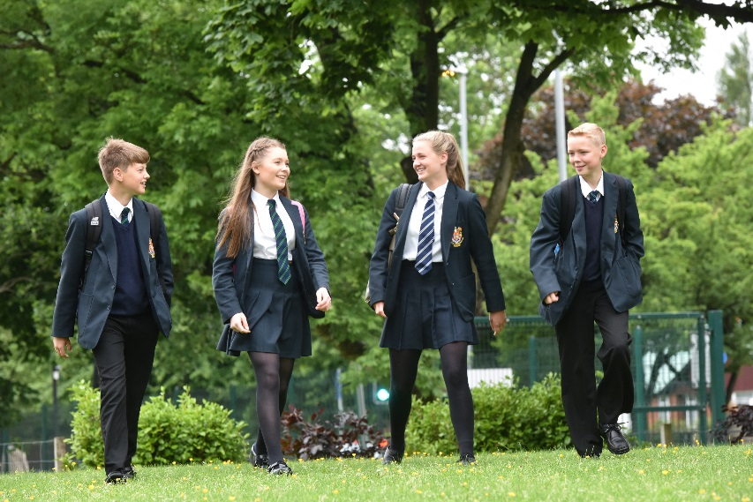

North Chadderton School is committed to safeguarding and promoting the welfare of children and young people. We expect all staff and volunteers to share this commitment. All successful post holders are subject to a satisfactory enhanced Disclosure & Barring Service Disclosure.
North Chadderton School
Chadderton Hall Road,
Chadderton,
OL9 0BN
0161 624 9939
www.northchadderton.co.uk
moffice@northchadderton.oldham.sch.uk

@Northchadderton
@NorthChaddertonSchool

