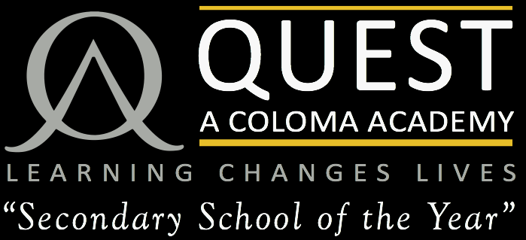

“Our priority is to

ensure that students, staff

and parents are proud

to belong to The Quest.”

Mr Andy Crofts

Principal, The Quest Academy

HUMANITIES FACULTY

The Quest Academy – Coloma Trust has a Humanities faculty consisting of seven full-time specialist members of staff. There are three History, two Geography, one Religious Studies and one Social Science (Psychology, Sociology, Citizenship) teachers. All teachers are expected to teach across the age, ability and subject range.

The Humanities area has six dedicated classrooms; each room is fully interactive and very well resourced.

**Humanities KS3**

Students follow a condensed Key Stage 3 course over two years and each student will follow a differentiated scheme of work in line with the National Curriculum. All Year 7 and 8 students have one lesson of PSHCE and Religious Studies and two lessons of History and Geography per week.

ICT is already used within the faculty and access to a variety of electronic resources is available.

**Humanities KS4**

Students follow Edexcel board course for History, the WJEC course for Religious Studies and the AQA board courses for Citizenship, Sociology and Geography. Currently, all students in Year 11 complete the full course GCSE in Religious Studies; from Year 9, Citizenship and Religious Studies are now offered as option subjects along with Geography, Sociology and History.

Year 9 and Year 10 both receive one enrichment period a week as part of a Global Citizenship carousel programme.

**Humanities KS5**

The Humanities Faculty offers A Levels in

* Geography
* Government and Politics
* History
* Philosophy and Ethics
* Psychology
* Sociology

LEARNING CHANGES LIVES

Principal: Mr Andy Crofts

Farnborough Avenue, Selsdon CR2 8HD T: 020 8657 8935 www.thequestacademy.org.uk

“Our priority is to

ensure that students, staff

and parents are proud

to belong to The Quest.”

Mr Andy Crofts

Principal, The Quest Academy