

**Job Description and Person Specification for Art Teacher**

**September 2017**

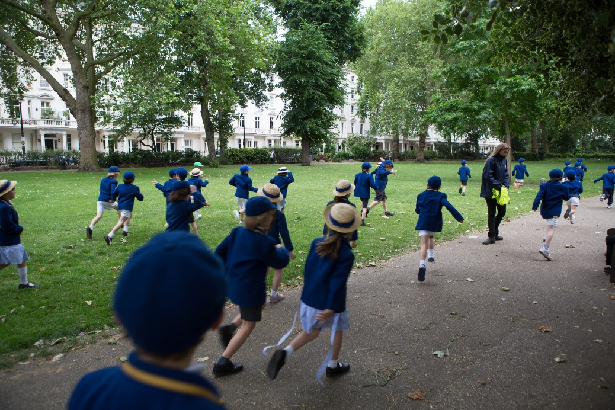

Eaton Square School is a well-established IAPS independent, co-educational Nursery, Pre-Preparatory and Preparatory school in the heart of central London, currently educating children from the age of 2 ½ to 13 years of age. Offering continuity of education in the important formative years of a child's life, the school is a vibrant, popular community where children learn not only the skills, but also the values that will prepare them for the next stage of their life at senior school and beyond.

The School comprises three sessional Nurseries in separate locations, a Pre-Prep housing reception and Year One, a Junior Prep section housing specialist facilities, administrative offices and classrooms for Year Two to Four and a Senior Prep section, currently housing specialist facilities and Classrooms for Year Five to Eight. Although non-selective standards at the main point of entry (Reception) the school maintains high academic standards, with many children moving on to the most selective of London Day Schools and Boarding Schools at 11+ and Common Entrance at 13+.

The school offers a breadth and depth of Education which goes beyond academic success in examinations and into every sphere of life. Equal emphasis is placed on intellectual, artistic, aesthetic, physical and musical pursuits. In addition, our teaching staff want children to learn moral and spiritual values that will make them happy and confident in themselves, without arrogance, so that they may become kind, well-rounded and respected members of society.

Eaton Square Upper School, Mayfair will open in September 2017 on 106 Piccadilly, opposite Green Park. Year 7 & 8 will transfer to the Upper School, and there will be an additional Year 9, all of whom will have one hour of timetabled art. The Upper School will grow by on year group each year, with the first sixth form cohort in September 2020.

*History of School*

Eaton Square School was founded in 1981 and began life as a Nursery School in the basement of a church on Eaton Square. Since then the school has expanded its operations across six sites in Belgravia, Knightsbridge, Pimlico and Richmond which include three feeder Nursery Schools, a Pre-Preparatory and a Preparatory School. It is now the second largest co-educational Prep school in Central London with over 500 pupils on roll.

Eaton Square School enjoys a very strong reputation locally with a large proportion of its parent body working in embassies and senior roles in the City of London.

The last few years have seen pupils moving on to Eton, Harrow, Tonbridge, Winchester, Westminster, Dulwich College, Alleyn’s, Kings College Wimbledon and St Paul’s. Girls are equally successful through 11+ entry moving on to schools such as City of London Girls, Godolphin and Latymer, Putney High, JAGS, Alleyn’s, Benenden, St Swithun’s and Downe House.

*Headmaster*

Sebastian Hepher took up the Headship of Eaton Square School in 2010. Prior to this, he spent 17 years as Headmaster of Eaton House The Manor School in Clapham.

**Aims of our school:**

*Every child, every single child has the capacity to excel in some way. We believe education*

*must be fostered from within; it stems from connecting, not directing.*

We aim:

* to offer academic excellence within excellent facilities
* to place an emphasis on the whole child
* to develop a purposeful attitude, self-confidence and a respect for others; developing trust, truth and a strong sense of community
* to develop a love of learning, which is fostered from within
* to offer a well-balanced, all-round education
* to ensure that children are happy in themselves, happy in each other’s company and confident in their ability

**Job Description for Art Teacher**

**Reporting to: The Headmaster, Deputy Head and the Assistant Heads**

* To plan and implement the schemes of work for pupils from Year Five to Year Nine and to oversee the planning for Year Two to Four
* To organise the running of the Art Rooms in the Prep School and Upper School
* To write a yearly development plan for Art
* To work closely with the Learning Support Department to provide adequate differentiation in Art lessons for EAL and SEN pupils
* To use I.C.T. to support and extend all areas of Art, including the use of interactive whiteboards as appropriate
* To be responsible for the Art budget
* To follow all school policies and to be fully aware of and comply with all Health and Safety arrangements for the Art Room
* To promote Art within the school by organising events such as visits to galleries
* To be responsible for the welfare of the pupils in your class
* To undertake duties before, during and after school as required
* To participate in after-school activities including residential field trips, as and when necessary
* To run an Art club after school on a weekly basis
* To attend school functions
* To undertake willingly all reasonable requests made by the Headmaster for the successful running of the school

**THE POST HOLDER MUST PROMOTE AND SAFEGUARD THE WELFARE OF CHILDREN AND COMPLY WITH THE EATON SQUARE SCHOOL SAFEGUARDING POLICY**