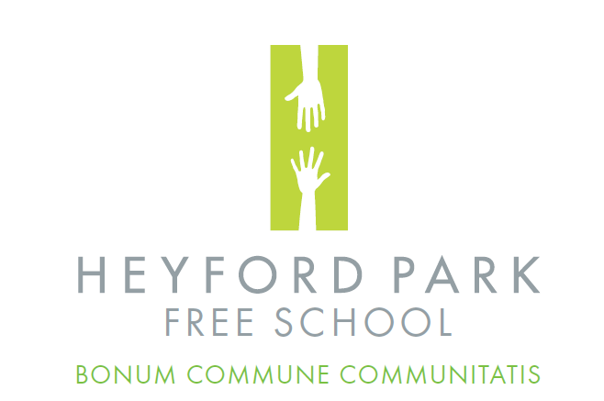
Heyford Park Free School
74 Camp Road
Upper Heyford
Bicester
OX25 5HD

T. 01869 232203
E. office@heyfordparkfreeschool.org
www.heyfordparkfreeschool.org

Principal: Ms Karen Healey

Dear Potential Candidate,

Heyford Park Free School opened in 2013 as an all through school offering education from reception to post 16. The schools vision is to “know every one of our students well, providing an environment that allows them to achieve what they are truly capable of by promoting both excellent academic progress and a ‘can do’ attitude.”
We are oversubscribed and experiencing rapid growth in both the Primary and Secondary phases. Our fantastic heritage site has been fully refurbished and provides a unique learning environment. Small year groups enable us to know every child well and personalise their learning. We are forward-thinking, with the freedom to shape our school curriculum in response to the needs of the local community and businesses. We are delighted that Ofsted judged us to be a Good school in April 2015.

As the new Principal joining in January 2017, I have found the school really welcoming. Students are a pleasure to teach and the parents and governors are fully committed to the school providing a wealth of opportunities. You will find staff are fully supportive of each other and as Team Heyford we are working together to ensure we enjoy the opportunities of a small school whilst setting our aspirations high.

I have been fortunate enough in the last three years to work with schools on their journey to outstanding in both England and South Wales and find Heyford Park Free School a community that is committed to the proverb “It takes a village to educate a child”.

We are a community school and our community play an important part in supporting our students. As a small school whilst having an academically above average intake we attract a number of families with children with special educational needs. Our school has a high number of children with ASD and we are proud to continually work with each of these children to ensure they achieve their dreams and achieve excellent academic progress. As a school we are committed to ensuring all our staff are well trained and whilst we have completed ASD Level 1 training we will all be completing the level 2 in February. As a school we are committed to ensuring we know each one of our children as individuals and can respond to them as such.

As a school, we build professional development into the working week with students leaving early one day a week which is enabling us to work as a team to drive our vision forward. This is further supported through whole school training and bespoke training which we broker through the local teaching school alliance, partner schools as well as the local authority.

Our first cohort of key stage 4 students will take their GCSEs in 2018 and we will welcome our first cohort to our Sixth Form in September 2018. This is an exciting time for the school which offers a number of opportunities now and in the future for the right candidate.

I look forward to receiving your application and meeting you at interview. If you have any questions or would like to visit the school, please email me on: khealey@heyfordparkfreeschool.org

Yours faithfully

Ms Karen Healey

