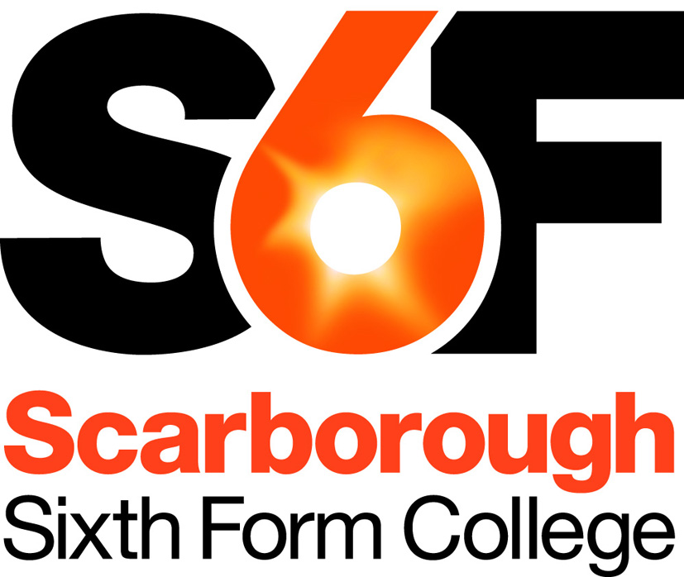
Person Specification
Human Resources Manager

Our aim is to recruit highly talented and competent people, fully committed to the College’s aims and values. Below we have identified the qualifications, skills, experience and attributes ideally required for this post. Applicants need to demonstrate how well they meet this profile and/or their potential to develop to meet the requirements of the post. This will initially be assessed based on quality of application, and then, if shortlisted, based on a combination of relevant task(s) and interview(s).
Qualifications & Training
- Qualified to at least level 3 (A-level equivalent)
- Holds a relevant professional qualification or working towards one (e.g. CIPD) or has attended recent training relevant to the post
Desirable
- Qualified to degree level

Professional Skills & Experience
- Up-to-date knowledge of key HR issues and legislation
- Previous HR experience which reflects the ability to work at the required level of responsibility
- A pro-active, flexible and adaptable approach
- Able to organise own and others’ workload to best meet the needs of the service and meet important deadlines
- Good written communication and presentational skills
- Able to deal confidently with a wide range of people and work in a confidential and sensitive manner
- Good organisational and administrative skills
- Able to operate within a busy environment whilst remaining accurate and attentive to detail
- Good all-round IT skills combined with previous experience of computerised HR systems
Desirable:
- Experience within the education sector

Personal Skills & Attributes
All staff are expected to demonstrate commitment to the college’s aims and values, including:
- Passionate about learning and its importance in life
- Having high expectations of self and others
- Honest, open, reflective and self-critical
- Doing one’s best, adapting well to change and always seeking to do better
- A supportive team worker
- Treating staff and students fairly and with respect, valuing their diverse contributions
- Fully committed to promoting & safeguarding welfare of children & young people

For staff with management or supervisory responsibilities, this also includes:
- Acting as a role model, with day-to-day behaviour reflecting college values and good professional practice
- Demonstrating a commitment to our students and to continuous improvement for their benefit
- Actively inviting and listening to feedback and keeping colleagues appropriately informed
- Able to make fair decisions, based on reliable information and a clear understanding.

Updated: September 2018

