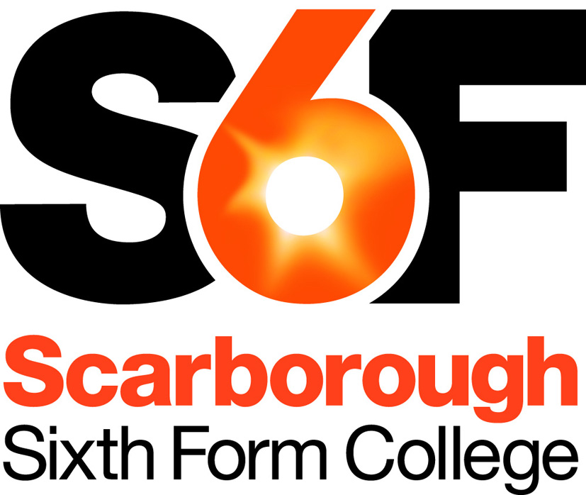
Human Resources Manager
Permanent, full-time or part-time

We are seeking a skilled, pro-active and committed individual to play a key role in supporting the College’s strategic and operational aims through the provision of an effective and efficient HR service.

The College employs 160+ staff, all based on the one site. Most staff are salaried and permanent, however, we do have a varied range of contractual arrangements to reflect the flexible staffing required in a College environment – these include sessional staff, relief staff, fixed terms, variable hours and term-time contracts.

As the lead HR role within College reporting directly to the Principal, you need to be able to confidently provide practical advice to governors, managers and staff on HR matters. You will have the skills to be sensitive and supportive of individuals whilst fully appreciating the operational and strategic needs of the College and the responsibility we have to our students.

Your previous HR experience must clearly reflect your potential to work at the appropriate level and demonstrate your practical ability to deal with a wide range of HR issues. Experience of the educational sector is not essential, since you will have access to support from other colleagues both within College and through our partnerships with other Sixth Form Colleges in the Yorkshire & Humber area. However, it is essential that you have the pro-activity and adaptability to quickly gain an understanding of College strategic aims and ethos as well as reviewing our existing HR policies, procedures and practices.

The work will be very varied and you will be pro-actively involved in all of the College’s key HR processes – including staff selection, induction, probation, performance management, training and support arrangements. It is a busy working environment and good prioritisation skills combined with a flexible approach are key in ensuring all demands are appropriately balanced.
The role has line management responsibility for the HR & Recruitment Officer who provides high level administrative support and helps co-ordinate key HR processes. Good IT skills are needed to be able to maintain and continue to develop our computerised HR records and systems.

The role is available either on a full-time basis or a significant part-time basis (provisionally 30 hours per week), dependent on the interests and skills of the successful candidate. For a part-time role there is flexibility in how the hours are worked, provided the needs of the role can be met, including a reduced commitment in the College holiday periods, if desired. For the full-time role you will be required to either take on the duties of Clerk to the governing body or alternatively to develop and deliver a package of training courses. The clerking role would provide an ideal opportunity to gain a broader understanding of the College’s education and business priorities. The training role is a new development and would involve offering a range of personal effectiveness and management related short courses to internal staff and to external customers (e.g. employees from other local schools or businesses). Both roles would receive administrative support from the HR & Recruitment Officer.

The HR Manager role is a challenging yet rewarding role and will provide you with a great opportunity to gain experience of all aspects HR within an educational establishment, whilst at the same time enabling you to play a key role in supporting the success of the College and its staff and students.

For further information, please see the Job Description and Person Specification.
Additional Information
Human Resources Manager

Grade & Salary Range
The successful candidate will be appointed to Scale G of the College’s support staff pay spine, within the range of £27,210 to £29,766 p.a. for full-time, dependent on experience. (Actual salary for a 30 hours per week contract would be within the range £22,062 to £24,135 p.a.)

Main Terms & Conditions
The contract will be on a permanent basis, starting as soon as the successful candidate is available.
The full-time contract will be for an average of 37 hours per week over the full year, whilst the part-time option will be for 30 hours per week average. There is flexibility in how the working times can be organised, including a reduced working commitment outside of term-time, providing duties and staffing of the HR office are adequately covered.
The post requires an occasional need to work outside of day-time hours to attend meetings or to deliver training. In addition, the full-time option with the clerking duties will require attendance at a number of evening governor meetings over the year (c. 15 per annum), which will be compensated for by time off in lieu.
You will be eligible to join the Local Government Pension Scheme. Salary payments are made monthly by credit transfer on the last business banking day of the month. Annual leave entitlement is 22 days per annum in addition to public holidays, rising to 25 days after 5 years’ continuous service. Holidays are normally expected to be taken outside of term time.

The information above is provided as an overview, for information only. Full details of actual terms and conditions will be supplied with the letter of appointment.

Safeguarding
The College is committed to safeguarding and promoting the welfare of children and young people and expects all staff and volunteers to share this commitment. To meet our safeguarding obligations:
- Applicants are required to submit a completed Declaration Form with their application
- Referees are asked if they are aware of any child protection allegations or issues
- All appointments are subject to verification of qualifications, medical clearance, satisfactory DBS Disclosure (Enhanced) and satisfactory written references.
Applicants who have worked abroad or lived abroad may also be required to provide a Certificate of Good Conduct for the Country they have resided in.

Application Procedure
Please complete and return the application online via TES jobs (https://www.tes.com/jobs/). If you are unable to access the online application or would prefer to fill out the application form by hand, please telephone 01723 380748, and an application pack will be sent to you.

Closing Date: Midnight, Monday 17th September 2018

Please ensure you use the Supporting Statement of the Application Form to explain how your skills, experience and attributes make you suitable for the post. Please do not include a C.V.

Interviews are provisionally arranged for Thursday 27th September 2018

If you have not heard within one month of the closing date, then please assume that you have not been successful on this occasion. For any queries, please contact Alexene Nellist on 01723 380748.

