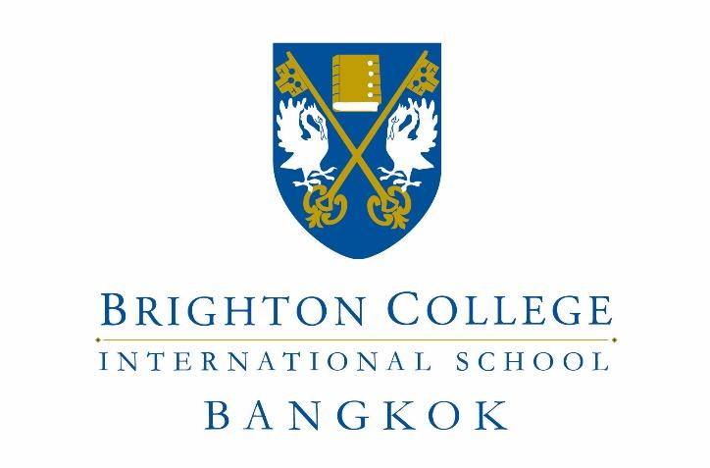

PREP AND SENIOR SCHOOL TEACHER
Job Description

For August 2018

INTRODUCTION
Brighton College Bangkok is a dynamic and exciting school looking for enthusiastic and passionate teachers. This is a unique opportunity to join an exceptional and hard working team with the united goal of ensuring that every child reaches their potential both academically and socially, by pushing boundaries and broadening horizons.

BRIGHTON COLLEGE BANGKOK
Brighton College opened its first sister school in Bangkok, one of South East Asia’s most vibrant and successful capital cities, in September 2016. Situated on an iconic and purpose-built 20-acre campus in central Bangkok. It is comprised of a Pre-Prep School (for 500 pupils aged 2 to 8), a Prep School (for 600 pupils aged 8 to 13) and a Senior School (for 400 pupils aged 13 to 18), with a pupil capacity of 1,500. It aspires to become one of Asia’s leading schools.

Brighton College Bangkok’s spectacular, state of the art campus includes a specialist Performing Arts Centre, a large Sports Centre with IOC approved swimming pools and an IOC 400m running track, as well as innovative and dynamic Learning Resource Centres which run through and link all areas of the College.

Brighton College Bangkok delivers the Brighton College curriculum leading to IGCSEs and A-levels. Its pupils will aspire to the leading universities of the world, including Oxbridge and the US Ivy League. The College is a member of COBIS and in due course, the College will seek accreditation from the ISC, and Membership of the HMC and IAPS.

Brighton College Bangkok benefits from its partnership with Brighton College, the UK’s top co-educational school, and with Brighton College Abu Dhabi and Brighton College Al Ain - its two sister schools in the Middle East. The Brighton family of schools currently educates more than 4,000 pupils.

THE PREP AND SENIOR SCHOOLS

The Headmaster now wishes to recruit experienced, well-qualified and inspirational subject teachers to teach in the Prep and Senior Schools – upper Key Stage 2, Key Stage 3, ISEB 13+ Common Entrance and IGCSE, with A Level from September 2019.

The Prep School will have a capacity for 600 pupils aged 9 to 13, in Years 4 to 8.

The Senior School will have a capacity for 400 pupils aged 13 to 18, in Years 9 to 13.

Personal Skills
- Enthusiastic and passionate about education with a sound understanding of UK best practice
- Flexible and adaptable to the varied demands of working in a world-class school environment
- Proactive in all aspects of College life
- Able to work independently and collaboratively as part of a team
- Creative and innovative across and beyond the curriculum
- Able to work successfully under pressure, with excellent organisational skills
- Reliable and respectful
- Able to demonstrate a positive and proactive attitude towards participation in professional development and the College’s induction and appraisal processes
- Able to present a professional image in line with the high expectations of Brighton College
- A talented communicator, orally and in writing
- A confident and competent user of IT in the classroom and for administrative purposes

Duties and Responsibilities
- To be an ambassador of the College at all times, in school and in Thailand
- To teach and carry out other professional duties as required by the Head, and actively support the Co-Curricular programme

Teaching and Learning
- To encourage all pupils to reach their academic potential through enthusiastic and personalised teaching, tailored challenge, rigorous record keeping and follow up
- To be aware of, and comply with, all the College policies including those for marking and assessment, teaching and learning and reporting
- To develop and share schemes of work and resources, using in-house formats
- To assist with covering colleagues as required
- To attend all meetings and INSET as required
- To prepare, invigilate and assess, as required, internal and external tests and examinations

Pastoral
- To work within a House team as a Tutor in a specified year group
- To show an active interest in each child’s personal and domestic circumstances, and to foster the personal and social developments of each pupil in your care
- To actively promote the social, moral and cultural ethos of the College community
- To create an atmosphere of support by being aware of, and fully compliant with, all the College Policies, including the Code of Conduct, the School Rules, and the Anti-bullying Policy
- To be familiar with all the College’s policies on Health and Safety and be proactive in ensuring the safety of all members of the College community at all times
- To promote exemplary behaviour and a responsible attitude amongst pupils
- To be aware of and act upon all policies regarding the safeguarding of children

Professional Responsibilities
- To promote pride in the College among the pupil body through high standards of dress behaviour and commitment
- To ensure that all communication is acted upon appropriately and in a timely manner
- To attend Parents’ Evenings, Assemblies and other school events during term time as the Head may from time to time require
- To be responsible for all College resources, particularly those in your care, reporting damage or loss to the appropriate authority within the College
- To contribute to the virtual learning environment, the website, social media and publications in support of your work
- To contribute to the College’s Self Evaluation and Development Plan
- To foster a close partnership with parents, initiating contact in appropriate circumstances and ensuring that there is a record of this
- To carry out any reasonable professional request made by the Headmaster or Head of School

Formal Qualifications/Experience

- A good UK Honours Degree (or equivalent)
- A certified teaching qualification (i.e. Qualified Teacher Status)
- A distinguished record of teaching
- A strong record of professional development
- Working knowledge of the National Curriculum, ISEB, GCSE/IGCSE and A Level/IB Diploma, as appropriate
- At least two years of teaching experience

Remuneration

- A competitive salary
- A relocation allowance
- Accommodation allowance
- 100% remission of school fees at BCB for two children, subject to the usual standards and procedures for admission
- Medical insurance for the post holder and his or her children and dependent spouse
- Return flights to point of origin for the post-holder and his or her family

Applications

To apply, please send the following to Mr David Tongue, the Head Master of Brighton College Bangkok, at applications@brightoncollege.ac.th

- An application letter, addressed to the Head Master, of no more than one and a half sides, outlining your strengths and stating why you wish to be considered for the role; Applicants should state their curriculum strengths and extra-curricular interests.
- Your CV, including contact details of three referees, one of whom must be your current or most recent employer;
- A completed Teaching Staff Application form, which is here

The College reserves the right to appoint candidates prior to the closing date and so early applications are advantageous.

Brighton College Bangkok is committed to safeguarding and promoting the welfare of children and young people and expects all staff and volunteers to share this commitment. Should your application be successful, a disclosure will be requested from the UK’s Disclosure and Barring Service for British nationals; local police checks will be undertaken for successful applicants of other nationalities.

