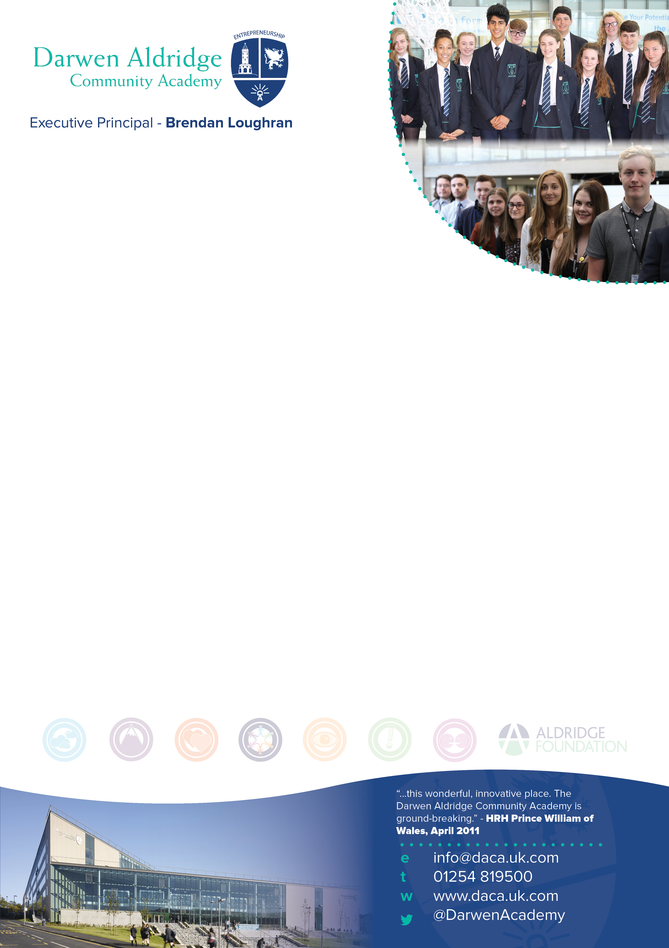

Academy Principal – Lisa Dolan

TEACHER OF ENGLISH
Salary: MPS

Information for applicants
Required January 2018

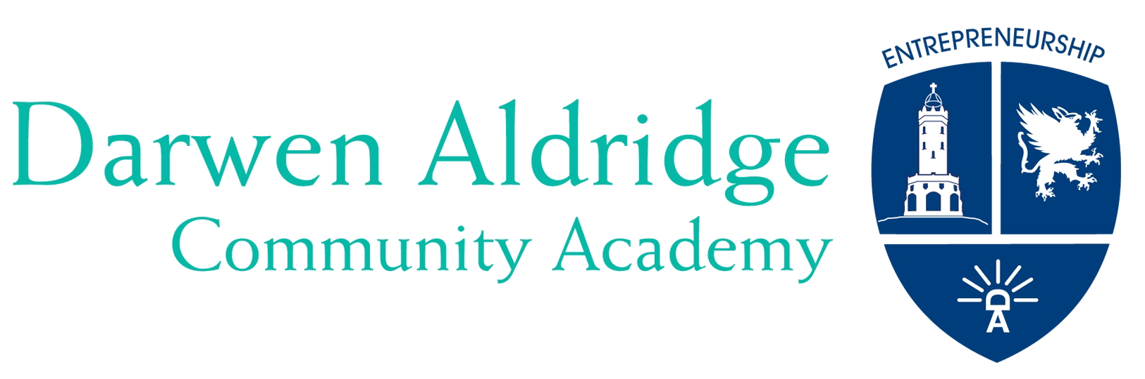
October 2017

Dear Colleague,

Thank you for expressing an interest in the post of Teacher of English at Darwen Aldridge Community Academy. Darwen Aldridge Community Academy opened in 2008 as an original sponsored Academy. It has been the catalyst to the transformation of educational provision in Darwen, a town of around 40,000 people. In May 2017 the Academy was again judged to be a good school in every respect, and we are determined to see the Academy judged as an outstanding school in due course as we continue to improve outcomes. In September 2015, for the first time, the Academy was oversubscribed with the number of first preferences exceeding the 240 places available in Year 7. In 2016, for the second consecutive year, were again significantly oversubscribed in Year 7 and we are in the same position in September 2017. Upon opening, the Academy Sixth Form was the only post-16 provision in the town of Darwen, and we now work alongside our 14-18 partner, Darwen Aldridge Enterprise Studio School, who provide a complementary Key Stage 5 curriculum. Currently there are 260 students and it is anticipated that the Sixth Form will grow to 400 learners.

Since the Academy opened, GCSE exam results have continued to improve year-on-year. In 2013 the Academy was recognised by the SSAT as the 7th most improved school in the country in terms of GCSE results. Year-on-year, around two-thirds of the Year 11 cohort progress into the Sixth Form. During this time English results have continued to improve, as have as those making the expected, and above, levels progress. To build on the popularity of the faculty’s post-16 subjects, and a growth in the number of students attending DACA, we are looking for an exceptional teacher who is deeply committed to raising progress and standards. Applications are sought from both newly qualified and experienced teachers who have the flexibility to offer teaching across the age, ability and subject range. Teaching is likely to include Key Stage 3 and GCSE, and post-16 may be available for a suitably qualified / experienced candidate. The Academy runs a comprehensive induction programme and staff are supported by weekly professional development opportunities throughout the year.
We seek to develop a passion for learning as well as an enterprising spirit, and encourage our students to recognise the potential that they have, and then to fulfil that potential. Potential applicants will find useful details about the Academy and MAT at http://www.daca.uk.com, and our sponsor Sir Rod Aldridge at www.aldridgefoundation.com/site/web/home.html. Our sponsor is a keen supporter of engaging young people in entrepreneurial education and raising their aspirations. In 2015, DACA was named the best UK school in Europe for entrepreneurial education and received the award from JA Europe at the European Parliament in Brussels. We operate as a northwest based cluster which is one part of a single national MAT, Aldridge Education. The cluster and the MAT are growing, creating opportunities for new partnerships and school to school support and learning.

Please find enclosed with this letter;
General information about the Academy
A job description for the post
A person specification for the post
An application form

I hope that this information will encourage you to apply for this key post. The closing date for applications is noon on Friday 20th October 2017 with interviews to be held the following week. If you do apply for the above position and have not heard anything within one week of the closing date, you can assume that you have not been short-listed on this occasion.

The Academy is committed to safeguarding and promoting the welfare of children and young people. References will be taken up for all shortlisted applicants, and successful candidates will be subject to satisfactory enhanced disclosure from the Disclosure and Barring Service.

Yours faithfully,
Lisa Dolan
Academy Principal

Darwen Aldridge Community Academy Information

The Academy opened in September 2008, and moved into a new state-of-the-art building adjacent to the town centre in September 2010. Its stunning facilities include state of the art classrooms and open learning environments, an entrepreneurship centre, a dedicated Sports Centre with 21st century gym equipment, a MUGA and an all-weather pitch. The building has been designed to meet the needs of our 21st century learners and our local community and businesses.

The Sponsor
The sponsor of the Academy is Sir Rod Aldridge, providing funding through his charitable trust, and on-going support through the Aldridge Foundation. The Aldridge Foundation brings extensive expertise from the public and private sectors to support this project.

The Multi Academy Trust
The MAT is a single national MAT, Aldridge Education. We operate in cluster across the country and we are the lead in the north-west cluster. Our plans are for growth of the MAT and cluster, so this is an exciting time to join us.

Sponsored Academies
Sponsored Academies are secondary schools aiming to break the cycle of under-achievement in areas of social and economic deprivation. Academies bring together innovative approaches to teaching and learning with state-of-the-art technology and surroundings. A defining feature of an Academy is its specialisms. Our first specialism is entrepreneurship which has been a real and dynamic part of Academy life from the moment we opened. The second specialism for the Academy is Sport, which has prominence in our Sixth Form through our sports academies.

Entrepreneurship
Entrepreneurship is the main specialism for the Academy. To us, entrepreneurship means:
Developing a positive attitude and a determination to succeed
Developing the highest standards in the teaching and learning of business and enterprise
Providing opportunities for young people to learn about and become involved in social entrepreneurship
Developing strong partnerships with a range of other education organisations
Developing strong partnerships with adult learning providers and the business community

Through our specialisms, the Academy will instil in young people a determination to succeed, to achieve high expectations and to become more responsible for the world within which they are growing up. An imaginative and innovative curriculum has been developed at the Academy. The timetable combines an offer of academic and vocational courses to ensure that the needs of all students are met. The design of the Academy reflects a curriculum structure where lessons are within extended morning and afternoon learning sessions, with additional extra-curricular sessions beyond the traditional school day. Our most recent Ofsted inspection in May 2017 achieved the grading of ‘Good’ under the new framework.

The Academy is committed to working in partnership with other organisations to support the development of provision, care and achievement for 14-19 year olds. The Academy is part of the Aldridge Multi Academy Trust and in collaboration with the Aldridge Foundation it was successful in its application to sponsor a Studio School based in Darwen. In addition, in the north-west cluster, our partner schools in the MAT are Darwen Vale High School, Sudell Primary School and we co-sponsor the MediaCity UK UTC at Salford.

We hope that this information motivates you to apply for this position. You will probably recognise that we are in the process of raising standards and embedding the Academy ethos, and this is a great opportunity to make a contribution to an exciting project and to be involved in shaping the future educational provision in the town.

The English Faculty

The English Faculty strives to be at the heart of a vibrant curriculum at DACA. Our aim is simple and relevant: we have high expectations and want all students to become an outstanding reader, writer and speaker of Standard English. We aim to equip all students with the communication skills that are needed in an ever changing, technologically diverse world. Through a range of exciting learning contexts they will be equipped with the foundations for GCSE, A-level and future entrepreneurial success. Our students enjoy academic success and the challenge of learning. They become experts in articulating their developing thoughts about a diverse range of texts.

Since the Academy opened standards of attainment and progress have continued to rise. In 2017, 75% of our A Level English Literature students achieved grades A*-B, all of whom have successfully gone onto study English at university, and the percentage of GCSE English students achieving grade 4+ was above the national average. Our priority now is to develop strategies which move us towards 100% success rates, including those for SEND and Gifted, Able and Talented students

There are currently thirteen full and three part time teaching staff who teach across the full age and ability range. There is HLTA and TA assistance, supporting additional literacy and reading as well as learning in the classroom. The Faculty has a suite of rooms across the third floor of the north wing of our new building. These are equipped with short throw interactive projectors, wireless access, high quality resources, and access to laptops. The Faculty has reviewed and re-written schemes of work and lesson plans which take full advantage of the longer learning sessions and the Academy specialism. A key feature of lessons in the English Faculty is an exciting and innovative approach to learning and teaching. Staff work collaboratively and creatively, use of ICT is widespread and teachers are encouraged to take risks and try something new. Results in external exams have been improving year-on-year. GCSE English results are consistently higher than the national average and there is nothing average about the approach we take in preparing students for success. Our OFSTED report of February 2013 stated, ‘Most students make good progress from their starting points, including in English and mathematics.’

But success does not stop at GCSE English. We offer English Literature and English Language and Literature at A-level; the number of students that opt for such a challenging subject is growing year on year. We believe that this is because we work hard to provide all students with the challenge and support that they require in order to thrive. And thrive they do! Beyond English the faculty also offers both Film and Media Studies at GCSE, BTEC and A-level. We have a dedicated media suite with outstanding Mac facilities. We even have a green screen to allow students the opportunity to fully realise their media productions. As you would expect such facilities, alongside our passion for working creatively, means that this is a popular subject area. Students have left our faculty to study both media and English to degree level. They are able to do this in the knowledge that we have taken the time to stretch, develop and inspire them. We really do push all students to realise their potential.

We are looking to appoint an English teacher who can inspire students, work as part of our team and contribute to the development of the English Faculty as a whole. A willingness to remain calm and the ability to retain a sense of humour are always a bonus. Obviously, we want someone with a passion for English and this is more important than the length time you may have currently spent in the profession. You will, of course, find your time with us rewarding and satisfying.

Jennifer Tipping
Director of Learning for the English Faculty

Darwen Aldridge Community Academy
Job description –Teacher of English MPS

You are to carry out the professional duties of a school teacher as set out in the current School Teachers’ Pay and Conditions Document, as well as in accordance with the Teachers’ Standards.

All colleagues are expected to demonstrate a wholehearted commitment to the development of the Faculty and a willingness to assist the Faculty Director of Learning in preparing for, and adapting to, the changing needs of the Faculty.

Your primary role is to assist in the delivery of English and to maintain standards of literacy, oracy, reading, writing and communication.

You will model the entrepreneurial traits of having a determination to succeed and a positive attitude in all aspects of your work. You will endeavour to instil these attitudes in colleagues and students. You will be sincere in the belief that no barrier can prevent a student from achieving.

PURPOSE OF POST:
To teach a core timetable of English at Key Stages 3 and 4, and Key Stage 5 (where available) across the ability range of the Academy, delivering agreed Schemes of Work, and to carry out the duties of a classroom teacher.
As part of an on-going review of monitoring of student progress, you have three core roles within the faculty:
Evaluating and reflecting upon the standards of students’ levels of attainment and progress.
The teaching and learning of students in your care.
Contributing to sustainable improvement by achieving those targets for improvement set by the head of the faculty.

Judging standards
You will work with the Director of Learning for English to make secure judgements about the standards of students’ attainment, rates of progress and personal development within your classes, on the basis of evidence gathered from:
- Analysis and interpretation of data on students’ attainment.
- Reviews with your Director of Learning of your assessments of progress for classes, identified groups and individual students.

Teaching and learning
You are accountable for the quality of teaching and learning within your classroom. You will need to understand what makes effective teaching in your subject area.
As a classroom teacher you are to carry out the day to day duties which include:
- using knowledge of academy policy, plan, deliver, evaluate and assess lessons differentiated to meet the needs of individuals and groups promoting progression, continuity and quality of learning;
- use a variety of suitable teaching and learning styles and clearly communicate learning objectives and expectations;
- take every opportunity in all academy activities to raise standards of literacy, numeracy, ICT and other key skills to give students access to all curriculum areas as well as enabling them to become lifetime learners;
- using relevant classroom management strategies to ensure a purposeful environment for teaching and learning to take place;
- using agreed procedures for assessing, recording and reporting on progress and attainment of students;
- preparing students for internal and external tests and examinations informing and using whole-school data to raise expectation and standards of achievement;
- setting and effectively marking homework;
- working as a team member, planning co-operatively, sharing information, ideas and expertise;
- playing an active part in school meetings and working groups.

Sustainable improvement
You will need to ensure that the review, construction and resourcing of your lessons bring about improvements.
- You will agree targets for raising students’ attainment in the classes you teach.
- You will work with other subject and Faculty staff in the development of the new Programmes of Study, Schemes of Work and lesson plans for the Academy lesson delivery structure in preparation for the new qualifications at Key Stages 4 and 5, as well as the Key Stage 3 curriculum reforms.

General Duties
- You will work in accordance with current health and safety requirements: Governing Body, DfE, and Government policies.
- You will abide by the Conditions of Employment set out in the relevant paragraphs of the School Teachers’ Pay and Conditions document in operation at the time when you are carrying out your duties.
- You will carry out any other duties relevant to your post designated by Senior Staff and Director of Learning.
- To participate in induction and / or Teacher Appraisal arrangements.
- To take an active part in the pastoral care and discipline of students within your classes and set appropriate sanctions as set out in Academy policies.
- To carry out the role of Form Tutor, according to the Academy policy.
- To carry out a share of supervisory duties in accordance with the duty rota schedules.

Relationships
- You are responsible to the Principal or Vice Principal as delegated.
- You are responsible to the Director of Learning and Assistant Director of Learning and faculty staff working within the faculty.

Additional Note
The above represents a broad outline of the duties and responsibilities currently attached to the post of English teacher. Depending on the needs of the Academy, these may be altered from time to time in accordance with the conditions set out in the currently operating School Teachers’ Pay and Conditions Document and the relevant Governors’ Policy Documents.

Darwen Aldridge Community Academy
Person Specification – Teacher of English
s
 | Essential | Desirable | Evidenced by
Experience | Relevant teaching experience 11-16  Recent experience of delivering consistently good and outstanding lessons | Recent, relevant teaching experience 11-18  Recent experience as a form tutor | Application form  Interview
Qualifications | Qualified Teacher Status  Suitable qualification for the subject required | Higher degree or advanced qualification  A commitment to pursuing further qualifications | Application form
Professional Development | Evidence of responsibility for own professional development  An understanding of the reformed GCSE qualifications | Recent, relevant in-service training in current educational practice related to developments in English | Application form  Interview
Skills and abilities | Evidence of successful teaching which is consistently good or better  Excellent ICT and pedagogical skills  Excellent classroom management skills  Knowledge and use of a range of appropriate teaching and learning styles including strategies for differentiation  Enthusiastic and creative approaches to teaching and learning which maximise students’ abilities  Able to develop others’ capabilities and help them realise their full potential  Effective organisational skills and the ability to meet deadlines  Ability and willingness to work effectively in a team, planning co-operatively, sharing information, ideas and expertise  Proven ability to transfer enthusiasm and understanding of English to students | Proven ability to inspire and motivate young people to achieve high standards  The ability to create and maintain a teaching environment which promotes effective learning and strives for achievement and excellence  Ability and willingness to initiate and participate in both cross curricular and extra-curricular activities, as well as demonstrating successful involvement in all aspects of Academy life  Evidence of excellent student achievement  A broad knowledge of relevant curriculum areas and current national initiatives including a sound understanding of assessment and monitoring | Application form  Interview  References  Lesson  observation
Other | Commitment to the safeguarding and welfare of students  Commitment to the aims and values of the Academy and its specialism.  Commitment to academic excellence and high standards  Presentational skills, confidence and fluency to deal with students, parents and others  Awareness, understanding and commitment to inclusion and equal opportunities  An understanding of the needs of young people  Capacity to work hard with all students  Energetic, positive and cheerful attitude  Is a strong role model for staff and students including having  excellent attendance and punctuality | A good sense of humour, able to work under pressure and the ability to keep things in perspective  Has the potential for further promotion | Interview  Lesson  observation

