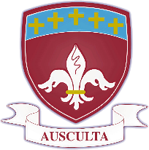St. Joseph’s Catholic High School

*Business & Enterprise College*

*Living, Loving & Learning Through Christ*

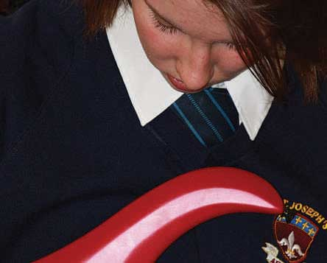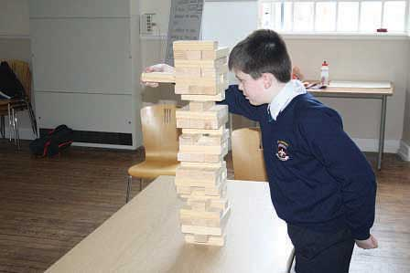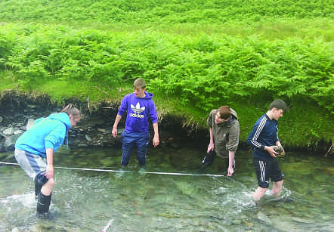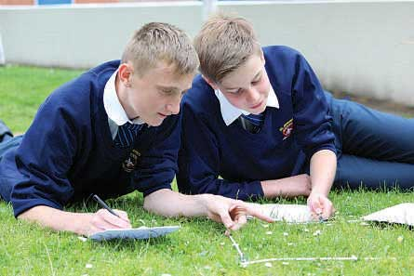

Teacher

of

Modern Foreign Languages

St Joseph’s Catholic High School - serving the community

• Judged ‘Good’ in their recent Ofsted

• Improved GCSE results

• Improved A* As

• Excellent Pastoral Care

Harrington Road, Workington CA14 3EE. 01900 873290

www.st-josephs.cumbria.sch.u



**St Joseph’s Catholic High School**

**Business & Enterprise College**

**Harrington Road, Workington, Cumbria CA144 EE**

**NOR 697 11-16 school**

**Full time Teacher of MFL (Spanish and French) for September 2018**

**M1- UPS3**

We are seeking to appoint an outstanding teacher of Spanish and French to join our modern foreign languages department. The position will be suitable for either a newly qualified or a more experienced teacher. The successful candidate will be expected to teach KS3 and KS4 Spanish as well as some KS3 French. You should be an enthusiastic, passionate teacher of Spanish and French, who is committed to the highest standards for our students.

The post holder will join a successful area of the school curriculum which is led by an experienced and capable Head of Department/Faculty Leader. We have a very well-resourced department and you will be based in a teaching room equipped with an interactive board.

St Joseph’s is a Good school. We offer a very supportive staff community. We have dedicated CPD and/or department time on a weekly basis. We ensure dedicated planning and preparation time by allocating more than the 10% normally afforded to staff.

Our students are well behaved and well-mannered and the school’s progress is improving at a fast rate.

The person appointed will have:

• A commitment to the Catholic ethos of the school

• High standards and expectations

• Highly developed inter personal skills

• A commitment to teamwork

• A positive outlook

If you would like more information about this post or wish to visit our school, please telephone Sybil Worsley, Business Manager on 01900 873290. Applications to be returned to Julie Gaffney at the school address. Miss Kennedy, our Headteacher is available to talk to prospective candidates.

**Closing date, noon 21st March 2018**

The school is committed to safer recruitment procedures.

Applicants are subject to an enhanced DBS. This is not an equal opportunities school but we subscribe to the North West Diocese Equal Opportunities policy.

March 2018

Dear Candidates,

Thank you for expressing an interest in our school. We hope you find the information that we have provided useful.

We would be very pleased to arrange visits from prospective candidates or respond to calls if you require more information.

We look forward to hearing from you in due course.

Best wishes,



Jacky Kennedy

Headteacher

# ST. JOSEPH’S CATHOLIC HIGH SCHOOL

Our Language department has two well equipped and an office used by the languages staff.

All of our Year 7 and 8 students study French. In addition, Spanish is introduced in Year 8 to students in Sets 1 and 2. Healthy numbers opt for GCSE French and Spanish at the end of Year 8 and we have a 3-year KS4 which allows us the time to thoroughly prepare our students for GCSE. You will be solely responsible for the successful delivery of the Spanish GCSE course. The department currently offers the AQA Spanish GCSE course.

The extra-curricular activities for the language department include students from Year 7 going to France for a few nights on an annual basis. Key stage 4 students have had an opportunity to go on a joint language/business trip to either Paris or Barcelona.

Results – A*-C

|  |  |  |  |
| --- | --- | --- | --- |
|  | **2017** | **2016** | **2015** |
| **French** | 57.7% | 60% | 62.5% |
| **Spanish** | 53.3% | 50% | n/a |
| **German** | n/a | n/a | 53.3% |

|  |  |  |
| --- | --- | --- |
| **Person Specification** | | |
|  | **Essential** | **Desirable** |
| **Qualifications/ training/ competencies** | Qualified teacher status | Evidence of participation in professional development or further study |
| Relevant qualification in subject area (degree) | Practising Catholic |
| Teaching qualification (PGCE/Cert Ed) |  |
| **Relevant experience** | Outstanding teaching ability | Experience of dealing with a wide range of students and responding to their needs |
| Experience of effective team working and promoting effective relationships | Understanding and experience of exam board procedures and administration |
| Ability to use IT in teaching and administrative duties | Experience of teaching to A level |
| Ability to teach across the ability range in Key Stage 3 and 4 |  |
| **Knowledge** | Knowledge and understanding of equality and diversity issues |  |
| Knowledge and understanding of different teaching strategies and ability to apply these appropriately |
| **Skills** | Excellent communication skills |  |
| Student focused |
| Flexible approach |
| Ability to manage time effectively and meet deadlines |
| Ability to demonstrate patience and understanding with learners |
| **Personal Qualities** | Commitment to actively supporting the school’s distinctive ethos |  |
| Ability to work as part of a team |
| Ambition and the capacity for hard work |
| Energy and imagination |
| A talent for motivating students across a range of abilities |
| Good organisational skills |
| Determination to achieve the very best result for every student |

**Staff development/ Career development**

We are part of the Western Lakes Teaching Schools Alliance and are continuing to build on the already strong links with other schools in the area. We have dedicated time after school on a Thursday for CPD/Department meetings. This time is used for whole school training, sharing best practice and work in departments.

The development of our staff is of the highest importance and it is a strong feature of our school and many staff have benefitted from internal promotions over the years. Career development is one of our school’s priorities in the school improvement plan 2017/2018 and we will be working with each member of staff to identify where they want to be in their stage of their careers and finding opportunities to gain experience receive mentoring and training to help the individual achieve their goals.

**Business and Enterprise:**

The school became a Business and Enterprise College in 2003 and we were re- designated as high performing as part of our Ofsted inspection in March 2009. We were awarded the ‘Centre for Excellence in Enterprise Education’ by the University of Warwick in May 2011. We were one of the first schools to receive this award in Cumbria.

Our Business and Enterprise is delivered through the curriculum where possible; as part of our Pupil Personal Development Days and as one-off Enterprise activity days. We celebrate National Enterprise week in November through form activities; Careers talks at breakfast and lunch time; extra-curricular events after school.

We have developed many partnerships with local business and commerce that help us out with events and in curriculum areas throughout the year. We hold a work ready day with mock interviews for Year 10 pupils.

A member of the Senior Team has taken a lead role in working with the Cumbria Enterprise Learning Partnership covering Enterprise Education from 4-19. This involved working with business commerce, Secondary, Primary School and FE Colleges. We delivered training programmes and shared best throughout to schools and Colleges throughout Cumbria. This work is on-going but in a slightly different format.

Students take part in a number of external competitions throughout the year.

# Conditions of Service

The above responsibilities are subject to the general duties and responsibilities contained in the statement of Conditions of Employment.

These duties may be amended as necessary at the discretion of the Headteacher in light of the future development of the school.

The creation of a truly Christian environment in which the Gospel is lived and experienced by all members of its community, is the central aim of St Joseph’s. All applicants are expected to be supportive of this central aim.

# Features of West Cumbria

The School is situated at the western fringe of the Lake District National Park.

Many staff choose to live locally and enjoy a rural lifestyle in towns such as Cockermouth, Keswick and the villages in West Cumbria.

Housing and rented accommodation are generally readily available at prices which are lower than urban and city locations.

The school exhibits all the advantages of a smaller comprehensive school. Children are known by name by all, standards of discipline and the quality of staff pupil relationships is excellent.

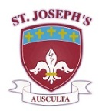Our School Mission Statement

AT ST. JOSEPH’S CATHOLIC HIGH SCHOOL

WE WILL CHALLENGE YOU TO AIM HIGH, WE EXPECT YOU TO SUCCEED

LIVING LOVING LEARNING

All members of the school community – pupils, staff, governors and parents – will be united in sharing a common purpose: to achieve their personal best, to pursue lifelong learning, to develop and model respect for themselves and others and lay a significant role in the life of the local community; and they will be able to articulate this common purpose and support each other to achieve these goals.

LIVING LOVING LEARNING

Our School will be characterised by positive, appropriate, productive and warm relationships all of which are at the heart of our faith. We will encourage all members of the community to reflect on and develop their relationships with each other to promote tolerance and understanding.

LIVING LOVING LEARNING

All members of the school community will strive to achieve excellence – their personal best in all areas of school life; academically, in extra-curricular activities and through their embodiment of positive attitudes and qualities.

*Living, Loving and Learning through Christ*