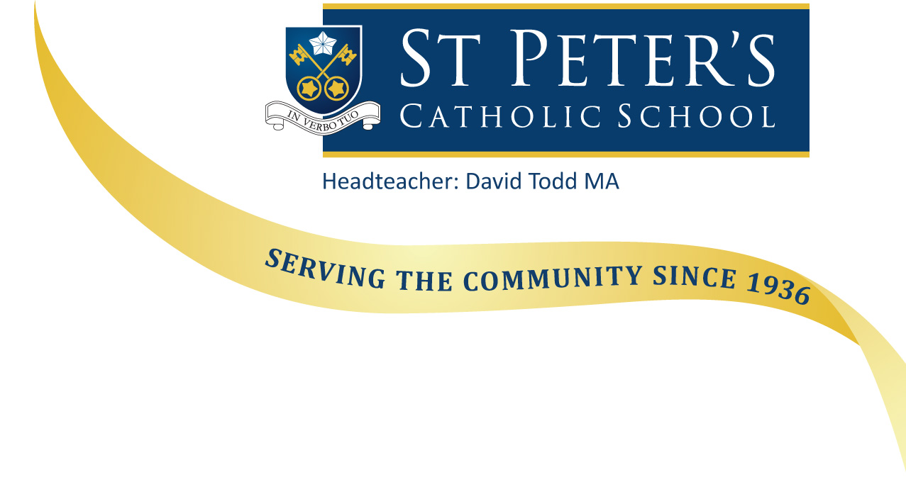

December 2017

Dear Applicant

Re: - Head of Primary Phase

Thank you for your request for information regarding this recently advertised post. I hope you find the information on our website useful. If you have any queries, please do not hesitate to contact the school.

St Peter’s Catholic School has a strong tradition and reputation in the local area. We are oversubscribed at both the primary and secondary points of entry. We are a Catholic school with a strong Christian ethos which underpins all we do. We are also an Academy jointly sponsored by the Catholic Diocese of Portsmouth and the De La Salle Order – an international organisation which has been running schools for over 300 years.

The secondary building and classrooms have been refurbished to provide superb primary accommodation, including a break area for each year group, a hall and a gym and extensive grounds.

Our facilities provide the potential for a developing an exciting and innovative curriculum, we require Phase Leader with the vision and determination to make it happen.

Relationships with families are extremely positive and constructive; parents and carers are keen to support the school and their children’s learning. We are not a complacent community; all staff are keen to learn and improve, developing pedagogy through research, shared practice and innovation.

If you believe you have:
- the vision and intellect to create the best possible combination of innovative curriculum and exemplary pedagogy…
- the determination and strategic thinking to plan and deliver the best education for our young people…
- and the spirituality and relational qualities to further develop our Catholic learning community…
then please apply for this role.

The closing date for applications is midnight Sunday 14th January 2018. We anticipate that interviews will take place on Thursday 1st February and Friday 2nd February 2018. If you do not receive a telephone call from us inviting you for an interview, please assume that on this occasion your application was not successful. Whatever the decision, however, I would like to thank you for your interest in St Peter’s School.

I look forward to receiving your application.

Yours sincerely
Mr D J Todd
Headteacher

