Martin High School

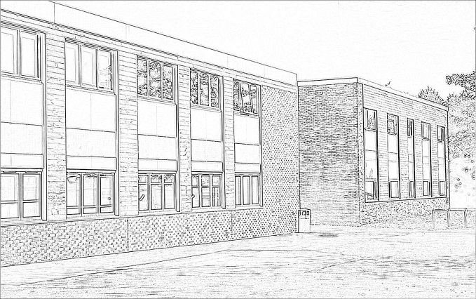

JOB DESCRIPTION

TEACHER OF MATHEMATICS

Link Road, Anstey, Leicestershire. LE7 7EB
Tel: (0116) 2363291
Fax: (0116) 2352121
Email: office@martin.leics.sch.uk
Website: www.martinhigh.org

Head Teacher: Mrs Laura Sanchez
Deputy Head Teacher: Mr Paul Wicken

January 2018

Mathematics at Martin High School

The Mathematics Department is a vibrant, forward thinking department, driven by a desire to make maths accessible to all.

At Martin High School we believe all learners have the right to be successful. The teaching in every lesson needs to reflect our high expectations of all learners; with no excuses and challenge academically for all.

A separate block has recently been built for Mathematics and English, meaning that all teachers have their own, well-proportioned classroom and a dedicated break out area; alongside ICT provision.

The department consists of six teachers, in addition to a graduate mentor who is able to withdraw learners from lessons to carry out more targeted intervention work. The team work tirelessly to ensure our learners make good progress and understand why maths is so relevant in everyday life.

The school has recently become a partner school of the Further Mathematics Support Programme and as a result is heavily involved in CPD, hosting events and attending trips.

Pupils are taught in ability based sets in Key Stage 3 and Key Stage 4 with regular assessment and progress checks; so students move groups when appropriate.

We look forward to welcoming an enthusiastic and passionate Mathematics teacher who is determined to change the lives of our students.

Martin High School is committed to safeguarding and promoting the welfare of children and young people/vulnerable adults and expects all adults to share this commitment.

All posts within MHS are exempted under the Rehabilitation of Offenders Act 1974, and as such, appointments to these posts will be conditional upon the receipt of a satisfactory response to a check of police records via the Disclosure and Barring Service (DBS).

All duties and responsibilities must be carried out with regard to the school’s Health and Safety Policy.

Duties which include the processing of any personal data must be undertaken within the corporate data protection guidelines.

Martin High School

PERSONNEL SPECIFICATION

TEACHER OF MATHEMATICS

The Personnel Specification outlines the essential and desirable qualities concerning the person we are seeking for this post.

Essential | Desirable
- Mathematics as the main subject at degree level  - Professional teaching qualification  - Experience of teaching at Key Stage 3 and Key Stage 4  - An understanding of national curriculum, KS3 and KS4 GCSE Mathematics and numeracy  - Developmental/creative mind – a good team contributor  - Excellent knowledge of pedagogy – an effective practitioner who will inspire the confidence and trust of the team  - An innovator with a passion for Mathematics  - An interest in personal and professional development  - An outstanding teaching practitioner  - Demonstrate a versatile approach to teaching strategies  - Working knowledge of ICT and how it can be used to analyse and track attainment  - Sensitive to pupils’ needs  - Strong developing educational philosophy  - Commitment to pastoral tutoring  - An interest in the broader education of students through extra-curricular enrichment activities  - Strong interpersonal skills – a high standard of written and spoken English | - An understanding of how Mathematics relates to other National Curriculum areas  - Evidence of curriculum, classroom materials which you have developed  - Teaching practice/experience to reflect this  - Evidence to support this

