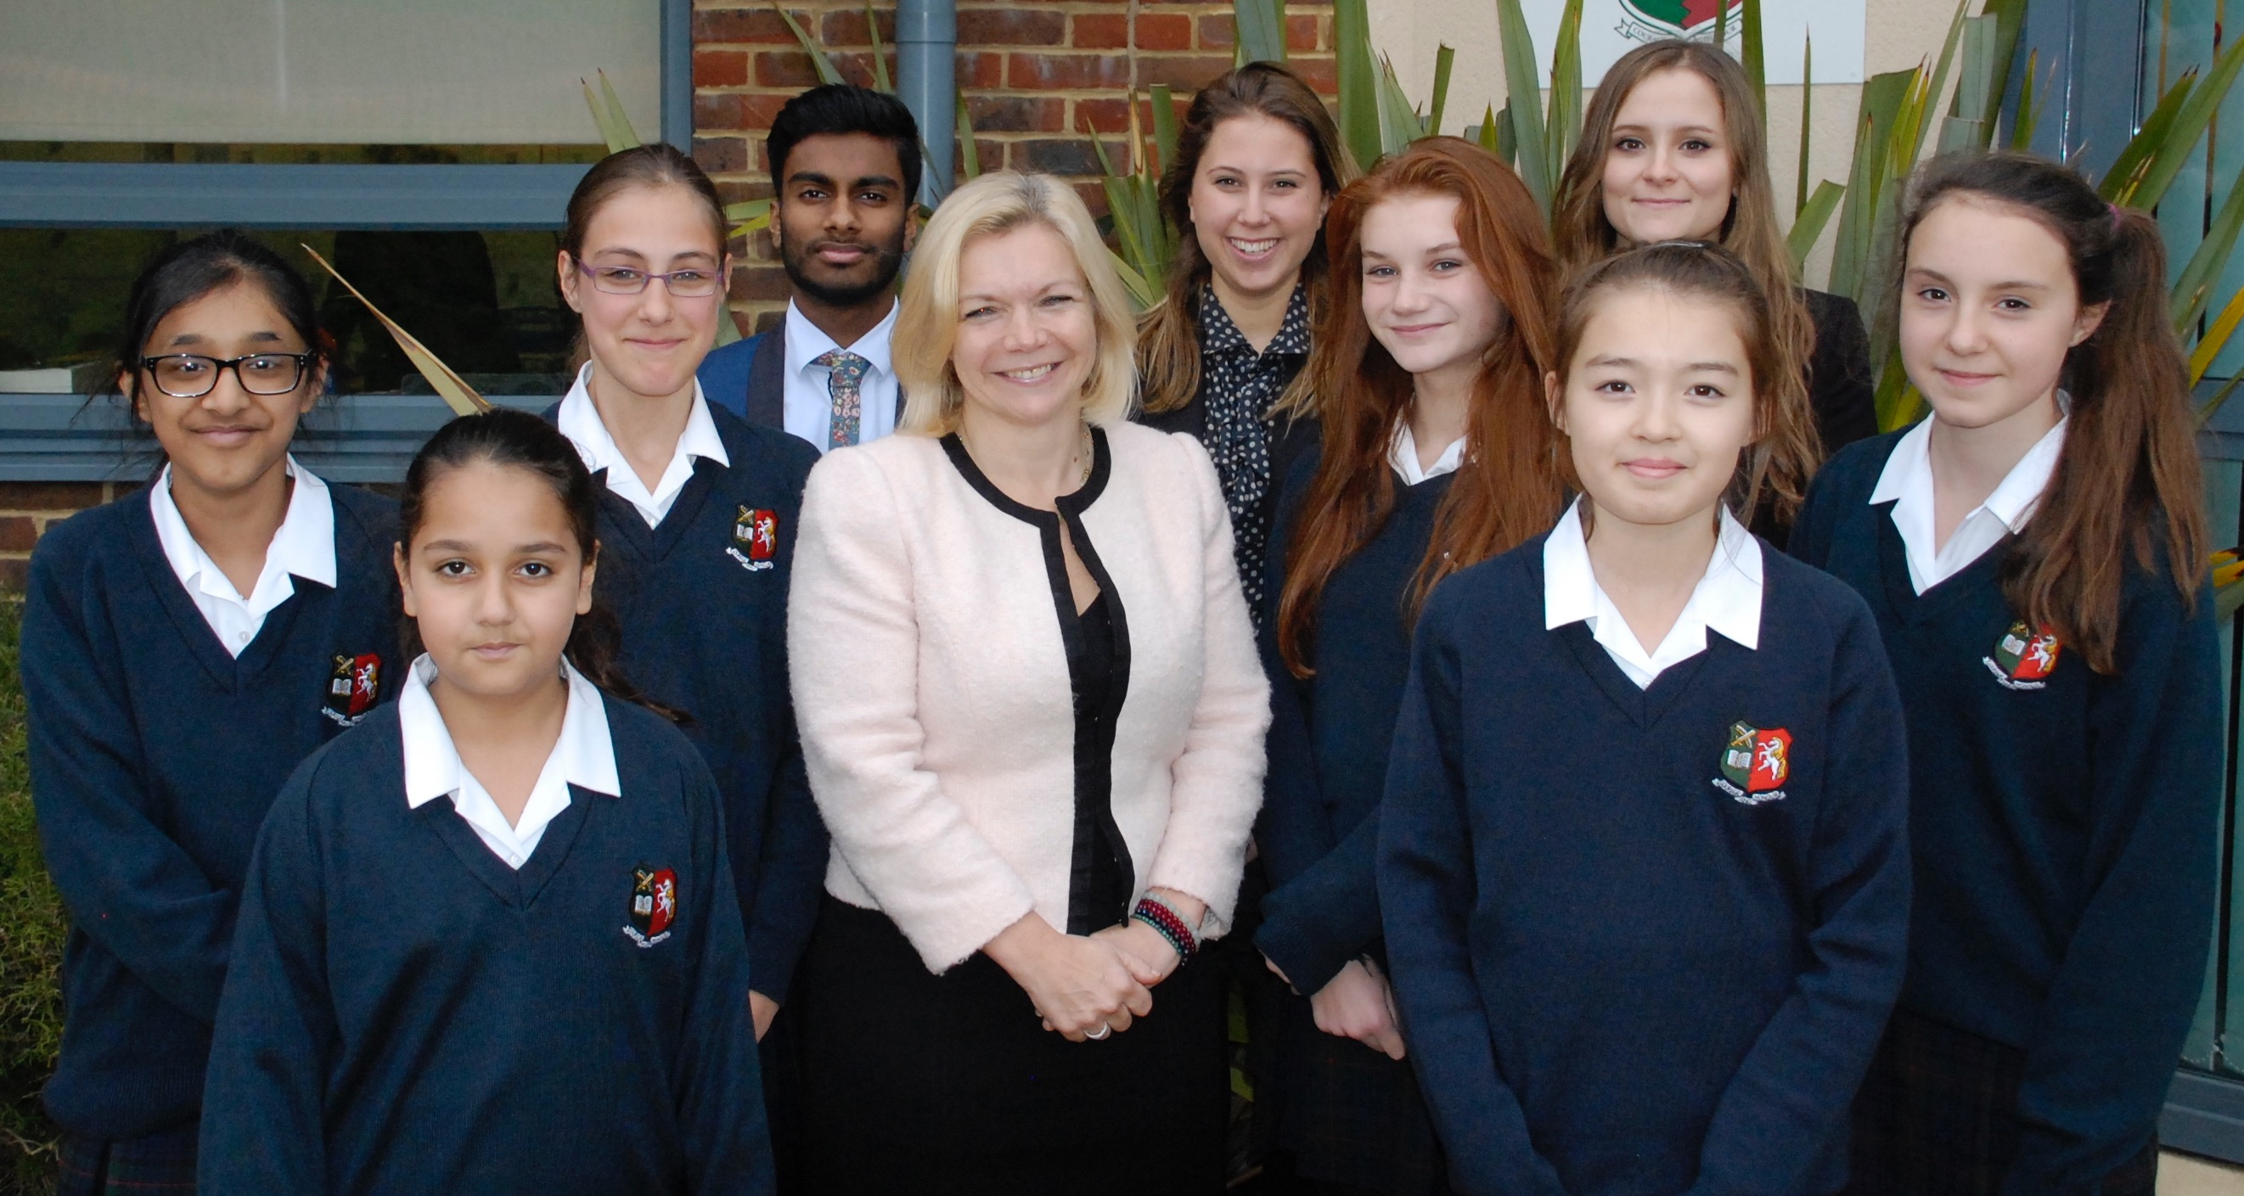

Tonbridge Grammar School

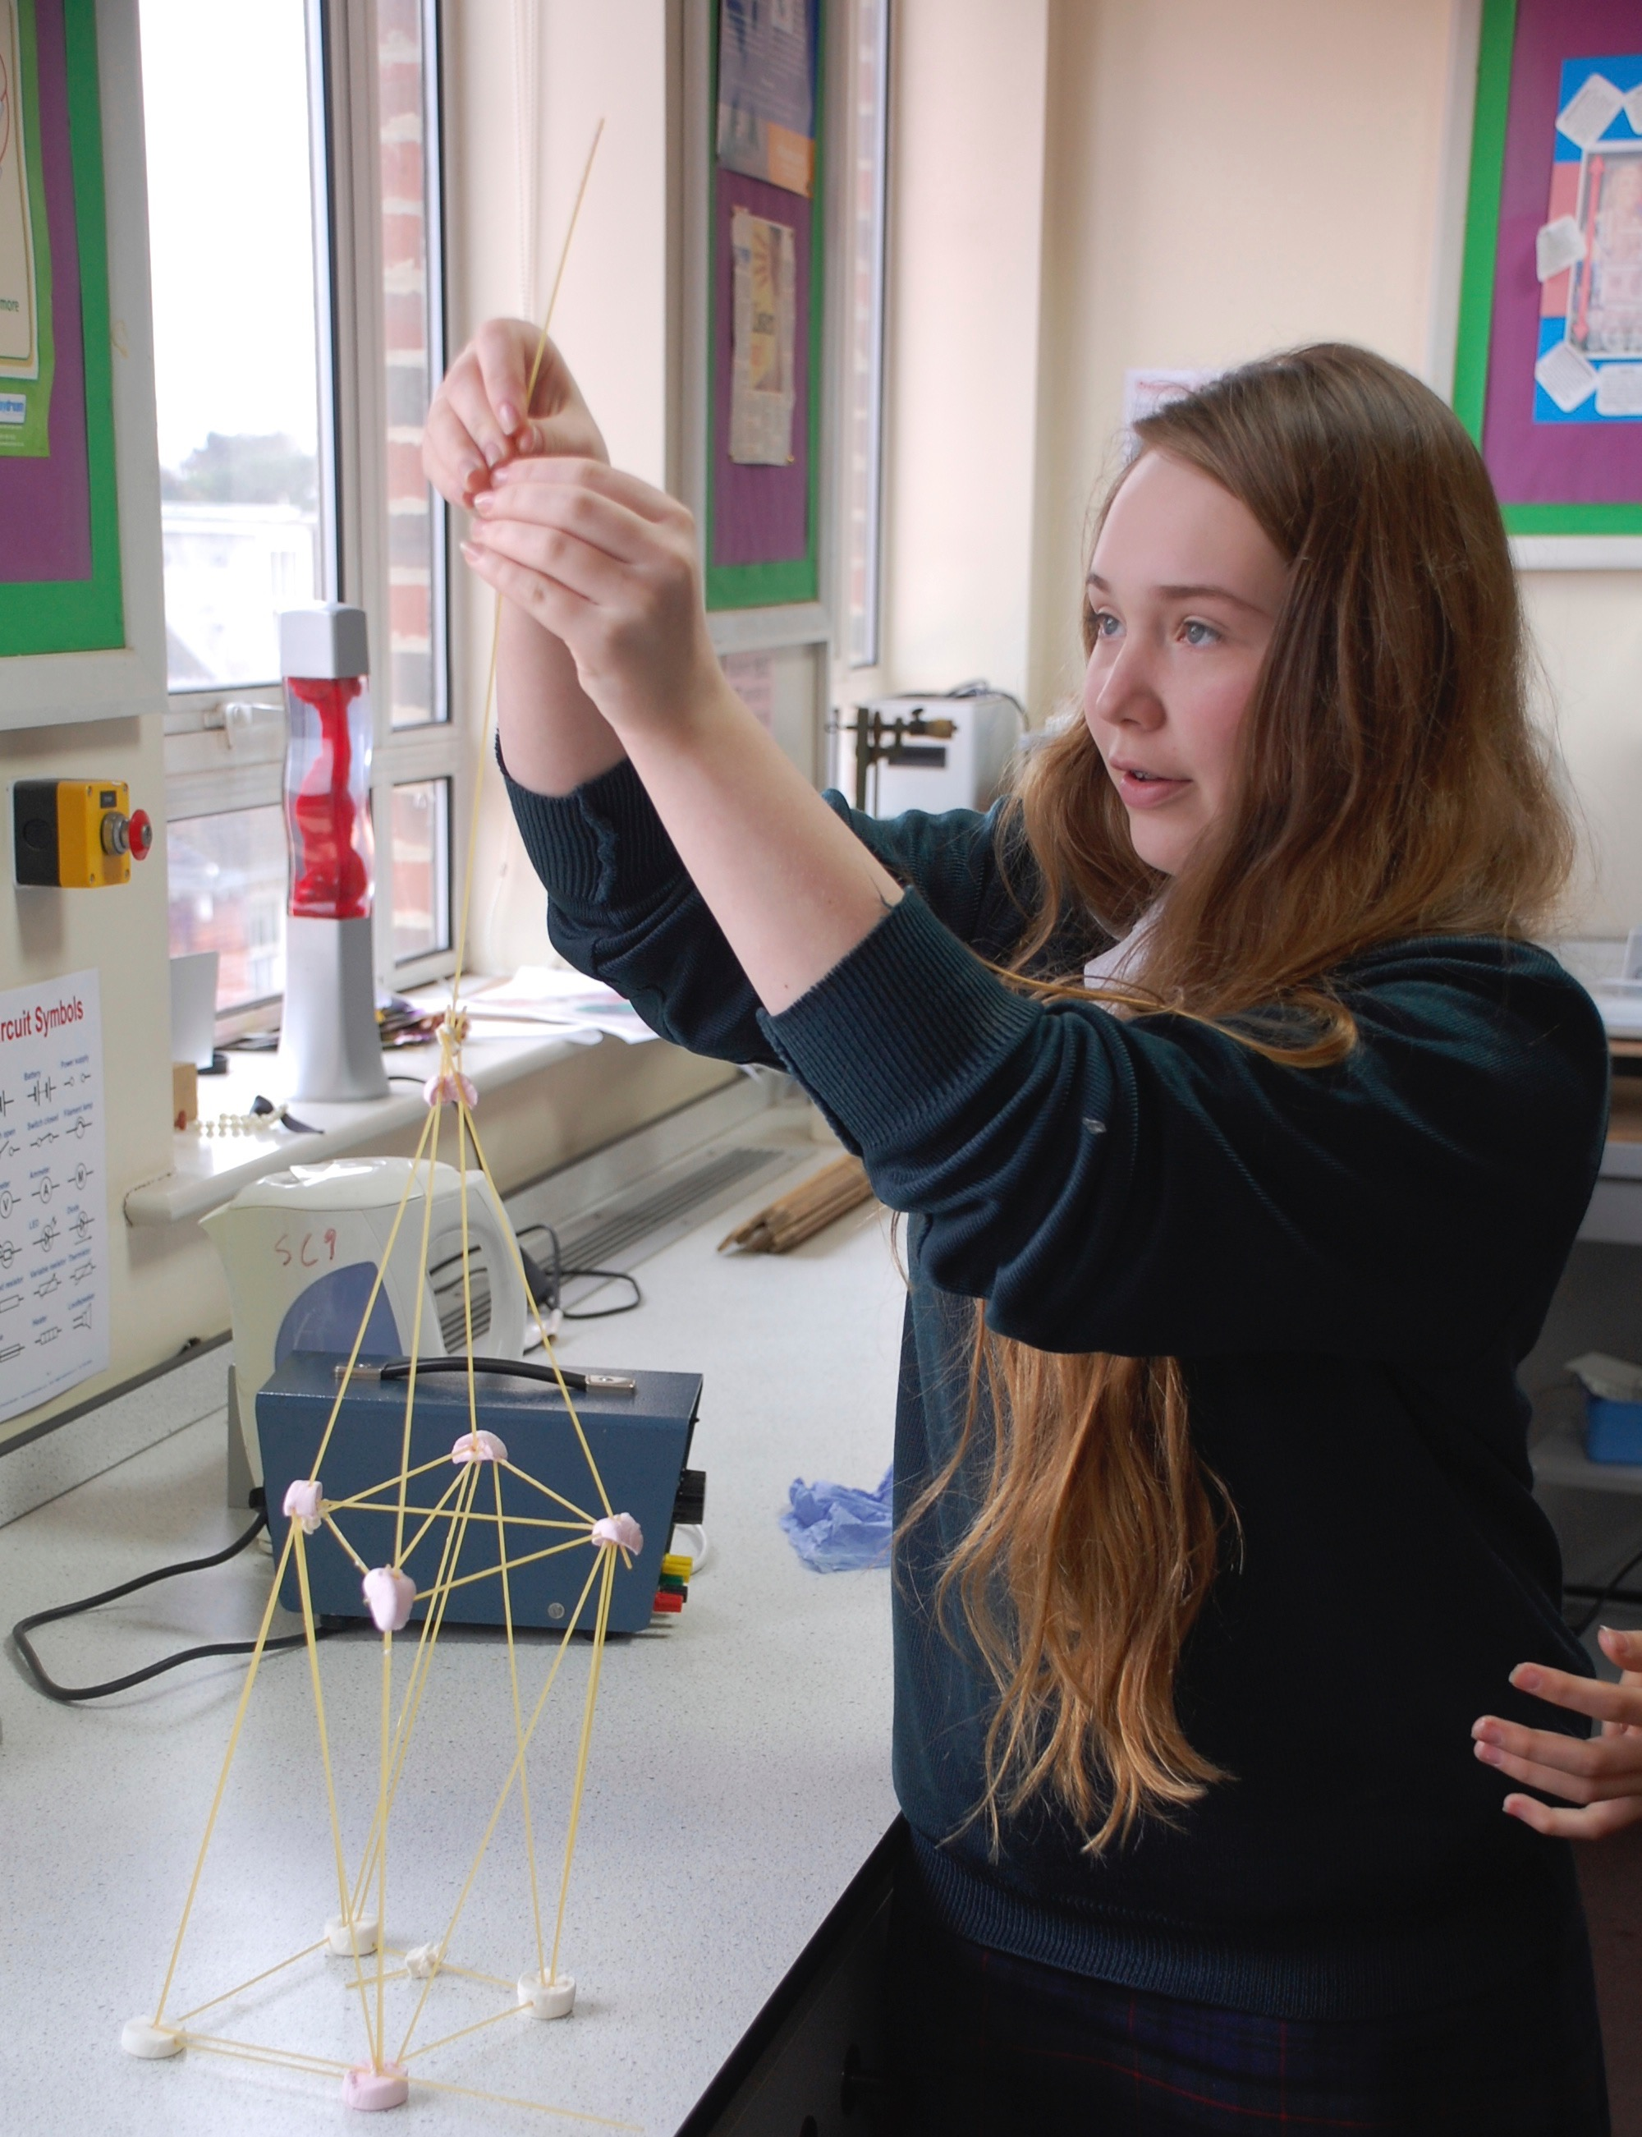

Information Pack: School Nurse

Welcome from the Head Teacher

Thank you for showing an interest in Tonbridge Grammar School. This post provides an exciting opportunity to work at a highly successful, creative and innovative school.
Tonbridge Grammar School is a successful and heavily oversubscribed selective school located in the busy commuter town of Tonbridge in Kent. We have an excellent academic reputation and are very proud of the academic success of our students. Our success, however, is built on far more than academic achievement. We are passionate about developing our students as inquisitive and independent learners. We seek to inspire our students to develop the skills and habits of mind to enable them develop as articulate and confident young people, able to take the best advantage of life. We are committed to offering a broad and enriching curricular and extra-curricular experience for our students including opportunities for leadership and community service locally and internationally.
Tonbridge Grammar School is an IBO World School and our ethos and values are closely aligned to those of the International Baccalaureate Organisation with its focus on intercultural awareness, holistic learning and communication.
As an ‘outstanding’ school we converted to an Academy on 1st January 2011. Tonbridge Grammar School continues to retain its tradition and distinctive ethos including our selective arrangements. We have a track record of successful collaboration with other schools and partnership working with the wider community of schools through our outreach work and as part of the Kaizen Teaching School Alliance.

Tonbridge grammar school
There is collegiality amongst the staff at Tonbridge Grammar School which creates a working environment that is intellectually stimulating and highly rewarding. There are first class professional development opportunities available to staff at all stages of their career including a full programme of development and support for those new to education.
I hope that after reading this information and finding out more about the school through the information on our website you wish to apply for the advertised post. In accordance with our safe recruitment policy, to be considered for a position you must complete the Tonbridge Grammar School application form. Please ensure that you provide evidence within your application that you have the skills and experience necessary for this particular position. The post is subject to a full enhanced Disclosure and Barring Service (DBS) check.
I look forward to receiving your application.
Rosemary Joyce
Head Teacher
Our Wellbeing Strategy
Tonbridge Grammar School is rightly known for outstanding examination outcomes, but truly excellent education is about more than academic achievement alone. It is about developing a passion for life, for learning and a capacity for independent thinking and emotional growth. Our nurturing approach helps students to acquire self-confidence without arrogance, develop moral values, and to discover genuine interests that extend beyond the classroom.

Pastoral Care and the support for well-being at Tonbridge Grammar School is not something that happens when things go wrong; it happens every second of the day. Relationships between our students and staff are warm and mutually respectful; and our parents tells us that this is a major reason for the School’s success. Our staff really believe in every young person and encourage a growth mindset – believing that everything is possible if you give it a go, and if you don’t succeed the first time, your mistakes and setbacks become a constructive learning experience in themselves.

Every student has a Learning Mentor and as well as wider support from School Leaders and Curriculum Directors who oversee the curriculum and student progress, there are three non-teaching Student Advisors led by an experienced Director of Student support. This exceptional team take the time to really get to know the students and their individual needs and strengths. They devote boundless energy and expertise to developing, encouraging and advising students.

In Years 7-8 we have a vertical tutoring system. This is where students from each year group form a learning community. In addition, our house system fosters an immensely powerful and strong sense of community amongst our young people and the vertical structure within the houses and across all year groups means that students of all ages integrate with one another and older students can share their experiences and help and support the younger ones.

We are experienced in supporting students in their seven year journey from the very first day at school. Each and every child is important to us. We value and understand their unique personalities, interests and contributions – and seek to develop their character through our proactive and forward-thinking well-being strategy.

The outstanding level of support for an individual’s well-being offered at our School places the student at the very heart of our decision making, acknowledging that every child is unique with individual needs, feelings, strengths, opportunities, limitations, circumstances, and expectations.

An example of the proactive nature of our wellbeing strategy is the opportunity we provide for all students to learn mindfulness - building techniques to develop emotional awareness and to manage emotions so that they can meet challenges, thrive and flourish in all aspects of life as they grow into adulthood.

An example of how we work together with students is the creation of our unique homework charter. This followed a well-being survey in which students made suggestions about how we set our homework. The main features are: not setting homework for the next day - allowing students to balance enrichment and family commitments; no homework in the holidays; and asking parents to stop their child if their assignments are taking too long, and to communicate this to us. The aim of the homework charter is therefore to support not just student, but also family wellbeing.
Our well-being strategy is interwoven throughout everything the students do; the skills learnt enable them to think ahead, to be resilient and resourceful and to develop strategies that they will carry with them long after they have walked out of the school gates.

Welcome from the Director of Student Support

I have been part of the wellbeing team at Tonbridge Grammar School since September 2006 when I started as the first Student Manager (now referred to as Student Advisors). This saw the beginning of the School’s further development plans for student wellbeing and the creation of a dedicated non-teaching wellbeing team. It is currently my pleasure to work with three exceptional and experienced Student Advisors. We work closely supporting the students and their families using a variety of strategies as well as supporting each other. We fully integrate with services and support offered from the wider community and professionals, accessing external help when appropriate.

We have an education programme for our students Health, Social and Emotional Education which the wellbeing team contribute to. We would very much welcome a school nurse to contribute to our preventative educational strategy, whilst providing additional support in response to their needs as they arise.

We are looking forward to welcoming an additional member to the wellbeing team and expanding the variety of support. We foresee the expertise you can bring to our team will enhance our student experience even further.

If you have any questions after reading the job profile, please do not hesitate to contact me.

Mary Hull (BSc PGCE NASENCO)

