YN  head of pe  - To start January 2018  - Full-time  - To teach up to and including GCSE and BTEC level 2  our latest success  - Maccabi Athletics Runners Up  - Inter Faith Games football winners  - GCSE Results 2017 – 89% A*-C  45% A* + A  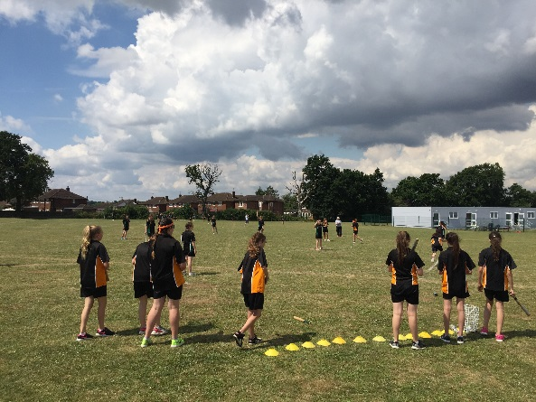  Every lunchtime there are different clubs and activities happening in the PE Department  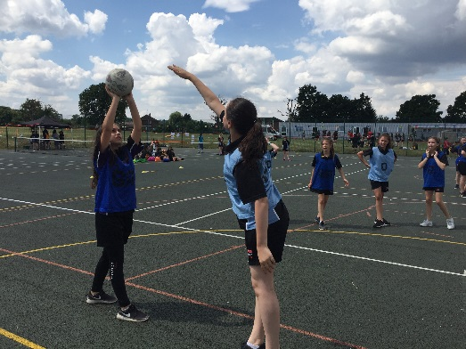  All pupils take part in our annual Sports Day  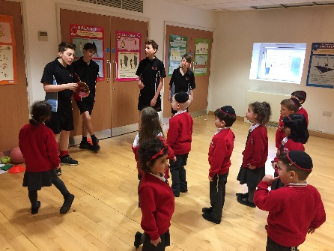  Our Sports Leaders are trained during lessons and enrichment sessions to lead activities with local Primary Schools  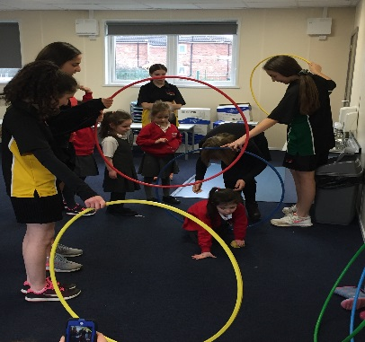 | Yavneh College  PE Department  The p.e Department  Aims of the Department  To provide High Quality Physical Education and Sport which should:  - Enable all students whatever their circumstances or ability, to take part in and enjoy PE and sport.  - Promote young people’s health, safety and well being  - Enable all young people to improve and achieve in line with their age and potential. Through this we aim to ensure our students are committed to PE and sport and make them a central part of their lives both in and out of school.  - Know and understand what they are trying to achieve and how to go about doing it.  - Understand that PE and sport are an important part of a healthy, active lifestyle.  - Have the confidence to get involved in PE and sport.  - Have the skills and control that they need to take part in PE and sport.  - Willingly take part in a range of competitive, creative and challenge-type activities, both as individuals and as part of a team or group.  - Think about what they are doing and make appropriate decisions for themselves.  - Show a desire to improve and achieve in relation to their own abilities.  - Have the stamina, suppleness and strength to keep going.  - Enjoy PE, school and community sport.  PE curriculum  The department is committed to equipping its pupils with the confidence and competence to enable them to make physical activity a central part of their everyday life. It strives to provide a dynamic and broad range of experience for its pupils which they enjoy and can succeed at. The pupils will have the chance to develop creativity, and personal and social skills whilst taking on different roles within the group. We offer a comprehensive extracurricular and enrichment programme which aims to provide varied opportunities for each and every pupil. We take our responsibility of guiding and informing pupils about the value of being healthy and active seriously so that our pupils can make informed decisions. We have, and will continue to develop, appropriate links with local sports clubs and other exercise organisations to facilitate these pathways. The profile of PE in the school is high. There is a positive ethos within school with regards to exercise and sport. The pupils recognise the link and importance of exercise in maintaining a healthy, happy and balanced lifestyle.  The Department provides a broad and balanced Physical Education Curriculum at Key Stage three for all pupils that follows guidelines of the National Curriculum whilst adapting to the individual needs of the pupils. Pupils are taught to:  - Use tactics to overcome opponents in  - Develop technique and improve performance  - Participate in Outdoor and Adventurous Activities  - Creatively explore movements and composition  - Analyse performances and compare  - Take part in competitive sports and activities in and out of school  - Lead healthy, balanced lifestyles  All pupils participate in 55 minutes of practical PE per week at Key Stage 4 in groups that are single sex and set by ability. Pupils gain experience as coaches, leaders and officials. Our overarching aim is to find activities which engage pupils enough for them to become lifelong participators in a variety of sporting roles. Pupils follow a common programme of study. Units of work are based on the National Curriculum. Pupils also have an opportunity at the start of the year to put forward their suggestions for activities that they would enjoy doing in PE.  examination p.e  We offer the GCSE full course and we follow the AQA examining board from Year 9 onwards.  We offer BTEC First Sport Level 1/2 Award from Year 9 onwards  Our most recent results have been outstanding and Examination PE is now a very popular subject.  The STAFF  The Department consists of 2 Males and 3 Females. 1 member of staff is also a Head of Year. The staff within the department are highly motivated and enjoy a great deal of collaborative work. Due to the nature of the subjects, we are often in and out of each other’s lessons. The staff are friendly and supportive and there is an open culture to develop and embrace new ideas. Staff in the department are well respected throughout the school and non-PE staff are often involved in running clubs and teams.  Extra Curricular  There are many extra-curricular activities which take place in the P.E Department. We pride ourselves on an excellent reputation of high levels of commitment and participation in District, Maccabi Schools and School Sports Partnership events in a range of sports.  We offer an extensive range of extra-curricular clubs before school, during lunchtime and after school.  The Department runs inter house competitions which culminates in an annual whole school multi sports and Athletics Sports Day.  Our talented pupils are provided with opportunities through the school to represent District, County and National Teams.  The PE Department is constantly developing links with local clubs and providers to provide opportunities to participate and compete in sports activities out of the school environment  Sports Leadership  We have introduced our own sports leaders enrichment sessions, which give our pupils a taster of the nationally recognised sports leaders program. We offer the Sport leaders programme to some of our Year 10/11pupils and pupils are given the opportunities to gain experience in leadership roles both in and out of school. The role of sports leaders and volunteers in sport can be very rewarding for all involved. It helps to build good citizenship and is therefore committed to developing the ethos of volunteering and the building of collaborative working and leadership skills across the entire school community of staff and pupils. The pupils help run after-school club both at Yavneh and in our feeder schools.  facilities  Our PE facilities are excellent. Our large, modern sports centre comprises a large sports hall, aerobics/dance studio, six changing rooms, showers, PE office, and reception suite. There are 9 acres of playing fields which provide excellent facilities for outdoor lessons in both summer and winter. There are 2 Multi Use Outdoor Games Areas. The department is very well-equipped, to ensure that our teachers and coaches are able to optimise pupils’ experiences in PE and sport.

academic success 2017
In the 2017 GCSE PE examination series, 89% of our pupils achieved A* - C. 45% of our pupils achieved a grade A* or A in GCSE PE.

Join our team
We appreciate the time and effort it takes to complete an application form and therefore thank you for taking the time to apply to Yavneh College.

