HMC Boarding and Day
670 Boys; 275 Sixth Form

Teacher of Religious Studies

Bedford School

Situated just 35 minutes on the train from London St Pancras, and half way between Oxford and Cambridge, Bedford School is one of the region’s leading boarding and day schools, educating boys from the ages of 7 to 18. Part of The Harpur Trust, Bedford’s leading educational and social welfare charity, we’re a vibrant school with a very strong sense of community, set in a beautiful 50-acre estate in the heart of the town.

There are some 694 pupils in the Upper School aged 13 to 18, with approximately 260 in the Sixth Form. 35% of the boys are boarders in our six boarding houses, each of which is “twinned” with a day house. Our Prep School with 400 boys caters for the 7-13 age range on the same campus, and has its own junior Boarding House.

Academic excellence is central to life at Bedford School, and we encourage boys to aspire to the highest possible standards and to exceed their expectations. Our success is demonstrated by a long history of impressive exam results at GCSE, A level, and in the International Baccalaureate Diploma. IB and A Level combined results saw 84% of grades at the equivalent of A* to B in 2017. 61% of GCSE results were at A/A* 2017. The vast majority of our leavers go on to Higher Education, and 78% of our Upper Sixth boys accepted places at Russell Group universities this summer; 10 boys went to Oxbridge in 2017.

The school was inspected in November 2016, and we are particularly proud of the fact that ISI (Independent Schools Inspectorate) gave us the top ratings possible. Full details, including a copy of the inspection report can be found here:
http://www.bedfordschool.org.uk/Inspection-Report

The school adopts a selective entry policy without being ruthless and seeks to provide an environment where all boys will thrive academically. It emphasises continuity of education at 13+ and 16+ so that, although there are academic entry requirements at each point, they are geared to whether boys are suitable to move to the next stage rather than over-formulaic targets. We believe in an all-round education that exposes all boys to a wide range of experiences and opportunities.

We place great emphasis on the value of Sport, Music and the Arts for the camaraderie, teamwork and self-motivation they instil, and encourage boys to explore their individual talents. Our extensive programme of extracurricular activities is wide-ranging and offers boys the opportunity to learn new skills and discover new interests outside the classroom. Boarding is at the heart of the school and all full-time members of staff are expected to contribute to the wider life of the school through involvement in the tutoring system and in activities outside the classroom.

The school’s ongoing development programme has included the construction of a new Library (2003), Observatory & Planetarium (2003), a new Music School (2006) and a wonderful new theatre in St Luke’s Church, on the edge of the estate (2015). Other developments have included renovation of the school dining halls and kitchens (2009), fitness suite (2010), staff common room (2011), sports pavilion (2012) and science department (2015).

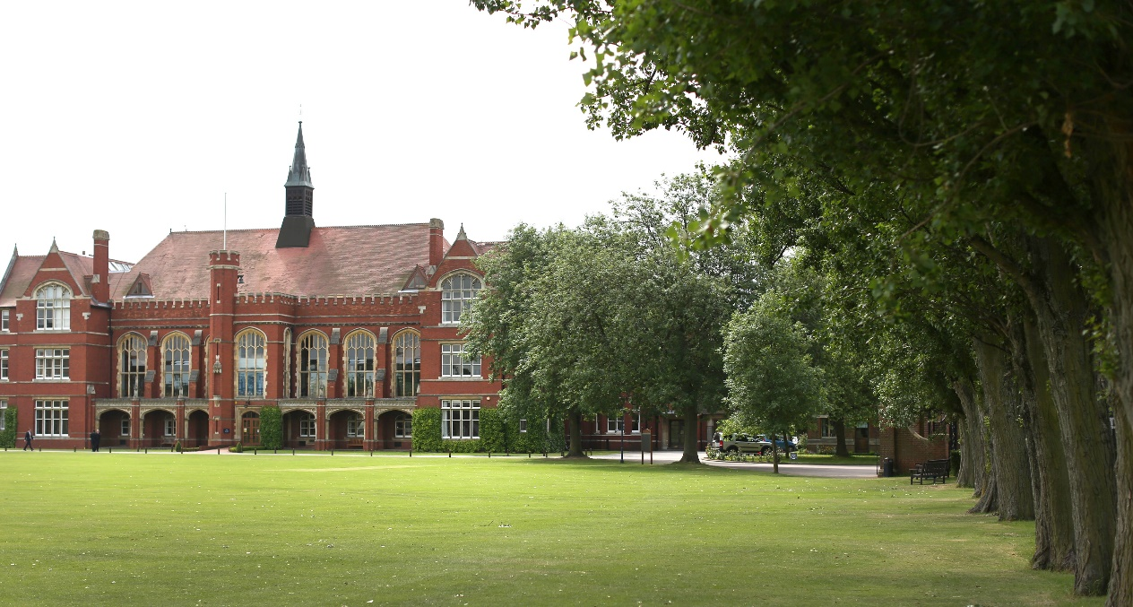

Religious Studies Department

The Religious Studies Department is at the heart of the School, with large numbers of boys choosing to follow examination courses and achieving academic results of the highest quality. It seeks to be a department which is open, caring and friendly, a department which stimulates the interest of boys in religion and ideas regardless of their ability or background. A Level Religious Studies and IB Philosophy are popular choices for Sixth Form students and many students go on to read related subjects at university. There are currently four Religious Studies teachers in the Upper School: the Head of Department, the Chaplain and two other full-time members of staff.

In the Upper School, all boys have two periods a week of religious education in 4th Form (Year 9). These teaching periods are used to begin the OCR GCSE course by studying two sections of the Religion, Philosophy and Ethics paper. These are ‘The Existence of God’ and ‘Religion, Peace and Conflict’. In Remove Form (Year 10) boys may choose to continue studying for a GCSE in Religious Studies, taking papers in Christianity, Judaism, and the final two sections of Religion, Philosophy and Ethics (‘Relationships and Families’ and ‘Dialogue between religious and non-religious beliefs and attitudes’). In the Sixth Form, we follow the OCR A-Level Religious Studies syllabus, with papers in Philosophy of Religion, Religion and Ethics, and Developments in Christian Thought. The Department also teaches Philosophy at Higher and Standard Level as a part of the International Baccalaureate. Students study the Core Theme (‘Being Human’), followed by the Optional Themes of Ethics and Philosophy of Religion; the set text is Mill’s On Liberty and Higher Level candidates will face an unseen text. All Philosophy students will also complete an Internal Assessment. Members of the Department often play a significant role in the delivery of the IB Theory of Knowledge course.

The Religious Studies Department provides a rich and varied learning environment for all pupils. The Department is well-resourced with books and teaching materials and teaching rooms are equipped with a data projector, interactive whiteboard and desktop computer. The Department uses Firefly and has a Twitter feed.

The Department also arranges extension lectures (through the Philosophy and Theology Society) and trips. Past trips have included Sixth Form lecture days and the Holocaust Educational Trust’s Lessons from Auschwitz project. The Art and Religious Studies Departments are currently organising a joint-trip to Berlin that will take place at the end of the summer holidays.

The successful applicant would be required to teach up to A Level/IB and share in teaching groups of varying abilities at all levels and be expected to play a full role in the Department. In recent years, teachers in the Department have gone on to gain Head of Department posts in similar leading independent schools. There are regular departmental meetings and new members of staff are supported in their professional development.

The Role

We wish to appoint a part-time teacher (approx. 50% timetable) from September 2018 or January 2019 who is enthusiastic and well qualified, to join a large, highly successful and thriving department. The successful candidate will have a genuine passion for Religious Studies, Philosophy and the Humanities and a desire to inspire this in others. They will also be eager to develop their own teaching skills and share ideas with colleagues.

We welcome applications from experienced teachers or NQTs from a wide range of backgrounds. We are also equally happy to consider applications from those without professional qualifications in teaching, if they are well qualified in RE (or a related field). Successful candidates in this category would typically be supported by the School to gain QTS in their first year. This is typically achieved through undertaking a PGCE through an Assessment Only (AO) route. We can also offer support through the iPGCE should that be the preferred route for the successful candidate.

Candidates are asked to make their starting date availability clear on the Application Form.

Benefits of Service

Bedford School has high expectations of its staff and therefore looks to reward them with generous salary scale increments and beneficial conditions of service. All teachers are offered membership of the Teachers’ Pension Scheme and have longer holidays than the maintained sector. Class sizes are small (maximum of 14 at Sixth Form and 24 at GCSE) and most teachers have their own classroom. A wide range of opportunities for professional development exist and staff are encouraged to develop their skills and consider career options at all levels. There is ample opportunity to take on additional responsibilities for which there are allowances.

Fee concessions are available across the Harpur Trust schools. A private health care scheme is also available for teaching staff.

Bedford is set in beautiful grounds and staff are welcome to make use of the extensive leisure and sporting facilities (which includes gym, swimming pool, tennis courts, squash courts etc.) for themselves and their immediate family.

All staff enjoy free on-site parking. Lunch (of outstanding quality) and free refreshments are available throughout the day; other meals are available according to staff commitments.

Each member of the teaching staff has a voice on professional matters via the Common Room Chair, and all staff are encouraged to contribute to the Teaching and Learning Group. The ability to join a strong community through a number of social events (Staff Bar, Staff sports leagues etc.) is encouraged.

Bedford is a dynamic and incredibly rewarding place to work with a strong sense of community.

General Information

Full-time teachers at Bedford are expected to:
• Play a full part in the extensive games and activities programme
• Be a Tutor attached to a boarding or day house

Bedford School is committed to safeguarding and promoting the welfare of children and young people and expects all staff to share this commitment. Offers of appointment are subject to satisfactory references and DBS clearance.

Staff are normally expected to find their own accommodation, although there may be some school accommodation available in certain circumstances.

Application Process

Applicants are asked to complete the School Application Form; CVs in place of an Application Form cannot be accepted.

Short-listed candidates will be invited to the school for interview on the advertised date. The selection process will involve a lesson observation and several interviews. Suitable candidates may be interviewed before the closing date and Bedford School reserves the right to withdraw the position if an early appointment is made. Applicants are therefore encouraged to apply early.

The current Head of Department, Mr Matt Bolton, would be happy to talk to prospective applicants; he can be contacted through the School Reception on 01234 362200 or by email mbolton@bedfordschool.org.uk

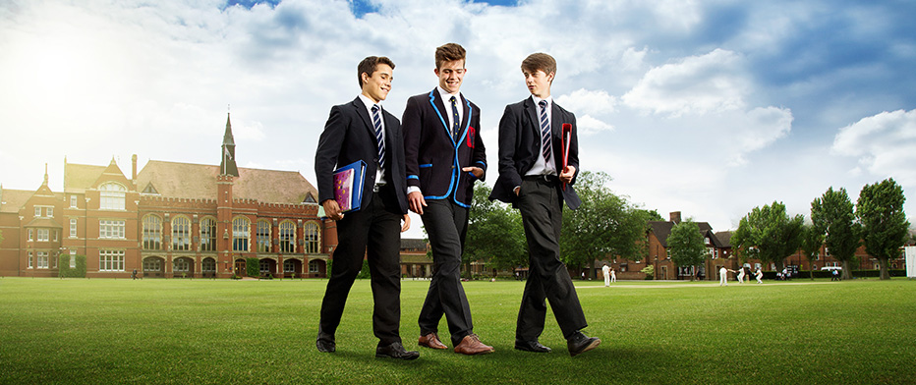
Bedford School is part of The Harpur Trust

