APPOINTMENT PACK

TEACHER OF SCIENCE
MPS/UPS

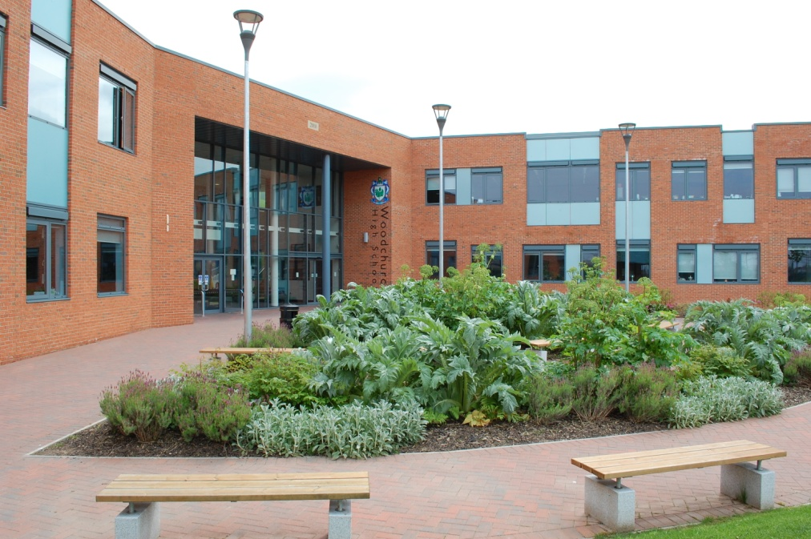

“May God be gracious to us and bless us and make his face to shine on us”
(Psalm 67:1)

THE SCHOOL
Thank you for applying for the post of Teacher of Science at Woodchurch High School.

We are a highly successful independent state funded Church of England Academy, which is co-educational and covers the 11 – 16 age phase, although there are plans to expand to cover Key Stage 5. There are over 1,400 pupils on roll, supported by 117 teaching and 120 support staff, resulting in small class sizes and greater personalised learning.

Woodchurch High School is an extremely popular school, attributable to its ‘Established Excellence’ in every aspect; including leadership and management, pupil progress and attainment. In addition, there is an ordered, disciplined environment, and extremely positive relationship within the school, and with parents / carers and the local community.

At Woodchurch High School, we always place pupils at the centre of all we do and this had been reflected in our last five Ofsted Inspection reports.

Woodchurch High School is a Church of England Academy. We hope to expand to include a sixth form in the near future. The Academy is also in a formal partnership with Liverpool Hope University in recognition of the outstanding work we do in relation to teacher training and teacher education. Consequently school is also a ‘College of Teacher Education.’

In addition, we have achieved numerous external awards in recognition of our outstanding practices (see our website for more information). Nevertheless, we are always seeking ways to constantly build upon our ‘Established Excellence’.

Woochurch High is committed to providing the best possible education for all our pupils and we work in partnership with parents to achieve this goal. “The staff are exceptional and strive to get the best out of our children; the pupils couldn’t have gone to a more supportive school. It motivates and encourages its pupils to success in everything they do and definitely lives up to its outstanding reputation” (‘A typical positive comment from a parent’. Ofsted)

Success in public examinations is important, as these are the qualifications which are required for further and higher education, as well as for employment opportunities. Our results and the improvements we have sustained in recent years reflect our ability to successfully prepare our pupils for the next phase of their lives. Our pupils make excellent progress, regardless of their starting point; they tell the staff that they like their school and are proud to be part of Woodchurch High School.

To ensure that all our pupils succeed, an extensive enrichment programme is provided including a breakfast club and a homework club. There are additional lessons at lunchtime, after school and during holidays.

Pastoral Welfare

For pastoral purposes the school is divided into year groups. In charge of each year group is a Pupil Progress Leader and an Assistant Pupil Progress Leader. The year groups are split into 2 bands, X and Y. Pupils are in mixed gender and ability forms of approximately 22. Each tutor group is registered by the same Form Tutor throughout the 5 years. This continuity ensures that pupils, parents and carers can forge strong links and positive relationships with the key pastoral staff. Within this pastoral system and through further support in lessons, pupils are encouraged to develop their emotional intelligence or SEAL skills.

Pupil Voice

Pupils regularly evaluate lessons and are included in whole-school decisions, such as the appointment of staff. In addition, there is a strong School Council, comprising of representatives from each Year Group. The Head Boy / Head Girl also attend Full Governors meetings, where they make a valuable contribution. Pupils also regularly comment on curriculum subject via online polls/surveys and are posted on the VLE.

In this way pupils are motivated to achieve, self awareness, empathy and can manage their own feelings and have good social skills. In addition, school now also undertakes peer mentoring to further enhance pastoral welfare.

The pastoral support means all pupils have the benefit of the facilities and curriculum of a large school, and at the same time, enjoy the same supportive organisation associated with a small school.

Collective Worship

Each day all pupils take part in collective worship unless withdrawn by their parents. As a school we believe it is important to promote the spiritual, moral, social and cultural
development of our pupils and to prepare them for the opportunities, responsibilities and experiences of adult life.

Behaviour for Learning

We believe an ordered, disciplined atmosphere is the best environment for learning. All our school rules are based upon the simple principles of self-discipline and mutual respect. We place great emphasis on the positive aspects of behaviour by rewarding pupils with praise in lessons, IRIS rewards, letters of commendation and prizes for effort and attainment in all subjects. We also promote good attendance by presenting prizes and certificates to pupils achieving 100%.

We hold an annual Awards’ Evening when pupils are presented with their prizes. This is always an enjoyable evening encompassing the musical and cultural talents of pupils which are shared with parents / carers and the community.

Pupils devised their own code of conduct, putting them at the heart of all we strive to do as a school.

Chaplaincy

As a Church of England Trust Academy, we are affiliated to the Diocese of Chester.

Our Christian ethos makes the school distinctive, as it fosters certain characteristics and aims, which form the basis of daily life and all we do. The Christian values serve to reflect a fully inclusive approach with strong pastoral support for all pupils and staff, good opportunities for reflection, the encouragement of strong personal relationships, respect for all and celebration of diversity within the school family. Work of the Chaplaincy Team underpins all of this work in the school community and beyond.

Inclusion

We are committed to ensuring that every pupil in our care is given an equal opportunity to develop socially, to learn and achieve, and to enjoy community life at Woodchurch High School.

To achieve these aims we:

- Develop strong links with our primary school partners to support transition.
- Deliver a curriculum appropriate to each child’s individual needs.
- Put in place strategies to ensure that all pupils, including those who face barriers to learning and those who are on the Gifted and Talented register make progress.
- Work in partnership with external support services to ensure a total care package is provided.
A Base for Pupils with Autistic Spectrum Disorder

Woodchurch High has special provision for pupils who have Autistic Spectrum Disorder. Our policy is that pupils follow a personalised learning programme combining small group social skills classes with mainstream lessons, if necessary with the help of Teaching Assistants.

Pupil Premium

At Woodchurch High School 44.2% of our pupils access pupil premium funding. The Pupil Premium team lead initiatives through the school and monitor and evaluate the success of programmes and interventions. Please refer to our website for further details.

We look forward to meeting you in the near future.

Yours sincerely

R Phillips

Ms R Phillips
Headteacher

25 Million New Build

Our school building was opened to pupils in September 2010, and officially opened by the Archbishop of York Dr John Sentamu in March 2011.
The new, state of the art faculties enables our pupils to experience a 21st Century education. The cutting edge ICT facilitates their learning so that they can participate, enjoy and achieve their full potential.
The school grounds have also been redeveloped as part of this new build and include a third generation all weather pitch as well as flood-lit multi-use games areas. These facilities are in addition to the recently built Sports Hall. This houses a dance studio, fitness suite and indoor sporting facilities, used for football, badminton, basketball etc.
There is also an established School Farm and environmental area.
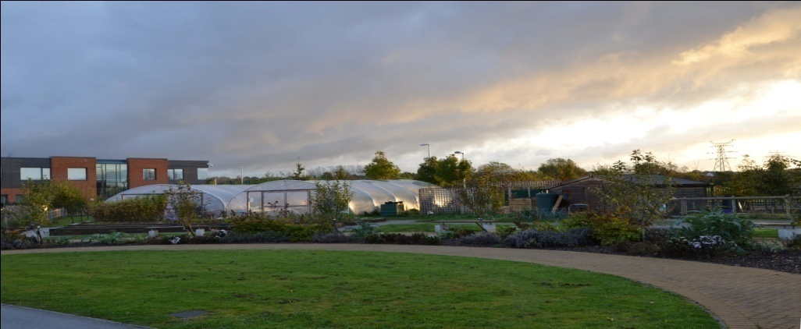

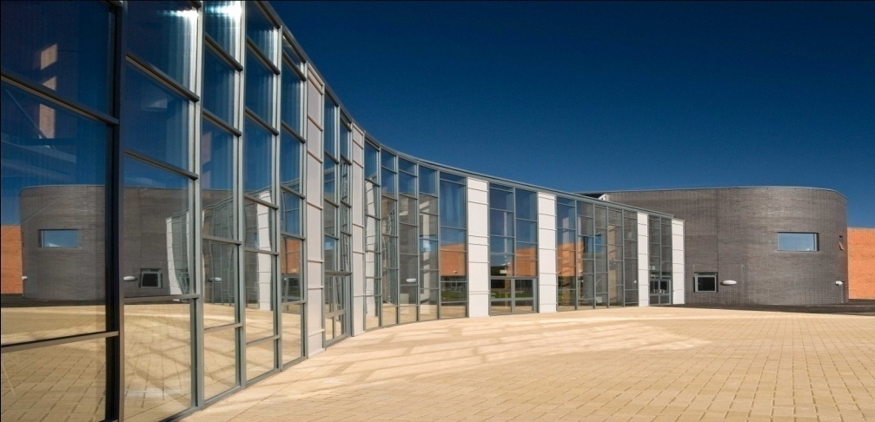
The Role

We are looking for a candidate who can join the Science Curriculum Area and build on our strengths, supporting our continued drive to move Science forward.

We need someone who is a highly effective and a forward thinking practitioner, who is dedicated to raising standards and aspirations for every pupil thus improving life chances.

The post of the Teacher of Science provides a professionally challenging opportunity to contribute to the development of Science, and to be part of a caring, dynamic and strategic learning community.

We are looking for a candidate of the highest calibre who is dynamic and inspiring with excellent communication skills and a commitment to developing Science across the key stages.

In choosing a Teacher of Science we will be looking for a candidate who can also demonstrate:

- Relentless positivity
- Integrity
- Resilience and a willingness to work hard
- Creativity and innovation
- An understanding of the demands of the science curriculum
- A commitment to meeting the needs of all pupils and all ability ranges
- The ability to promote the caring ethos of the school
- Outstanding interpersonal skills
- A commitment to extracurricular activities and community liaison
- The ability to teach Science to an outstanding level

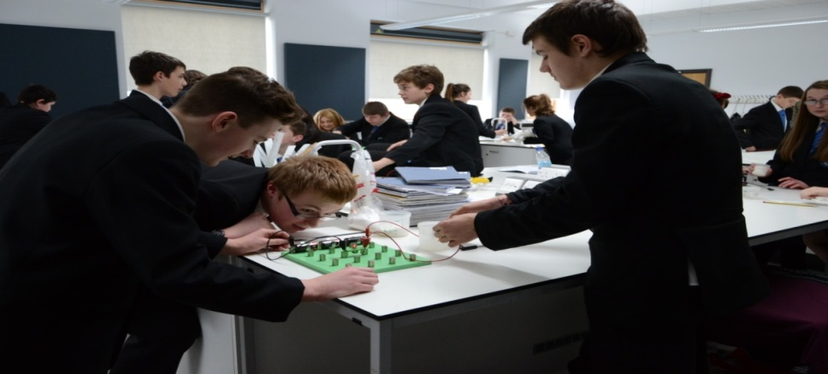

Subject Area

Curriculum, Staffing and Resources

The Science faculty at Woodchurch High School is developing into a successful department. The faculty is constantly seeking to improve and rise to the challenge of an ever changing curriculum. The department offers support with professional development being the hub school for Wirral triple science network of excellence. There is also a strong focus on enrichment, there is a STEM club and organising of trips is encouraged.

At present pupils are able to follow a variety of programmes, including Combined Science Trilogy, Physics, Chemistry, Biology, and BTEC Animal Care.

Key Stage 3 Curriculum

In Year 7 & 8 we teach our own KS3 Scheme of Work which has been developed in house and designed to prepare pupils for GCSE by teaching 6 topics per year. The Scheme of Work has been designed to make science relevant and engaging for our pupils, and has a strong focus on scientific skills. All lessons are delivered through the TEEP model and with reference to Quality First Teaching.

Key Stage 4 Curriculum

In Year 9 pupils start the GCSE Course in Science and for the majority of the time teachers teach within specialism.

The science faculty is staffed by 14 full time teachers, 4 lab technicians and a dedicated science teaching assistant. All teachers are expected to teach the full age and ability range.

The faculty consists of a Curriculum Leader and 2 Assistant Curriculum Leaders.

The faculty is based in an area of 11 Science Labs all of which are equipped with digital projectors. A wide range of resources exist to support student learning with all students giving access to an online textbook. There is excellent service from the lab technicians who work with teaching staff including supporting in practical lessons.

The science staff have their own meeting area and a Science Pod for independent and small group learning activities.

The school farm and environmental area is well established and is a valuable learning resource for science and other curriculum areas throughout the school.

The School website contains information regarding the development of the area and the activities which take place within the school and the wider community.

MAKING YOUR APPLICATION

Please complete the application form provided with this information pack and attach a covering letter which should address the following issues:
- Your ability to communicate with pupils, in an inclusive school environment, in a way which promotes their academic spiritual and social development, and their personal welfare.
- Your understanding of the role of tracking/monitoring systems to identify pupils’ academic progress.
- Describe how your teaching and learning strategies have both motivated and raised the achievement of students across a range of abilities.

Please email your application to: recruitment@woodchurch-high.wirral.sch.uk

Deadline for completed applications: 26th March 2018 at 1.00 pm

If you would like to discuss your application, please contact: Mr R Wheadon, Curriculum Leader Science
WheadonRST@woodchurch-high.wirral.sch.uk

Please arrange for a hard copy to be forwarded to:

Mrs A Williams
Personnel Officer
Woodchurch High School
Carr Bridge Road
Woodchurch
Wirral CH49 7NG



