

**Job Description and Personal Specification for KS2 Teacher**

**2018**

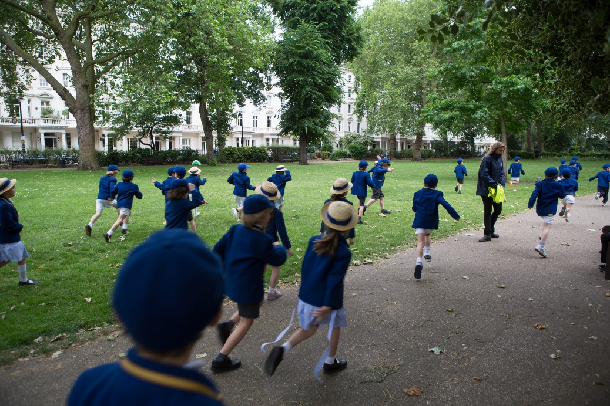

Eaton Square School is a well-established IAPS independent, co-educational Nursery, Pre-Preparatory and Preparatory school in the heart of central London, educating children from the age of 2 ½ to 11 years of age. Offering continuity of education in the important formative years of a child's life, the school is a vibrant, popular community where children learn not only the skills, but also the values that will prepare them for the next stage of their life at senior school and beyond.

The School became a member of the Minerva Group of Schools in 2013, and as a result enjoys an excellent relationship with partner schools. As well as benefiting from the support of experienced professionals committed to improving the growth and educational provision across all the Group’s schools. <http://minervaeducation.co.uk/>

The School comprises three sessional Nurseries in separate locations, a Pre-Prep housing Reception and Year One, a Junior Prep section housing specialist facilities, administrative offices and classrooms for Year Two to Four and a Senior Prep section, housing specialist facilities and Classrooms for Year Five to Six. Although non-selective at the main point of entry (Reception), the school maintains high academic standards, with many children moving on to the most selective of London Day Schools and Boarding Schools at 11+ (and via 13+ CE at the Upper School).

The school offers a breadth and depth of education which goes beyond academic success in examinations and stretches into every sphere of life. Equal emphasis is placed on intellectual, artistic, aesthetic, physical and musical pursuits. In addition, our teaching staff want children to learn moral and spiritual values that will make them happy and confident in themselves, without arrogance, so that they may become kind, well-rounded and respected members of society.

Eaton Square Upper (based in Piccadilly in Mayfair) opened in September 2017. There is a separate staff team there although the Headmaster of the Prep. School overseas the whole Eaton Square Group of schools. It is envisaged that a number of ESS Prep. School pupils will transfer each year, allowing for an education within one school from Nursery to A level.

*History of School*

Eaton Square School was founded in 1981 and began life as a Nursery School in the basement of St Peter’s Church on Eaton Square. Since then the school has expanded its operations across six sites in Belgravia, Knightsbridge, Pimlico and Richmond which include three feeder Nursery Schools, a Pre-Preparatory and a Preparatory School. It is now one of the largest co-educational Prep schools in Central London with over 500 pupils on roll.

Eaton Square School enjoys a very strong reputation locally with a large proportion of its parent body working in embassies and senior roles in the City of London.

The last few years have seen boys moving on to Eton, Harrow, Tonbridge, Winchester, Westminster, Dulwich College, Alleyn’s, Kings College Wimbledon and St Paul’s. Girls are equally successful, moving on to schools such as City of London Girls, Godolphin and Latymer, Putney High, JAGS, Alleyn’s, Benenden, Downe House, St Swithun’s and Wycombe Abbey. Both boys and girls are also now transferring to our own Upper School.

*Headmaster*

Sebastian Hepher took up the Headship of Eaton Square School in 2010. Prior to this, he spent 17 years as Headmaster of Eaton House The Manor School in Clapham.

**Aims of our school:**

*Every child, every single child has the capacity to excel. We believe education must be fostered from within; it stems from connecting, not directing.*

We aim:

* to ensure that children are happy in themselves, happy in each other’s company and confident in their ability
* to offer academic excellence within excellent facilities
* to place an emphasis on the whole child
* to develop a purposeful attitude, self-confidence and a respect for others; developing trust, truth and a strong sense of community
* to develop a love of learning, which is fostered from within
* to offer a well-balanced, all-round education

**Job Description for KS2 Teacher**

**Reporting to:** The Headmaster, the Deputy Head and the Head of Juniors/ Seniors

**Aim:** The Teacher will uphold the aims and objectives of the school and promote these whenever possible. The Teacher will endeavour to provide his or her pupils with the highest standards of education and care in accordance with the school’s aims, policies and procedures.

**Duties:**

* To teach all subjects as required to a class of Key Stage Two children
* To teach any other subject to other groups as reasonably required of a teacher
* To create written medium and short term planning to ensure that pupils develop at an appropriate pace, with clear differentiated planning and teaching
* To assess, report on and record the development, progress and attainment of pupils
* To write a formal reports on each pupil as required by the role
* To report to parents verbally and in writing. To prepare for and attend Parent Evenings as necessary over the academic year
* To work closely with the Learning Enrichment Department in supporting children with special educational needs or English as an additional language
* To provide a stimulating learning environment through classroom displays
* To use I.T. to support and extend all areas of the curriculum, including the use of interactive whiteboards
* To participate in staff meetings, open days, social evenings as required
* To be responsible for the welfare and social well-being of the pupils in your class
* To register the pupils in your Class / Form at the beginning of the day and after lunch
* To encourage each child to reach his or her individual potential
* To ensure that pupils are well-behaved i.e. that they are both courteous and conduct themselves in a safe manner
* To ensure that pupils are aware of the School Rules
* To ensure the safety of pupils both in and outside of the school, having regard to the school’s Health and Safety Policy
* To attend to children who become ill or have an accident
* To raise any significant concerns about a child with the Head, SLT and colleagues
* To supervise the collection of pupils at the end of the day
* To undertake duties before, during and after school as required
* To participate in after school activities including residential field trips, as and when necessary
* To keep the Head of Juniors / Seniors, SLT and the Headmaster, fully informed of any significant developments concerning any child in the classes taught
* To participate in the school’s appraisal procedures
* To undergo training and professional development as and when required
* To support colleagues as necessary and to work co-operatively as part of a team attending all meetings and inset

**Salary for the position:** Eaton Square School has its own salary scale.

**THE POST HOLDER MUST PROMOTE AND SAFEGUARD THE WELFARE OF CHILDREN AND COMPLY WITH THE EATON SQUARE SCHOOL SAFEGUARDING POLICY**