Sir Francis Hill Primary School
‘Learn, Achieve, Succeed’
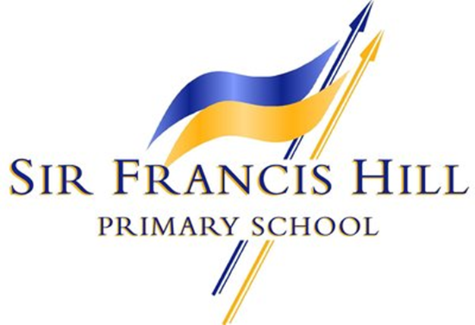

Bristol Drive, Lincoln, LN6 7UE
September 2017
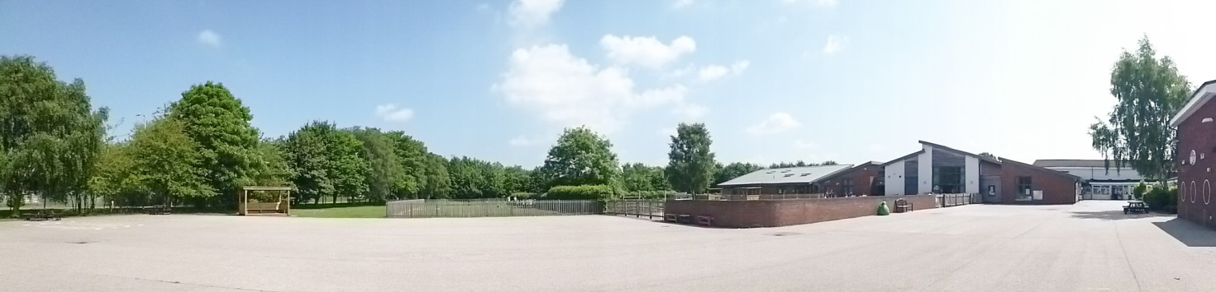

About our school
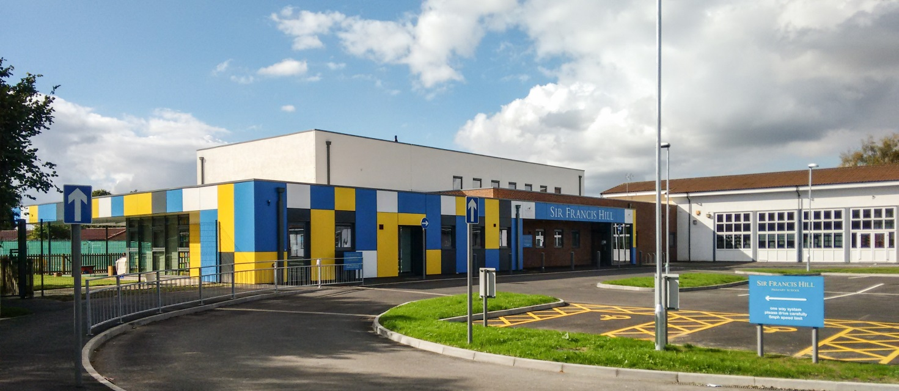
Sir Francis Hill Primary school is a thriving local community primary school in the heart of Lincoln City, which prides itself on providing a varied, fun and engaging curriculum to all of our children. Our goal is that every child is able to learn, achieve and succeed to the very best of their ability and thereby reach their own potential. We aim to ensure that all the children who are educated at Sir Francis Hill enjoy coming to school and gain an enthusiasm and love for learning that will continue throughout their lives.

The history of the school is varied; the school in Bristol Drive opened its doors as Boultham Junior in 1952 and changed to Boultham Middle in the 1970s. In 1984, the school opened an Infant department and in 2006, following the closure of local Infant schools, the school expanded to be a two form entry school.

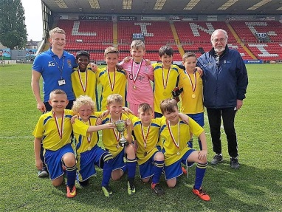
The behaviour and safety of pupils in school is outstanding (Graded by Ofsted July 2012), and pupils are given lots of opportunities to take part in school life both in and out of the classroom. Pupils enjoy a sense of fairness, equality and belonging, and every pupil is encouraged to strive for personal excellence and the highest standards of social, spiritual and intellectual development.
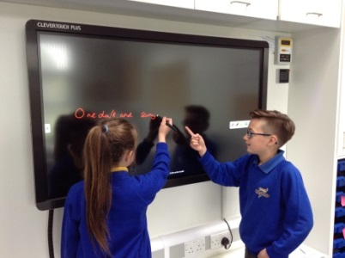
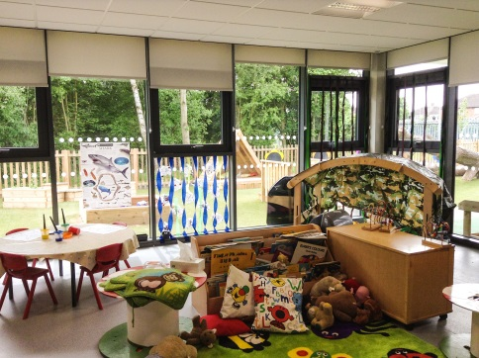
Our staff are hard-working, dedicated and committed to the welfare and progress of all children, based on excellent relationships with them. Pupils are given equal opportunities to succeed in school, allowing them to develop their talents in art, music and sport, as well as in the core curriculum.

At present, we have 480 children on roll. Currently, we have a Nursery, three Reception, Year One and Year Two classes and two classes in each of our Key Stage Two year groups.

Our Senior Leadership team comprises of the Headteacher, Deputy Head Teacher and two Assistant Headteachers. We have a number of Middle Leaders, who contribute to SLT in their roles in Teaching & Learning, including a Reading Lead, a Writing Lead and Maths Lead.
In total, we have 21 teachers (mainly full-time, but some part-time). Our highly trained Teaching Assistants and 1:1 Teaching Assistants provide support throughout the day in varying roles and are involved in delivering bespoke interventions as required.
We are fortunate to have an Inclusion Team which provides pastoral care and focuses on our SEND and more vulnerable children. This team consists of the SENCO, Assistant SENCO and Learning Mentor.

What we can offer you:
The chance to lead a ‘Good’ school on its next journey!
In our most recent OFSTED inspection (June 2017), Sir Francis Hill was judged as ‘Good’. This follows four years of work by our school to strengthen the leadership team, extending their roles and responsibilities. We have also empowered staff through a coaching model and introduced a range of initiatives to continue our progress, such as IPEELL, Read, Write, Inc., Active English and Active Maths.

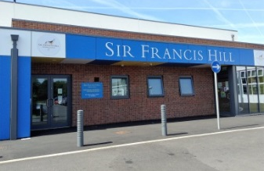
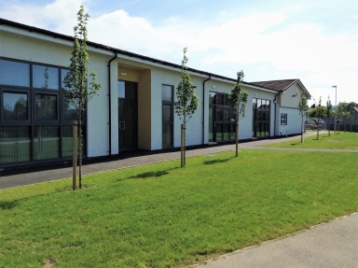
All staff at Sir Francis Hill strive for the best possible outcomes for all our pupils and our ethos of ‘Learn, Achieve, Succeed’ is embedded throughout the school community. Our school has been transformed over the past 18 months with an extensive build. We need a Headteacher that can continue to support our children and staff on this already established journey.

‘The school has undergone significant structural changes over the last year as it prepares to expand to meet the needs of the growing community. This has enabled you to further develop provision for children in the early years. Nursery and Reception year children benefit from motivating outdoor learning environments and large indoor spaces that are rich with learning opportunities.’

‘Pupils are self-assured and happy in school. Pupils I spoke to said that they felt safe in school. They feel well cared for by staff in school. Pupils know how to use the internet safely and could explain to me how they can keep safe, especially in relation to road safety and danger from strangers.’

Ofsted June 2017

An innovative curriculum:
We ensure children receive a broad and balanced curriculum which uses elements from the local, national and global community to support their understanding of 'Life' and to support them in reaching their individual potential.


Phonics is taught using the Read Write Inc. programme; it provides a structured and systematic approach to teaching literacy. It is used by more than a quarter of the UK's primary schools and is designed to create fluent readers, confident speakers and willing writers. Following this our children, when they are ready, mostly in Year 2, move onto a programme called Active English. Active English is an approach for teaching grammatical understanding to primary-aged pupils. It uses the principles of mnemonics to teach and embed the learning in an active and engaging way, providing the pupils with a deeper grasp of language that will benefit them for life.

We want to help our children to become real learners, who not only have the key skills of literacy, numeracy, ICT and science, but have a thirst for learning. We recognise that in a fast changing world, our learners will need a wide range of skills and through our curriculum, these are taught. They will need to be able to carry out research, work independently and with others, and to have developed a resourcefulness that will see them through periods of challenge or change. Each year group has a long term topic plan which allows coverage of all curriculum subjects and engages and motivates all pupils to make links between areas of learning. There is a planned balance between intellectual, physical and personal development. A good range of teaching and learning strategies provide learning opportunities for all.

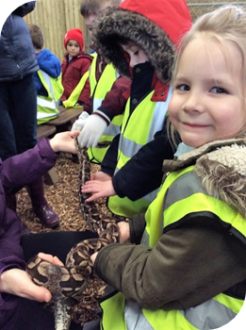
Our curriculum enables learners to achieve well in all subjects, taking into account their starting points, learning styles and capabilities; subjects also aim to enhance learning, including the application of core skills such as literacy, numeracy and computing across the curriculum. Each topic begins with a hook for learning, this provides a starting point which will hopefully hook in the learning and give them the interest and desire to learn more. These hooks may take the form of a visit off-site or a workshop on-site.

Teachers tailor the curriculum to meet the specific needs of pupils and work successfully to make sure that everyone is included in all that the school has to offer. This is particularly evident in the range of out-of-hours activities. Clubs are available for all ages and cater for a variety of interests.
Children are taken on Educational Visits throughout the year, where these are related to curriculum work in the classroom. Also, for Years 4 and 6, residential visits are arranged, often with outdoor education content. These visits will extend and develop the whole child, not only their academic, but social and physical skills.

‘You and your staff recognised the need to create a curriculum to better meet the needs of all learners, particularly disadvantaged pupils. Scrutiny of pupils’ books showed that more-able pupils are challenged to extend their thinking and specific teaching of mathematics and English skills is promoting good progress. Pupils of different abilities and in different year groups produce a good standard of work across the curriculum.’
Ofsted June 2017
Excellent resources and environment:
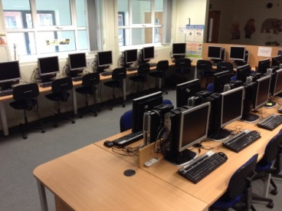
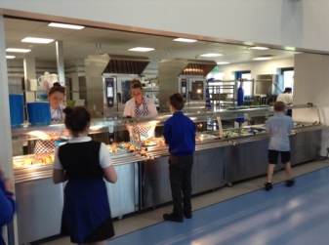
In the past 18 months, we have undergone an extensive new build which includes a dedicated Computing suite, an Art room and a brand new kitchen, which serves hot dinners daily to over 200 children. We have extensive outdoor grounds, which are used by the children for sport and extended classroom activities. The school has a Hall and a Studio which enable all classes to have PE indoors if needed and assemblies to occur daily. We have iPads in each classroom, which enable staff to plan for learning opportunities for all children, including embedding their learning by using Apps. The school also has a healthy carry forward in times when current financial constraints can hinder this.

A shared ethos:
At Sir Francis Hill, we want our children to be:

Successful
Independent
Respectful

Friendly
Responsible
Achievers
Nurtured
Curious
Inspired
Safe

Happy
Imaginative
Leaders
Lifelong Learners

Dedicated & motivated staff:
As well as an experienced and well established Senior Leadership Team, we have a number of Middle Leaders who lead initiatives in school, running meetings and assessing pupil progress and attainment. We have a team of Administrative Staff who enable the school to run smoothly, this team includes a Bursar and a Finance Assistant.
We currently have three SLEs who work within the Teaching School and further afield, offering School to School support to develop and empower colleagues in their roles in school and facilitating coaching and training sessions with Newly Qualified Teachers.
We have 9 Curriculum Teams which enables subject leadership to be shared equally and fairly across all staff in school. Regular curriculum team meetings are held and ‘Themed weeks’ are planned for, embedding the curriculum for the children in our care.
All of our teachers have a ‘Wider Professional Role’, including Research Lead, Marking and Feedback Lead, TA CPD lead, Secondary Links and Transition Lead and Behaviour Lead.
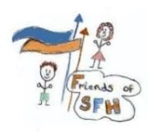
Supportive and caring parents:
We have a PTA, ‘Friends of Sir Francis Hill’ who regularly organise and run events for parents, including quiz nights, family picnics, Prom for our Year 6 leavers and a Summer Fair.
Parents describe our school as supportive, friendly, and inclusive. In a recent survey sent to parents, we gained the following views:

‘I can always approach anybody about my daughter’s education’
‘The teachers are always approachable at any time’
‘We know the door is always open which is reassuring’
‘All of my opinions about my child’s learning are taken into consideration’
‘Teachers are always welcoming and kind regarding any issues we may come across and allow me as a parent to support my child where possible’
‘Very patient staff’
‘Staff have an individual approach to each child, recognising that different approaches are needed for different children’

Skilled and committed Governors:
We have a strong and established team of School Governors who have wide and varied skills which enable them to act as a ‘Critical Friend’ for our staff in school. The Governing Body is very keen to support the new Head teacher on their journey. The Governors recognise the changing landscape of Education and understand that Professional Development is important for all staff. They understand the need for partnerships to be formed with local schools and further afield and will offer their on-going encouragement to the Head.

Strong partnerships:
We currently work alongside 8 local Primary schools to provide on Peer to Peer support, offering evaluation systems and support to each other. Sir Francis Hill is also a member of the Equate Teaching School Alliance, the vision being that all members can benefit from exceptional levels of professional development, peer support and leading-edge practice, so that every child within the Alliance receives the best possible education.

What our staff would like from their next leader:
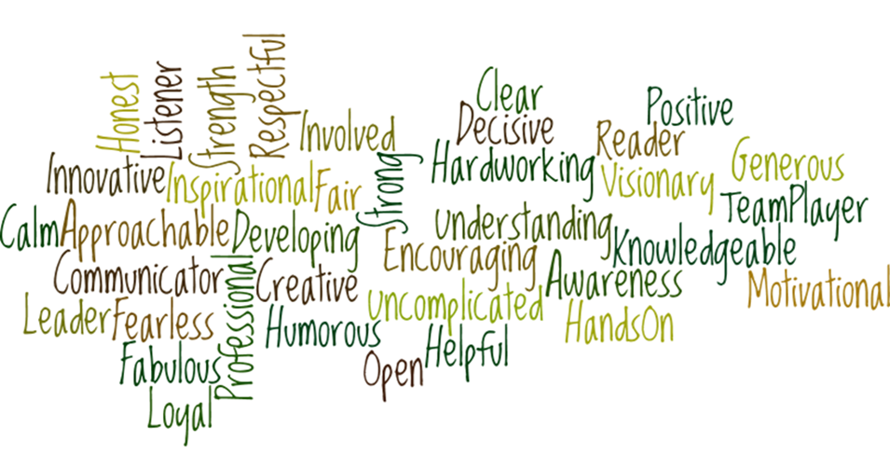

Our staff would like their next Headteacher to be a person who:
- has a good relationship with the children
- will treat all staff and children fairly
- will focus on continuing Professional Development for staff
- has a clear philosophy and vision
- has an ‘hands on’ approach

What our children want from a new Headteacher:

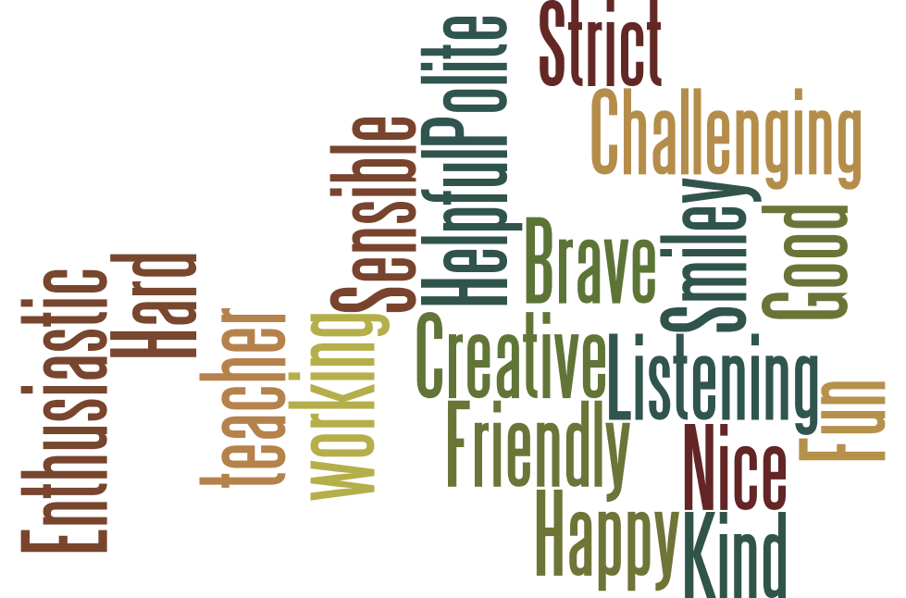

Why work at Sir Francis Hill?
This is what our children said about our school and why you should come to work here, ‘Because all the children are kind’, ‘Everyone is really thoughtful’, ‘Because the children are fair’, ‘Because our school is getting bigger and more children can come’

But most importantly, ‘Because it’s great fun’.

