Science Teacher
COOPERS SCHOOL
Application Pack for a Teaching Post
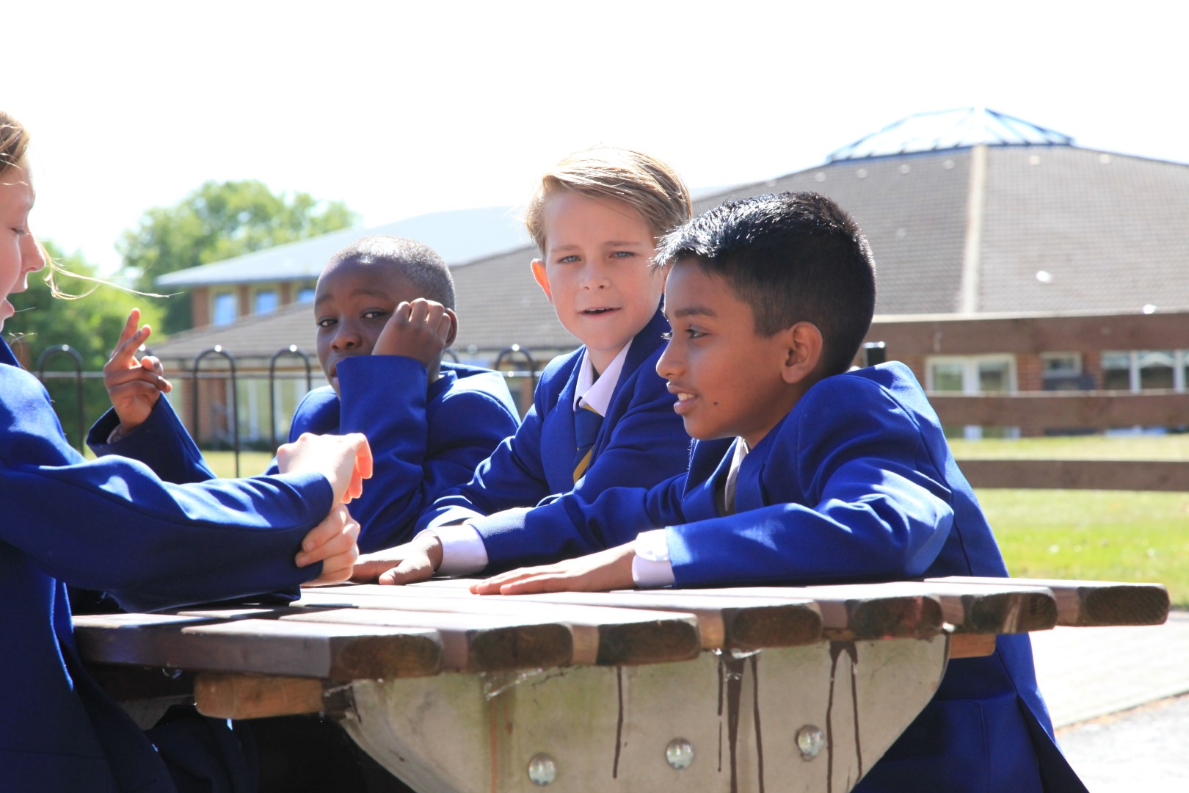
Coopers is a successful 11-18 co-educational school
with a strong caring and inclusive culture

Science Teacher
Required for September 2018
Applications invited from NQTs or experienced teachers – post of responsibility would be available for the right applicant
Main Scale - Outer London

Due to expansion and an increased roll, a vacancy has arisen for a dynamic and passionate teacher of Science – any specialism. Successful applicants will join our team of specialists at a crucial stage of our journey to become “outstanding”. The Faculty currently teaches all Science specialisms at KS4 and KS5.

We offer outstanding induction and support programmes with many opportunities for professional development which would suit those with a desire for career progression. Coopers School is part of the Bromley Schools’ Collegiate teacher training organisation.

If you are interested in this exciting opportunity, for more information please contact Rachel Gulyas on 0208 468 1681 / email: rgulyas@coopersschool.com

Closing Date: Wednesday 18 April 2018
(Please note that we encourage early applications, and reserve the right to close this vacancy at any time should the right candidate be found.)

This post is considered to be a customer-facing position. As such, it falls within scope of the Code of Practice on English Language requirement for public sector workers. The School, therefore, has a statutory duty under Part 7 of the Immigration Act 2016 to ensure that post holders have a command of spoken English sufficient for the effective performance of the job requirements. The appropriate standards are set out in the person specification. These will be applied during the recruitment/selection and probationary stages.

‘Coopers School is committed to safeguarding and promoting the welfare of children and young people and expects all staff and volunteers to share this commitment’
 | Coopers School |  | Hawkwood Lane Chislehurst Kent. BR7 5PS
 | An IB World School  CEO: Mrs S Puxty BSc (Hons) NPQH  Headteacher: Mrs S Wood BA (Hons) NPQH |  | Tel:020 8467 3263
 |  |  | Fax.020 8295 0342
 |  |  | Email: adm@coopersschool.com
 |  |  | Website: www.coopersschool.com
’Enabling learners of today to become achievers of tomorrow’

March 2018

Dear Applicant
Re: Vacancy for Science Teacher
Thank you for your enquiry about the post of Science Teacher at Coopers School. I hope that this pack gives you all the information you need at this stage, and that we can look forward to your application.
The closing date for all applications is Wednesday 18 April 2018, although early applications are encouraged, and we reserve the right to close this vacancy at any time should the right candidate be found.
Please send your completed application form and covering letter to jobs@coopersschool.com. If you require any additional information or have any questions, please contact Rachel Gulyas, PA to the Principal / Trust CEO, and Head of HR, at rgulyas@coopersschool.com.
Yours faithfully

Shirley Puxty

Shirley Puxty
Principal
CEO – William Willett Learning Trust

Chair of Governors: Andrew Downes
Senior Vice Principal: Matthew Baker
Vice Principals: Rob Carling | Hazel Hatch | Jane Salt | Niall Toal
Curious Creative Resilient Respectful Empathetic

Coopers School is an Independent Academy Trust operated by the William Willett Learning Trust which is a charitable company limited by guarantee and registered in England and Wales with company number 07520128.
The Registered Office is at Hawkwood Lane Chislehurst Kent BR7 5PS
COOPERS SCHOOL
WELCOME

Coopers is a warm, welcoming and friendly School situated in 33 acres of parkland in Chislehurst in the borough of Bromley, about eight miles from central London. It is a place where all students are happy learners. My mission as Principal and CEO of the William Willett Learning Trust is to take Coopers from being a good to an outstanding school. We are very proud of our latest Ofsted Report which shows that we can achieve this.

When the School was last inspected in January 2014, the inspectors said that 'Coopers is a well led school within which a well-planned curriculum and good teaching lead to very high standards and very good examination results, in the top 20% of the country.' They described the school as "bubbling outstanding."

- "Students’ progress overall was well above national figures."
- "The overall quality of teaching is good and, as a result, students learn well and make at least good progress."
- "Teachers receive high quality professional development from outstanding teachers in the school and external consultants."
- "Senior leaders have been successful in raising achievement and improving the quality of teaching over recent years."
- "The curriculum goes far beyond academic subjects with worthwhile vocational and practical courses."

The inspectors also commented that the very good behaviour of the students makes an important contribution to the welcoming, supportive and orderly learning environment created by the School as we strive for academic success.

We are very proud of our school, of the opportunities we provide, and of its role in the community. We strive to create an environment where each individual is valued, an environment that fosters tolerance and compassion, vibrant, caring relationships, lifelong learning skills and a strong sense of moral purpose. We operate through a core set of values:

- Curious - We have active minds, immersing ourselves in new ideas with a thirst for learning. We engage with issues and ideas that have local and global significance.
- Creative - We are enterprising and unafraid to challenge and be innovative. We are multi-faceted and independent, understanding that skills are transferable across all disciplines.
- Resilient – We understand that we need to be creative and determined in order to achieve our best. We are resilient and resourceful in the face of challenge and change.
- Respectful - We are confident and articulate in more than one language and demonstrate appropriacy and respect through our interactions. We act with integrity and honesty, have a strong sense of fairness and take responsibility for our actions. We have self-respect and take pride in our own work.
- Empathetic - We reflect on and evaluate our actions and the actions of those around us in order to have a better understanding of the world and our place within it. We are empathetic and compassionate and understand that our lives are interdependent with other people’s lives.

Coopers School became a Grant Maintained School in the 90’s, followed by a Foundation School and then became an Independent Academy in March 2011. It is a founder member of the William Willett Learning Trust and acts as a sponsor for Mead Road Infants School. We are also a founder member of the Bromley Schools Collegiate with an Ofsted outstanding judgement for ITT. The Trust is due to expand further for 1 September 2017 subject to consultation. We are really excited at the increased opportunities for collaboration and career opportunities for staff.
Our examination results at Key Stage 4 have shown many rises. We are most proud of our post 16 outcomes, the end of the seven year journey, which see ALPs 2 Grades for AS and BTEC and ALPs 3 for A2, significantly above national average. A range of post 16 courses are taught. We are a World IB School and we offer, A levels, AS courses, BTecs and the IBCP. We are the only school in Bromley to offer IBCP (Careers Programme) and currently only about twenty schools in the country can teach this. Of a role of 1600, 320 students are in the Sixth Form. We have an impressive number of young people leave us for top universities and apprenticeship programmes.

Our Students
Our students feel happy and secure. We have a well-developed pastoral system and staff genuinely care about our students as individuals. We encourage students to assume and enjoy responsibility through our Student Leadership and Ambassador Teams. Our highly skilled staff work closely with students to monitor their progress to ensure they exceed their potential. There is an excellent student volunteer peer mentor scheme and students are encouraged to play an active part in the running of the school.
We understand that students need a range of skills and opportunities to fulfil their potential and therefore encourage students to undertake a full range of extra curriculum activities in addition to the educational requirements. We have an extensive enrichment programme, the full details of which can be found on the website.

Our Staff
We recognise and value the skills, knowledge and expertise of all our staff and are committed to supporting their professional development. To this end, we have a vibrant and varied Continual Professional Development programme, which is personalised each year to support both our main school priorities and the individual needs of staff. This programme includes opportunities to share excellent practice between colleagues as well as drawing on external expertise. Cross collaboration between other local schools and schools in the Trust is also encouraged so that best practice is formulated. We encourage and support further learning and research.
Staff give freely of their time to the broad extra-curricular programme which includes sports, music, drama and a host of trips, exchanges, clubs and other activities. There is a blend of youth and experience among the staff and newcomers have always commented on the warm welcome they have received.

Coopers School is an Equal Opportunities employer.

Mrs Shirley Puxty BSc (Hons) NPQH Mrs Sue Wood BSc (Hons) NPQH
Principal Headteacher
CEO – William Willett Learning Trust

THE SCIENCE FACULTY

The Science Faculty at Coopers comprises a friendly and hardworking team of fourteen specialist full time teachers and three Science technicians, and has a record of excellent and continually improving examination results. Leadership of Science includes a Director, a Lead Practitioner and Heads of Biology, Chemistry and Physics.
Coopers operates a pathway system, whereby students are split into classes broadly according to ability, and all teachers teach a range of abilities across different key stages. Science is taught in our ‘Lomax’ building consisting of eleven laboratories (four recently refurbished), a computer room, a Sixth Form private study area with computers and a technician preparation room.
All Year 9 students now study the new combined Science GCSE, with top pathway students studying separate Biology, Chemistry and Physics. Currently, KS4 students sit the Edexcel course. At ‘A’ Level we currently offer Biology, Chemistry and Physics as well as a Post-16 BTEC qualification in Science. A Level Science enrolment is consistently high.
Like all departments at Coopers, the Science team runs deep learning days throughout the year with students across all year groups. These ‘Dedicated Learning Days’ provide exciting opportunities for students to immerse themselves in STEM related learning as well as attending many trips. The Science Faculty works closely with a number of Primary partner schools to promote Science at KS1-2 and enhance outcomes. One member of the Science Faculty has a role as the Transition Coordinator to maintain and create new and exciting primary projects.
The continuing professional development of all staff at Coopers is a priority and the opportunities given for staff to further their career are clearly evident in Science. The Faculty is well established in training new teachers through the SDS, Collegiate SCITT and university PGCE programmes, and many of these teachers have gone on to senior positions both within the Faculty and across the school.

FACILITIES
Coopers’ campus is set in 33 acres of parkland on the edge of Chislehurst.

The School offers exceptional educational facilities which are continually being extended and developed. We have recently been successful in securing over £8million to enhance our facilities in our peaceful setting. We have now built a £3million new Performing Arts Block which opened in September 2015.

We live in a time of such rapid technological and scientific change that new ways of teaching are needed to prepare children for the world we live in today.

To support this, our technological facilities include:
- Twenty networked computer suites across the school
- Six networked Apple Mac computer classrooms
- Over four hundred wireless laptops available across the site
- Industry standard machinery including a laser cutter and CAD/CAM equipment
- State of the art digital cameras and iPads for sports students to self-assess their performance

GENERIC JOB DESCRIPTION: TEACHER
Title: Teacher
Salary: Main Scale
Conditions: Permanent
Line led by: Subject Leader
Line leadership of: None

All staff at Coopers School are expected to:
- actively contribute to the School’s achievement culture;
- share our common values of Curiosity, Creativity, Resilience, Respect and Empathy in the face of challenges;
- make a commitment to achieving the highest possible standards in all areas of their work;
- contribute to the development of the School’s ethos.

JOB PURPOSE
- To promote high standards of student learning, achievement, attainment and behaviour through the effective teaching of individuals, groups and classes.
- Create positive learning environment

RESPONSIBILITIES
- Carry out all duties and responsibilities in accordance with school policies, procedures and statutory health and safety requirements.
- Help all students develop as independent learners and make optimum progress.
- Implement school policy on Assessment for Learning, Homework (including Y7-8 extended learning projects) and Differentiation.
- Assess the development, progress and attainment of students.
- Use assessment information to plan, prepare and deliver lessons and courses which meet student needs in terms of challenge, relevance, continuity and progression.
- Evaluate teaching and strive to maintain and improve quality.
- Ensure that students with special educational needs and in all vulnerable groups are identified at the earliest possible stage and receive appropriate support.
- Ensure that any other adults who assist in lessons are fully briefed on curriculum planning and are deployed effectively in order to maximise student progress.
- Contribute to curriculum development by working collaboratively with colleagues to design schemes of learning and materials.
- Provide students with constructive feedback on their progress, achievement and attainment.
- Report regularly on students’ progress and attainment to parents, students and other staff.
- Ensure high quality display is used to support and inspire learning and celebrate achievement.
- Work actively to develop professional expertise by seeking and participating in on-going professional development and supporting the professional development of colleagues.
- Lead and support enrichment activities and inter-house competitions.
- Undertake any other duties commensurate with the level of the post, as required to ensure the efficient and effective running of the school.

General Responsibilities
- Promote the values and ethos of the School in accordance with its Professional Code.
- Identify personal training needs with line managers and work actively to develop professional expertise by participating in on going professional development.
- Support the professional development of colleagues.
- Ensure that personal knowledge base is in keeping with the School’s needs at all times, to undertake all duties with due regard for Health and Safety regulations.
- Be fully conversant with the national and local developments, to develop the full range of managerial and professional skills and the knowledge needed to satisfy the requirements of the post.
- Contribute to the School’s Enrichment Programme.
- Undertake relevant and appropriate whole School CPD.
- Adhere to the National Standards for Teachers
- Comply with all School policies and the Staff Code of Conduct
- Contribute to Duty Rotas as assigned
- Any duty assigned by the Principal which is commensurate with the role

PERSON SPECIFICATION: MAIN SCALE TEACHING POST

 | ESSENTIAL | DESIRABLE | HOW ASSESSED
QUALIFICATIONS | - Good honours degree  - Teaching qualification | Evidence of other professional study  Higher degree | Application
EXPERIENCE | - Evidence of successful involvement in teaching at KS3, KS4 or post 16 recent developments in the teaching and learning of the curriculum area | Involvement in a key departmental development  Strong involvement in extra-curricular activity | Application, references and interview
KNOWLEDGE | - strategies for raising achievement in the curriculum area  - different teaching and learning styles  - the use of performance data to track student progress and monitor achievement  - strategies for ensuring equal opportunities for staff and students | Curriculum Planning and curriculum changes
TRAINING | - Evidence of high quality training in designated subject area  - Strong awareness of educational developments |  | Application and interview
SKILLS | - Strong and methodic administrative skills  - Positive student behaviour management skills  - Excellent communication and interpersonal skills  - Strong ICT competence  - Analytical and problem solving skills |  | Application and interview
QUALITIES | - Strong public presence  - Good communicator  - Ambitious and self-confident  - Student focused commitment  - Ability to inspire  - A clear educational vision  - A sense of humour  - Strong motivation and sense of initiative  - Open and transparent work ethic  - Flexibility  - Role model for students and staff  - Seek support and advice when needed  - Excellent attendance and punctuality | Evidence of ‘going the extra mile’ | References and interview

CODE OF PRACTICE ON LANGUAGE REQUIREMENTS | - Ability to speak with confidence and accuracy, using accurate sentence structures and vocabulary.  - Ability to choose the right kind of vocabulary for the situation in hand without a great deal of hesitation.  - Ability to listen to stake holders and understand their needs.  - Ability to tailor your approach to each conversation to be appropriate to the stake holder, responding clearly with find shakes of meaning, even in complex situations.

February 2018

“Coopers School is committed to safeguarding and promoting the welfare of children and young people and expects all staff and volunteers to share this commitment”

Explanatory Notes

Applications will only be accepted from candidates completing the Trust’s Application Form which can be found on the website (under vacancies). Please complete ALL sections of the Application Form which are relevant to you as clearly and fully as possible. CVs will not be accepted in place of a completed Application Form. Instructions and advice on “How to apply” can be found on the website: www.coopersschool.com

Safeguarding Children & Young People

We are committed to safeguarding and promoting the welfare of children and young people. We expect all staff to share this commitment and to undergo appropriate checks, including enhanced CRB checks and DBS checks.
- Candidates should be aware that all posts in the Trust involve some degree of responsibility for safeguarding children and young people, although the extent of that responsibility will vary depending on the nature of the post. Please see the job description enclosed in this Application Pack for further details.
- Accordingly, this post is exempt from the Rehabilitation of Offenders Act 1974 and, therefore, all convictions, cautions and bind-overs, including those regarded as “spent” must be declared.
- If you are currently working with children, on either a paid or voluntary basis, your current employer will be asked about disciplinary offences, including those related to children or young people (whether disciplinary sanction is current or time-expired), and whether you have been the subject of any child protection allegations or concerns and, if so, the outcome of any investigation or disciplinary proceedings. If you are not currently working with children, but have done in the past, that previous employer will be asked about these issues.
- Where neither your current or previous employment has involved working with children, your current employer will be asked about your suitability to work with children, although it may where appropriate be answered not applicable if your duties have not brought you into contact with children or young people.

Interview Process

After the closing date, short listing will be conducted by a Panel, who will match your skills/experience against the criteria in the Person Specification. You will be selected for interview entirely on the contents of your application form, so please read the Job Description and Person Specification carefully before you complete your form.

All candidates invited to interview must bring the following documents if external applicants:
- Documentary evidence of right to work in the UK
- Documentary evidence of identity that will satisfy CRB requirements such as a current driving license including a photograph and/or a passport and/or a full birth certificate
- Documentary proof of current name and address (i.e. utility bill, financial statement etc.)
- Where appropriate any documentation evidencing change of name
- Documents confirming any educational or professional qualifications that are necessary or relevant for the post

Please note that originals of the above are necessary. Photocopies or certified copies are not sufficient.

We will seek references on shortlisted candidates for Trust based positions and may approach previous employers for information to verify particular experience or qualifications before interview. Any relevant issues arising from references will be taken up at interview.

In addition to candidates’ ability to perform the duties of the post, the interview will also explore issues relating to safeguarding and promoting the welfare of children, including:
- Motivation to work with children and young people
- Ability to form and maintain appropriate relationships and personal boundaries with children and young people and staff
- Emotional resilience in working with challenging behaviours
- Attitudes to use of authority and maintaining discipline

Conditional Offer: Pre-Employment Checks
Any offer to a successful candidate will be conditional upon:
- Verification of right to work in the UK
- Receipt of at least two satisfactory references (if these have not already been received)
- Verification of identity checks and qualifications
- Barred List
- Satisfactory CRB/DBS Disclosure
- Verification of professional status such as QTS Status, NPQH (where required)
- Satisfactory completion of a Health Assessment
- Satisfactory completion of the probationary period (where relevant)
- Where the successful candidate has worked or been resident overseas in the previous five years, such checks and confirmations as may be required in accordance with statutory guidance

For teaching posts:

- Verification of successful completion of statutory induction period (applies to those who obtained QTS after 7 May 1999)
- Verification of medical fitness in accordance with DfE Circular 4/99 Physical and Mental Fitness to Teach of Teachers and Entrants to Initial Teacher Training

You should be aware that provision of false information is an offence and could result in your application being rejected or summary dismissal if you have been selected, as well as possible referral to the police and/or DBS and/or other relevant investigating bodies.

