



King Henry VIII School, Abergavenny

Ysgol Brenin Harri’r VIII

Subject Leader Physics

Information Pack

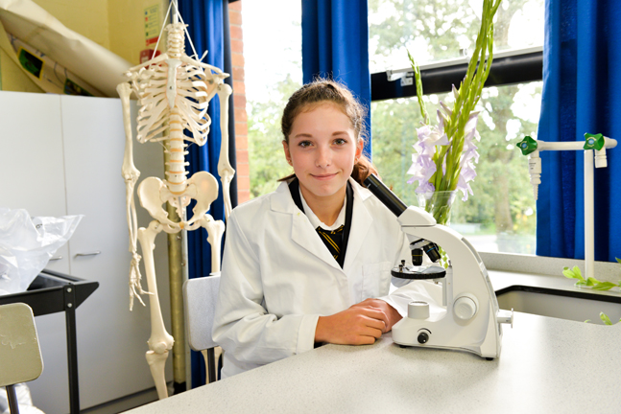

*“Respecting tradition, embracing the future”*

**Introduction**

Dear Candidate

Welcome to King Henry VIII School and thank you for considering applying for the position of Subject Leader of Physics. To assist you with your application I thought it would be useful if I gave you a brief introduction to our school.

The school is currently going through an exciting school improvement journey and we are seeking a dynamic and inspirational leader to join our school. I have been Headteacher here since September 2014 and was delighted in the positive pupil outcomes last summer. In 2016 our A2 results were our best ever with 60.1% of grades A*-B. In addition the number of pupils gaining 5 or more GCSE A*-C including English and maths was 71.2%, placing the school in the top 25% when compared to similar schools. These results demonstrate the excellent relationships that exist between our dedicated staff and hardworking pupils. We have laid solid foundations for what will be sustained progress with the aim KHS becomes an outstanding school.

Staff here are extremely friendly and welcoming. They are passionate about our pupils, the school and want to be successful. They have embraced a number of significant changes implemented since my arrival and the level of care they show to pupils is exemplary. The Governors are supportive of the school and contribute greatly to our self-evaluation and improvement processes.

Our pupils have positive attitudes to learning and behave very well around the school and in lessons. We are an inclusive community with a caring ethos that celebrates and rewards success and achievement of every individual pupil. The school is set in well maintained grounds and our buildings provide a stimulating environment that enhances pupils’ learning.

Although we are pleased with the improvements we recognise there is still work to do to ensure that every pupil attending our school gets the best possible opportunities and education regardless of their ability or background. Our School Development Plan has focussed on key priorities including delivering high quality teaching, learning and assessment leading to outstanding outcomes.

I truly believe that King Henry VIII School has the potential to be excellent in the next few years. If you are ready for the challenge of playing a lead role in helping us achieve this, have a core belief that all pupils no matter their background or ability can achieve, have a passion for and a clear understanding of excellent learning, you are definitely the right person for us.

Please feel free to telephone my PA, Teresa Worthing on 01873 735300 if you would like any more information or if you would like a tour of the school. I hope you will apply because this is an excellent opportunity and a great place to work. I look forward to hearing from you.



Elspeth Lewis

Headteacher

**Science Faculty**

The Science faculty comprises of 9 specialist teachers and a team of 2 lab technicians. The department operates out of a suite of 10 laboratories, all equipped with interactive whiteboards or projectors. Each of the three science departments have access to both laptops and iPads. All classes from Year 7 upwards are taught via the specialisms of Biology, Chemistry and Physics via a theme based approach. At Key Stage 4, most students follow WJEC Science Double Award along with an accelerated Triple Award group and a small provision, Applied Science class. Teachers deliver only to their specialism at Key Stage 4 and Key Stage 5.

Results within the faculty have improved significantly at all key stages over the last three years. This has been the product of the coordinated hard work of an effective team contributing to strategic planning and curriculum development. The science faculty is now in BMQ 1 or 2 for all headline measures.

**Key Stage 3 results and trends**

| **Science** | **2013/14** | **2014/15** | **2015/16** |
| --- | --- | --- | --- |
| **L5+** | 93.8% (3) | 96.65%(2) | 97.5% (2) |
| **L6+** | 59.3% (3) | 74.8%(1) | 80.7%(1) |
| **L7+** | 27.1%(1) | 30.6%(1) | 52.2%(1) |

**Key Stage 4 results and trends**

|  |  |  |  |  |
| --- | --- | --- | --- | --- |
| **Science** | **2012/13** | **2013/14** | **2014/15** | **2015/16** |
| Level 2 %pass | 48% | 59% | 68% | 95% |

The Physics department has achieved success at Key Stage 5, with 20% of the cohort achieving A* and 60% achieving A*/B grade. One student from the 2016 cohort is currently reading Natural Science (Physics) at Girton College Cambridge. We have a healthy number of students taking Physics in Year 12, with 25 currently enrolled.

The vision of this faculty is to continue to improve and become a beacon for outstanding practice and provision. We require an enthusiastic Leader of Physics who inspires both students and staff to excel. The successful candidate will need to demonstrate innovation, excellent leadership skills and the ability to deliver continued improvement in teaching and learning throughout the faculty.

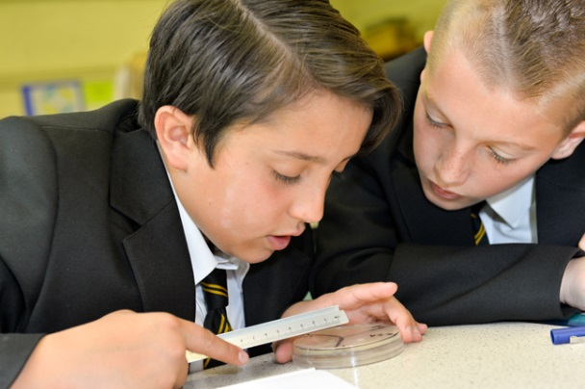

**JOB DESCRIPTION**

Subject Leader Physics

**JOB PURPOSE**

To lead, manage and develop the work of the Physics department to secure high quality teaching, effective uses of resources and the highest standards of learning and achievement for all pupils.

**PRINCIPAL RESPONSIBILITY AREAS**

A *(impact on education progress beyond the teachers’ assigned pupils)*

* To lead developments in teaching and learning across the department and all

key stages

* To monitor and evaluate the quality of teaching and learning in the department

across all key stages

B *(leading, developing and enhancing the teaching practice of others)*

* To lead and manage the teachers within the department
* To support the training needs of teachers in the department
* To evaluate the impact of professional learning activities on the quality of

teaching and learning.

C *(having accountability for leading, managing and developing a subject or curriculum area or curriculum area or pupil development across the board)*

* To establish a vision and improvement plan for physics in respect of pupils of all ages and abilities.
* To contribute to whole school improvements through membership of the middle leadership team.

**KEY TASKS**

A1 To oversee and monitor the development of Physics Schemes of Work, teaching and assessment strategies in the department ensuring the entitlements and needs of all learners are met across all key stages.

A2 To use lesson observations, book scrutiny, pupil evaluations and other strategies to monitor the experience of learners in responsibility areas.

A3 To lead the sharing of effective teaching, learning and assessment strategies within the department.

A4 Working with other leaders in the faculty, to track pupil progress and implement strategies to address under-achievement.

A5 To oversee the implementation of the Literacy and Numeracy Framework across the department ensuring pupils develop their skills in a progressive manner and in a range of different contexts.

B1 To develop effective working relationships and communication with all teachers within the department; parents, curriculum leader and senior leaders.

B2 To contribute to regular Science meetings as a means to improving teaching, learning and assessment within the department.

B3 To identify training needs of and opportunities for colleagues in Physics and to report on the impact of professional learning in the annual departmental review.

B4 To contribute to quality control procedures regarding pupil reports.

B5 To participate in the performance management of staff as required by school policy.

B6 To advise the Headteacher on the appointment of new staff to the Physics subject area.

C1 To provide an annual evaluation report and a costed improvement plan as a means of raising achievement and developing the quality of provision.

C2 Contribute to efficient and effective use of the Science resources.

C3 To ensure pupil progress is recorded in line with the school’s ARR calendar

C4 To lead the moderation and standardisation of pupil work across Physics to ensure a shared common understanding of standards across the faculty.

C5 Contribute to the profile of the Science department and to create a culture where success is recognised and celebrated.

C6 To keep abreast of developments in Physics and contribute to the school-wide self-evaluation and improvement planning through contribution to middle leadership meetings.

C7 To have day-to-day responsibility for Health and Safety in the Department’s teaching environment and in adjacent areas and to carry out a half-termly inspection, reporting any areas of concern to the Estates Manager.

C8 To be responsible for ensuring that Health and Safety issues appear termly in department meetings.

The above job description should be read alongside the Practising Teacher Standards (Wales).

**Workload**

The criteria used to form the TLR weighting calculations were used to assess the workload impact of this post and allocate the appropriate TLR allowance. In addition the STPCD 2016 and the joint union short of strike action document were used to work load assess the above job description.

|  |  |
| --- | --- |
| **PERSON SPECIFICATION**  **Subject Leader Physics** |  |

The person appointed must fulfill the following requirements or have the potential to do so quickly through available training:-

|  |  |  |
| --- | --- | --- |
| **Attainments (Education, Experience and Training)** | **Essential** | **Desirable** |
| Good honours degree, Physics or related subject;  PGCE/Q.T.S;  Masters Qualification/Further degree;  Experience of teaching and leading KS3 and KS4;  Experience of teaching at KS5;  Recent and relevant CPD linked to Physics | ✓  ✓  ✓ | ✓ |

|  |  |  |
| --- | --- | --- |
| **Knowledge and Experience** | **Essential** | **Desirable** |
| Excellent classroom practitioner;  Evidence of raising achievement;  Understanding of effective teaching and learning strategies;  Good knowledge of science and physics curriculum;  Good knowledge of the Literacy and Numeracy Framework  An understanding of the Digital Competency Framework  Evidence of leadership of teaching and learning  Ability to meet targets by being consistently focused on achieving high educational standards;  Effective and systematic promotion of a positive attitude to learning with clear boundaries, sanction, praise and reward;  Able to use ICT effectively for teaching and administration;  Pastoral experience;  Commitment to extra-curricular activities. | ✓  ✓  ✓  ✓  ✓  ✓  ✓ | ✓ |

|  |  |  |
| --- | --- | --- |
| **Personal Qualities** | **Essential** | **Desirable** |
| High personal and professional standards;  Ability to developing excellent relationships with colleagues  Ability to manage a substantial workload effectively and independently and meet deadlines;  An innovator;  Comfortable when working in unchartered territory;  Patience;  Excellent communication skills;  Excellent organisational skills.  Excellent health record | ✓  ✓  ✓  ✓  ✓  ✓  ✓ |  |