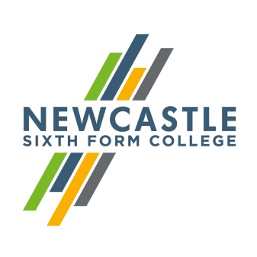
Gerard Garvey
Principal

Dear Applicant,
Personal Development Coach

Thank you for your interest in Newcastle Sixth Form College. I am delighted that you are considering becoming part of our team. As the largest provider of A Levels in the Newcastle area, we are always keen to add new talent. I hope that the information below proves useful as you put your application together.

Skilful and inspirational staff are fundamental to our success. As an inclusive sixth form we attract students from the full range of ability and we only offer academic qualifications (GCSE and A Levels). This means that we rely upon staff who are ambitious for their students and willing to go the extra mile in supporting them to realise their potential. Standards of behaviour are very high both in and out of lessons. Our students come from across the region and bring a variety of different social and cultural experiences. We are keen to celebrate this; in recent years we moved to rainbow lanyards and have developed a culture of inclusivity, with events promoting equality and diversity at every opportunity.

Our team is relatively small; there are 100 staff who teach and support about 100 students on our Access to Level 3 (GCSE) and approximately 1200 students on an A Level programme. This post is for a Personal Development Coach. In your first year you would be working with approximately 180 first year A level students. You would have regular 1:1 coaching conversations with the students where you use our VESPA mindset model to set ambitious progression plans, and monitor their progress towards them. You would lead approximately 7 hours of group Personal Development sessions each week where you would facilitate about 25 students to research and develop their plans as well as covering wider aspects of adult life including British Values and equality and diversity. You will be a lynchpin between parents, teachers and students, and it will be your careful monitoring, and appropriate blend of support and challenge that will allow the students to achieve their very best. A desire to develop your skills and expertise is essential, and intensive and ongoing training will be provided.

I hope that you will visit our website to find out more about the College, and if you wish to visit us to look around informally we would welcome that. If you would like to arrange a visit, please contact my PA on 0191 226 6225.
Yours faithfully,
Gerard Garvey
Principal
Newcastle Sixth Form College, Westmorland Road, Newcastle upon Tyne, NE4 7SA
T: 0191 272 1001 E: enquiries@newcastlesixthformcollege.ac.uk
www.newcastlesixthformcollege.ac.uk

 | Newcastle Sixth Form College  Information for Applicants | 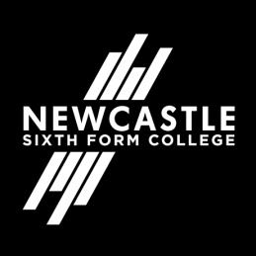

Newcastle Sixth Form College
Newcastle Sixth Form College is a dedicated academic college focusing on the needs of 16 to 18 year olds in a purpose built multi-million pound Sixth Form College. Our breadth of A Level subjects is second to none in the region and our students are nurtured to achieve the best possible results for them to move on to higher education at universities and colleges or into the workplace.
Our culture is based on support and challenge for both students and staff. We provide the highest standards of teaching and learning and a wide range of exciting opportunities for our students to develop their skills, talents and interests while they are with us. We aim to help our students develop a responsible and positive attitude in an all-inclusive environment where different cultures and diversity are embraced. We expect that all students and staff will share in these values

Personal Development Team
This is a new department of 4 members of staff who will report directly to the Assistant Principal for Students. You will work collaboratively to ensure that first year A level students achieve their potential while at the Sixth Form.

Newcastle upon Tyne
Newcastle upon Tyne is the regional capital of the north east and renowned as one of the best student cities in the UK. A vibrant student population and a warm and friendly atmosphere make it a popular destination for students from far and wide.
World-class culture, vibrant nightlife, fantastic shopping, award-winning dining, inspiring heritage and acclaimed architecture are just some of the things you can expect from this exciting city. Newcastle has a population consisting of nationalities from all over the world and offers something for everyone.
Newcastle benefits from a low cost, quick transport link – the Metro, so you can see everything the local area has to offer. Newcastle also has its own international airport and major train station both with excellent links. With so much to do and fantastic transport links to get you there, Newcastle really is a city you’ve got to experience for yourself.

