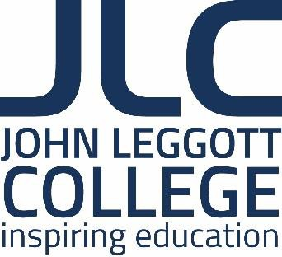
John Leggott College Job Description

JOB TITLE: Teacher of Biology (1.0 FTE)

REPORTS TO: Area Leader WORK PATTERN: Full Time/Temp
SALARY: Teachers Main Scale (depending on qualifications and experience)

Purpose of the Role

- Ensure successful delivery of the biology provision at JLC.
- Ensure a high quality and relevant learning experience for all students on the courses
- Ensure that all students are given the opportunity to achieve their academic potential

Key Responsibilities

- Employ a range of teaching and learning practices successfully
- Be responsive to innovations and changes in the teaching of Biology
- Include numeracy and literacy in all teaching and learning practices
- Promote Equality and Diversity in all teaching and learning practices
- Promote the prevent agenda in all teaching and learning practices
- Work with Area Leaders to identify and achieve annually negotiated targets such as those related to student enrolment, retention and achievement
- Produce schemes of work, learning plans and personal learning checklists as appropriate
- Set suitable learning targets and prepare learning programmes that achieve these
- Use appropriate assessment techniques to track student progress effectively and make best use of learner data to inform lesson planning
- Employ diagnostic test data in all lesson planning
- Organise and manage the classroom effectively
- Work with team members to ensure outstanding outcomes for learners
- Forge links with feeder secondary schools and be actively involved in the college recruitment and enrolment processes
- Liaise with the advocate team to support the learning of the students
- Liaise with SENCO to ensure all students are fully supported in their learning
- Access training and other CPD opportunities when presented
- Utilise the college’s VLE in order to support teaching and learning
- Be involved in learner support and enrichment activities to provide the best student experience in Biology
- Work collaboratively with colleagues across all areas of the college

- Continue to develop his or her own skills in the teaching, learning and assessment of Biology
- Be enthusiastic, dynamic, committed and well organised
- Be flexible and prepared to contribute to the delivery of other L2 and L3 Biology courses.

In addition to the above mentioned attributes the successful candidate will be expected to:

  - Support effective safeguarding of all young people throughout the college.

  - Attend as necessary, meetings of all Biology and college staff.

  - Adhere to college policies and procedures e.g. Equality and Diversity; Health and Safety.
  - Undertake any such other duties as may be required, commensurate with the post, which do not change the character or purpose of the post which are necessary to maintain outstanding standards.

The job description is an outline of the key tasks and responsibilities and is not intended as an exhaustive list. The job may change over time to reflect the changing needs of the college, as well as the personal development needs of the post holder.

We strive for equality throughout the college and positively encourage applications from all sections of the community. The college has a strong commitment to safeguarding and promoting the welfare of young people and vulnerable adults and all appointments are subject to an enhanced DBS clearance.

LEON RILEY

Principal

Employee signature: …………………………………. Date: ……..……………… Line manager signature: ………………………………. Date: ……..………………

