Presdales School

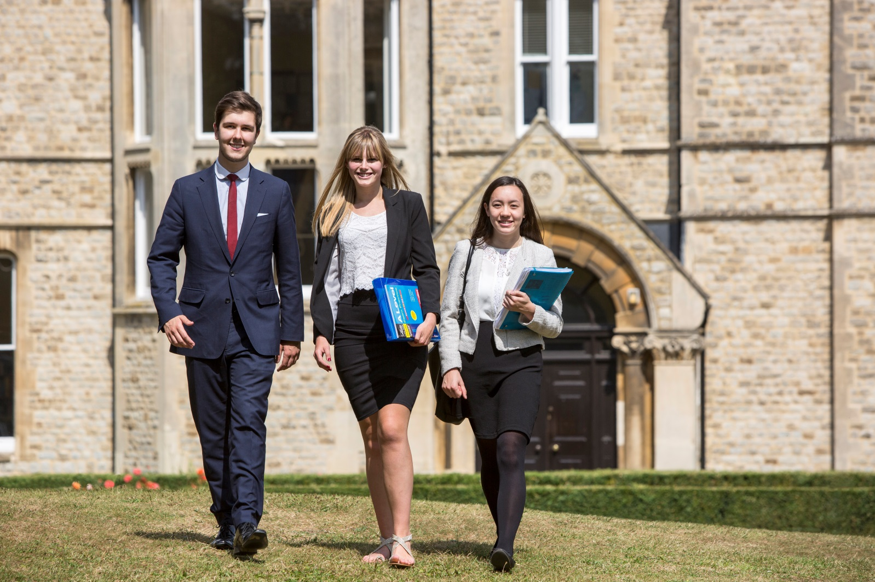

Candidate Information Pack
Head of Key Stage Maths (Key stage to be agreed with HOF)

Presdales School – Head of Key Stage Maths (Key Stage to be agreed with HOF)

Information for candidates
Start date: September 2018
Full-time permanent position
TLR: 2a

Thank you for your interest in joining our team of outstanding staff. Please find enclosed in this pack general information about the school and also specific information about the post.

Presdales is a high achieving, all-girl, non-selective 11-18 school (boys are accepted into the sixth form). We pride ourselves on developing our students to be articulate and confident young adults by the time they leave Presdales. We are passionate about ensuring that all students fulfil their potential both academically and pastorally, regardless of their background or academic starting point.
Presdales has been graded as ‘Outstanding’ by Ofsted in the last four inspections. Student achievement is high, with 85% of the girls achieving a grade 4 or higher in both English and Maths, an attainment 8 score of 55 and a progress 8 score of 0.14. 67% of our students achieved the EBacc measure. Our A Level results are equally impressive, with an average score of above 37 points per entry and a value added of 0.13. We have an intensive extra-curricular programme which offers the girls a chance to develop their leadership and team building skills as well as numerous trips during the year.
We are seeking a confident and enthusiastic teacher of Maths who would like to take the next step in their career by becoming a leader of a Key Stage. You will have the strategic overview for the Key Stage and be responsible for all matters concerning that Key Stage. We have a successful and dedicated Maths department who enjoy working supportively as a team and are fully open to new ideas to improve the experience for the students. Throughout Key Stage 3 and 4, students are set for Maths and we continually monitor their progress, success and confidence. Every student has a Maths textbook which is used alongside other resources to maximise learning. In Maths, we use mini-whiteboards quite extensively to help promote risk-taking and problem solving. The Maths teaching rooms have interactive whiteboards and one classroom has 18 desktop computers and there is a set of 20 laptops for students’ use within the department.
For Maths GCSE this year, we are entering just under a third of our Year 11 students for the AQA Foundation GCSE and the rest for Edexcel Higher GCSE. The top 31 students are also completing their legacy GCSE in Statistics. There are over thirty students taking Maths A level in each of Year 12 and 13, with a good size group (about 8 students) additionally studying Further Maths A level in each year. We currently use Edexcel exam board for all KS5 taking the Further Statistics 1 and Decision 1 options within Further Maths. In 2017 87% of our students gained Grade 4 and above at Maths GCSE, with 63% gaining 5 and above and 31% achieving grade 7 or higher. At A level Maths, 41% achieved Grade A*-A last year, with 100% (5 students) gaining A*-A in Further Maths.
I do understand and appreciate the time and effort it can take to complete an application for a job such as this; thank you for considering Presdales School.
Matt Warren
Headteacher

Presdales School

Head of Key Stage Maths (KS to be agreed with HOF)
Start date: September 2018
Full-time permanent
TLR: 2a

We are looking to appoint an outstanding teacher who will lead and manage a Key Stage in Maths

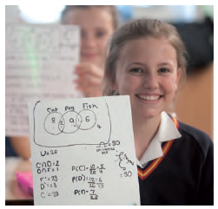
Presdales is an outstanding all-girls 11-18 school, with boys in the sixth form. We are a school which values all students, irrespective of their age and ability and helps them to exceed expectations through high quality teaching and learning and the opportunity to take part in a wide variety of activities which will enrich their educational and personal development beyond the classroom.
We provide a caring environment where all students are supported, as well as challenged, to ensure that there is no limit to their potential. We prepare our students for a world that is constantly changing by encouraging them to be independent learners who are determined, confident and who never give up. Alongside academic excellence there is a strong focus on enjoyment, excellent behaviour and respect for all.
The school is committed to safeguarding and promoting the welfare of young people and expect staff to share this commitment. Applicants must be willing to undergo an Enhanced DBS disclosure and approved references will be required for the post

Closing date for applications: 9.00 am Monday 23rd April 2018
(we reserve the right to close applications before this date, so early applications are advisable)
We expect to interview: w/c Monday 23rd April 2018

Please submit:

- A letter of application outlining how you meet the person specification
- A completed application form (available on the school website)

You can post your application to the school, or send by email to recruitment@presdales.herts.sch.uk
Please note that CVs will not be accepted

Person Specification – Head of Key Stage Maths (KS to be agreed with HOF)

We are looking for a candidate who is able to demonstrate the following essential or desirable requirements

Qualifications
- A good honours degree
- Qualified teacher (QTS)
- A commitment to on-going professional development with evidence of further study or professional training
Knowledge and Experience
- Successful teaching of KS3/GCSE and A Level
- Evidence of adding value to current students
- Knowledge of current educational developments in subject and implications
- Good understanding of how students learn and how to raise standards of achievement
- Evidence of active involvement in own professional development
- Experience of using data systems such as SISRA/4Matrix
- Understanding of the curriculum transitions from KS2-3 and from KS3-4, or KS3-4 and KS4-5 depending on role
Skills and Abilities
- Able to communicate well, both in writing and orally
- Excellent organisational skills
- Good ICT skills and be able to use them in own teaching
- Able to manage time effectively and work to deadlines
- An excellent classroom practitioner
Personal Qualities
- Committed to safeguarding and promoting the welfare of young people
- Excellent record of attendance and punctuality
- Ability to work well within a team
- Ability to work under pressure and meet deadlines
- The ability to motivate others
- Positive attitude
- Self-motivated and hardworking
- Creative
- Sense of humour

Job Description – Head of Key Stage Maths (KS to be agreed with HOF)

Vision and Purpose

- To lead and manage all areas of the Key Stage in Maths, maintaining and striving to continually improve standards
- To ensure effective transitions from the previous Key Stage to the next
- To provide a learning environment that enables all students to make progress regardless of their starting points
- To share the responsibility of all staff to ensure that our students are challenged, encouraged, nurtured and developed as all-round young people

Main Responsibilities

- Teach across the full range of age and abilities
- Lead by example with high quality teaching
- Monitor and evaluate the progress of students in the Key Stage in line with school policies, and lead on actions to address underachievement
- Support and develop staff within your team
- Actively engage in the performance management process to develop staff and monitor standards
- Ensure that there is a high quality curriculum for the Key Stage that is fit for purpose, up to date, engaging and can be accessed by all students
- Working with the Head of Faculty, ensure that the department evaluation and improvement plans are completed and are implemented effectively
- Communicate effectively both orally and in writing with students, staff, parents and governors
- Have a commitment to your own continued professional development
- Lead department meetings as and when required
- Deputise for the HOF when required
- Organise resources within the Key Stage effectively
- Be a form tutor as required
- Committed to safeguarding and promoting the welfare of young people
- Ensure that all students have equality of opportunity
- Promote the school’s ethos and culture within the department and wider community
- To comply with the school’s Health and Safety policy

Whilst this job description is current, and every effort has been made to explain the main duties and responsibilities of the post, each individual task may not have been identified. Employees will be expected to comply, following consultation, with any reasonable request from the Headteacher to carry out tasks and duties that are of a similar level, but not specified in the job description.

