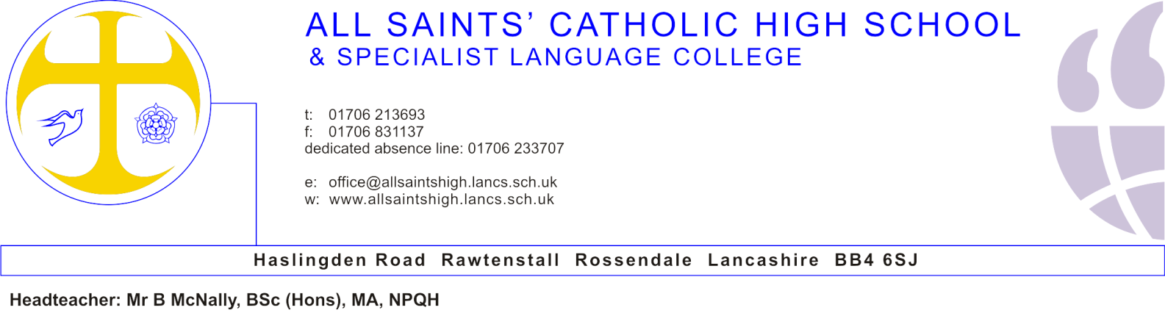
7th March 2018

Dear Candidate,

Teacher of Religious Education
I am delighted to provide further details about the permanent post of Teacher of Religious Education, as advertised.
We were thrilled to be the first school in the area to be inspected under the new rigorous Ofsted framework and to be judged as a good school. Our report can be distilled into; “The school is improving rapidly due to strong leadership. Pupils’ achievement and progress are good. Our pupils are thriving in a traditional academic approach, in a safe environment where teachers have high expectations” (Ofsted, 2016).
We were also delighted with further affirmation from inspectors that All Saints’ is a good school, during our recent Section 48 inspection. “There is a collective ambition to improve outcomes for all pupils” (Section 48, Nov 2016) and we are looking for an outstanding Teacher of Religious Education who shares that ambition, and who will make a significant contribution to raising attainment and progression for all pupils in religious education, alongside supporting the whole-school Catholic ethos.
Professional development has a high priority, and staff have regularly been promoted internally and to other schools. Our support and induction programmes are very good. This is a full time, permanent position required from 1st September 2018. Applications are welcome from experienced teachers and NQTs.
Following your examination of the enclosed information, I hope you will feel able to apply for this post. Applications should be forwarded to Mrs T Torr, School Business Manager, t.torr@allsaintshigh.lancs.sch.uk. The closing date for applications is Friday 23rd March at 12 noon. Interviews will take place as soon as possible thereafter.
Yours sincerely
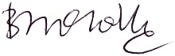
B McNally
Headteacher
Enc.

