Bullers Wood Multi- Academy Trust
Bullers Wood School for Boys
C/o St Nicolas Lane, Logs Hill, Chislehurst, BR7 5LJ
Email: gnewton@bullerswood.bromley.sch.uk

www.bwsboys.org

Part-time Teacher of Spanish
(or FT depending on the candidate’s second subject)
Outer London Pay Scale

Closing date: Tuesday 22nd May, 2018 – 9am

Dear Candidate
Thank you for expressing an interest in our school. As the founding Headteacher, I am delighted to welcome you to Bullers Wood School for Boys, an exciting, new, boys’ comprehensive school for Bromley.
We will open in September 2018 providing 180 places for boys living in the local area. Over the next five years we will grow to accommodate 900 boys from Years 7 - 11. Our ambition is for our boys to progress on to Bullers Wood Sixth Form, located on our partner school site, Bullers Wood School for Girls.
For the first two years, we will be based in temporary accommodation in the centre of Bromley, moving to a brand new building, located at our permanent site, St Hugh’s Field, Bickley in September 2020.
Our aim is to provide an outstanding education for boys within a culture of high aspiration, courtesy and respect. It is our core belief that all of our boys can enjoy and achieve success whatever their starting points.
The next few years will be a very exciting time for us as we establish, grow and develop as a school. However, this journey will not be without its challenges. Therefore, attracting the very best staff is key. We are seeking staff who are passionate, engaging, driven, resilient and flexible. Most of all, staff who are unafraid of rolling their sleeves up and getting stuck-in when necessary.

In return, we offer you the chance to be part of a pioneering team, creating a fantastic school serving this local community. We also offer you the support network of our established partner School, Bullers Wood School for Girls, as well as opportunities for enhanced professional and career development within the School and across BWMAT.

We are building a great school in Bromley that will hopefully serve many generations of boys to come. After reading about us, I hope you will want to be part of our story.
I look forward to welcoming your application.

Yours sincerely,
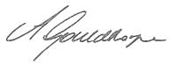

Anne Gouldthorpe
Headteacher
The School
Bullers Wood School for Boys will be a thriving 11 – 16 boys’ comprehensive school situated in the London Borough of Bromley. We will open in September 2018 with our first cohort of 180 boys and will grow year on year until we reach our full capacity of 900 in Years 7 to 11.
When we open, we will become the partner school to Bullers Wood School for Girls, (a successful comprehensive girls’ school with a large, co-educational sixth form), responding to significant demand for more secondary school places, particularly for boys, in the local area.
For the first 2 years we will operate out of our temporary site moving into our brand new £20 million building from September 2020.
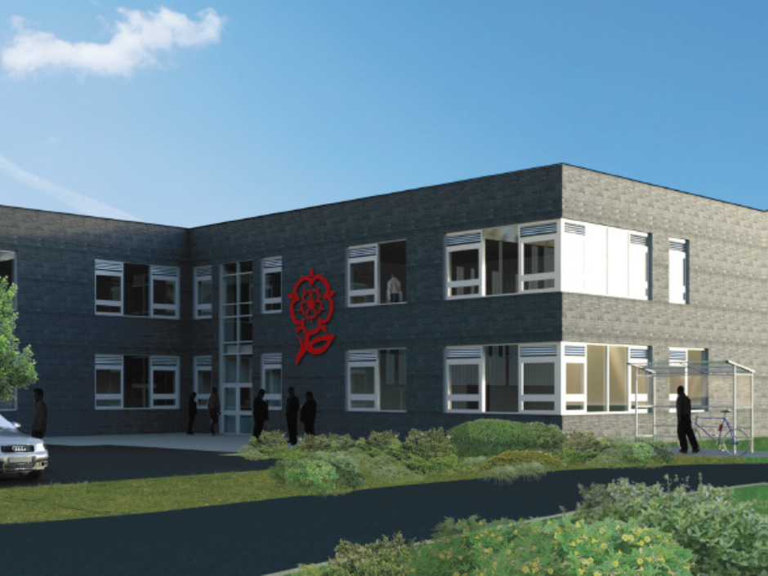
We want to build a staff team at Bullers Wood School for Boys that is relentlessly focused on improving the achievement and opportunities for our boys. All staff working at the school will subscribe to our ethos and values, and will seek to improve and develop their own practice and performance for the benefit of our boys
Working in a new and expanding school is a once in a lifetime opportunity. You will need to demonstrate a commitment to and evidence of success in sustaining academic excellence, help every boy to succeed, be an excellent classroom practitioner, demonstrate that you can work as part of a team, roll up your sleeves and inspire others to excel.
We will provide an academic curriculum with an emphasis on the EBacc suite of subjects (English, maths, sciences, humanities, languages), and Sport. We believe that qualifications in these subjects will be essential for our boys to progress successfully onto the next stage of their careers. Our curriculum will also be responsive to the needs of individuals providing a personalised approach when and where necessary.
Our Ethos
Bullers Wood School and Bullers Wood School for Boys are schools where all children and young people are able to enjoy and achieve success.
Both schools exist to provide all children and young people with high quality learning experiences delivered by teachers who are passionate and able to convey their knowledge effectively and enthusiastically within a stimulating, safe and supportive environment.
Our ultimate aim is to produce well-rounded, confident and successful individuals who enjoy learning, make ambitious progress and achieve high quality and meaningful qualifications. We want them to become emotionally resilient and responsible citizens who make a positive contribution to society, including both their local community and the wider world in which they live.

Our Principles

Bullers Wood School for Boys will have an unremitting focus on learning, and a genuine conviction that each boy has the potential to achieve and enjoy success. We aim to create a culture of caring masculinity where boys develop into and leave us as happy, healthy, resilient and successful young men.
We will:
- Ensure that we deliver outstanding educational provision to local boys
- Provide high quality teaching & learning experiences in a modern technologically rich environment within a culture of traditional values, courtesy & respect.
- Provide an academic education with an emphasis on the EBacc suite of subjects, high value qualifications and Sport.
- Provide extensive extra-curricular opportunities beyond the academic curriculum so that boys can find their niche, experience success and develop self-confidence.
- Ensure that our boys excel and exceed their predicted educational outcomes.
- Ensure that a strong and caring pastoral system underpins and supports boys’ in their academic progress, personal development, mental health and well-being.

Features of Bullers Wood School for Boys
- High quality teaching and learning that raises boys’ achievement, removes barriers to learning, develops a growth mind-set and is tailored to the ways boys learn.
- Seamless progression from KS2 to KS3 so that there is no loss in learning, progress and attainment between key stages.
- An academic curriculum with an emphasis on the EBacc and other high value subjects- but one that is also responsive to the needs of each individual student, providing support and stretch where necessary. This will enable our boys to achieve the qualifications they need to progress successfully to some of the top H.E. institutions in the country.
- A fundamental belief that being literate and numerate is key to accessing the curriculum - and as a non-selective mainstream boys’ school with a comprehensive intake, we will create a curriculum to address these needs quickly and from the outset.
- Innovative technology to support successful learning and extensive IT systems to manage data and communication efficiently and effectively.
- Extra-curricular opportunities beyond the academic curriculum so that boys can find their niche, experience success and develop self-confidence. This will also include competitive sport.
- A strong and caring pastoral system where every boy is known and feels listened to and supported - achieved through a team of pastoral leaders and tutors who will provide high quality care, guidance and support to boys on a daily basis and throughout their time at the School.
- Powerful partnerships between the schools within the BWMAT, parents and the local community. Parents are integral to their sons’ long term success through their engagement and support of the School.
- A personal development programme that enables boys to develop into confident, independent, courteous and respectful young men. This programme will address not just QCA requirements, but also develop self-confidence, leadership, organisation, resilience, and independence and communication skills in boys.
- The development of student leadership so that boys can share in the decision making processes of the School, act as role models and support others academically and interpersonally.
- Firm discipline and clear boundaries with high expectations of attendance, punctuality, uniform and attendance balanced by a reward system that celebrates endeavour and success.
Expectations

At Bullers Wood School for Boys, we expect our teachers to:
- Have a passion for education and be open to innovative approaches in everyday aspects of school life
- Be passionate about their subject area and lifelong learning
- Be committed to securing the best outcomes for all boys in the school
- Offer enrichment and extra-curricular experiences related to their subject area and beyond
- Be committed to ensuring that Bullers Wood School for Boys becomes a centre of excellence for Sport
- Contribute to the overall development of the school
- Be flexible in their approach, adapting to new challenges
- Be prepared to teach a second subject (particularly in the early years of opening)
In return, we will offer you:
- The opportunity to be part of a forward thinking team
- The opportunity to work with pastoral and subject leaders to create an exciting and engaging curriculum
- Access to the latest technology to assist in delivering and developing outstanding teaching and learning
- The opportunity to strategically shape the future of the School
- The opportunity to be part of a pioneering team creating a fantastic school for boys in our local community
- Enhanced professional and career development
- The opportunity to work across both schools in our Trust

The Post and Specifications

Position: P/T Teacher of Spanish

Reports to: Headteacher

Individual Job Description

This is an excellent opportunity for an outstanding, ambitious and passionate teacher to establish the teaching of Spanish at this new school. You will have the support of the Boys’ school’s leadership team as well as the more established and experienced MFL department at our partner school.

There is the potential from September 2019, for the post to grow into a full time teaching post as the school roll increases.

The successful candidate will also be part of the Year 7 tutoring team.

Classroom Teacher Responsibilities:
All teachers will:
- Provide positive support and guidance with regard to the personal, academic, social and moral development of all students.
- Provide a high quality educational experience for all students.
- Help the school achieve its purpose, aims and values
- Carry out the duties of a School Teacher as set out in the School Teachers Pay and Conditions Document.
- Continue to meet the Professional Standards for Teachers in England
- Follow school, Trust and departmental procedures.
- Support the school ethos and adhere to school policies
- Be committed to safeguarding and promoting the welfare of children and young people
- Be aware of and actively promote the school’s/Trust’s aims, values, priorities, targets and action plans.
- Have a secure knowledge and understanding of specialist subject(s)
- Have a detailed knowledge of the relevant aspects of the students’ National Curriculum and other statutory requirements.
- Understand progression in specialist subject(s)
- Cope securely with subject-related questions which students raise and know about students’ common misconceptions and mistakes in their specialist subject(s).
- Identify clear teaching objectives, content, lesson structures and sequences appropriate to the subject matter and the students being taught as identified in the school’s Teaching & Learning policy
- Set appropriate and demanding expectations for students’ learning and motivation.
- Set and monitor clear targets for students’ learning, building on prior attainment.
- Ensure effective teaching of whole classes, groups and individuals so that teaching objectives are met, pace and challenge are maintained, and best use is made of teaching time.
- Use teaching methods which keep students engaged, including stimulating students’ intellectual curiosity, effective questioning and response, clear presentation and good use of resources.
- Participate in preparing and presenting students for public examinations
- Identify students who have special educational needs, and implement and keep records
- Identify students who are gifted and talented and provide appropriate stimuli
- Assess how well learning objectives have been achieved and use this assessment and school provided data on a regular basis for future teaching and target-setting.
- Keep regular records of student progress
- Set homework in accordance with the School’s Homework Policy
- Mark and monitor students’ class and homework providing constructive oral and written feedback, setting targets for students’ progress.
- Understand the demands expected of students in relation to the National Curriculum, KS4 and post-16 courses.
- Record and report on student progress, following school and departmental policy.
- Set high expectations for students’ behaviour, establishing and maintaining a good standard of discipline through well-focused teaching and through positive and productive relationships, following the school systems.
- Consistently apply the school’s Behaviour Management policy, encouraging positive behaviour, using the classroom code and taking appropriate action in cases of indiscipline
- Prepare and present informative reports to parents.
- Attend parents’ evenings and Open Evenings as required
- Recognise that learning takes place outside the school context and provide opportunities to develop students’ understanding by relating their learning to real and work-related examples.
- Be prepared to liaise with agencies responsible for students’ welfare.
- Take responsibility for own professional development and to keep up-to-date with research and developments in pedagogy and in the subjects taught, within the context of the School/Trust Improvement Plan.
- Understand professional responsibilities in relation to school policies and practices.
- Set a good example to the students in presentation and personal and professional conduct.
- Evaluate own teaching critically and use this to improve effectiveness.
- Participate in school system of performance development
- Participate in arrangements for further training and professional development, including INSET
- Attend and participate in departmental and other meetings as required.
- Establish and maintain effective working relationships with colleagues including support staff.
- Advise and co-operate with all colleagues on the preparation and development of courses of study, teaching materials, teaching programmes, methods of teaching, assessment and pastoral arrangements
- Select and make good use of textbooks, ICT, DVD/video, internet and other learning resources which enable teaching objectives to be met.
- Be familiar with and comply with the School’s Health and Safety policies
- Be responsible for the health & safety of students when they are authorised to be on school premises and when engaged in authorised activities elsewhere
- Prepare risk assessments as appropriate
- Take class register on SIMS and inform the office of any concerns
- Undertake any other professional requirements specific to this post.

This job description may not necessarily be a comprehensive definition of the post. It will be reviewed as appropriate and may be subject to modification or amendment at any time after consultation with the holder of the post.
Person Specification
The successful applicant is likely to demonstrate the following qualities:

Knowledge & Experience
- A good degree in a relevant subject
- Qualified Teacher Status (QTS)
- A clear philosophy on how and why Spanish should be taught
- Subject knowledge sufficient to challenge students and achieve high outcomes
- Awareness of the strategies available for improving the learning & achievement of students
- A good understanding of curriculum developments in the specific subject area
- Recent relevant professional development
- An excellent classroom practitioner

Skills & Abilities
- Able to use a range of teaching & learning strategies
- An understanding of how assessment for learning can improve student performance
- A confident & competent user of ICT in the teaching of the subject to enhance student learning
- Able to use student level data to raise standards
- Able to communicate both orally & in writing to students & their parents
- Be willing to be fully engaged in the whole life of the school
- Have a commitment to team work

Personal Qualities
- Enthusiasm & a positive outlook
- The ability to motivate, support, inspire and work collaboratively with a team of specialist staff, teaching and support
- The ability to work independently and collaboratively as a member of a team Commitment to high student expectations
- Creative in problem solving together with a willingness to take on or try new approaches & ideas
- Commitment to extracurricular activities
- A positive attitude towards professional development and own learning
- Reliability & integrity
- Good personal organisation
- Excellent record of attendance and punctuality
- Commitment to high standards and expectations

In addition the successful candidate must be willing to uphold the ethos and policies of the school, including the commitment to safeguarding and promoting the welfare of children and young people.

Salary
The DfE no longer publishes any pay scale points for reference. Pay scales at Bullers Wood are based on previous STPCD pay scale points for ‘Main’, ‘Upper’ and ‘Leadership’ pay scales uprated as appropriate in line with guidance set out by the STPCD.

APPLICATION PROCEDURE

- Read carefully all the information about this post
- If you have any questions, please do not hesitate to telephone or email Gill Newton, Human Resources Manager, on ext 359 or gnewton@bullerswood.bromley.sch.uk). Please also contact her if you wish to have a discussion with the Headteacher, Anne Gouldthorpe before applying.
- Complete the application form as fully as possible. If there is insufficient room on any section of the form, please provide the additional information on a separate sheet. Please note that your application form will be photocopied for the Selection Panel, therefore clarity is essential. It is important that you do not leave any gaps in your career history – any gaps in employment should be fully explained please.
- In section 8 Letter of Application, please tell us
  - Why you are applying for this post
  - How your experience, skills, training and/or qualifications equip you for it i.e. how you meet the person specification and requirements of the job description.

Send your completed application form by fax, email (if downloaded from our website) or through the post to:-
Mrs Gill Newton
Human Resources Manager
(Bullers Wood School for Boys)
c/o Bullers Wood School
St Nicolas Lane, Logs Hill, Chislehurst, Kent BR7 5LJ
gnewton@bullerswood.bromley.sch.uk

Please send your application by Tuesday 22nd May 2018 – 9am
Appointment Process

- Suitable applications will be shortlisted for interview as quickly as possible.
- If you are successful, you will receive either a phone call and/or email inviting you to attend for interview. It is therefore important that you give us a daytime telephone number and/or an email address that you regularly access so that we can contact you to make the necessary arrangements if you are shortlisted.

If you require any assistance in attending for interview, please let us know the nature of that assistance in good time so that we may make appropriate arrangements.
iii. Candidates called to interview will:
- Usually have an opportunity to meet key staff
- Have a tour of the School (this will not be possible for September 2018)
- Normally be expected to conduct a short teaching task to students that will be observed by one or more members of staff and usually include the Headteacher and/or deputy Headteacher and the Head of department. Details of the task will be given in advance.
- Have an interview and presentation with members of the Senior Leadership Team and Governors.

.

