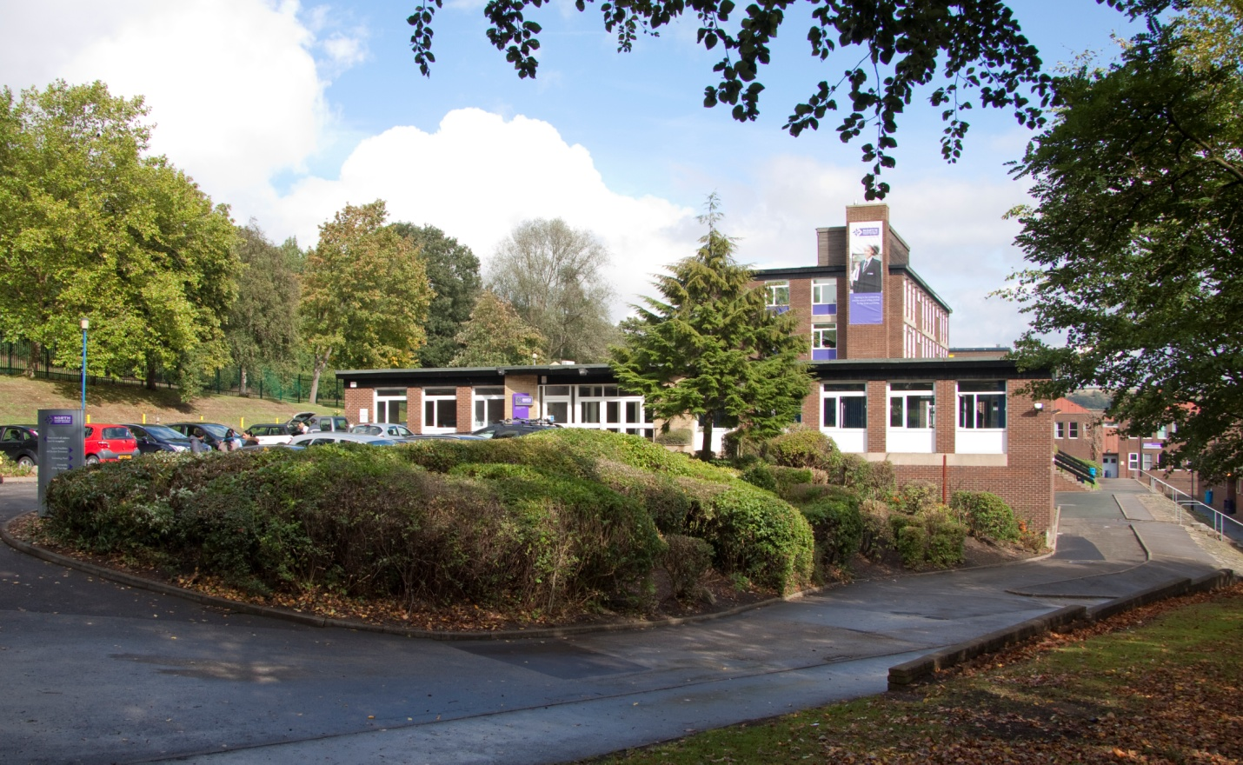

Vacancy: Student Support Officer: On Call
Applicant Information Pack

Welcome

Thank you for your interest in this vacancy at North Huddersfield Trust School. We hope that you find the information within this pack useful and that it helps you to build a good picture of the exciting opportunities at the school.

North Huddersfield Trust School is now 6 years old and as we continue to move from strength to strength, our growing student numbers reflect that families are recognising the hard work of staff and students in creating a school of which the local community can be justifiably proud.
Ofsted has recognised us as a “Good” school which is outstanding in its work in keeping students safe and secure and for students’ personal development and well-being. We will continue to drive forward standards and ensure that we provide the best education for our students. Above all, our main priority is that we have a happy school where students feel safe, well-supported and able to thrive to achieve their full potential, so that when they leave us at 16 they are well-rounded, confident young people who will willingly contribute to their local community and far beyond.
Whilst we are aware of the fantastic progress we have made we will not rest on our laurels and have a clear plan for further improvement. There are a whole range of challenges ahead, but with these challenges come opportunities and excitement.

Thank you again for taking in interest in North Huddersfield Trust School and we look forward to hearing from you.

Loz Wilson
Head Teacher

Vacancy Details

Post: Student Support Officer: On Call

Grade 7 (£19,273 -£20,533)
Permanent Contract
37 hours per week, term time + 5 training days

Ofsted has recognised us as a “Good” school, which is outstanding in its work in keeping students safe and secure and for students’ personal development and well-being. We will continue to drive forward standards and ensure that we provide the best education for our students. We are passionate about maximizing the potential in our students and our caring and nurturing approach helps us achieve this.

We are looking to recruit a Student Support Officer: On Call to provide support for colleagues across the school in instances where students’ behaviour is causing disruption to teaching and learning. To build positive and supportive relationships with students and parents in particular, those students whose behaviour or attendance is cause for concern.

If you wish to apply for this vacancy, please apply through the TES Website www.tes.com or North Huddersfield Trust School website www.nhtschool.co.uk. Applications should be returned to Mrs Nora Brown, Operations Manager, by email to nbrown@nhtschool.co.uk by 12 midday on Friday 29th June.

We are committed to safeguarding and promoting the welfare of children and young people. An enhanced DBS is required for successful candidates.

Woodhouse Hall Road, Huddersfield, West Yorkshire, HD2 1DJ 01484 452100
www.nhtschool.co.uk

JOB DESCRIPTION
Role | Student Support Officer: On call
Grade (SCP) | 7 (23-25)
Weekly hours | 37 hours (flexible pattern)
Non-term time arrangements | Term time + 5 training days

Job Summary
To provide support for colleagues across the school in instances where students’ behaviour is causing disruption to teaching and learning. To build positive and supportive relationships with students and parents; in particular, those students whose behaviour or attendance is cause for concern.
Key Responsibilities:
- On call
- Student support
- General
Duties
Key accountabilities | Key tasks
On call | - Through operational management of the On Call system, support teachers in the management of disruptive learners and help reduce the behaviour management workload, allowing classes to focus on teaching and learning  - Use Restorative Practice principles to resolve differences and enable the student to re-enter the classroom to continue their learning without being disruptive  - Play an active part in the school’s student support systems, including working with the Student Development Centre, to encourage students to manage their own behaviour and work better with others  - Provide guidance and support for students where necessary  - Share on call information with colleagues, parents and other stakeholders as required  - Work with senior colleagues to develop strategies and practice that reduce the need for on call  - Promote a positive working attitude and set an excellent example for students, in particular those who display extreme behaviour  - Assist with the supervision of students when they are not in lesson time, including break and lunch time duties as required  - Assist with day to day operational aspects of the school’s work as required  - Support and contribute to initiatives and policies designed to improve behaviour across the school  - Produce and communicate data on on call incidents as required  - Attend meetings as required
Targeted support | - Work with colleagues to identify students most at risk of failing their potential through behavioural or attendance issues  - Under the guidance of senior leaders, offer 1:1 and small group support to targeted students to improve attendance and behaviour and reduce exclusions  - Provide support for the school’s Attendance Officer in building relationships with parents and students to improve attendance, particularly for persistent absentees  - Provide individual and group support of targeted students to ensure that all students understand how to achieve their full potential  - Develop one to one and group mentoring relationships with students who require particular support to achieve their targets  - Build relationships with parents, including home visits as appropriate, of targeted students to support and nurture students to improve standards  - Produce regular reports for stakeholders to reflect the impact of the targeted support / mentoring programme  - Attend meetings as required
General | - Always uphold the school’s PRIDE agenda  - Adhere to strict standards of confidentiality  - Ensure compliance with data protection, equal opportunities, health and safety and safeguarding regulations, policies and guidance  - Undertake training and continuing professional development as required

This job description is not necessarily a comprehensive definition of the post and may be subject to modification or amendment at any time after consultation with the post holder. Additional duties may be requested from time to time which are commensurate with the post.
We are committed to safeguarding and promoting the welfare of children and young people and all post-holders are expected to share this commitment.
Reports to: | Assistant Headteacher (Behaviour)
Responsible for: | -

PERSON SPECIFICATION
 | ESSENTIAL | DESIRABLE
Education / training | - Maths and English GCSE at Grade C or above, or equivalent | - Positive Handling / Team Teach (or similar behaviour management) training
Experience | - At least 2 years’ experience of working with students aged 11-16  - Proven ability to work with challenging students | - Previous on call experience  - Experience of working in a school setting
Specialist knowledge / skills | Training will be given
Personal skills | - Ability to build positive working relationships with students, staff and parents  - Ability to remain calm and positive in challenging situations  - Ability to prioritise tasks  - Outstanding communication skills  - Professional resilience  - A sensitive and diplomatic approach
General | - Excellent understanding of safeguarding guidance | - A good understanding of school policies

