a

Primary Class Teacher
Application Pack

Welcome to Atlantic Academy Portland, Jewell Academy Bournemouth and Ocean Academy Poole.

Thank you for considering our academies for your next appointment.

We are passionate about excellence in education, giving pupils the very best start in life with a firm belief that excellent teaching transforms lives. Our core belief is that for all students to have high aspirations they must believe in themselves, be actively engaged in their learning and see the connection between what they learn today and who they want to become tomorrow.

We are looking for qualified teachers to join our 3 academies in the South Coast. Ocean Academy Poole and Jewell Academy Bournemouth.

It is an excellent opportunity for someone wishing to further their career, with development opportunities to either take on TLR responsibilities and/or become a Specialist Leader of Education (SLE) or Aspirant Lead Practitioner/Lead Practitioner (paid on the Leadership pay scale).

Positions are available across the 3 academies with full time teaching positions available from September 2018 but there is the exciting opportunity of an earlier start for the right candidate.

With great students who behave impeccably, an outstanding team of staff, state of the art facilities, and very pleasant locations in beautiful Dorset, our academies offer excellent opportunity for ambitious, talented individuals looking to develop their career. Ofsted have highlighted our very effective staff training and support and outstanding CPD.

As part of a newly designated NCTL Teaching School and National Support School Alliance, with Magna Academy, you would be joining us at a very exciting time and become part of a vibrant learning community that will offer you fantastic opportunities for CPD, career development, future promotions and for you to be able to make your mark.

Whatever your level of experience, there will be opportunities for career development and promotion either within individual academies or across the Trust. Excellent further professional development is supported by the innovative and unique Aspirations training program, The Aspirations Leadership Incubator (ALI) for aspiring senior leaders.

Atlantic Academy Portland is an all through academy with Reception to Year 11 (post 16 from 2018)

Atlantic Academy is located in stunning buildings, having benefitted from a £20 million plus full renovation program. It is situated on the beautiful Isle of Portland, at the heart of the Jurassic Coast, in Dorset within easy reach of Weymouth, Dorchester, Yeovil, Poole and Bournemouth. This really is an academy at the very heart of the community. There is also the potential for onsite accommodation be made available at a subsidised rate.

Jewell Academy Bournemouth is a primary academy with Reception to Year 5 (Year 6 from 2018)
Jewell Academy Bournemouth is a primary academy in north Bournemouth which opened in September 2013 with just Reception and Year 1 pupils, and has grown year on year. It currently has pupils up to Year 5 and will be at full capacity in 2018 when those pupils reach Year 6. It was judged outstanding in all areas by Ofsted in June 2015.
Ocean Academy Poole is a junior academy with Year 3 to Year 5 (Year 6 from 2018)
Ocean Academy Poole is a new junior academy which opened in September 2015 close to the center of Poole. It has gained an excellent reputation locally and is already oversubscribed. It currently has Years 3, 4 and 5 pupils and from 2018 will be at full capacity when those pupils reach Year 6.
The Academies are sponsored by the Aspirations Academies Trust (www.aspirationsacademies.org) and are a member of one of their three clusters: The South Coast District, which consists of Jewell Academy Bournemouth (Primary, rated outstanding), Ocean Academy Poole (Junior, to be inspected), Magna Academy Poole (Secondary, rated outstanding) and Atlantic Academy Portland (All through, to be inspected). The district members will work closely together sharing resources, expertise, CPD and providing specialist support where appropriate.

You would be joining us at such an exciting time and become part of a vibrant learning community that will offer you fantastic opportunities for your career development. This really is a chance for you to be able to make your mark.

Please indicate on your application form if you wish to be considered for a position at a particular academy or are able to take a role across the district.

Yours faithfully

Claire Addis
Executive Principal

If you would like to take your career to a very different level then please apply through TES online.

For an informal chat about the post or to arrange a visit please contact:
For an informal chat about the post or to arrange a visit to please contact:
Atlantic Academy, Elaine Clayton: eclayton@atlantic-aspirations.org
Jewell Academy, Sarah Lowe: office@jewell-aspirations.org
Ocean Academy, Jane Burry: office@ocean-aspirations.org

Closing date for applications: Friday 23rd February
Interviews: Week commencing Monday 26th February
For more information please visit: www.aspirationsacademies.org

To be able to dream about the future, while being inspired in the present to reach those dreams. Dr Russell J Quaglia

The Aspirations Academies Trust –Company Registration Number 07867577
Chief Executive: Steve Kenning

The Aspirations Academies Trust
The Aspirations Academies Trust (AAT) as a sponsor of primary and secondary age academies in England, is committed to raising students’ aspirations so that all young people reach their fullest potential and achieve the success they want for themselves.

The Aspirations Academies Trust in England benefits from QISA’s (The Quaglia Institute for Student Aspirations) remarkable record of more than 30 years of research and experience working with students, educators, and schools.

Aspirations is the ability to dream about the future while being inspired in the present to reach those dreams. The Aspirations Academies Trust was set up in England with the vision to combine the thirty years of educational research by Dr. Russ Quaglia on student aspirations with effective and innovative school improvement techniques in order to create truly outstanding schools that would fully prepare students to succeed in this exciting world.

Central to the philosophy of the Aspirations Academies Trust is the innovative Aspirations Framework developed by the Quaglia Institute for Student Aspirations (QISA) which outlines the belief that for all students to have high Aspirations, three Guiding Principles must be present: Self‐Worth, Engagement, and Purpose. These Guiding Principles direct the development of educational experiences from the individual classroom to the entire school building. The Three Guiding Principles, in turn, are lived out through 8 Conditions that emphasise relationships, active and engaging teaching and learning, and a sense of responsibility over one's own aims and goals.

The 8 Conditions are: Belonging, Heroes, Sense of Accomplishment, Fun & Excitement, Curiosity & Creativity, Spirit of Adventure, Leadership & Responsibility and Confidence to Take Action. Students who have high aspirations believe in themselves, are meaningfully engaged in their learning and the life of the school and work with intention toward their goals.

Our Aspirations Academies have a commitment to make certain that all young people achieve their fullest academic potential and become responsible citizens. To achieve this goal we are dedicated to promoting and putting into practice the Three Guiding Principles and 8 Conditions that foster student aspirations. Each Academy strives to ensure that all students have the opportunity to discover and appreciate their endless promise for a successful future.

The Aspirations Academies Trust considers that its beliefs and principles are applicable and effective with students from age 3 to 18. Each stage of a child’s education is extremely important ‐ pre‐school, primary and secondary ‐ and should, where possible be coherent across the phases of education in the practice of developing the principles and conditions central to the beliefs and aims of the Aspirations Academies Trust. For this reason, we support primary, secondary and, where possible, all through (Ages 3‐18) academies.

At whatever stage a child joins an Aspirations Academy, whether it is at the age of three or sixteen, the aim is to provide each individual child with the best possible life chance. This is done through the achievement of the highest level of qualifications, the development of skills essential to success in an interconnected and highly competitive world, as well as encouraging the highest aspirations, expecting every student to gain a place at university or enter skilled employment.

South Coast District

South Coast District

Our Academies
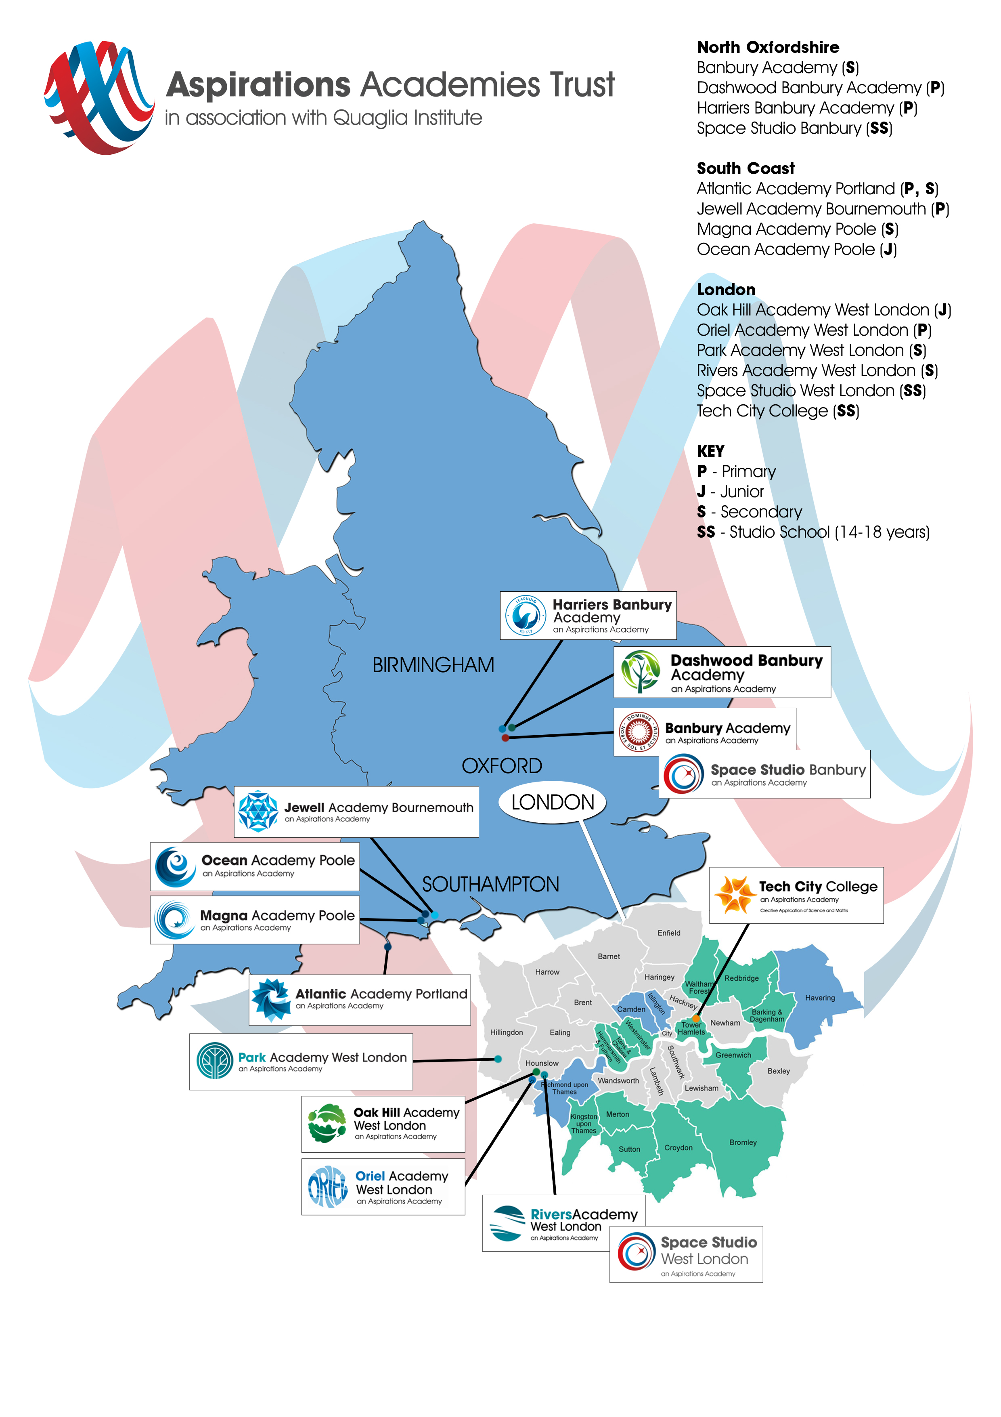

South Coast District

Continuous Professional Development
We offer unique and bespoke training for staff at all levels. This includes the Aspirational Senior Leaders Programme. For teachers we have the Level 1 - Understanding Aspirations Programme, Level 2 – Aspirations and Outstanding Programme, Polishing Pedagogy Programme and Agents of Change Programme, complimented by various staff Coaching and Mentoring training. For support staff we offer an Understanding Aspirations Programme. Staff will be supported to develop a positive orientation to professional learning as reflective practitioners and will be empowered to take ownership and responsibility for their professional learning and development.

We strive to embed the voice of students (for example, through My Voice, iKnow My Class Surveys and student voice and leadership developments) and the active engagement of students in the process of CPD and staff professional learning.

Promoting Aspirations Project
CPD in AAT Academies will have a research orientation. All staff will be expected to engage annually in a Promoting Aspirations Project and make use of research reports to inform their practice. The Promoting Aspirations Project is undertaken over the course of an academic year. Staff can conduct their Promoting Aspirations Projects alone or in collaboration with a small group of colleagues from within their academy or across Aspirations Academies. Innovation Awards will be given to the best projects and they will be shared with other staff at the yearly forum when all staff from all academies come together for an exciting event.

South Coast District

Unique Resources

Available to our academies are some unique resources that include:

My Voice Surveys are designed to measure the 8 Conditions across an entire school. Available for students, staff, and parents, these online surveys take about 15 minutes to complete and provide survey administrators with real-time reports. By utilizing My Voice Survey Reports, teams of educators and students can work together to develop shared objectives and inspire meaningful improvements within their schools.

iKnow My Class is an online, formative course assessment that helps educators discover students' perspectives about themselves as learners, course content, and instruction. Survey questions are based on more than 20 years of aspirations research, and are designed to help teachers promote the conditions that inspire students to achieve their fullest potential.

My Aspirations Action Plan (MAAP) focuses everything we know about educational "next practices" into an integrated, practical system. This revolutionary, online portfolio provides students with an active voice in their own learning by allowing them to set goals and track their academic achievement and personal growth along the way.

Using progressive gaming and mobile technology, this interactive and engaging platform also invites teacher participation so they can better understand their students' personal and academic aspirations, and guide their progress toward those goals. MAAP additionally allows optional access to parents, and selected students for peer mentoring.

Not just for students. We also have a staff MAAP so you can track your own personal goals and professional development.

Safe Recruitment Procedure

The AAT is committed to safeguarding and promoting the welfare of children and young people in its academies. In order to meet this responsibility, its academies follow a rigorous selection process to discourage and screen out unsuitable applicants. This process is outlined below, but can be provided in more detail if requested.

Disclosure
This post is classified as having substantial access to children, and appointment is subject to an enhanced police check of previous criminal convictions (DBS). Applicants are required, before appointment, to disclose any conviction, caution or binding over including ‘spent convictions’ under the Rehabilitation of Offenders Act 1974 (Exemptions) Order 1975. Non-disclosure may lead to termination of employment. However, disclosure of a criminal background will not necessarily debar individuals from employment – this will depend upon the nature of the offence(s) and when they occurred.

Shortlisting
Only those candidates meeting the relevant criteria indicated in the personal specification will be taken forward from application.

Interview
Longlisted candidates may be subject to a screening interview. Those shortlisted will take part in an interview with questions relating to the job description and person specification and may also have to take part in a selection exercise such as a lesson observation.

Where necessary, candidates will be asked to address any discrepancies, anomalies or gaps in their application form.

Reference checking
At least two references will be requested, normally from the previous and current employers. These may be contacted before the interview and in all cases before an offer of appointment is confirmed.

