Teacher of Mathematics
Permanent
Full or Part Time
Newly Qualified Teachers, Main pay Scale or Upper Pay Spine
Starting Autumn Term 2018

Content

Vision, Values and Ethos |  | Page 3
Department Profile |  | Page 4-5
The Application Process |  | Page 6
Vacancy Advert |  | Page 7
The Role |  | Page 8
Letter from the Head of School and CEO/Executive Headteacher |  | Page 9
Job Description |  | Page 10-11
Person Specification |  | Page 12-13

Vision, Values and Ethos

Vision: | Bosworth Academy to be consistently outstanding in both OFSTED terms but more importantly in its delivery of outcomes for young people in and for, our community. Bosworth Academy is an unstoppable force for affecting social mobility.
Values: | ‘No student will underachieve’ means: Outstanding outcomes for every child of every ability from every background no matter what the barriers.  ‘Be better than you thought you could be’ means: We understand that our role is not to ensure students reach their potential, it is to help define that potential.
Ethos: | We do this in an environment which is inclusive, exciting, varied and highly aspirational. The individual is recognised and celebrated. We strive for excellence and challenge in all that we do and seek out feedback and positive criticism. We believe in the capacity for continual improvement and appreciate the role of leadership. We never give up and never accept that our work is done. We enjoy and achieve and embrace our responsibility as a force for good. We can and will make a difference through the empowerment of learning.

Mathematics Faculty
About us…
The Maths team at Bosworth currently consists of 11 full time specialists with a variety of skills and strengths. All of the team are committed to doing well, are supportive of each other and work effectively together.
The management team in Maths is composed of the Team Leader, a Team Co-ordinator (TLR2b) and two Assistant Team Co-ordinators (1 TLR2b & 1 TLR2a).
In addition to the teaching staff we have two Learning Support Assistants linked specifically to Maths who work in classes to aid those with learning difficulties. We also have two maths Tutors to provide one-to-one support to targeted students.
The Mathematics Curriculum
Key Stage 3
2017 saw our fourth intake of Year 7 students. We have made the decision to introduce the internationally renowned ‘Singapore Maths Scheme’. This places an emphasis on moving from concrete representation to pictorial and finally abstract methods to solve problems.
Key Stage 4
Students at Key Stage 4 currently follow the AQA Mathematics GCSE. Less able students are entered for an Entry Level qualification.
Maths results at GCSE have been improving year on year. In 2017, 61% of our students achieved grade 5-9 and 27% grade 7-9 and we have also seen significant improvements in the measures of progress across all groups. Our challenge currently is to ensure that our level of achievement is not merely maintained but is improved upon still further. We also enter a small number of our most able Year 11 students for the AQA Level 2 Further Mathematics qualification.

Mathematics Faculty Continued

Post 16
Mathematics is one of the most popular A Level subjects at Bosworth, and one of the most successful.
There are currently 3 AS groups in Year 12, and 3 A2 groups in Year 13. Students follow the AQA GCE course at AS and A2.
We also have a group studying Further Mathematics in each Year 12 and Year 13, following the Edexcel specification.
We were one of the partner schools in the Cambridge Mathematics Education Project (Underground Maths) aimed at enhancing the teaching and learning of Mathematics at A Level.
There is also the facility for students to join a retake GCSE group if appropriate.

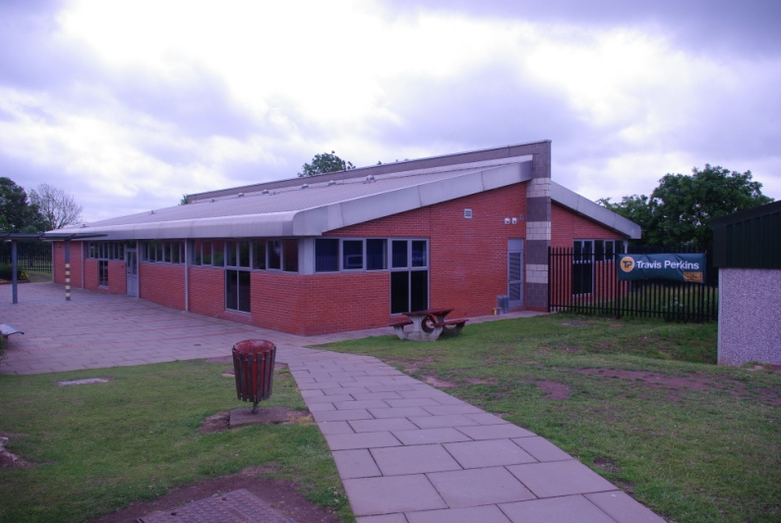
General Information, accommodation and resources
Recent areas of focus for our planning work have included approaches that encourage the development of problem solving skills, developing lesson plans that follow the Academy model for outstanding, making maths real, and, identifying opportunities and strategies to engage students in active learning.

The Application Process

Complete application should be returned to hr@bosworthacademy.org.uk

Or by post to

F.A.O. Mrs Carly Harper,
Bosworth Academy,
Leicester Lane,
Desford
LE9 9JL

A letter will be sent to shortlisted candidates with details of the interview process.

Queries

If you have any queries on any aspect of the application or need additional information please contact Mrs Carly Harper, HR Manager on 01455 822841

Thank you

The Advert

Teacher of Mathematics
Permanent
Full or Part Time
Newly Qualified Teachers, Main Pay Scale or Upper Pay Spine
Required from 23rd August 2018.

Bosworth Academy is a popular and expanding 11-19 school, within the LiFE Multi-Academy Trust, which is increasingly the school of choice for parents in the area. We are seeking to appoint a committed and enthusiastic teacher of Mathematics. The successful candidate will have a real passion for their subject and the ability to translate this for the students in their care. You will have the desire to ensure that our core value of ‘no student will underachieve’ is fulfilled.
We have high expectations of all our staff, which makes our faculty an exciting and progressive environment in which to work. The team is forward thinking and extremely supportive of each other, working collaboratively to secure high standards of teaching and learning. We are passionate in our goal of ensuring that our students get every opportunity to be the best they can possibly be. Students in Mathematics achieve GCSE grades significantly above national averages and progress is significantly positive.
Bosworth Academy is the lead school in the LiFE Multi Academy Trust which has been recognised by Ofsted as an ‘Outstanding’ school in our recent inspection (3-4th October 2017). We believe our community deserves nothing less. The English faculty has been accredited as an ‘Area of Excellence’ by Challenge Partners and has delivered Leadership Training to schools nationally.
Application forms and further details may be obtained from Mrs Carly Harper (HR Manager) at the address below or can be downloaded from www.bosworthacademy.org.uk
The closing date for completed applications is 12noon on Monday 21st May 2018
“The LiFE Multi-Academy Trust is committed to safeguarding and promoting the welfare of children and young people and expects all staff and volunteers to share this commitment”
Bosworth Academy
Leicester Lane, Desford, Leicester. LE9 9JL
Tel 01455 822841, email hr@bosworthacademy.org.uk
The LiFE MAT CEO/Executive Head Teacher: Mr Chris Parkinson
Bosworth Academy Head of School: Mr Simon Brown

Teacher of Mathematics
Permanent
Full or Part Time
Newly Qualified Teachers, Main Pay Scale,
Upper Pay Scale or Unqualified

Starting Autumn Term 2018

May 2018

Dear Applicant

Permanent Teacher of Mathematics

Thank you for your interest in the above post.

We are seeking to appoint a graduate teacher with energy and enthusiasm who enjoys working supportively with young people as both a subject teacher and a tutor to start in the Autumn Term 2018. Teaching is a challenging job and the person appointed will need to be creative, have stamina and will need a sense of humour. We wish to appoint a teacher who can successfully employ a range of teaching strategies to maximise the potential of our students at key stages 3, 4 and 5.

The successful applicant will join the Mathematics faculty who have strong and committed teachers. There will be a range of developmental opportunities to enhance professional skills. The Academy is a welcoming and friendly place to work. The post would suit an NQT who would receive a full induction and support programme.

The following information is included in this pack:
- Job Profile and Personnel Specification
- An application form can be downloaded from our website
- Details of our most recent Ofsted report can also be found on our website or the Ofsted website.

If you are interested in applying for the post, please complete the following:-
- Application form
- Letter (of no more than two sides of A4), outlining your experience of, and interest in teaching Mathematics as well as indicating how you might contribute to our team.

The Personnel Specification indicates the specific skills and qualities we are interested to see in your letter and application.

Your application should be sent to Carly Harper, HR Manager at the school, by 12.00 noon Monday 21st May 2018.

I look forward to receiving your application.

Yours sincerely

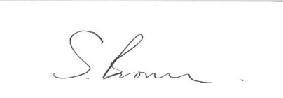

Mr Chris Parkinson Mr Simon Brown
CEO/Executive Headteacher Head of School
The LiFE Multi-Academy Trust Bosworth Academy

Job Profile

Title: | Teacher of Mathematics  Applications from newly qualified teachers would be welcome, a full induction programme is offered
Job Purpose: | To be a member of the Teaching staff of the Academy with specific responsibility for teaching Maths and being a tutor
Responsible to: | The Executive Headteacher, Head of School, Head of Faculty/Maths Coordinators and a Year Head
Responsible for: | - The planning and delivery of effective classroom teaching in Maths incorporating appropriate ICT skills  - Supporting students to achieve their best, whatever their ability  - Monitoring the progress of students within classes taught  - Using effective assessment techniques and providing students with achievable targets and appropriate feedback  - Tutoring a group of students, providing guidance, delivering a PSHE programme, and monitoring their progress across the curriculum  - Liaison with their parents/guardians  - Working collaboratively with colleagues in both Curriculum and year teams  - Ensuring that Academy policies are implemented  - Promoting the Academy ethos
Functional Relationships: | - Membership of the Maths Faculty, subject specialist teams and a Year team  - Liaison with other subject teachers  - Liaison with learning support staff  - Liaison with clerical and technical associate staff
Grade and Salary: | MPS/UPS/NQT/UQ  Applications from newly qualified teachers would be welcome, a full induction programme is offered
Conditions of Service: | Post subject to Teachers’ Pay and Conditions
Specific Duties and Responsibilities
1. Day to Day Management: | - Classroom management and general oversight of the welfare of students in classes and around the Academy  - Implementation of all Academy policies and routines  - Contribute to the continued improvement of the Academy
2. Teaching Role: | As in Teachers’ Pay and Conditions of Service and as directed by the Head of School

Teacher MPS/UPS/NQT/UQ

Applications from newly qualified teachers would be welcome, a full induction programme is offered

Examples of the types of responsibilities and activities associated with the specific duties of this post. This is not exhaustive and will be subject to changing emphasis.
- Day to Day Management

Day to day classroom management activities
Recording Student attendance | Planning and preparing lessons
Assessing students’ work and progress | Producing appropriate learning materials and ensuring students develop key learning skills
Recording student assessment data | Participating in Faculty and whole school planning
Using assessment data to inform lesson planning | Setting achievable/aspirational targets for students
Maintaining effective contact with parents | Working to achieve Faculty and whole school targets
Taking responsibility for the classroom learning environment:  - Display  - Reporting routine maintenance needs  - Monitoring the condition of furniture etc | Implementation of academy policies in relation to:  - Equal Opportunities  - Student Welfare and Behaviour  - Health and Safety,  - Classroom Observation etc
Participating in Staff Development | Teaching the Tutor Programme

Personnel Specification
 | Essential | Desirable
Qualifications | Appropriate Degree  Qualified Teacher | Evidence of a range of supportive professional development  Evidence of post-qualification development
Experience | At least one teaching practice in a comprehensive school | Experience of working with young people in the 11 to 19 age range
Curriculum | Understanding of current curriculum issues with particular reference to the teaching of Mathematics  Enthusiasm for the subject.  Understanding of the importance of the inter-relationship between all areas of the curriculum in a secondary school.  Ability to teach Maths at key stages 3 and 4  Knowledge of ICT applications  Willingness to deliver the Academy’s PSHE programme | Evidence of clear ideas about the delivery of the Maths curriculum to all abilities  Evidence of the production of learning resources  Knowledge of the GCSE syllabus and appropriate ‘A’ level syllabus  Experience of teaching Maths at key stage 5  Ability to contribute to extra-curricular activities  Ability to contribute to the teaching of Computer Science
Management | Understanding of good classroom management techniques  Ability to be part of a Faculty team and a year team | Evidence of effective classroom management strategies  Evidence of being an effective member of a team
Parents and the Community | Understanding the importance of the partnership between parents and Bosworth Academy | Evidence of involvement with Community groups and/or Parents
Personal Qualities | Ability to develop good relationships  Good communication skills  High level of commitment to the Academy  Ability to work in a team, follow instructions and be self-organising  Record of good attendance | Evidence of good working relationships with a range of people  Evidence of a willingness to work hard  Be able to demonstrate that she/he can work as part of a team and be able to meet deadlines and achieve targets

