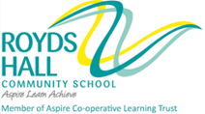

November/December 2016

Dear Colleague

Thank you for your interest in the position of Excellent Practitioner in Humanities at Royds Hall Community School. I enclose an application form together with details of the school and the post for which you are applying. I hope you find the information to be both interesting and useful.

Royds Hall Community School is a successful and over-subscribed community school which encompasses Royds Hall Secondary, Luck Lane Primary and Beech Primary on its own site; currently catering for approximately 1100 students aged 3–16, with a national reputation for innovation and excellence. In collaboration with the local authority and as a result of a shortage of school places in the local area, we became a Through School from September 2014. A new purpose-built two-form entry primary school has been built on our site and will open in September 2016. The primary phase will have 210 students in September 2016 and 420 in September 2020.

We are the Kirklees Specialist Provision Hub for students with Speech, Language and Communication Need. Our school is enriched by its diversity. Approximately 40 per cent of students are from various ethnic minorities and, with more than 26 languages and 30 countries represented in school; we take great pride in our role at the heart of the local community.

We are an active Cooperative Trust school and our community benefits through excellent links with our trust partners, The Science Centre at Sheffield Hallam University, Huddersfield New College, Huddersfield Town Football Club, Holmfirth Fair Traders Association and the University of Huddersfield. We are delighted that two of our local primary schools decided to join the trust from May 2014, enabling our new primary phase to work collaboratively with and share best practice with other primary providers.

‘A good school with many outstanding features….a friendly, welcoming and increasingly successful school…. a very cohesive community…..a well-established trend of improvement….’
Ofsted

At Royds Hall we are delighted to have;
- Happy, confident and aspirational students who express a real pride in their school
- Expert staff in all areas with a passion for learning and a determination to ensure all students maximise their potential
- Calm and purposeful learning environments
- Excellent partnerships between students, parents, staff, governors and community
- A forward-thinking and innovative approach to teaching and learning throughout the school

In September 2011, Ofsted recognised our achievements, finding us to be a good school with a significant number of features, including our care, guidance and support for students, judged to be outstanding. They also highlighted our well-established trend of improvement and mutually respectful relationships between students and teachers which results in confident learners who make ‘remarkable progress’.

Clearly, I am looking for someone who shares my enthusiasm for the school and is prepared to make a major commitment to its future as an Excellent Practitioner in Humanities.

In addition to the Kirklees application form, please describe how your experience to date fits you for the post. (No more than 2 sides of A4)

Applications should be returned to school by 12 noon on Monday 5th December 2016

As we are unable to write to all unsuccessful applicants, if you do not hear from me again, may I thank you again for your interest and wish you every success with any other applications you may make. Due to time constraints we are only able to provide feedback to applicants who reach the interview stage.

The school is committed to safeguarding and promoting the welfare of children and young people and expects all staff and volunteers to share this commitment.

I look forward to receiving your application.

Yours sincerely
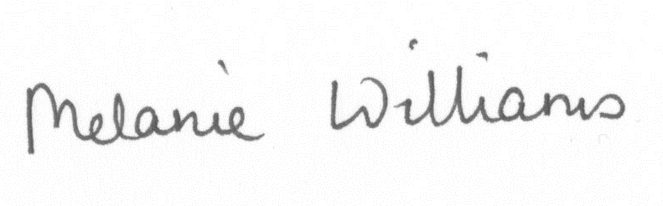
Melanie Williams
Executive Headteacher

