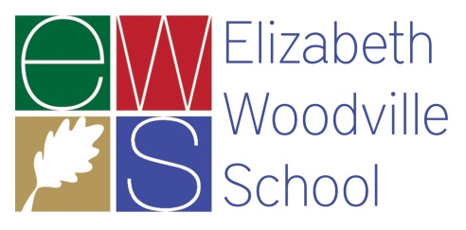
Elizabeth Woodville School

Rated as a good school by Ofsted in May 2014, Elizabeth Woodville School (EWS) is a high-achieving comprehensive school across two sites serving many villages and the fringes of both Northampton and Milton Keynes. EWS joined Tove Learning Trust in 2016, whose vision is to ensure all pupils are provided with outstanding educational experiences that lead to outstanding outcomes. The school is ambitious and well managed with an inspiring learning environment for both students and staff.

Required for January 2018:
Teacher of Computing and ICT
Full Time
Permanent

There are new and exciting challenges daily in education, and as a computing and ICT specialist you will be acutely aware of this. In Computing and ICT at EWS, students are challenged from the beginning of Year 7 to work with, and gain inspiration from, a wide range of practical and coding experiences. We are introducing the Computing curriculum to our key stage 3, and this can be a rewarding time, with the appointed teacher having the opportunity to help design a new and exciting curriculum. We keep this level of challenge high as our students - a vibrant and dynamic body of engaging young people – work with us towards their BTEC ICT qualifications at Level 2 and Level 3, which has Web Design and HTML subject focus. In addition we intend to offer OCR Computer Science GCSE.

Come and join our forward looking, student-focused, energetic team – we work hard, but we work smart and we always work together. We need you to help us move forward with your drive and attention to detail, making your lessons the highlight of every student’s day.

If you have the relevant skills and experience for this post, please apply by completing an application form, available from our website at www.ewsacademy.org.uk, along with a covering letter explaining how your knowledge, skills and experience are suitable for this role.

Applications should be e-mailed to michelle.saint@ewsacademy.org.uk, or by post for the attention of Michelle Saint to our North Campus, telephone (01604) 862125. Visits to the school are encouraged - to arrange a visit please contact Louise Symonds at louise.symonds@ewsacademy.org.uk

Closing date: 26 September 2017
Interviews: w/c 2 October 2017

The governors of Elizabeth Woodville School and the Trustees of Tove Learning Trust are committed to safeguarding and promoting the welfare of children, young people and vulnerable adults and expect all staff and volunteers to share this commitment. Successful candidates must be willing to undergo Enhanced DBS and other checks appropriate to the post. Tove Learning Trust is an equal opportunities employer.

