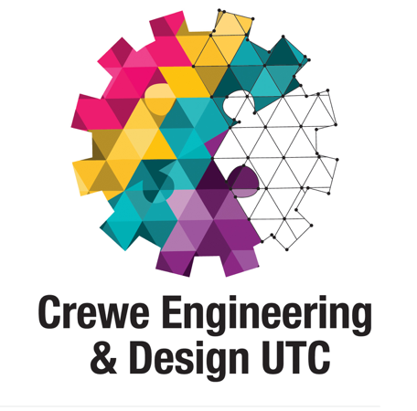

Support Posts - Candidate Information

Crewe Engineering & Design UTC
Create. Build. Grow.
Dear Colleague,
Thank you for taking the time to look at the employment opportunities we have available at Crewe Engineering & Design UTC (University Technical College). This is a hugely exciting and unique chance to be involved in leading the field in a brand new type of school; teaching knowledge and skills in new ways and in new types of spaces to directly prepare students for the world of work. We very much hope you will be as inspired by the potential of our school as much as we are.

Crewe Engineering & Design UTC is a new specialist school which opened in September 2016, it offers students a personalised course of study designed in partnership with Manchester Metropolitan University and our employer partners: Bentley, OSL, Network Rail, Air Products, Cheshire East Council, Chevron, Bosch, Siemens, James Walker, Leoni, RAF, Unipart Logistics, Arriva Train Care and Optical 3D. The school specialises in outstanding quality education in engineering and design giving today’s young people the skills they need to succeed in tomorrow’s workplace.

We are dedicated to continually developing our expertise in teaching and learning and engaging with our sponsors and employers to develop our curriculum offer. We are passionate about the impact we have within our local community and relentless in our pursuit of excellence.

We are looking for ambitious people with a strong commitment to deliver an innovative and vibrant education. You will be a skilled practitioner who understands the challenges of educating 14-19 year olds in an employer led technology rich environment. Effective partnership working is absolutely critical to the UTC’s success.
We see our UTC as a huge opportunity to give young people more chances to succeed, develop a passion for lifelong learning and improve the educational choices that are available to them as they prepare for the ever changing world of work.

If being part of this vision excites you and you are seeking a fresh challenge, I encourage you to study the information we have provided. We sincerely look forward to receiving your application.

David Terry

David Terry
Principal and Chief Executive

The Sponsors and Partners
The UTC is sponsored by Manchester Metropolitan University, Bentley and OSL Rail. Our employer partners include Cheshire East Council, RAF, Network Rail, Air Products, Unipart Logistics, Chevron, Bosch, Siemens, James Walker, Arriva Train Care, Leoni and Optical 3D. The partners play a crucial role in supporting the development of an outstanding curriculum and educational experience for our students.

The UTC
Crewe Engineering & Design UTC, will deliver the highest quality school leavers who will be the next generation of engineers and technicians, driving growth in the region’s key industries of automotive and rail industries.
Through a learning environment and experience which models the best professional practice in the fields of advanced engineering, manufacturing, and design the student engineers and applied scientists graduating from Crewe Engineering and Design UTC will have the academic qualifications, professional characteristics and personal qualities that render them highly valued employees, researchers and future leaders in engineering. They will develop seven key attributes of curiosity and imagination; enquiry and analysis; problem-solving and resilience; self-management and organisation; teamwork and collaboration; technological confidence and technical skills; creativity and ingenuity.
A distinctive element of the Crewe Engineering and Design UTC curriculum will be the formative experience provided by students’ involvement in a number of major employer projects, which are designed to draw on and provide relevant contexts for application of learning across subjects. Through engaging with these ‘problem based’ projects in collaborative Project Teams, students will simultaneously build the (aforementioned) Seven Key Attributes considered essential for our developing engineers.

Crewe
Crewe is a town that was originally created for the purpose of serving the railways as they grew in the 19th century.
After the station was established, the Grand Junction railway company created its main workshops to the north of the junction and the town expanded rapidly. In the 1930s Crewe attracted Rolls-Royce who opened their factory to produce Merlin aircraft engines for the RAF. The factory later became the production centre for Rolls-Royce and Bentley cars. Today the factory is dedicated to the manufacture of Bentleys, a major employer in the area and a sponsor of the UTC. Crewe is also home to part of the Manchester Metropolitan University.

Outstanding Facilities
The UTC is based in the heart of Crewe within easy travelling distance of all regions across Cheshire and the North West. The specialist facilities incorporate the very best of equipment and learning spaces to support outstanding learning. The UTC website contains a vision of how world class engineering and design will look in our second state of the art building.

Support Team
Overall Job Purpose
- To support the Principal and Senior Team in developing Crewe Engineering & Design UTC as a unique and exciting place for learning which equips students with the skills, knowledge and aptitudes to give them a competitive advantage in engineering and science related skills.
Duties
- Ensure the agreed vision and strategic direction for the UTC is understood and acted upon.
- Ensure the UTC achieves its performance targets.
- Support the Principal and Senior Team in developing the identity of Crewe Engineering & Design UTC to ensure that it has an excellent reputation within the local, regional and national context through effective partnership working.
- Actively demonstrate creativity and innovation in the use of new technologies to achieve excellence in all aspects of curriculum development and delivery.
- Work with the Principal, UTC colleagues, sponsors and other education partners, to develop and implement models of education that raise student achievement and aspiration, and offer students world class 21st century learning opportunities.
- Foster an innovative and flexible UTC environment which is responsive to change.
- Contribute to the development of a model of student engagement that ensures the effective contribution of the Student Voice.
- Work with employer partners and other stakeholders to ensure that Crewe UTC promotes and delivers real working environments and practices, ensuring that students are supported in making an effective transition towards their educational and career goals.
- Contribute to the creation of a culture of challenge, support and high expectations, which is inclusive and supportive so that the UTC is a place where all young people feel welcome and all individual needs are met.
- Help create a strong collaborative, challenging and stimulating learning culture with active engagement from employer partners.

How to apply:
An application form and further information is available from the UTC website.
an application form and

