Gosford Hill School

Computing, Business and Languages Faculty

The Curriculum

In Key Stage 3, we offer French, Computing and a one term taster course in German in Year 8. Students are taught in mixed ability groups in Years 7 and 8. Students follow different ‘flight paths’ depending on prior attainment which provides for differentiated learning as they progress through Key Stage 3. Teacher assessment informs further differentiation and progression from one flight path to another.

At Key Stage 4 we offer Computer Science, Business Studies, French, German and ICT. We do select students for Computer Science, recognising that it is easily as challenging as any one of the Triple Sciences. Otherwise, students are taught in mixed ability groupings.

The faculty follows a number of courses, depending on the subject. ICT at Key Stage 4 follows the Ingots/TLM level 2 ICT Technical for years 10 and 11, we have introduced the OCR iMedia course for year 9, and in Computer Science we follow the OCR Computer Science GCSE. At Key Stage 5 (Year 12 and 13) we follow the OCR Cambridge Technical in ICT, and we are exploring the possibility of introducing the OCR Computer Science A Level. In Key Stage 4 Business Studies we follow the AQA Business Studies GCSE and at Key Stage 5 we follow the AQA GCE Applied Business course. In French and German at Key Stage 4 we follow the Edexcel GCSE and in Key Stage 5, we follow the AQA A Levels.

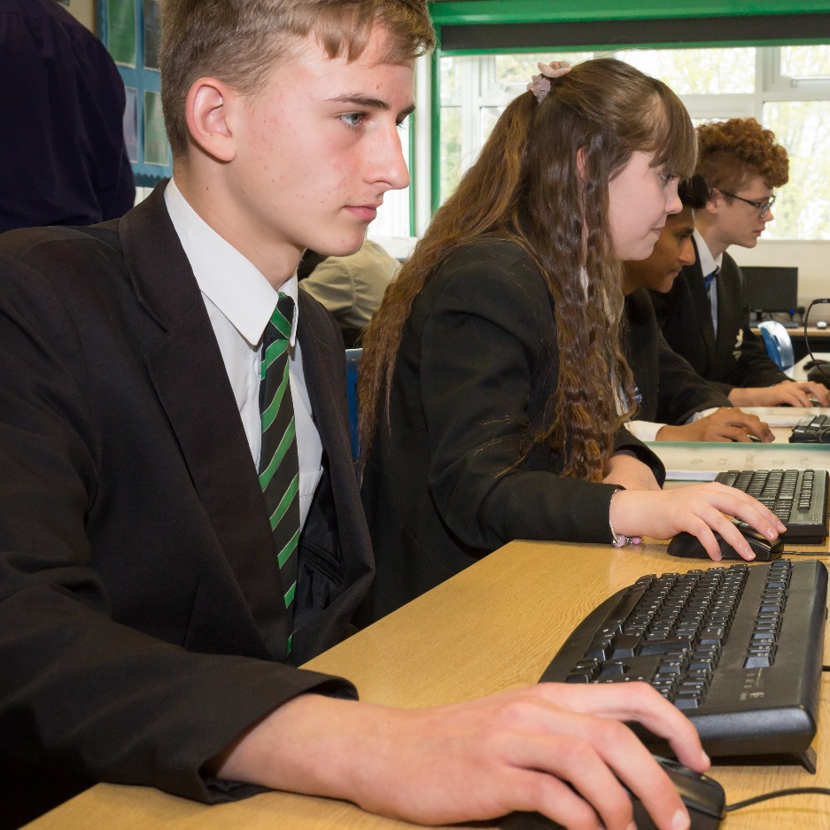

In Modern Foreign Languages teaching is based on developing student’s competencies in grammar, speaking, listening, reading and writing in the target language. In Key Stage 3 students follow the Studio textbooks exploring a range of topics including identity, local area, school, new technology and a study of Paris. In addition to this students begin to recognise and reproduce key grammatical features in each skill. Teachers create a learning environment in which students have the capacity to use new vocabulary in a creative way. Routine paired work, group work and team competitions encourage Gosford students to aim high, using all tools at their disposal to be able to write and speak imaginatively.

In Computing students develop a range of creative ICT skills in areas such as web design, spread-sheeting, databases and word processing. They develop the computational skills of sequencing instructions, flow charting, and programming and structured query language. They will also be taught about how computers and networks work. Students are taught to be critical of the information available via the internet and consider the challenges of e-Safety.

At Key Stage 4 students doing the Ingots technical in ICT complete and online exam and units including Spreadhseets, Databases, email, Digital Presentations, game making, and web design. In the OCR iMedia course we have three creative units: web design, 2D Game engines, and then the mandatory graphic design unit. In addition they also take the externally examined Pre-production skills unit. They have access to the industry standard software Photoshop and Dreamweaver. Students following the OCR Computer Science GCSE have one piece of controlled assessment and two exams to complete. We pride ourselves on delivering cutting edge programming teaching and have pioneered teaching python programming through the Minecraft environment. We have also introduced databases and MYSQL through the command line interface.

In Business Studies, our fundamental philosophy is for students to gain a deeper understanding of the nature of business, how they are formed and grown into large entities. We encourage our students to actively experience the business environment. This can be achieved through a variety of approaches, including work experience, links with local employers, case studies and research. Opportunities also exist to develop a practical approach through schemes such as Young Business Enterprise.
Business Studies provides stimulating and relevant courses that encourages a practical application of business concepts as well as building vital skills for higher education and students’ careers. Our courses are filled with relevant and stimulating concepts that encourage students to engage with real business cases such as Tesco, Facebook, Marks and Spencer and to link theory to business practice.
Lessons are extremely interactive. Group discussion, presentations and real world role plays, form the basis for stimulating lessons where business is brought to life. The higher order skills of independent investigation are often explored through portfolios, Controlled Assessments and the opportunity to set up an Enterprise makes teaching interactive and this encourages the skills needed to achieve in higher education.

Extra-Curricular Provision

Business Studies

In Business Studies, the department proudly encourages students to develop key employability skills and experience of the real business environment. We do this through the provision of enterprise activities; The Young Enterprise Company Programme in Year 12, The Tenner Challenge in Year’s 9 and 10 and educational visits to a range of businesses to supplement the syllabus.
The Young Enterprise Company Programme is delivered across an academic year, young people make all the decisions about their company, from raising the initial share capital through to designing their product or service to selling directly to customers and ultimately winding up the company and paying their taxes. All this takes place with the support of a Business Adviser who brings a wealth of business knowledge and expertise to the team.
Students can also choose to set up their business as a social enterprise, which focuses on addressing a social need rather than maximising profit. Young Enterprise helps teachers embed practical business skills and the government’s statutory guidance on careers advice in the curriculum. Students meet twice a week for board meetings, an hour after school and during a lunch break. The Young Enterprise Company Programme supports a range of qualifications and University entrance.
The department also offers The Tenner Young Enterprise National Challenge, which helps young people develop key skills including creativity, positivity, resilience and problem solving, using real money to take calculated risks in business. Students have one month to set up a business – coming up with an idea of a product or service they can sell and experience what it’s like to be an entrepreneur.
Computing
This year we have run a Lego ‘Stem’ club for students to come and get involved in programming and entry level robotics. After school sessions take place on Tuesdays, Wednesdays and Thursdays for students who need help with their coursework
Modern Foreign Languages
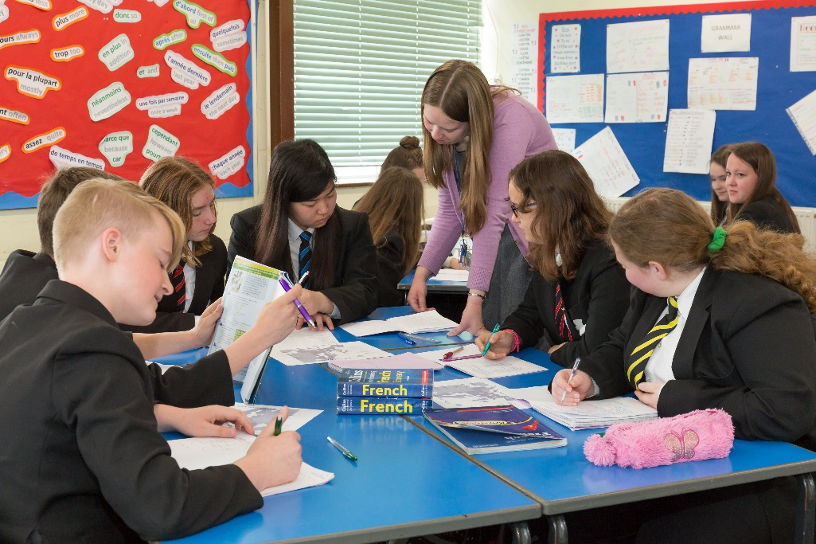
In July 2015 Year 10 German students went on a trip to Bonn where they were able to use their language skills in reals contexts. Students visited the Schokoladmuseum, der Kölner Dom and also spent a morning in a German school attending lessons with students they had written to prior to the visit. The MFL department is eager for visits of this nature to continue and is currently planning trips for 2017. A number of revision workshops and also organised for Year 11 students in preparation for their summer exams, they are also invited to a revision breakfast in the language department on the morning of their exam. In addition Sixth Form students attend study days offered by Oxford University.

Examination Results

Examination Results 2017 in CBL
GCSE | No. of Students | %A*/A | %A*-C
GCSE Business Studies | 43 | 25.6% | 65.1%
GCSE French | 11 | 9.1% | 54.5%
GCSE German | 42 | 16.3% | 74.4%
GCSE ICT | 62 | 19.4% | 95.2%
GCSE Computer Science | 35 | 14.3% | 77.1
A LEVEL | No. of Students | %A*-B | %A*-E
Business | 5 | 100% | 100%
German | 2 | 100% | 100%
ICT | 10 | 90% | 100%

Staffing, Resources and Accommodation

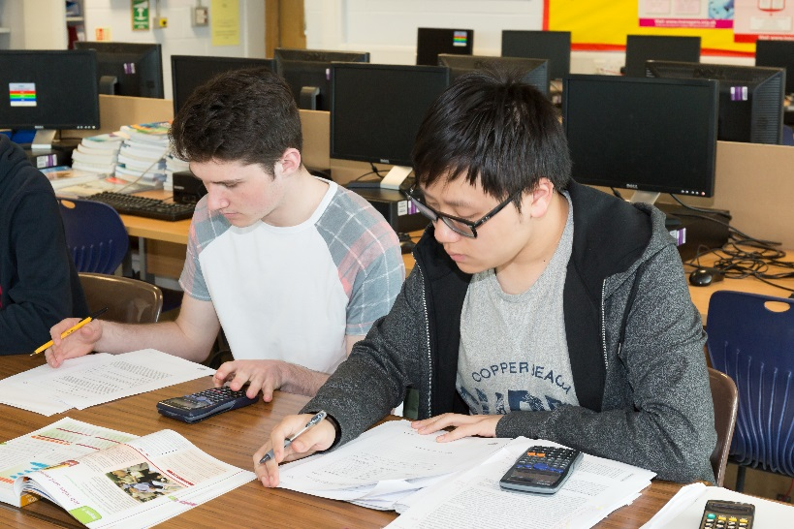
The Business department consists of one full time and one part time experienced, passionate and friendly staff, who work hard to provide our students with a rich learning experience of Business Studies and the business environment. The subject leader is highly experienced with a successful business background, and encourages students to develop a ‘can do’ attitude towards all aspect of their learning. We work closely with UK based businesses and have established close links with companies such as Jaguar Land Rover, BMW Mini Cowley and The London Maritime Museum, Greenwich.

Business Studies is taught in two rooms, with the main teaching room based in the ICT building. It has thirty computers, and a large space designed for working in other ways.

The department is well resourced with learning materials including textbooks, specialist business magazines, broad sheet business newspapers, interactive teaching resources and portfolio and Controlled Assessment assignment briefs developed by the subject leader to enable our students to become better researchers and writers the subject.

The Computing and ICT Team is currently is made of three full time staff. Both of the full time staff can deliver both Computing and ICT and one colleague teaches A Level. We have three dedicated computer rooms with 32 computers in each room. We have a huge library of electronic resources and the Microsoft School agreement and our Adobe licence means that we always keep up to date with the latest releases of the Microsoft Office Suite and the Adobe Creative Cloud suite.

The MFL Department is an enthusiastic team of three full time members of staff, each member of the department teaches French and German is also taught by two teachers. The department is friendly, supportive and forward-looking. The department has three teaching rooms, and each room is equipped with an interactive whiteboard, French / German dictionaries, textbooks, as well as books and magazines in the target language. Schemes of work and resources are clearly set out and available for Key Stage 3, Key Stage 4 and ‘A’ level. Students visit computer rooms at various stages in the year to complete projects or practice grammar.

Informal visits to the school are welcome; please telephone to make an appointment to be shown around.

Gosford Hill School is an equal opportunities employer and is committed to safeguarding and promoting the welfare of children and young people. We expect all staff and volunteers to share this commitment. Due to this post having access to children and/or vulnerable adults, candidates will be required to undertake a Disclosure and Barring Service check. The possession of a criminal record will not necessarily prevent an applicant from obtaining this post, as all cases are judged individually according to the nature of the role and information provided.
Gosford Hill School operates a ‘No Smoking Policy’ for all new appointments. April 2016

